**[V] DOUBLE CHECKED**

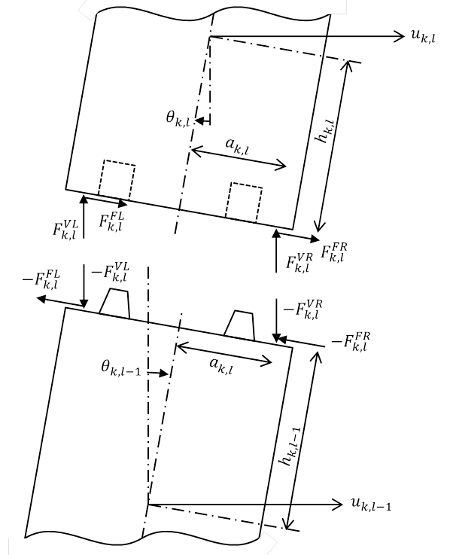 

하중 모멘트암 길이

On the interface between the lower left corner of the block (k,l) and the upper left corner of the block (k,l-1), the relative velocity of those two corners:

$$ξ_{k,l}^{L}=\left\{{\dot{u}}_{k,l}-\left(h_{k,l}\cos{θ_{k,l}}-a_{k,l}\sin{θ_{k,l}}\right){\dot{θ}}_{k,l}\right\}-\left\{{\dot{u}}_{k,l-1}+\left(h_{k,l-1}\cos{θ_{k,l-1}}+a_{k,l}\sin{θ_{k,l-1}}\right){\dot{θ}}_{k,l-1}\right\}$$

If $F_{k,l}^{VL}≤0$ or $ξ_{k,l}^{L}=0$: (there is no fiction force)

$$F_{k,l}^{FL}=F_{k,l-1}^{FL}=M_{k,l}^{FL}=M_{k,l-1}^{FL}=0$$

Otherwise, if $\left|ξ_{k,l}^{L}\right|<ξ_{cr}^{F}$:

$$F_{k,l}^{FL}=-μ_{s}F_{k,l}^{VL}\frac{ξ_{k,l}^{L}}{ξ_{cr}^{F}}$$

else:

$$μ\left(ξ\right)=μ_{k}+\left(μ_{s}-μ_{k}\right)\exp\left(-d_{μ}\left(\left|ξ\right|-ξ_{cr}^{F}\right)\right)$$

$$F_{k,l}^{FL}=-sign\left(ξ_{k,l}^{L}\right) μ\left(ξ_{k,l}^{L}\right) F_{k,l}^{VL}$$

where,

$μ_{s}$: Static friction coefficient

$μ_{k}$: Kinetic friction coefficient

$d_{μ}$: Decay coefficient of Static-kinetic friction coefficient relationship

$ξ_{cr}^{F}$: Critical relative velocity for frictional slip/stick condition

The friction force on the upper left corner of the block (k,l-1) and the corresponding moments are:

$$F_{k,l-1}^{FL}=-F_{k,l}^{FL}$$

$$M_{k,l}^{FL}=-F_{k,l}^{FL}\left(h_{k,l}\cos{θ_{k,l}}-a_{k,l}\sin{θ_{k,l}}\right)$$

$$M_{k,l-1}^{FL}=F_{k,l-1}^{FL}\left(h_{k,l-1}\cos{θ_{k,l-1}}+a_{k,l}\sin{θ_{k,l-1}}\right)$$

On the interface between the lower right corner of the block (k,l) and the upper right corner of the block (k,l-1), the relative velocity of those two corners:

$$ξ_{k,l}^{R}=\left\{{\dot{u}}_{k,l}-\left(h_{k,l}\cos{θ_{k,l}}+a_{k,l}\sin{θ_{k,l}}\right){\dot{θ}}_{k,l}\right\}-\left\{{\dot{u}}_{k,l-1}+\left(h_{k,l-1}\cos{θ_{k,l-1}}{-a}_{k,l}\sin{θ_{k,l-1}}\right){\dot{θ}}_{k,l-1}\right\}$$

If $F_{k,l}^{VR}≤0$ or $ξ_{k,l}^{R}=0$:

$$F_{k,l}^{FR}=F_{k,l-1}^{FR}=M_{k,l}^{FR}=M_{k,l-1}^{FR}=0$$

Otherwise, if $\left|ξ_{k,l}^{R}\right|<ξ_{cr}^{F}$:

$$F_{k,l}^{FR}=-μ_{s}F_{k,l}^{VR}\frac{ξ_{k,l}^{R}}{ξ_{cr}^{F}}$$

else:

$$F_{k,l}^{FR}=-sign\left(ξ_{k,l}^{R}\right) μ\left(ξ_{k,l}^{R}\right) F_{k,l}^{VR}$$

The friction force on the upper left corner of the block (k,l-1) and the corresponding moments are:

$$F_{k,l-1}^{FR}=-F_{k,l}^{FR}$$

$$M_{k,l}^{FR}=-F_{k,l}^{FR}\left(h_{k,l}\cos{θ_{k,l}}+a_{k,l}\sin{θ_{k,l}}\right)$$

$$M_{k,l-1}^{FR}=F_{k,l-1}^{FR}\left(h_{k,l-1}\cos{θ_{k,l-1}}-a_{k,l}\sin{θ_{k,l-1}}\right)$$

The resultant forces and moments acting on block (k,l) and (k,l-1):

$$ΣF_{k,l}^{F}=F_{k,l}^{FL}+F_{k,l}^{FR}$$

$$ΣM_{k,l}^{F}=M_{k,l}^{FL}+M_{k,l}^{FR}$$

$$ΣF_{k,l-1}^{F}=F_{k,l-1}^{FL}+F_{k,l-1}^{FR}$$

$$ΣM_{k,l-1}^{F}=M_{k,l-1}^{FL}+M_{k,l-1}^{FR}$$

For l=1, following equations should be modified:

$$ξ_{k,1}^{L}={\dot{u}}_{k,1}-\left(h_{k,1}\cos{θ_{k,1}}-a_{k,1}\sin{θ_{k,1}}\right){\dot{θ}}_{k,1}-{\dot{u}}_{0}$$

$$ξ_{k,1}^{R}={\dot{u}}_{k,1}-\left(h_{k,1}\cos{θ_{k,1}}+a_{k,1}\sin{θ_{k,1}}\right){\dot{θ}}_{k,1}-{\dot{u}}_{0}$$

$$M_{k,0}^{FL}=M_{k,0}^{FR}=0$$