**[ ] DOUBLE CHECKED**

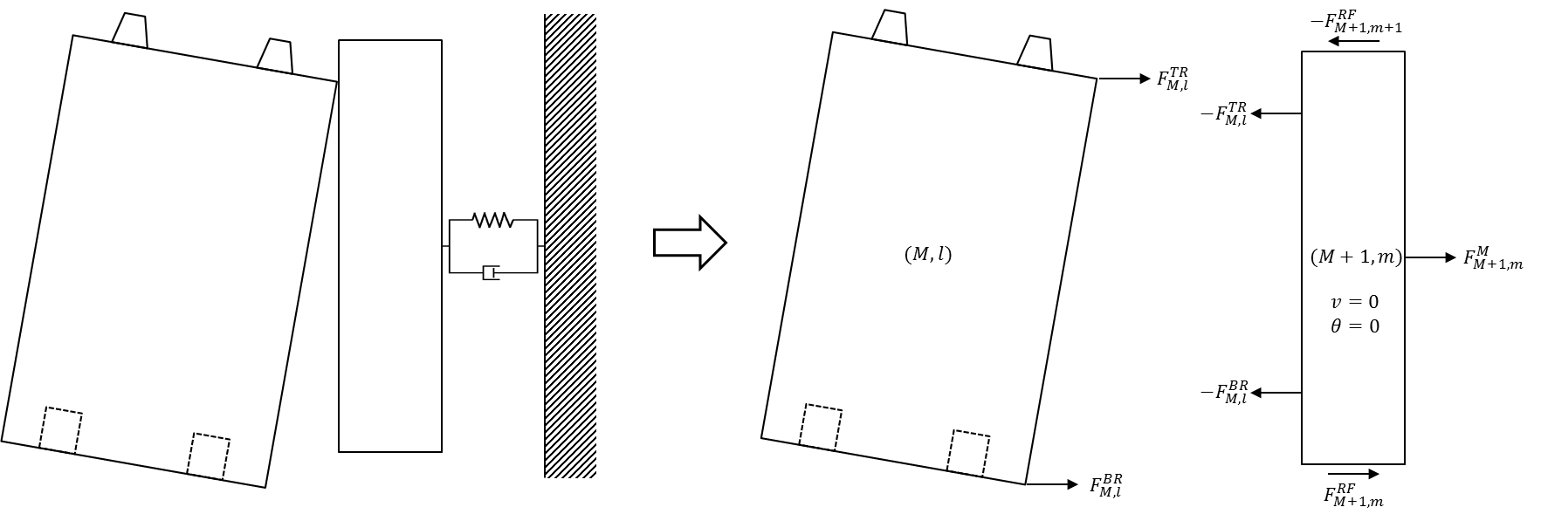

Outermost blocks have interfaces with side restraint plates or blocks which are attached to the seismic load boundary or wall by Kelvin-Voigt spring-damper connections. On the right boundary, the block (M, l) will contact with the side restraint (M+1, m) as shown in Fig. XXX. On the left boundary, the block (1, l) will contact with the side restraint (0, m). m is the contacting side restraint number counted from bottom. The computer program will compare the location of the block corners with the side restraints locations to determine the row number, m for each contacting mode.

(1) Impact on the upper right corner of the block (M, l)

The spring contraction and its velocity are:

$$ε_{M,l}=u_{M,l}+h_{M,l}\sin{θ_{M,l}}-b_{M,l}\left(1-\cos{θ_{M,l}}\right)-u_{M+1,m}-δ^{B}$$

$${\dot{ε}}_{M,l}={\dot{u}}_{M,l}+\left\{h_{M,l}\cos{θ_{M,l}}-b_{M,l}\sin{θ_{M,l}}\right\}{\dot{θ}}_{M,l}-{\dot{u}}_{M+1,m}$$

If $ε_{M,l}>0$:

$$F_{M,l}^{TR}=-K_{M,l}^{B}ε_{M,l}-C_{M,l}^{B}{\dot{ε}}_{M,l}$$

$$M_{M,l}^{TR}=F_{M,l}^{TR}\left(h_{M,l}\cos{θ_{M,l}}-b_{M,l}\sin{θ_{M,l}}\right)$$

(2) Impact on the lower right corner of the block (M, l)

The spring contraction and its velocity are:

$$ε_{M,l}=u_{M,l}-h_{M,l}\sin{θ_{M,l}}-b_{M,l}\left(1-\cos{θ_{M,l}}\right)-u_{M+1,m}-δ^{B}$$

$${\dot{ε}}_{M,l}={\dot{u}}_{M,l}-\left\{h_{M,l}\cos{θ_{M,l}}+b_{M,l}\sin{θ_{M,l}}\right\}{\dot{θ}}_{M,l}-{\dot{u}}_{M+1,m}$$

If $ε_{M,l}>0$:

$$F_{M,l}^{BR}=-K_{M,l}^{B}ε_{M,l}-C_{M,l}^{B}{\dot{ε}}_{M,l}$$

$$M_{M,l}^{BR}=-F_{M,l}^{TR}\left(h_{M,l}\cos{θ_{M,l}}+b_{M,l}\sin{θ_{M,l}}\right)$$

(3) Impact on the upper left corner of the block (1, l)

The spring contraction and its velocity are:

$$ε_{1,l}=u_{0,m}-u_{1,l}-h_{1,l}\sin{θ_{1,l}}-b_{1,l}\left(1-\cos{θ_{1,l}}\right)-δ^{B}$$

$${\dot{ε}}_{1,l}={\dot{u}}_{0,m}-{\dot{u}}_{1,l}-\left\{h_{1,l}\cos{θ_{1,l}}+b_{1,l}\sin{θ_{1,l}}\right\}{\dot{θ}}_{1,l}$$

If $ε_{1,l}>0$:

$$F_{1,l}^{TL}=K_{1,l}^{B}ε_{1,l}+C_{1,l}^{B}{\dot{ε}}_{1,l}$$

$$M_{1,l}^{TL}=F_{1,l}^{TL}\left(h_{1,l}\cos{θ_{1,l}}+b_{1,l}\sin{θ_{1,l}}\right)$$

(4) Impact on the lower left corner of the block (1, l)

The spring contraction and its velocity are:

$$ε_{1,l}=u_{0,m}-u_{1,l}+h_{1,l}\sin{θ_{1,l}}-b_{1,l}\left(1-\cos{θ_{1,l}}\right)-δ^{B}$$

$${\dot{ε}}_{1,l}={\dot{u}}_{0,m}-{\dot{u}}_{1,l}+\left\{h_{1,l}\cos{θ_{1,l}}-b_{1,l}\sin{θ_{1,l}}\right\}{\dot{θ}}_{1,l}$$

If $ε_{1,l}>0$:

$$F_{1,l}^{BL}=K_{1,l}^{B}ε_{1,l}+C_{1,l}^{B}{\dot{ε}}_{1,l}$$

$$M_{1,l}^{BL}=-F_{1,l}^{BL}\left(h_{1,l}\cos{θ_{1,l}}-b_{1,l}\sin{θ_{1,l}}\right)$$

The force on the side restraint from the restraint spring-damper components are:

$$F_{0,m}^{M}=K_{0,m}^{M}\left(u_{Base}-u_{0,m}\right)+C_{0,l}^{M}\left({\dot{u}}_{Base}-{\dot{u}}_{0,m}\right)$$

$$F_{M+1,m}^{M}=K_{M+1,m}^{M}\left(u_{Base}-u_{M+1,m}\right)+C_{M+1,l}^{M}\left({\dot{u}}_{Base}-{\dot{u}}_{M+1,m}\right)$$

The calculation of friction force between side restraints (i, m) and (i, m-1) needs relative velocity in-between where i is 0 or M+1:

$$ξ_{i,m}={\dot{u}}_{i,m}-{\dot{u}}_{i,m-1}$$

Otherwise, if $\left|ξ_{i,m}^{}\right|<ξ_{cr}^{F}$:

$$F_{i,m}^{RF}=-μ_{s}F_{i,m}^{VM}\frac{ξ_{i,m}^{}}{ξ_{cr}^{F}}$$

else:

$$μ\left(ξ\right)=μ_{k}+\left(μ_{s}-μ_{k}\right)\exp\left(-d_{μ}\left(\left|ξ\right|-ξ_{cr}^{F}\right)\right)$$

$$F_{i,m}^{RF}=-sign\left(ξ_{i,m}^{}\right) μ\left(ξ_{i,m}^{}\right) F_{i,m}^{VM}$$

However, the vertical reaction force, $F_{i,m}^{VM}$ is not identified in this stage of study. The test fixture is expected to have negligibly small vertical force and the friction force is assumed to be zero.

The resultant forces and moments acting on the blocks (1, l) and (M, l) are:

$$ΣF_{1,l}^{}=F_{1,l}^{TL}+F_{1,l}^{BL}$$

$$ΣM_{1,l}^{}=M_{1,l}^{TL}+M_{1,l}^{BL}$$

$$ΣF_{M,l}^{}=F_{M,l}^{TR}+F_{M,l}^{BR}$$

$$ΣM_{M,l}^{}=M_{M,l}^{TR}+M_{M,l}^{BR}$$

The resultant forces acting on the side restraints (0, m) and (M+1, m) are:

$$ΣF_{0,m}^{}=F_{0,m}^{M}+F_{i,m}^{RF}-F_{i,m+1}^{RF}-F_{1,l}^{TL}-F_{1,l}^{BL}$$

$$ΣF_{M+1,m}^{}=F_{M+1,m}^{M}+F_{M+1,m}^{RF}-F_{M+1,m+1}^{RF}-F_{M,l}^{TR}-F_{M,l}^{BR}$$