**[ ] DOUBLE CHECKED**

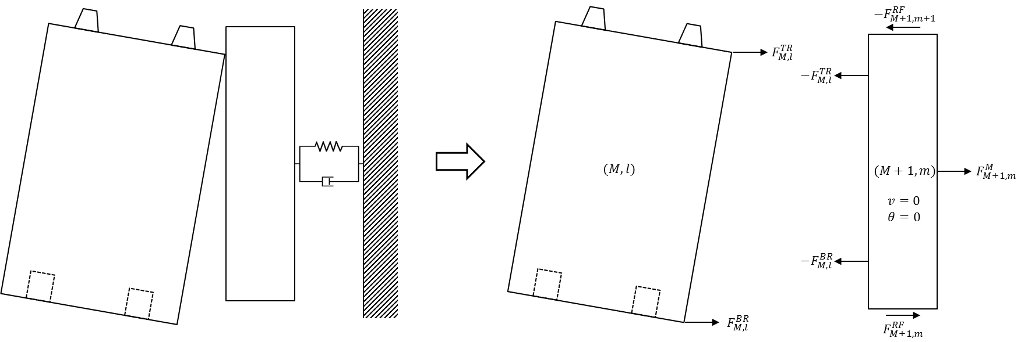

Outermost blocks have interfaces with permanent side reflectors (PSRs) which are attached to the seismic load boundary or wall by Kelvin-Voigt spring-damper connections. On the right boundary, the (M, l) block will contact with the (M+1, l) PSR as shown in Fig. XXX. On the left boundary, the (1, l) block will contact with the (0, l) PSR.

(1) Impact on the upper right corner of the block (M, l)

The spring contraction and its velocity are:

$$ε_{M,l}=u_{M,l}+h_{M,l}\sin{θ_{M,l}}-b_{M,l}\left(1-\cos{θ_{M,l}}\right)-u_{M+1,l}-δ^{B}$$

$${\dot{ε}}_{M,l}={\dot{u}}_{M,l}+\left\{h_{M,l}\cos{θ_{M,l}}-b_{M,l}\sin{θ_{M,l}}\right\}{\dot{θ}}_{M,l}-{\dot{u}}_{M+1,l}$$

If $ε_{M,l}>0$:

$$F_{M,l}^{TR}=-K_{M,l}^{B}ε_{M,l}-C_{M,l}^{B}{\dot{ε}}_{M,l}$$

$$M_{M,l}^{TR}=F_{M,l}^{TR}\left(h_{M,l}\cos{θ_{M,l}}-b_{M,l}\sin{θ_{M,l}}\right)$$

(2) Impact on the lower right corner of the (M, l) block

The spring contraction and its velocity are:

$$ε_{M,l}=u_{M,l}-h_{M,l}\sin{θ_{M,l}}-b_{M,l}\left(1-\cos{θ_{M,l}}\right)-u_{M+1,l}-δ^{B}$$

$${\dot{ε}}_{M,l}={\dot{u}}_{M,l}-\left\{h_{M,l}\cos{θ_{M,l}}+b_{M,l}\sin{θ_{M,l}}\right\}{\dot{θ}}_{M,l}-{\dot{u}}_{M+1,l}$$

If $ε_{M,l}>0$:

$$F_{M,l}^{BR}=-K_{M,l}^{B}ε_{M,l}-C_{M,l}^{B}{\dot{ε}}_{M,l}$$

$$M_{M,l}^{BR}=-F_{M,l}^{TR}\left(h_{M,l}\cos{θ_{M,l}}+b_{M,l}\sin{θ_{M,l}}\right)$$

(3) Impact on the upper left corner of the (1, l) block

The spring contraction and its velocity are:

$$ε_{1,l}=u_{0,l}-u_{1,l}-h_{1,l}\sin{θ_{1,l}}-b_{1,l}\left(1-\cos{θ_{1,l}}\right)-δ^{B}$$

$${\dot{ε}}_{1,l}={\dot{u}}_{0,l}-{\dot{u}}_{1,l}-\left\{h_{1,l}\cos{θ_{1,l}}+b_{1,l}\sin{θ_{1,l}}\right\}{\dot{θ}}_{1,l}$$

If $ε_{1,l}>0$:

$$F_{1,l}^{TL}=K_{1,l}^{B}ε_{1,l}+C_{1,l}^{B}{\dot{ε}}_{1,l}$$

$$M_{1,l}^{TL}=F_{1,l}^{TL}\left(h_{1,l}\cos{θ_{1,l}}+b_{1,l}\sin{θ_{1,l}}\right)$$

(4) Impact on the lower left corner of the (1, l) block

The spring contraction and its velocity are:

$$ε_{1,l}=u_{0,l}-u_{1,l}+h_{1,l}\sin{θ_{1,l}}-b_{1,l}\left(1-\cos{θ_{1,l}}\right)-δ^{B}$$

$${\dot{ε}}_{1,l}={\dot{u}}_{0,l}-{\dot{u}}_{1,l}+\left\{h_{1,l}\cos{θ_{1,l}}-b_{1,l}\sin{θ_{1,l}}\right\}{\dot{θ}}_{1,l}$$

If $ε_{1,l}>0$:

$$F_{1,l}^{BL}=K_{1,l}^{B}ε_{1,l}+C_{1,l}^{B}{\dot{ε}}_{1,l}$$

$$M_{1,l}^{BL}=-F_{1,l}^{BL}\left(h_{1,l}\cos{θ_{1,l}}-b_{1,l}\sin{θ_{1,l}}\right)$$

The vertical and rotational displacements of PSR blocks are assumed to be zero because they are tightly constrained by pin joints with neighboring PSR blocks. The horizontal spring-damper systems between PSR blocks and the base exist to consider the lateral restraint mechanism to hold the core assembly in the pressure vessel.

The force on the PSR from the restraint spring-damper components are:

$$F_{0,l}^{M}=K_{0,l}^{M}\left(u_{Base}-u_{0,l}\right)+C_{0,l}^{M}\left({\dot{u}}_{Base}-{\dot{u}}_{0,l}\right)$$

$$F_{M+1,l}^{M}=K_{M+1,l}^{M}\left(u_{Base}-u_{M+1,l}\right)+C_{M+1,l}^{M}\left({\dot{u}}_{Base}-{\dot{u}}_{M+1,l}\right)$$

The calculation of friction force between (i, l) and (i, l-1) PSRs needs relative velocity in-between where i is 0 or M+1:

$$ξ_{i,l}={\dot{u}}_{i,l}-{\dot{u}}_{i,l-1}$$

Otherwise, if $\left|ξ_{i,l}^{}\right|<ξ_{cr}^{F}$:

$$F_{i,l}^{RF}=-μ_{s}F_{i,l}^{VM}\frac{ξ_{i,l}^{}}{ξ_{cr}^{F}}$$

else:

~~However, the vertical reaction force, $F_{i,l}^{VM}$ is not identified in this stage of study. The test fixture is expected to have negligibly small vertical force and the friction force is assumed to be zero.~~

is the sum of the weights of (i, l)~(i, N) PSRs and the pressure drop force. The lateral cross-sectional area of the PSRs are assumed to be hexagons. Then, the $F_{i,l}^{VM}$ is calculated as:

$$F_{i,l}^{VM}=g\sum_{j=l}^{N}{m_{i,j}}+2\sqrt{3}b_{i,N}^{2}ΔP$$

where $b_{i,N}$ is the width of the (i, N) PSR and $ΔP$ is the pressure drop between inlet and outlet.

The resultant forces and moments acting on (1, l) and (M, l) blocks are:

$$ΣF_{1,l}^{}=F_{1,l}^{TL}+F_{1,l}^{BL}$$

$$ΣM_{1,l}^{}=M_{1,l}^{TL}+M_{1,l}^{BL}$$

$$ΣF_{M,l}^{}=F_{M,l}^{TR}+F_{M,l}^{BR}$$

$$ΣM_{M,l}^{}=M_{M,l}^{TR}+M_{M,l}^{BR}$$

The resultant forces acting on (0, l) and (M+1, l) PSRs are:

$$ΣF_{0,l}^{}=F_{0,l}^{M}+F_{i,l}^{RF}-F_{i,l+1}^{RF}-F_{1,l}^{TL}-F_{1,l}^{BL}$$

$$ΣF_{M+1,l}^{}=F_{M+1,l}^{M}+F_{M+1,l}^{RF}-F_{M+1,l+1}^{RF}-F_{M,l}^{TR}-F_{M,l}^{BR}$$