교육 제목 | 딥러닝
교육 일시 | 2021-10-26
교육 장소 | 영우글로벌러닝
교육 내용
오전 | Boston 에서 MEDV 값 예측하기  from google.colab import files  file_uploaded = files.upload()  import matplotlib.pyplot as plt  import pandas as pd  import tensorflow as tf  data = pd.read_csv("./BostonHousing.csv")  print(data.info())  x_data = data.copy()  tf.random.set_seed(100)  y_data = x_data.pop('MEDV') # MEDV 값만 표에서 삭제 MEDV값을 예측하기 위해서  model = tf.keras.Sequential()  model.add(tf.keras.layers.Dense(64, input_dim=13, activation='sigmoid' ))  model.add(tf.keras.layers.Dense(128, activation='sigmoid'))  model.add(tf.keras.layers.Dense(256, activation='sigmoid'))  model.add(tf.keras.layers.Dense(1))  model.summary()  optimizer = tf.keras.optimizers.SGD(learning_rate=0.04)  loss = tf.keras.losses.mean_squared_error  metrics = tf.keras.metrics.RootMeanSquaredError()  model.compile(loss=loss, optimizer=optimizer, metrics=[metrics])  result = model.fit(x_data, y_data, epochs=100, batch_size=100)  loss = result.history['loss']  # loss 그래프  epochs = range(1, len(loss)+1)  plt.subplot(211) # 행렬,위  plt.plot(epochs, loss, 'b-', label='Training loss')  plt.title('Training loss')  plt.xlabel('Epochs')  plt.ylabel('Loss')  plt.legend()  mae = result.history['root_mean_squared_error']  epochs = range(1, len(mae)+1)  # mae그래프  plt.subplot(212) # 행렬,아래 그래프  plt.plot(epochs, mae, 'r-', label='Training mae')  plt.title('Training rmse')  plt.xlabel('Epochs')  plt.ylabel('rmse')  plt.legend()  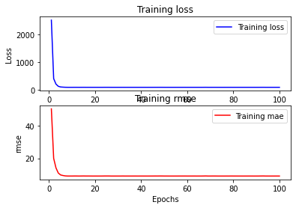  normalization  from google.colab import files  file_uploaded = files.upload()  import seaborn as sns  import pandas as pd  import matplotlib.pyplot as plt  data = pd.read_csv('./test.csv')  x_data = data.copy()  y_data = x_data.pop("D")  # 데이터 분포도 확인하기  sns.pairplot(data[["A","B","C","D"]], diag_kind='hist')  plt.show()  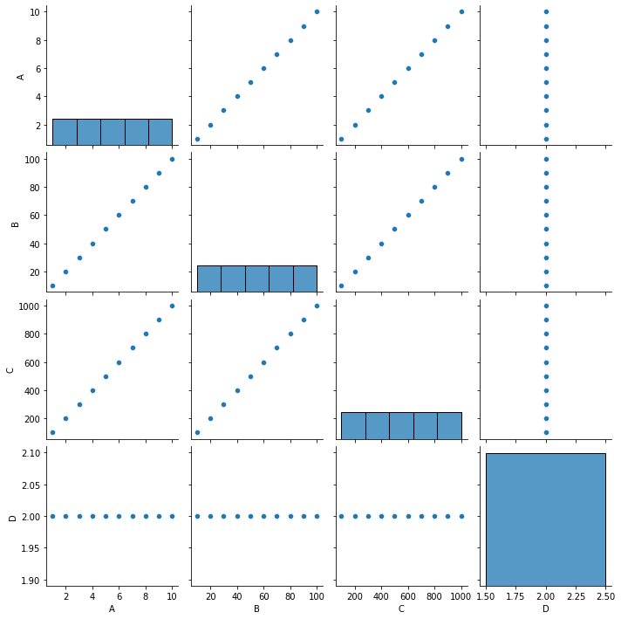  # data의 min, max, mean, std값 구하기  dataset_stats = data.describe()  dataset_stats = dataset_stats.transpose()  #data.min()  #data.max()  #data.mean()  ## data normalization  def min_max_norm(x):  return (x - dataset_stats['min']) / (dataset_stats['max'] - dataset_stats['min'])  def standard_norm(x):  return (x - dataset_stats['mean']) / dataset_stats['std']  min_max_norm_train_data = min_max_norm(data)  standard_norm_train_data = standard_norm(data)  BostonHousing Normalization  from google.colab import files  file_uploaded = files.upload()  data = pd.read_csv('./BostonHousing.csv')  x_data = data.copy()  y_data = data.pop('MEDV')  dataset_stats = data.describe()  dataset_stats = dataset_stats.transpose()  ## data normalization  def min_max_norm(x):  return (x - dataset_stats['min']) / (dataset_stats['max'] - dataset_stats['min'])  def standard_norm(x):  return (x - dataset_stats['mean']) / dataset_stats['std']  normed_train_data = standard_norm(data)  input_layer = tf.keras.layers.Input(shape=(13,))  x = tf.keras.layers.Dense(50, activation='sigmoid')(input_layer)  x = tf.keras.layers.Dense(100, activation='sigmoid')(x)  x = tf.keras.layers.Dense(300, activation='sigmoid')(x)  output_layer = tf.keras.layers.Dense(1, activation=None)(x)  model = tf.keras.Model(inputs=[input_layer], outputs=[output_layer])  model.summary()  loss = tf.keras.losses.mean_squared_error  optimizer = tf.keras.optimizers.SGD(learning_rate=0.007)  metrics = tf.keras.metrics.RootMeanSquaredError()  model.compile(loss=loss,  optimizer=optimizer,  metrics=[metrics])  result = model.fit(normed_train_data, y_data, epochs = 1000, batch_size=100)  loss = result.history['loss']  # loss 그래프  epochs = range(1, len(loss)+1)  plt.subplot(211)  plt.plot(epochs, loss, 'b-', label='Training loss')  plt.title('Training loss')  plt.xlabel('Epochs')  plt.ylabel('Loss')  plt.legend()  mae = result.history['root_mean_squared_error']  epochs = range(1, len(mae)+1)  # mae그래프  plt.subplot(212)  plt.plot(epochs, mae, 'r-', label='Training mae')  plt.title('Training rmse')  plt.xlabel('Epochs')  plt.ylabel('rmse')  plt.legend()  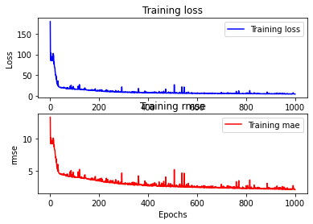
오후 | ·BostonHousing split  from google.colab import files  file_uploaded = files.upload()  data = pd.read_csv('./BostonHousing.csv')  x_data = data.copy()  ori_y = x_data.pop('MEDV')  from sklearn.model_selection import train_test_split  x_train1, x_test, y_train1, y_test = train_test_split(x_data, ori_y, test_size=0.3, shuffle=True)  x_train, x_valid, y_train, y_valid = train_test_split(x_train1, y_train1, test_size=0.2, shuffle=True)  input_layer = tf.keras.layers.Input(shape=(13,))  x = tf.keras.layers.Dense(50, activation='sigmoid')(input_layer)  x = tf.keras.layers.Dense(100, activation='sigmoid')(x)  x = tf.keras.layers.Dense(300, activation='sigmoid')(x)  out_layer = tf.keras.layers.Dense(1, activation=None)(x)  model = tf.keras.Model(inputs=[input_layer], outputs=[out_layer])  model.summary()  loss = tf.keras.losses.mean_squared_error  optimizer = tf.keras.optimizers.SGD(lr=0.0004)  metrics = tf.keras.metrics.RootMeanSquaredError()  model.compile(loss = loss,  optimizer = optimizer,  metrics = [metrics])  result = model.fit(x_train, y_train, epochs = 200, batch_size = 10, validation_data=(x_valid, y_valid))  loss = result.history['loss']  val_loss = result.history['val_loss']  ### loss와 val_loss를 그래프화  epochs = range(1, len(loss) + 1)  plt.subplot(211) ## 2x1 개의 그래프 중에 1번째  plt.plot(epochs, loss, 'b-', label='Training loss')  plt.plot(epochs, val_loss, 'r', label='Validation loss')  plt.title('Training and validation loss')  plt.xlabel('Epochs')  plt.ylabel('Loss')  plt.legend()  ### history에서 mean_absolute_error val_mean_absolute_error key를 가지는 값들만 추출  rmse = result.history['root_mean_squared_error']  val_rmse = result.history['val_root_mean_squared_error']  epochs = range(1, len(rmse) + 1)  ### mean_absolute_error val_mean_absolute_error key를 그래프화  plt.subplot(212) ## 2x1 개의 그래프 중에 2번째  plt.plot(epochs, rmse, 'b-', label='Training rmse')  plt.plot(epochs, val_rmse, 'r', label='Validation rmse')  plt.title('Training and validation rmse')  plt.xlabel('Epochs')  plt.ylabel('rmse')  plt.legend()  print("\n Test rmse: %.4f" % (model.evaluate(x_test, y_test)[1]))  plt.show()  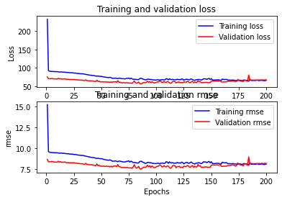  One hot encoding 실습  import tensorflow as tf  import pandas as pd  from sklearn.preprocessing import LabelEncoder  import numpy as np  from google.colab import files  file_uploaded = files.upload()  data = pd.read_csv('./one_hot_encording_test.csv', names = ["length", "width", "height", "volume", "class_name"]) # class_name =Y 데이터 나머지 = x데이터  x_data = data.copy()  y_data = x_data.pop('class_name')  print("data value : {}".format(x_data))  print("data Label : {}".format(y_data))  # case 1) sklearn  # Label Encoder는 독립 변수가 아닌 종속 변수(라벨)에 대해 사용한다.  # 문자열이나 정수로된 라벨 값을 0 ~ K−1 까지의 정수로 변환.  e = LabelEncoder()  e.fit(y_data)  print("Label Class String : {}".format(e.classes_))  Y = e.transform(y_data)  print("Label Class int : {}".format(Y))  y_encoded = tf.keras.utils.to_categorical(Y)  print("case 1 One hot label class : {}".format(y_encoded))  print(np.argmax(y_encoded, axis=1).reshape(-1,1))  print(y_encoded.shape)  # case 2) pandas  one_hot_label = pd.get_dummies(y_data)  print("case2 one_hot_label : ", one_hot_label)  print(one_hot_label.shape)  Iris multi classification  import tensorflow as tf  import matplotlib.pyplot as plt  from sklearn.model_selection import train_test_split  from sklearn.preprocessing import LabelEncoder  import pandas as pd  from google.colab import files  file_uploaded = files.upload()  # csv read  data = pd.read_csv('./iris.csv', names = ["sepal_length", "sepal_width", "petal_length", "petal_width", "species"])  x_data = data.copy()  y_data = x_data.pop("species")  X = x_data.copy()  # 문자열을 숫자로 변환  e = LabelEncoder()  e.fit(y_data)  y = e.transform(y_data)  y_encoded = tf.keras.utils.to_categorical(y)  # train과 test를 분리  x_train1, x_test, y_train1, y_test = train_test_split(X, y_encoded, test_size=0.1, shuffle=True)  # train set에서 train과 validation 분리  x_train, x_valid, y_train, y_valid = train_test_split(x_train1, y_train1, test_size=0.2, shuffle=True)  input_layer = tf.keras.layers.Input(shape=(4,))  x = tf.keras.layers.Dense(16, activation='sigmoid')(input_layer)  x = tf.keras.layers.Dense(32, activation='sigmoid')(x)  output_layer = tf.keras.layers.Dense(3, activation='softmax')(x)  model = tf.keras.models.Model(inputs=[input_layer], outputs = [output_layer])  model.summary()  loss = tf.keras.losses.categorical_crossentropy  optimizer = tf.keras.optimizers.SGD(learning_rate=0.04)  metrics = tf.keras.metrics.categorical_accuracy  model.compile(loss=loss, optimizer=optimizer, metrics=[metrics])  history = model.fit(x_train, y_train, epochs=200, batch_size=50, validation_data=(x_valid, y_valid))  loss = history.history['loss']  val_loss = history.history['val_loss']  # loss와 val_loss를 그래프  epochs = range(1, len(loss)+1)  plt.subplot(211)  plt.plot(epochs, loss, 'b-', label='Training loss')  plt.plot(epochs, val_loss, 'r', label='Validation loss')  plt.title('Training and validation loss')  plt.xlabel('Epochs')  plt.ylabel('Loss')  plt.legend()  acc = history.history['categorical_accuracy']  val_acc = history.history['val_categorical_accuracy']  plt.subplot(212) ## 2x1 개의 그래프 중에 2번째  plt.plot(epochs, acc, 'b-', label='Training acc')  plt.plot(epochs, val_acc, 'r', label='Validation acc')  plt.title('Training and validation accuracy')  plt.xlabel('Epochs')  plt.ylabel('Accuracy')  plt.legend()  model.save('iris_multi_model.h5')  모델 불러오기  import tensorflow as tf  import matplotlib.pyplot as plt  from sklearn.model_selection import train_test_split  from sklearn.preprocessing import LabelEncoder  import pandas as pd  # csv read  data = pd.read_csv('./iris.csv', names = ["sepal_length", "sepal_width", "petal_length", "petal_width", "species"])  x_data = data.copy()  y_data = x_data.pop("species")  X = x_data.copy()  # 문자열을 숫자로 변환  e = LabelEncoder()  e.fit(y_data)  y = e.transform(y_data)  y_encoded = tf.keras.utils.to_categorical(y)  # train과 test를 분리  x_train1, x_test, y_train1, y_test = train_test_split(X, y_encoded, test_size=0.1, shuffle=True)  # train set에서 train과 validation 분리  x_train, x_valid, y_train, y_valid = train_test_split(x_train1, y_train1, test_size=0.2, shuffle=True)  model_path = "./{epoch:02d}-{val_loss:.4f}.h5"  model = tf.keras.models.load_model('iris_multi_model.h5')  모델 중단됬을 때, retrain  # csv read  data = pd.read_csv('./iris.csv', names = ["sepal_length", "sepal_width", "petal_length", "petal_width", "species"])  x_data = data.copy()  y_data = x_data.pop("species")  X = x_data.copy()  # 문자열을 숫자로 변환  e = LabelEncoder()  e.fit(y_data)  y = e.transform(y_data)  y_encoded = tf.keras.utils.to_categorical(y)  # train과 test를 분리  x_train1, x_test, y_train1, y_test = train_test_split(X, y_encoded, test_size=0.1, shuffle=True)  # train set에서 train과 validation 분리  x_train, x_valid, y_train, y_valid = train_test_split(x_train1, y_train1, test_size=0.2, shuffle=True)  model = tf.keras.models.load_model('iris_multi_model.h5')  model.summary()  # 모델 컴파일  loss=tf.keras.losses.categorical_crossentropy  optimizer = tf.keras.optimizers.SGD(learning_rate=0.01)  model.compile(loss=loss,  optimizer=optimizer,  metrics=[tf.keras.metrics.categorical_accuracy])  import math  def step_decay(epoch):  initial_lrate = 0.001  drop = 0.98  epochs_drop = 50.0  lrate = initial_lrate * math.pow(drop, math.floor((1+epoch)/epochs_drop))  return lrate  modelpath = "./{epoch:02d}-{val_loss:.4f}.h5"  callback_list = [tf.keras.callbacks.EarlyStopping(monitor='val_loss', patience=20),  tf.keras.callbacks.ModelCheckpoint(filepath=modelpath, monitor='val_loss', verbose=1, save_best_only=True),  tf.keras.callbacks.LearningRateScheduler(step_decay, verbose=1),  tf.keras.callbacks.TensorBoard(log_dir=logdir, histogram_freq=1)]  # ModelCheckpoint  # LearningRateScheduler  result = model.fit(x_train, y_train, epochs=200, batch_size= 50, validation_data = (x_valid, y_valid), callbacks=callback_list)  #model.save('iris_multi_model2.h5')  ### history에서 loss와 val_loss의 key를 가지는 값들만 추출  loss = result.history['loss']  val_loss = result.history['val_loss']  ### loss와 val_loss를 그래프화  epochs = range(1, len(loss) + 1)  plt.subplot(211) ## 2x1 개의 그래프 중에 1번째  plt.plot(epochs, loss, 'r-', label='Training loss')  plt.plot(epochs, val_loss, 'b', label='Validation loss')  plt.title('Training and validation loss')  plt.xlabel('Epochs')  plt.ylabel('Loss')  plt.legend()  ### history에서 binary_accuracy와 val_binary_accuracy key를 가지는 값들만 추출  acc = result.history['categorical_accuracy']  val_acc = result.history['val_categorical_accuracy']  ### binary_accuracy와 val_binary_accuracy key를 그래프화  plt.subplot(212) ## 2x1 개의 그래프 중에 2번째  plt.plot(epochs, acc, 'b-', label='Training acc')  plt.plot(epochs, val_acc, 'r', label='Validation acc')  plt.title('Training and validation accuracy')  plt.xlabel('Epochs')  plt.ylabel('Accuracy')  plt.legend()  