교육 제목 | 머신러닝
교육 일시 | 2021-10-20
교육 장소 | 영우글로벌러닝
교육 내용
오전 | import numpy as np #매트릭스 연산  import pandas as pd #액셀  import matplotlib.pyplot as plt #plot  wine = pd.read_csv('https://bit.ly/wine-date')  wine.head()  wine.info() # 데이터타입  data = wine[["alcohol","sugar","pH"]].to_numpy()  target = wine["class"].to_numpy()  data[:10]  from sklearn.model_selection import train_test_split  train_input,test_input,train_target,test_target = train_test_split(  data,target,stratify = target)  print(train_input.shape)  print(test_input.shape)  from sklearn.tree import DecisionTreeClassifier # 트리모양을 임폴트 해줌  dt = DecisionTreeClassifier() # 객체생성  dt.fit(train_input,train_target) # 학습  from sklearn.tree import plot_tree  plt.figure(figsize = (10,7))  plot_tree(dt)  plt.show() #오버피팅 생김  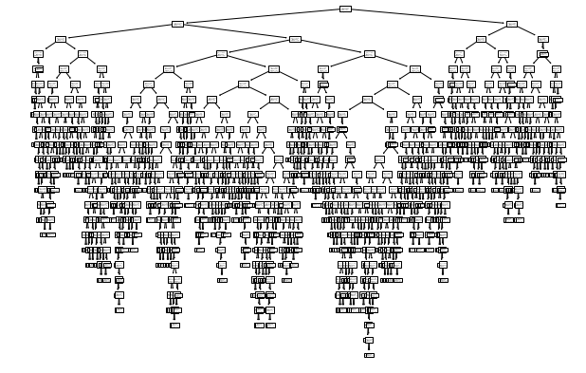  from sklearn.tree import plot_tree  plt.figure(figsize = (10,7))  plot_tree(dt,max_depth=1,feature_names = ['alcohol',"sugar","pH"])  plt.show()  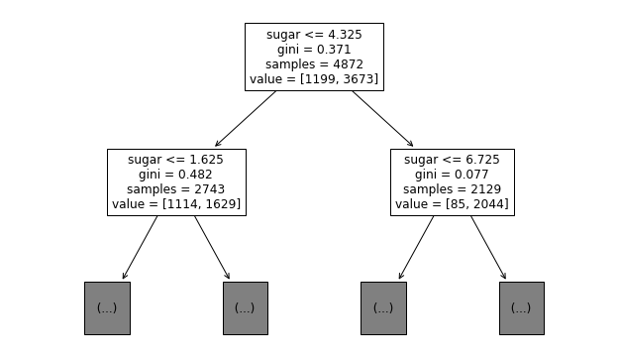  dt = DecisionTreeClassifier(max_depth=3,random_state=42)  dt.fit(train_input,train_target)  print(dt.score(train_input,train_target))  print(dt.score(test_input,test_target))  plt.figure(figsize = (20,15))  plot_tree(dt,feature_names = ['alcohol','sugar','pH'])  plt.show() # 3개의 트리를 만듬  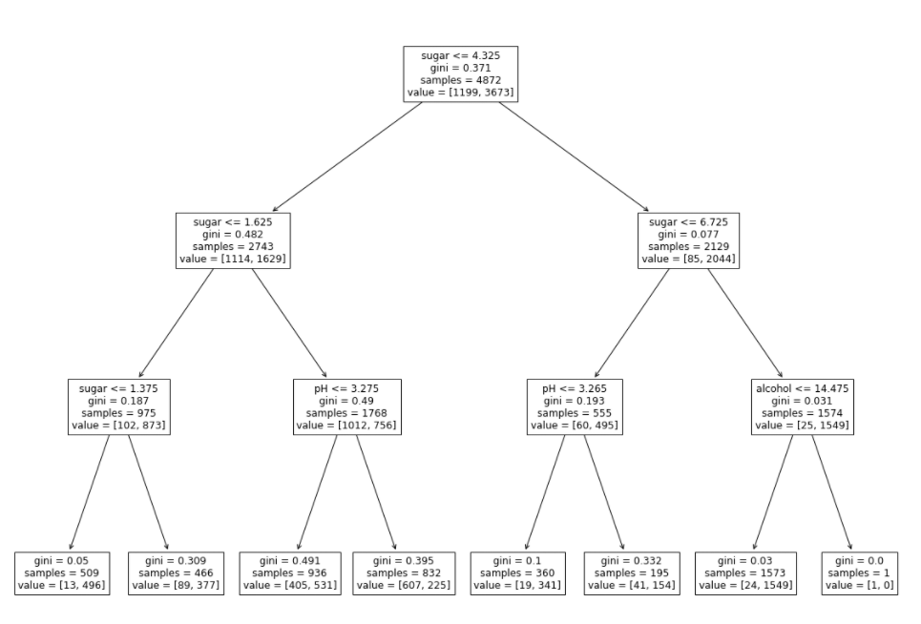  Cross validation and Grid search  import numpy as np #매트릭스 연산  import pandas as pd #액셀  import matplotlib.pyplot as plt #plot  wine = pd.read_csv('https://bit.ly/wine-date')  wine.head()  wine.info() # 데이터타입  data = wine[["alcohol","sugar","pH"]].to_numpy()  target = wine["class"].to_numpy()  print(data.shape)  from sklearn.model_selection import train_test_split  train_input,test_input,train_target,test_target = train_test_split(  data,target,stratify = target,random_state = 42)  from sklearn.tree import DecisionTreeClassifier  dt = DecisionTreeClassifier(random_state = 42 ) # 객체생성 , 데이터샘플링(나눌때)에 대해서 랜덤스테이트  from sklearn.model_selection import cross_validate  from sklearn.model_selection import StratifiedKFold  splitter = StratifiedKFold(n_splits=10,shuffle=True,random_state=42)  score = cross_validate(dt,train_input,train_target,cv=splitter)  score['test_score'] # cv값에 따라서 몇번나오는지 나옴  score['test_score'].mean() # 평균값  ##  from sklearn.model_selection import GridSearchCV  dt = DecisionTreeClassifier() # 객체생성  papam = {'max_depth':np.arange(4,20,1),  'min_impurity_decrease' : np.arange(0.0001,0.001,0.001)}  gs = GridSearchCV(dt,param_grid = papam,cv=5,  n_jobs = -1)  gs.fit(train_input,train_target)  gs.cv_results_['mean_test_score'] ## 뎁스 2,3,4,5,6 중에서 6가 가장 좋은 결과가 나옴  # 뎁스 1,2,3,4,5를 다 자동으로 돌려줌  dt = gs.best_estimator_ # 'max_depth':[2,3,4,5,6] 뎁스가 5로 되어있음 가장 베스트이기 때문  print(dt.score(train_input,train_target)) ## 0.872가 나오는 이유는 cv에서 나누지않고 데이터전체에서 가장 뽑아서  gs.best_params_ # 0.0001이 가장 좋은 결과를 나타낸다는 뜻  plt.plot(gs.cv_results_['mean_test_score'])  plt.show()  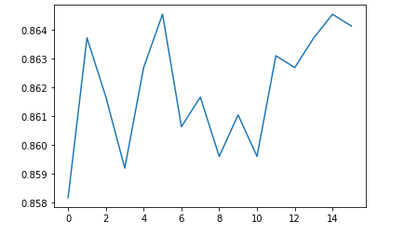
오후 | ·  k-means clustering  import numpy as np  import matplotlib.pyplot as plt  fruits = np.load('fruits_300.npy')  fruits[0] # 첫번째 슬라이스 , 이것이 300장 있음 , 100by 100  plt.imshow(fruits[0],cmap="gray_r") # 이미지show  plt.show()  print(fruits.shape) # 300장이 있고 가로세로 100  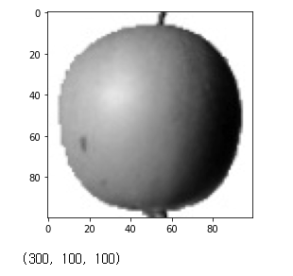  # 2d로 바꿔주기  fruits_2d = fruits.reshape(-1,10000) #array가 1열로 퍼지고 100x100  print(fruits_2d.shape)  fig,axs = plt.subplots(1,3)  axs[0].imshow(fruits[0],cmap='gray_r')  axs[1].imshow(fruits[100],cmap='gray_r')  axs[2].imshow(fruits[200],cmap='gray_r')  plt.show()  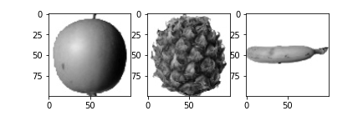  # k-means 시작  from sklearn.cluster import KMeans  km = KMeans(n_clusters=3,random_state = 42)  km.fit(fruits_2d)  km.cluster_centers_.shape # 각각 3개의 클러스터가 10000개로 되어있음  km_center = km.cluster_centers_.reshape(-1,100,100)  print(km_center.shape)  fig,axs = plt.subplots(1,3)  axs[0].imshow(km_center[0],cmap='gray_r')  axs[1].imshow(km_center[1],cmap='gray_r')  axs[2].imshow(km_center[2],cmap='gray_r')  plt.show()  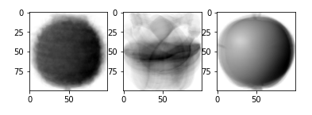  inertia = []  for k in range(2,7):  km = KMeans(n_clusters = k,random_state = 42)  km.fit(fruits_2d)  inertia.append(km.inertia_)  plt.plot(range(2,7),inertia)  plt.show()  