교육 제목 | 머신러닝
교육 일시 | 2021-10-22
교육 장소 | 영우글로벌러닝
교육 내용
오전 | 소형 개인 프로젝트 발표  import numpy as np #매트릭스 연산  import pandas as pd #액셀  import matplotlib.pyplot as plt #plot  df = pd.read_csv('index.csv') # C:/Users/user/Downloads/mywep/index.csv  health_full = df.to_numpy() # 데이터 타입을 numpy로 바꿔주기  print(df.shape) # 배열의 형태  # df.columns = ['steps','distance(km)','kcal']  df.head()  # Healthy_steps = np.array(  # [2364.0, 3268.0, 4119.0, 1908.0, 900.0, 1014.0, 904.0, 2231.0, 4826.0, 2775.0,  # 2954.0, 7860.0, 0.0, 7372.0, 7424.0, 0.0, 3394.0, 7120.0, 0.0, 7436.0, 1112.0,  # 1209.0, 6399.0, 0.0, 3511.0, 9380.0, 12744.0, 0.0, 1037.0, 7542.0, 9163.0, 1511.0,  # 5021.0, 0.0, 8583.0, 0.0, 824.0, 0.0, 911.0, 0.0, 2197.0, 0.0, 0.0, 0.0, 1861.0,  # 4064.0, 7297.0, 0.0, 0.0, 1344.0, 2405.0, 0.0, 1573.0, 0.0])  Healthy_steps = pd.read_csv('index2.csv')  Healthy_steps.head()  # print(np.shape(Healthy_steps))  from sklearn.model_selection import train_test_split  from sklearn.linear_model import Lasso ## 라소패널티  train_input,test_input,train_target,test_target = train_test_split(  health_full,Healthy_steps,test_size = 0.3 ) # 전체 데이터 독립X,종속y , random_state = 난수 발생의 seed 값  ## polynomial transform  from sklearn.preprocessing import PolynomialFeatures # 항을 늘려주는 역할 , Polynomial = multiful  poly = PolynomialFeatures(degree = 3,include_bias = False) # 3차항 , 절편 False  poly.fit(train_input) # 계산  train_poly=poly.transform(train_input) # 형식변환  test_poly=poly.transform(test_input)  from sklearn.preprocessing import StandardScaler # 규제를 쓸 때 반드시 필요  ss= StandardScaler()  ss.fit(train_poly)  train_scaled = ss.transform(train_poly)  test_scaled = ss.transform(test_poly)  lasso = Lasso()  lasso.fit(train_scaled,train_target)  fig = plt.figure()  ax = fig.add_subplot(111)  ax.plot(range(len(test_target)), test_target )  plt.show()  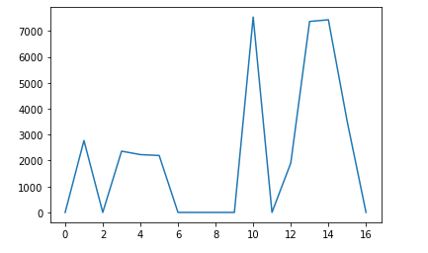  train_score = []  test_score = []  alpha_list = [0.1,1,10] # 람다 값  for alpha in alpha_list:  lasso = Lasso(alpha=alpha, max_iter=10000)  lasso.fit(train_scaled, train_target)  train_score.append(lasso.score(train_scaled, train_target))  test_score.append(lasso.score(test_scaled, test_target))  plt.plot(np.log10(alpha_list), train_score,c='blue',label="Train")  plt.plot(np.log10(alpha_list), test_score ,c='red',label="test")  plt.xlabel('alpha')  plt.ylabel('R^2')  plt.legend()  plt.show()  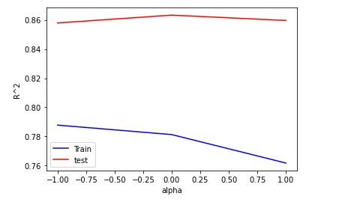  lasso = Lasso(alpha = 10)  lasso.fit(train_scaled,train_target)  print(lasso.score(train_scaled,train_target))  print(lasso.score(test_scaled,test_target))  # 걷기와 칼로리 상관관계  plt.scatter(df["step"],df["kcal"])  #거리와 걸음의 상관관계  # plt.scatter(df["distance"],df["step"])  plt.show()  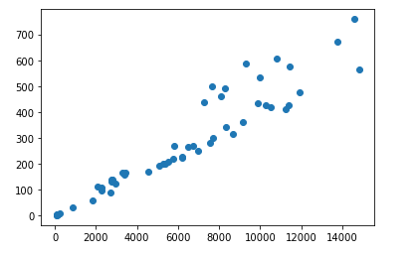
오후 | 특강대체

