교육 제목 | 머신러닝
교육 일시 | 2021-10-18
교육 장소 | 영우글로벌러닝
교육 내용
오전 | k-최근접 이웃의 한계  perch_length = np.array(  [8.4, 13.7, 15.0, 16.2, 17.4, 18.0, 18.7, 19.0, 19.6, 20.0,  21.0, 21.0, 21.0, 21.3, 22.0, 22.0, 22.0, 22.0, 22.0, 22.5,  22.5, 22.7, 23.0, 23.5, 24.0, 24.0, 24.6, 25.0, 25.6, 26.5,  27.3, 27.5, 27.5, 27.5, 28.0, 28.7, 30.0, 32.8, 34.5, 35.0,  36.5, 36.0, 37.0, 37.0, 39.0, 39.0, 39.0, 40.0, 40.0, 40.0,  40.0, 42.0, 43.0, 43.0, 43.5, 44.0]  )  perch_weight = np.array(  [5.9, 32.0, 40.0, 51.5, 70.0, 100.0, 78.0, 80.0, 85.0, 85.0,  110.0, 115.0, 125.0, 130.0, 120.0, 120.0, 130.0, 135.0, 110.0,  130.0, 150.0, 145.0, 150.0, 170.0, 225.0, 145.0, 188.0, 180.0,  197.0, 218.0, 300.0, 260.0, 265.0, 250.0, 250.0, 300.0, 320.0,  514.0, 556.0, 840.0, 685.0, 700.0, 700.0, 690.0, 900.0, 650.0,  820.0, 850.0, 900.0, 1015.0, 820.0, 1100.0, 1000.0, 1100.0,  1000.0, 1000.0]  )  from sklearn.model_selection import train_test_split  # 훈련 세트와 테스트 세트로 나눕니다  train_input, test_input, train_target, test_target = train_test_split(  perch_length, perch_weight)  # 훈련 세트와 테스트 세트를 2차원 배열로 바꿉니다  train_input = train_input.reshape(-1, 1)  test_input = test_input.reshape(-1, 1)  from sklearn.neighbors import KNeighborsRegressor  knr = KNeighborsRegressor(n_neighbors=3)  # k-최근접 이웃 회귀 모델을 훈련합니다  knr.fit(train_input, train_target)  # 50cm 농어의 이웃을 구합니다  dist, indx = knr.kneighbors([[50]])  print(indx)  plt.scatter(train_input, train_target)  plt.scatter(50, 1033, marker='D')  plt.scatter(train_input[indx], train_target[indx], marker='D',s=100) #marker = 모양, s = 크기  plt.show()  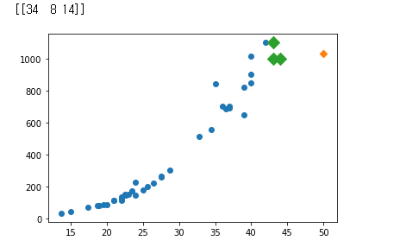  from sklearn.linear_model import LinearRegression  lr = LinearRegression()  # 선형 회귀 모델 훈련  lr.fit(train_input, train_target)  x_new = np.arange(12,60)  y_new=x_new*lr.coef_+lr.intercept_  # 훈련 세트의 산점도를 그립니다  plt.scatter(train_input, train_target)  # 50cm 농어 데이터  plt.scatter(50,1252,marker="^")  plt.plot(x_new,y_new)  plt.show()  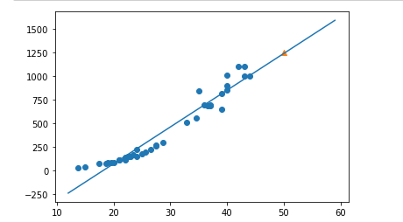  train_input[:10]  #print(train_input.shape)  train_poly = np.column_stack((train_input**2,train_input))  test_poly = np.column_stack((test_input**2,test_input))  test_input[:10]  lrp = LinearRegression()  lrp.fit(train_poly,train_target)  x_new = np.arange(10,50)  y_new = 116.05 - 21.55 * x_new + 1.01 * x_new**2  plt.scatter(train_input,train_target)  plt.plot(x_new,y_new)  plt.show()  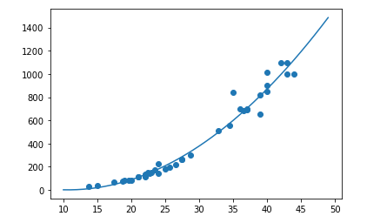
오후 | · import numpy as np #매트릭스 연산  import pandas as pd #액셀  import matplotlib.pyplot as plt #plot  df = pd.read_csv('https://bit.ly/perch_csv')  print(type(df))  print(df.shape)  perch_full = df.to_numpy() # 데이터 타입을 넘파이로 바꿔주기  print(type(perch_full))  # print(df.shape)  # df.head()  print(np.shape(perch_full))  perch_weight = np.array(  [5.9, 32.0, 40.0, 51.5, 70.0, 100.0, 78.0, 80.0, 85.0, 85.0,  110.0, 115.0, 125.0, 130.0, 120.0, 120.0, 130.0, 135.0, 110.0,  130.0, 150.0, 145.0, 150.0, 170.0, 225.0, 145.0, 188.0, 180.0,  197.0, 218.0, 300.0, 260.0, 265.0, 250.0, 250.0, 300.0, 320.0,  514.0, 556.0, 840.0, 685.0, 700.0, 700.0, 690.0, 900.0, 650.0,  820.0, 850.0, 900.0, 1015.0, 820.0, 1100.0, 1000.0, 1100.0,  1000.0, 1000.0]  )  print(np.shape(perch_weight))  from sklearn.model_selection import train_test_split  train_input,test_input,train_target,test_target = train_test_split(  perch_full,perch_weight,random_state = 42)  ## polynomial transform  from sklearn.preprocessing import PolynomialFeatures # 항을 늘려주는 역할  poly = PolynomialFeatures(degree = 3) ## 3차항  poly.fit([[2,3]])  poly.transform([[2,3]])  poly = PolynomialFeatures(degree = 2,include_bias = False)  poly.fit(train_input)  train_poly=poly.transform(train_input)  test_poly=poly.transform(test_input)  # print(train_poly[:10])  poly.get_feature_names() # 2 차항을 보여줌  from sklearn.linear_model import LinearRegression  lr = LinearRegression() # 리니얼리그레션 객체를 만듬  lr.fit = (train_poly,train_target)  print(lr.score(train_poly,train_target))  print(lr.score(test_poly,test_target))  ##  poly = PolynomialFeatures(degree = 5,include_bias=False) ## 5차항  poly.fit(train_input)  train_poly = poly.transform(train_input)  test_poly = poly.transform(test_input)  print(np.shape(train_input))  print(np.shape(train_poly))  train_input[:5]  train_poly[:5]  r = LinearRegression()  lr.fit(train_poly, train_target)  print (lr.score(train_poly,train_target))  print (lr.score(test_poly,test_target))  # 그냥 리그레션해서 오버피팅 생김  ## rigde regression  from sklearn.preprocessing import StandardScaler  ss= StandardScaler()  ss.fit(train_poly)  train_scaled = ss.transform(train_poly)  test_scaled = ss.transform(test_poly)  from sklearn.linear_model import Ridge  ridge = Ridge()  ridge.fit(train_scaled,train_target)  print(ridge.score(train_scaled,train_target))  print(ridge.score(test_scaled,test_target))  ##Rigde lambda plot  train_score = []  test_score = [] # 여기안에 람다 값을 넣어서 바꿔줄 것임  alpha_list = [0.001, 0.01, 0.1, 1, 10, 100]  for alpha in alpha_list:  # 릿지 모델을 만듭니다  ridge = Ridge(alpha=alpha)  # 릿지 모델을 훈련합니다  ridge.fit(train_scaled, train_target)  # 훈련 점수와 테스트 점수를 저장합니다  train_score.append(ridge.score(train_scaled, train_target))  test_score.append(ridge.score(test_scaled, test_target))  plt.plot(np.log10(alpha_list),train_score,label="train")  plt.plot(np.log10(alpha_list),test_score,label="test")  plt.xlabel("log10(alpha)")  plt.ylabel("R^2")  plt.legend()  plt.show() #람다 (R^2) 가 0.1 일 때 = log10 = 1  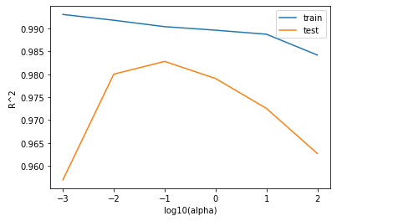  ## 라소패널티  from sklearn.linear_model import Lasso  lasso = Lasso()  lasso.fit(train_scaled,train_target)  train_score = []  test_score = []  alpha_list = [0.001, 0.01, 0.1, 1, 10, 100]  for alpha in alpha_list:  # 라쏘 모델을 만듭니다  lasso = Lasso(alpha=alpha, max_iter=10000)  # 라쏘 모델을 훈련합니다  lasso.fit(train_scaled, train_target)  # 훈련 점수와 테스트 점수를 저장합니다  train_score.append(lasso.score(train_scaled, train_target))  test_score.append(lasso.score(test_scaled, test_target))  plt.plot(np.log10(alpha_list), train_score)  plt.plot(np.log10(alpha_list), test_score)  plt.xlabel('alpha')  plt.ylabel('R^2')  plt.show()  