교육 제목 | 딥러닝
교육 일시 | 2021-10-28
교육 장소 | 영우글로벌러닝
교육 내용
오전 | NN_TEST  import tensorflow as tf  import matplotlib.pyplot as plt  import numpy as np  (x_train, y_train), (x_test, y_test) = tf.keras.datasets.mnist.load_data()  test_image = x_test[0]  test_image_reshape = test_image.reshape(1, 784).astype('float64')  # 28 * 28이미지를 784개로 reshape하고, 1--> 데이터가 1개다. batchsize  model = tf.keras.models.load_model('my_NN_Test.h5')  y_pred = model.predict(test_image_reshape)  index = np.argmax(y_pred)  print(index)  index = np.argmax(y_pred)  value = y_pred[:, index]  plt.imshow(test_image, cmap='Greys')  plt.xlabel(str(index)+" "+str(value))  plt.show()  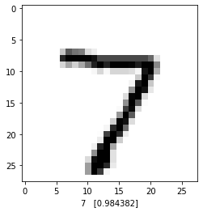  NN_TEST_Rotation  import tensorflow as tf  import matplotlib.pyplot as plt  import numpy as np  import cv2  (x_train, y_train), (x_test, y_test) = tf.keras.datasets.mnist.load_data()  # 이미지 회전 변환 매트릭스 구하기  M = cv2.getRotationMatrix2D((28/2, 28/2), 0, 1) # Matrix생성  # 이미지 이동 변환 매트릭스 구하기  M[0, 2] = M[0, 2] +3  M[1, 2] = M[1, 2] +3  # 이미지 변환 매트릭스 적용  test_image = cv2.warpAffine(x_train[5], M, (28, 28)) #image에 matrix곱  plt.imshow(test_image, cmap="Greys")  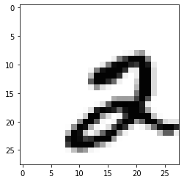  test_image_reshape = test_image.reshape(1,784).astype('float64')  model = tf.keras.models.load_model('my_NN_Test.h5')  y_pred = model.predict(test_image_reshape)  index = np.argmax(y_pred)  value = y_pred[:, index]  plt.imshow(test_image, cmap='Greys')  plt.xlabel(str(index)+" "+str(value))  plt.show()  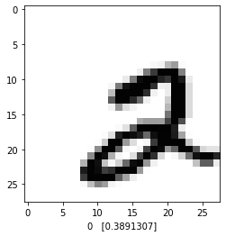  plt.imshow(x_train[5], cmap='Greys')  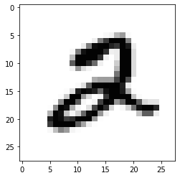
오후 | ·  MNIST_CNN  import matplotlib.pyplot as plt  import os  import tensorflow as tf  import numpy as np  (x_train, y_train), (x_test, y_test) = tf.keras.datasets.mnist.load_data()  # 데이터 (배치사이즈 x 28 x 28 x 1)로 이미지로 변환 --> 그레이스케일 채널은 1  x_train = x_train.reshape(x_train.shape[0], 28, 28, 1).astype('float32')  x_test = x_test.reshape(x_test.shape[0], 28, 28, 1).astype('float32')  y_train = tf.keras.utils.to_categorical(y_train)  y_test = tf.keras.utils.to_categorical(y_test)  # CNN 모델 설계  input_layer = tf.keras.layers.Input(shape=(28, 28, 1))  x = tf.keras.layers.Conv2D(32, (3, 3), strides =1, activation='relu', padding='same')(input_layer)  x = tf.keras.layers.MaxPool2D((2, 2))(x)  x = tf.keras.layers.Conv2D(64, (3, 3), strides=1, activation='relu')(x)  x = tf.keras.layers.MaxPool2D((2, 2))(x)  x = tf.keras.layers.Flatten()(x)  output_layer = tf.keras.layers.Dense(10, activation='softmax')(x)  model = tf.keras.Model(inputs=[input_layer], outputs=[output_layer])  model.summary()  loss = tf.keras.losses.categorical_crossentropy  optimizer = tf.keras.optimizers.RMSprop(learning_rate=0.0001)  metrics = tf.keras.metrics.categorical_accuracy  model.compile(loss=loss,  optimizer = optimizer,  metrics= [metrics])  model_dir = './cnn_mnist_model/'  if not os.path.exists(model_dir):  os.mkdir(model_dir)  model_path='./cnn_mnist_model/{epoch:02d}-{val_loss:.4f}.hdf5'  callback_list = [tf.keras.callbacks.ModelCheckpoint(filepath=model_path, monitor='val_loss', verbose=1, save_best_only=True),  tf.keras.callbacks.EarlyStopping(monitor='val_loss', patience=10)]  history = model.fit(x_train, y_train, validation_split=0.2, epochs=5, batch_size=200, verbose=1, callbacks=callback_list)  # 테스트 정확도 출력  print("\n Test Accuracy: %.4f" % (model.evaluate(x_test, y_test)[1]))  # 테스트 셋의 오차  y_vloss = history.history['val_loss']  # 학습셋의 오차  y_loss = history.history['loss']  # 그래프로 표현  x_len = np.arange(len(y_loss))  plt.plot(x_len, y_vloss, marker='.', c="red", label='Testset_loss')  plt.plot(x_len, y_loss, marker='.', c="blue", label='Trainset_loss')  # 그래프에 그리드를 주고 레이블을 표시  plt.legend(loc='upper right')  plt.grid()  plt.xlabel('epoch')  plt.ylabel('loss')  plt.show()  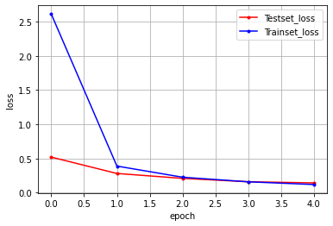  Fashion mnsit CNN  import matplotlib.pyplot as plt  import os  import tensorflow as tf  import numpy as np  # 데이터 불러오기  (x_train, y_train), (x_test, y_test) = tf.keras.datasets.fashion_mnist.load_data()  # (배치사이즈 * 28 * 28 * 1)로 이미지 변환 ---> 그레이스케일은 채널 1  x_train = x_train.reshape(x_train.shape[0], 28, 28, 1).astype('float32')  x_test = x_test.reshape(x_test.shape[0], 28, 28, 1).astype('float32')  y_train = tf.keras.utils.to_categorical(y_train)  y_test = tf.keras.utils.to_categorical(y_test)  # CNN 모델 설계  input_layer = tf.keras.layers.Input(shape=(28, 28, 1))  x = tf.keras.layers.Conv2D(32, (3,3), strides=1, activation='relu', padding='same')(input_layer)  x = tf.keras.layers.MaxPool2D((2, 2))(x)  x = tf.keras.layers.Conv2D(64, (3, 3), strides=1, activation='relu', padding='same')(x)  x = tf.keras.layers.MaxPool2D((2, 2))(x)  x = tf.keras.layers.Flatten()(x)  x = tf.keras.layers.Dense(512, activation='relu')(x)  output_layer = tf.keras.layers.Dense(10, activation='softmax')(x)  model = tf.keras.Model(inputs=[input_layer], outputs=[output_layer])  model.summary()  loss = tf.keras.losses.categorical_crossentropy  optimize = tf.keras.optimizers.RMSprop(learning_rate=0.0001)  metric = tf.keras.metrics.categorical_accuracy  model.compile(loss=loss,  optimizer = optimize,  metrics=[metric])  model_dir = './cnn_fasion_mnist_model/'  if not os.path.exists(model_dir):  os.mkdir(model_dir)  model_path='./cnn_fasion_mnist_model/{epoch:02d}-{val_loss:.4f}.hdf5'  callback_list = [tf.keras.callbacks.ModelCheckpoint(filepath=model_path, monitor='val_loss', verbose=1, save_best_only=True),  tf.keras.callbacks.EarlyStopping(monitor='val_loss', patience=10)]  history = model.fit(x_train, y_train, validation_split=0.2, epochs=5, batch_size=200, verbose=1, callbacks=callback_list)  #테스트 정확도 출력  print("\n Test Accuracy: %.4f" % (model.evaluate(x_test, y_test)[1]))  # 테스트 셋의 오차  y_vloss = history.history['val_loss']  # 학습셋의 오차  y_loss = history.history['loss']  # 그래프로 표현  x_len = np.arange(len(y_loss))  plt.plot(x_len, y_vloss, marker='.', c="red", label='Testset_loss')  plt.plot(x_len, y_loss, marker='.', c="blue", label='Trainset_loss')  # 그래프에 그리드를 주고 레이블을 표시  plt.legend(loc='upper right')  plt.grid()  plt.xlabel('epoch')  plt.ylabel('loss')  plt.show()  