교육 제목 | 머신러닝
교육 일시 | 2021-10-15
교육 장소 | 영우글로벌러닝
교육 내용
오전 | import numpy as np #매트릭스 연산  import pandas as pd #액셀  import matplotlib.pyplot as plt #plot  bream_length = [25.4, 26.3, 26.5, 29.0, 29.0, 29.7, 29.7, 30.0, 30.0, 30.7, 31.0, 31.0, 31.5, 32.0, 32.0,  32.0, 33.0, 33.0, 33.5, 33.5, 34.0, 34.0, 34.5, 35.0, 35.0, 35.0, 35.0, 36.0, 36.0, 37.0,  38.5, 38.5, 39.5, 41.0, 41.0]  bream_weight = [242.0, 290.0, 340.0, 363.0, 430.0, 450.0, 500.0, 390.0, 450.0, 500.0, 475.0, 500.0, 500.0,  340.0, 600.0, 600.0, 700.0, 700.0, 610.0, 650.0, 575.0, 685.0, 620.0, 680.0, 700.0, 725.0,  720.0, 714.0, 850.0, 1000.0, 920.0, 955.0, 925.0, 975.0, 950.0]  print(type(bream_length))  print(np.shape(bream_length))  ##도미  plt.scatter(bream_length,bream_weight,s=100) ## s는 점의 크기  plt.title("Bream,Length vs Weight",pad = 20)  plt.xlabel("Length (cm)")  plt.ylabel("Weight (g)")  plt.show()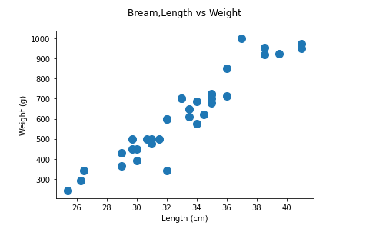  smelt_length = [9.8, 10.5, 10.6, 11.0, 11.2, 11.3, 11.8, 11.8, 12.0, 12.2, 12.4, 13.0, 14.3, 15.0]  smelt_weight = [6.7, 7.5, 7.0, 9.7, 9.8, 8.7, 10.0, 9.9, 9.8, 12.2, 13.4, 12.2, 19.7, 19.9]  print(np.shape(smelt_length))  plt.scatter(bream_length,bream_weight , label = "Bream")  plt.scatter(smelt_length,smelt_weight , label = "smelt")  plt.title("Bream,Smelt")  plt.xlabel("Lenght (cm)")  plt.ylabel("weight (g)")  plt.legend() ## 좌측상단에 label을 띄움  plt.show()  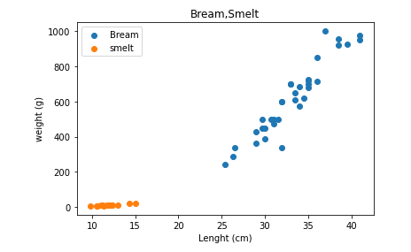  ## knn을 이용한 분류  length = bream_length + smelt_length  weight = bream_weight + smelt_weight  print(np.shape(length)) ## shape은 크기를 말함 , 인덱스x  print(length)  fish_data = [[l,w] for l,w in zip(length,weight)] ## length와 weight를 합침  print(type(fish_data))  print(np.shape(fish_data))  fish_data[:5]  fish_target = [1]*35 + [0]*14 ## 타겟 생성 1을 35개,0을 14개  print(fish_target)  ## sklearn knn module import  from sklearn.neighbors import KNeighborsClassifier  ## 객체 생성  kn = KNeighborsClassifier(n_neighbors = 5)  ## knn 모델 fitting  kn.fit(fish_data,fish_target)  ## knn model metrics  kn.score(fish_data,fish_target)  ## prediction  kn.predict([[30,600]]) # 2차원으로 랜덤한 값을 넣고 이게 돔인지 잉어인지 결정해달라는 뜻  plt.scatter(bream_length,bream_weight,s=100,label="bream=1")  plt.scatter(smelt_length,smelt_weight,s=100,label="bream=0")  plt.scatter(30,600,s=100,label="New")  plt.title("Bream vs Smelt")  plt.xlabel("Length")  plt.ylabel("Weight")  plt.legend()  plt.show() # 돔이란 뜻  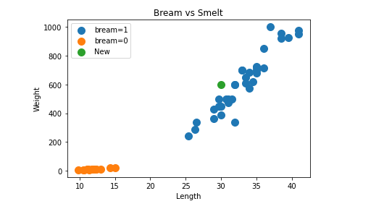  import numpy as np #매트릭스 연산  import pandas as pd #액셀  import matplotlib.pyplot as plt #plot  fish_length = [25.4, 26.3, 26.5, 29.0, 29.0, 29.7, 29.7, 30.0, 30.0, 30.7, 31.0, 31.0, 31.5, 32.0, 32.0,  32.0, 33.0, 33.0, 33.5, 33.5, 34.0, 34.0, 34.5, 35.0, 35.0, 35.0, 35.0, 36.0, 36.0, 37.0,  38.5, 38.5, 39.5, 41.0, 41.0,9.8, 10.5, 10.6, 11.0, 11.2, 11.3, 11.8, 11.8, 12.0, 12.2, 12.4, 13.0, 14.3, 15.0]  fish_weight = [242.0, 290.0, 340.0, 363.0, 430.0, 450.0, 500.0, 390.0, 450.0, 500.0, 475.0, 500.0, 500.0,  340.0, 600.0, 600.0, 700.0, 700.0, 610.0, 650.0, 575.0, 685.0, 620.0, 680.0, 700.0, 725.0,  720.0, 714.0, 850.0, 1000.0, 920.0, 955.0, 925.0, 975.0, 950.0,6.7, 7.5, 7.0, 9.7, 9.8, 8.7,  10.0, 9.9, 9.8, 12.2, 13.4, 12.2, 19.7, 19.9]  #fish_data[[l,w] for l,w in zip(fish_length,fish_weight)]  fish_data = np.column_stack((fish_length,fish_weight))  fish_target = [1]*35 + [0]*14  print(np.shape(fish_data))  fish_data[:5]  ##  train_input = fish_data[:35]  test_input = fish_data[35:]  train_target = fish_target[:35]  test_target = fish_target[35:]  샘플링 편향  from sklearn.neighbors import KNeighborsClassifier  kn = KNeighborsClassifier()  kn.fit(train_input,train_target)  kn.score(test_input,test_target)  print(type(fish_data))  fish_target = np.array(fish_target)  print(type(fish_data))  print(fish_data)  print(fish_target)  #np.arange(1,11,2)  index = np.arange(49)  print(index)  np.random.shuffle(index) # 순서를 섞음  print(index)  train_input = fish_data[index[:35]]  tarin_target = fish_target[index[:35]]  test_input = fish_data[index[35:]]  test_target = fish_target[index[35:]]  train_input[:5]  plt.scatter(train_input[:,0],train_input[:,1]) #첫번째 low 두번째 컬럼  plt.scatter(test_input[:,0],test_input[:,1])  plt.show()  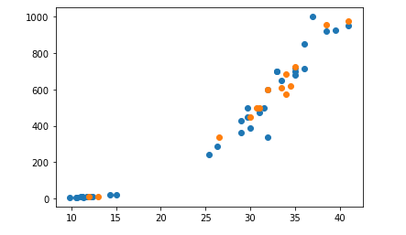
오후 | import numpy as np #매트릭스 연산  import pandas as pd #액셀  import matplotlib.pyplot as plt #plot  fish_length = [25.4, 26.3, 26.5, 29.0, 29.0, 29.7, 29.7, 30.0, 30.0, 30.7, 31.0, 31.0,  31.5, 32.0, 32.0, 32.0, 33.0, 33.0, 33.5, 33.5, 34.0, 34.0, 34.5, 35.0,  35.0, 35.0, 35.0, 36.0, 36.0, 37.0, 38.5, 38.5, 39.5, 41.0, 41.0, 9.8,  10.5, 10.6, 11.0, 11.2, 11.3, 11.8, 11.8, 12.0, 12.2, 12.4, 13.0, 14.3, 15.0]  fish_weight = [242.0, 290.0, 340.0, 363.0, 430.0, 450.0, 500.0, 390.0, 450.0, 500.0, 475.0, 500.0,  500.0, 340.0, 600.0, 600.0, 700.0, 700.0, 610.0, 650.0, 575.0, 685.0, 620.0, 680.0,  700.0, 725.0, 720.0, 714.0, 850.0, 1000.0, 920.0, 955.0, 925.0, 975.0, 950.0, 6.7,  7.5, 7.0, 9.7, 9.8, 8.7, 10.0, 9.9, 9.8, 12.2, 13.4, 12.2, 19.7, 19.9]  fish_data = np.column_stack((fish_length,fish_weight))  #fish_target = [1]*35+[0]*14  #np.ones(35)  #np.zeros(14)  fish_target = np.concatenate((np.ones(35),np.zeros(14)))  # print(np.shape(fish_data))  #print(fish_target)  fish_data[:5]  fish_target[:5]  from sklearn.model_selection import train_test_split  ·# train_test_split(  # *arrays,  # test_size=None,  # train_size=None,  # random_state=None,  # shuffle=True,  # stratify=None,  # )  train_input,test_input,train_target,test_target = train_test_split(  fish_data,fish_target,  stratify = fish_target,random_state = 42)  print(np.shape(fish_data))  print(np.shape(train_input))  print(np.shape(test_input))  print(test_target)  ## knn  from sklearn.neighbors import KNeighborsClassifier  kn = KNeighborsClassifier()  kn.fit (train_input , train_target)  kn.score (test_input,test_target)  kn.predict([[25,150]])  distances,inds=kn.kneighbors([[25,150]])  print(distances)  print(inds)  plt.scatter(train_input[:,0],train_input[:,1])  plt.scatter(25,150,marker = '^')  plt.scatter(train_input[inds,0],train_input[inds,1],marker='D') #x축에다 inds를 넣어줌 marker는 모양을 그리는것  plt.xlabel("Lelngth")  plt.ylabel("Weight")  plt.show()  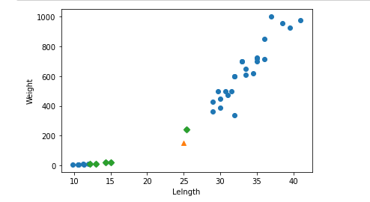  import numpy as np #매트릭스 연산  import pandas as pd #액셀  import matplotlib.pyplot as plt #plot  perch_length = np.array(  [8.4, 13.7, 15.0, 16.2, 17.4, 18.0, 18.7, 19.0, 19.6, 20.0,  21.0, 21.0, 21.0, 21.3, 22.0, 22.0, 22.0, 22.0, 22.0, 22.5,  22.5, 22.7, 23.0, 23.5, 24.0, 24.0, 24.6, 25.0, 25.6, 26.5,  27.3, 27.5, 27.5, 27.5, 28.0, 28.7, 30.0, 32.8, 34.5, 35.0,  36.5, 36.0, 37.0, 37.0, 39.0, 39.0, 39.0, 40.0, 40.0, 40.0,  40.0, 42.0, 43.0, 43.0, 43.5, 44.0]  )  perch_weight = np.array(  [5.9, 32.0, 40.0, 51.5, 70.0, 100.0, 78.0, 80.0, 85.0, 85.0,  110.0, 115.0, 125.0, 130.0, 120.0, 120.0, 130.0, 135.0, 110.0,  130.0, 150.0, 145.0, 150.0, 170.0, 225.0, 145.0, 188.0, 180.0,  197.0, 218.0, 300.0, 260.0, 265.0, 250.0, 250.0, 300.0, 320.0,  514.0, 556.0, 840.0, 685.0, 700.0, 700.0, 690.0, 900.0, 650.0,  820.0, 850.0, 900.0, 1015.0, 820.0, 1100.0, 1000.0, 1100.0,  1000.0, 1000.0]  )  np.shape(perch_length)  plt.scatter(perch_length, perch_weight)  plt.xlabel('length')  plt.ylabel('weight')  plt.show()  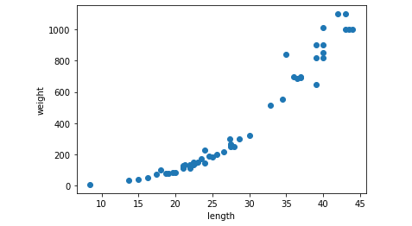  from sklearn.metrics import mean_squared_error  mse = mean_squared_error(test_target,test_prediction)  print(mse)  knr = KNeighborsRegressor()  r2_train = []  r2_test = []  neighbor_n = []  for n in range(1,21):  knr.n_neighbors = n  knr.fit(train_input,train_target)  r2_train.append(knr.score(train_input,train_target))  r2_test.append(knr.score(test_input,test_target))  neighbor_n.append(n)  print(r2_train)  print(r2_test)  print(neighbor_n)  plt.scatter(neighbor_n,r2_train,label = "train")  plt.scatter(neighbor_n,r2_test,label = "test")  plt.xlabel(" Number of neighbors")  plt.ylabel("R^2")  plt.legend()  plt.show()  