SIMEDTRIESTE UI/UX RELEASE NOTE

TABLE OF CONTENTS

1 INTRODUCTION 1

2 SCOPE 1

3 User Guide 1

3.1 Prepare environment for Front-End 1

3.2 Bringup the localserver 1

4 UI/UX Expirence 2

4.1 SignUp 2

4.2 Login 2

4.3 LandingPage for data loading from CSV file 2

4.4 Send email 3

RECORD OF CHANGE

|  |  |  |  |
| --- | --- | --- | --- |
| **Document Version History** | | | |
| **Version** | **Date** | **Author** | **Details** |
| 0.1 | 08 Mar 2018 | Vu Nguyen | Phase1 – UI Signup, Login, Loading CSV data file |
|  |  |  |  |
|  |  |  |  |

# INTRODUCTION

This document guides to setup Front End UI/UX environment for developer who could bring up the build locally for development and troubleshooting if any.

# SCOPE

1. Front-End technology
   1. ReactJS
2. Dependencies for UI/UX development
   1. React-Bootstrap
3. Browser for testing:
   1. Chrome (latest version)
   2. Firefox (latest version)
   3. Safari (latest version)
4. Content of website
   1. Support SignUp, Login of user
   2. Load CSV data file to website
   3. Dictate the relationship between the actual and predictable temperature in Medical station.

# User Guide

## Prepare environment for Front-End

### NodeJS

It’s required to install eco system of NodeJs to target development environment.

Go <https://nodejs.org/en/download/> and start the download of latest version of NodeJs.

### ReactJS

Download CLI command for React environment. Using node package management in the console for this purpose (yarn is another choice, but you have to install YARN first):

$ npm install -g create-react-app

### Clone the SIMD repository on GITHUB

Clone the front-end source code from link <https://github.com/kangkang11052017/SIMD>

Change to target directory where the ‘package.json’ located, start to install all dependencies for development environment.

Run command: **yarn**

## Bringup the localserver

After install all dependencies for the project, start the server:

Run command: yarn start

# UI/UX Expirence

## SignUp

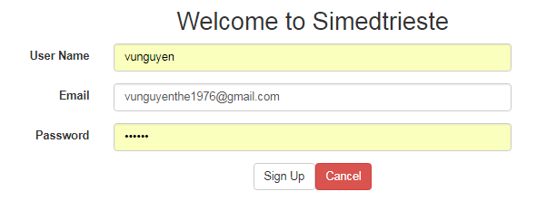

## Login

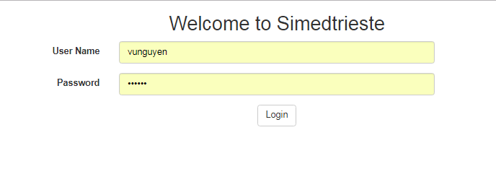

## LandingPage for data loading from CSV file

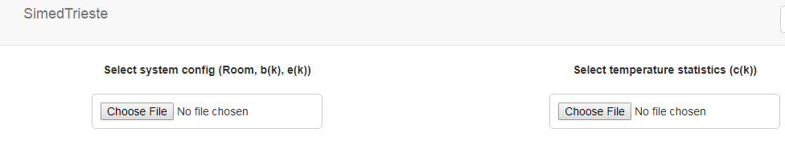

Steps to run to show chart.

* Select a configuration file: simedconfig.csv
* Select a SIMED Trieste-starts csv file

The chart should display as below.

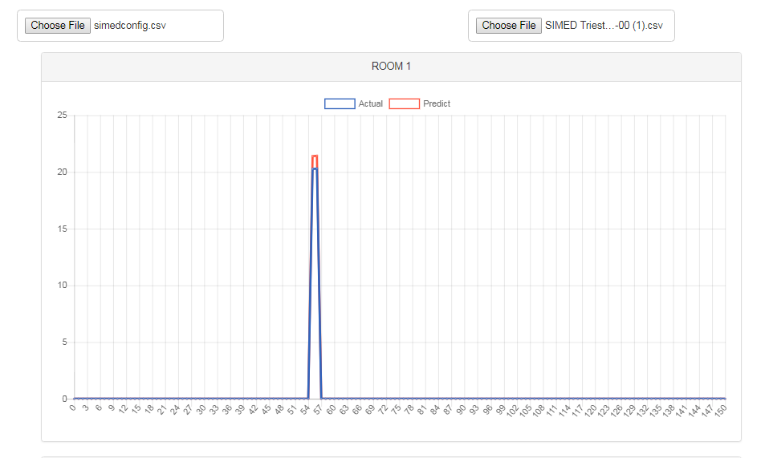

## Send email

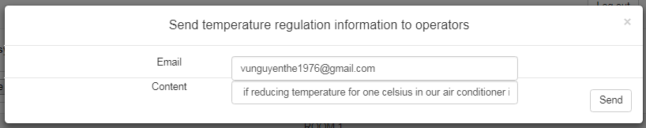

## Configuration file

e(k) : error

b(k): coefficient

For example

|  |  |  |  |  |
| --- | --- | --- | --- | --- |
| Month | Room | b(k) | e(k) |  |
| 1 | 1 | 0.05 | 0.208995 |  |
| 1 | 2 | 0.05 | 0.208995 |  |
| 1 | 3 | 0.05 | 0.208995 |  |
| 1 | 4 | 0.05 | 0.208995 |  |
| 1 | 5 | 0.05 | 0.208995 |  |
| 2 | 1 | 0.05 | 0.11261 |  |
| 2 | 2 | 0.05 | 0.11261 |  |
| 2 | 3 | 0.05 | 0.11261 |  |
| 2 | 4 | 0.05 | 0.11261 |  |
| 2 | 5 | 0.05 | 0.11261 |  |
| 10 | 1 | 0.05 | 0.11261 |  |
| 10 | 2 | 0.05 | 0.11261 |  |
| 10 | 3 | 0.05 | 0.11261 |  |
| 10 | 4 | 0.05 | 0.11261 |  |
| 10 | 5 | 0.05 | 0.11261 |  |
| 11 | 1 | 0.05 | 0.114471 |  |
| 11 | 2 | 0.05 | 0.114471 |  |
| 11 | 3 | 0.05 | 0.114471 |  |
| 11 | 4 | 0.05 | 0.114471 |  |
| 11 | 5 | 0.05 | 0.114471 |  |
| 12 | 1 | 0.05 | 0.11261 |  |
| 12 | 2 | 0.05 | 0.11261 |  |
| 12 | 3 | 0.05 | 0.11261 |  |
| 12 | 4 | 0.05 | 0.11261 |  |
| 12 | 5 | 0.05 | 0.11261 |  |
|  |  |  |  |  |