# Pre Lab– IST-S-STUDENTS

## Overview

In this short pre-lab we will learn how to connect to SQL Server, insure your account is working, and make you aware of the options available to you for remote connectivity.

### Learning Objectives

By the time the lab is complete you should be able to:

Connect to the SQL Server using MS SQL Server Management Studio.

Understand how to connect outside of the iSchool lab.

### What you will need

To complete this lab, you will need:

* Internet connectivity (via a secure tunnel if you are off-campus).
* Microsoft SQL Server Management Studio Software

### Lab Goals

This lab consists of 3 parts:

1. Connecting to MS SQL SERVER
2. A description of your deliverable to satisfy the lab requirements. This usually involves uploading a document into Blackboard before the deadline.
3. Connecting from outside the labs.

## Part 1: Connecting to MS SQL SERVER

It’s time to learn how to use the software we will need for class.

### 1a: Connecting to Microsoft SQL Server

First, let’s learn how to connect to SQL Server. To Connect to SQL Server you will need a program called **SQL Server Management Studio** (or SQL Server Management Studio Express) this program is available on Windows Operating systems only. It has been pre-installed in the iSchool computer labs for your convenience. If you would like to install this program for use on your personal computer, please consult Part 2 of this document.

1. On your computer open **SQL Server Management Studio**. This program is available from the Windows Start menu.
2. Once the program launches, a **Connect to Server** dialog will appear.
   1. For server type, choose **Database Engine**
   2. For server name, enter **dblab.ischool.syr.edu**
   3. For Authentication, choose **Windows Authentication**

(Selecting this should change the Username to "AD\yourNetID")

Click Connect (The Password field will be blank)

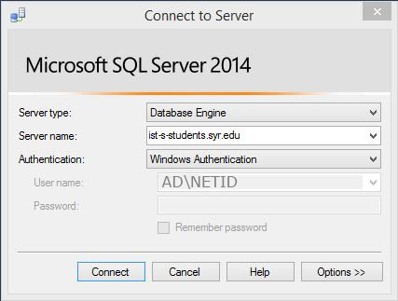

1. When you’re ready, click **Connect** to log in to the Server. On the left-hand side of the screen, you will see the **Object Explorer**:  
   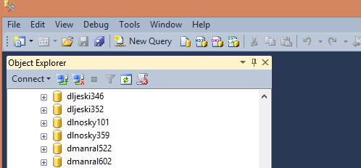
2. **Double-Click** the **Databases** folder to open it, and find *your database*. Your database will be listed as IST359_SectionNo_NetID. For instance, if your NetID is jpstudent, your database name will be IST359_M001_jpstudent. When you find it, **Double-click** on it and you will open the objects in your database:  
   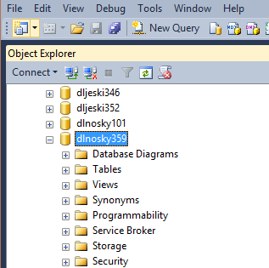
3. Now let’s give it a test. **Right-click** on your database and from the menu and select **New Query.** This will open a new query window. In the query window, type:

SELECT @@VERSION  
And then click the **! Execute** button to run the query. If Everything’s working you should see output like this:  
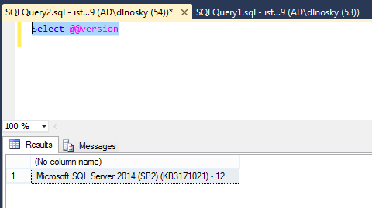

The area on the bottom of the screen is known as the results window. Note: there are two tabs one shows the result or output of your query. The second tab is where error messages will appear. We’ll see that one quite a bit at the beginning of the semester.

## Part 2: Putting it together & Going Beyond: Simulating Weekly Lab Procedures

Each week you will complete a post-lecture lab related to the current topic. Post-lectures allow you to practice what we did in pre-lab and often ask you to go one step beyond what was discussed. Don’t be surprised if you have to do some investigation or reading (or google searching) to find the answer. Not only will you execute the steps in the lab just as you have done in this example but you also will turn it in according to the instructions. Here are the instructions for this week

### 1.a: Confirm you Have a Working account and Access to SQL Server Management Studio

1. This time let’s write a query to see the current Date and Time. Type **SELECT GETDATE() and then execute**
2. Instead of grabbing a screen shot, this time let’s copy our results into an EXCEL Worksheet. **Figure it out!**
3. **Once in Excel give it an appropriate column name and be sure the cell is correctly formatted.**

Your worksheet should look something like this. If your date does not appear correctly, you can right click on it, choose "format cells" and pick a data type that displays dates properly.

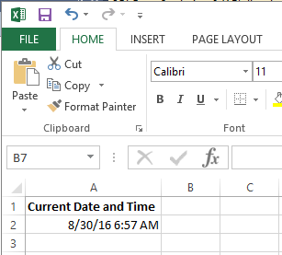

1. Save your Excel document being sure to name it with your last name as part of the file name. For example **SmithLab00.xls**
2. Upload the Excel document under Lab 1. It can be found under Content -> Unit 01 -> L1

## Part 3: Connecting From Outside the Labs

**Note: Do this from home.**

Remote Lab (RLab) for Windows and Mac

Remote lab allows you to connect to a computer at the iSchool and work on that computer as if you were sitting in the lab. There are two ways to connect to remote lab. Use RDP (remote desktop connection), the browser option is unstable and should only be used as a last resort. Instructions are here: <https://answers.syr.edu/display/ITHELP/Remote+Desktop+Services+via+RDP+Client>