Assignment 7
吴霄 SA13226367 软件系统设计专业
- Exercise 96 in Chapter 8.
Exercise 96. In the shared bathroom problem, there are two classes of threads, called male and female. There is a single bathroom resource that must be used in the following way:
- Mutual exclusion: persons of opposite sex may not occupy the bathroom simultaneously,
- Starvation-freedom: everyone who needs to use the bathroom eventually enters.

The protocol is implemented via the following four procedures: enterMale() delays the caller until it is ok for a male to enter the bathroom, leaveMale() is called when a male leaves the bathroom, while enterFemale() and leaveFemale() do the same for females. For example,
enterMale();
teeth.brush(toothpaste);
leaveMale();
- Implement this class using locks and condition variable.
Solution:

public class Bathroom implements MaleFemaleLock {

/**
* @param args
*/
volatile int males;
volatile int females;
volatile bathroom bathr = new bathroom();

Lock lock;
Condition condition;
Lock malelock, femalelock;

public Bathroom() {
males = 0;
females = 0;
lock = new ReentrantLock();
malelock = new MaleLock();
femalelock = new FemaleLock();
condition = lock.newCondition();
}
class FemaleLock implements Lock {
public void enterFemale() {
lock();
}

public void leaveFemale() {
unlock();
}

public void lock() {
lock.lock();
try {
while (males > 0) {
condition.await();
}
females++;
} catch (InterruptedException e) {
// TODO Auto-generated catch block
e.printStackTrace();
} finally {
lock.unlock();
}
}

public void unlock() {
lock.lock();
try {
females--;

if (females == 0) {
condition.signalAll();
}
} finally {
lock.unlock();
}
}
}

class MaleLock implements Lock {
public void enterMale() {
lock();
}

public void leaveMale() {
unlock();
}

public void lock() {
lock.lock();
try {
while (females > 0) {
condition.await();
}
males++;
} catch (InterruptedException e) {
// TODO Auto-generated catch block
e.printStackTrace();
} finally {
lock.unlock();
}
}

public void unlock() {
lock.lock();
try {
males--;
if (males == 0) {
condition.signalAll();
}
} finally {
lock.unlock();
}
}

public Lock male() {
// TODO Auto-generated method stub
return malelock;
}

@Override
public Lock female() {
// TODO Auto-generated method stub
return femalelock;
}
}

interface MaleFemaleLock {
Lock male();
Lock female();
}
Explain:
- Implement this class using synchronized, wait(), notify(), and notifyAll().
Solution:
For each implementation, explain why it satisfies mutual exclusion and starvation-freedom.
- [Optional] Exercise 97 in Chapter 8.
Exercise 97. The Rooms class manages a collection of rooms, indexed from 0 to m (where m is an argument to the constructor). Threads can enter or exit any room in that range. Each room can hold an arbitrary number of threads simultaneously, but only one room can be occupied at a time. For example, if there are two rooms, indexed 0 and 1, then any number of threads might enter the room 0, but no thread can enter the room 1 while room 0 is occupied. Fig. 8. 15 shows an outline of the Rooms class.
Each room can be assigned an exit handler: calling setHandler(I, h) sets the exit handler for room i to handler h. The exit handler is called by the last thread to
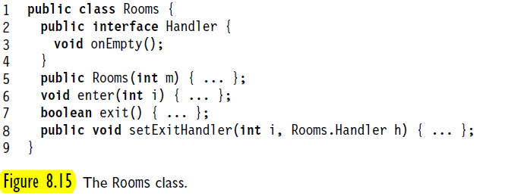
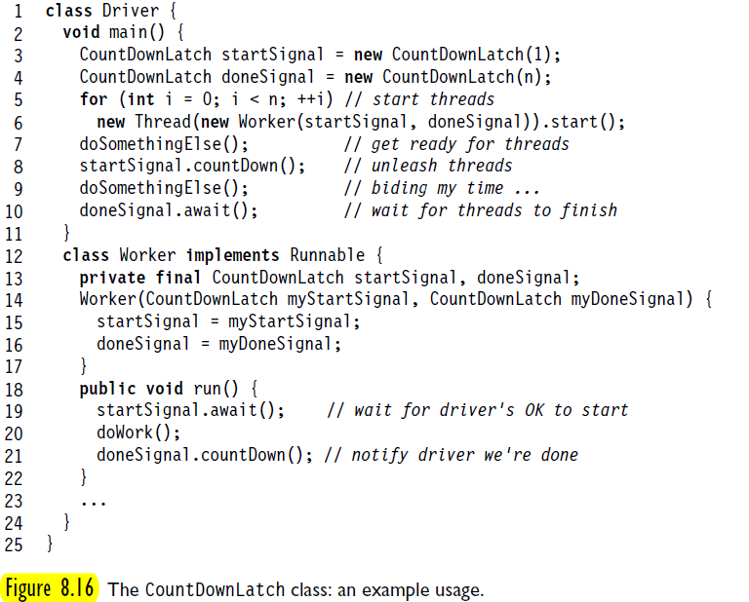
Leave a room, but before any threads subsequently enter any room. This method is called once and while it is running, no threads are in any rooms.
Implement the Rooms class. Make sure that:
If some thread is in room I, then no thread is in room j != i.
The last thread to leave a room calls the room’s exit handler, and no threads are in any room while that handler is running.
Your implementation must be fair: any thread that tries to enter a room eventually succeeds. Naturally, you may assume that every thread that enters a room eventually leaves.

Solution:
- Exercise 101 in Chapter 9.
Exercise 101. Explain why the fine-grained locking algorithm is not subject to deadlock.
Solution:
细粒度锁与粗粒度锁算法不同。
对于粗粒度锁算法而言，如果竞争不激烈，该算法是实现某些数据结构并发执行的好方法，然而，如果竞争激烈，则即使锁本身非常好，线程也会延迟等待其他线程。
对于细粒度锁算法而言，其不再使用单一锁来解决每次对象存取的同步问题，而是将对象分解成一些独立的同步组件，对单元级别的对象设置相应的锁，并确保只有当多个方法调用试图同时访问同一个组件时，才会触发相应的锁。这样可以进一步细化并发的区域，减少串行执行的部分，从而减少线程间因争用而形成的相互等待（死锁问题）的可能性。例如利用细粒度锁算法对链表进行并发操作时，可以对待操作的节点其本身以及前驱节点设置“交叉手”锁方式（并按照相同次序去获取锁），从而防止类似于“线程A已锁住b节点并试图去锁住head，而线程B已锁住head并试图去获取b节点”等死锁情况的发生。
- Exercise 108 in Chapter 9.
Exercise 108. Show that in the optimistic algorithm, the add() method needs to lock only pred.（在乐观算法中，add只需锁住pred）
Solution:
乐观同步算法：不需获得锁就可以进行查找，对找到的节点加锁(add方法)，然后确认锁住的节点是正确(validate方法)。如果一个同步冲突导致节点被错误地锁定，则释放这些锁并重新开始。
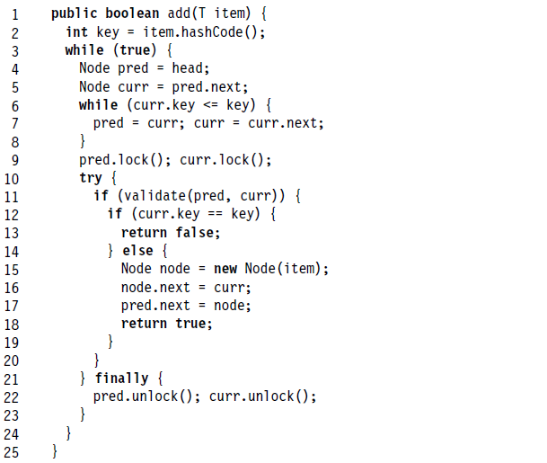
Fig. 4. 1 The OptimisticLicst class: the add() method traverses the list lignoring locks
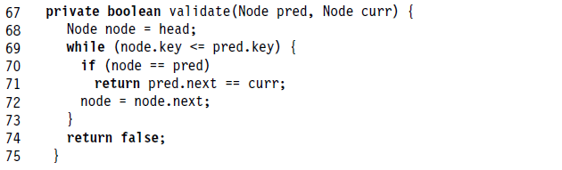
Fig. 4. 2 The OptimisticLicst: validation checks that pred point to curr
在验证程序validate中，通过对整个链表的遍历，查找pred节点，并判断pred->next域是否指向curr节点。在validate()的line 69 – line 73之间，程序总是循环的检查当前节点与pred节点是否一致，因此我们需要对pred上锁。
然而，我们可以不对curr设置锁操作。利用validate()方法中对pred的判断，倘若并行的线程B对线程A的当前操作有干扰（修改了curr的指向），那么在line 71:
return pred.next == curr;
将返回false，随即在add()方法中也返回false，这种逻辑冲突将不存在。
此外，在add()方法的line 12 – line 13：
If (curr.key == key) {
return false;
}
若在此处，有线程更改了curr的值，这两行语句同样可以检查到逻辑问题，因此返回false。
另一方面，由于乐观算法对应的前提是默认利用机遇的，即我们总是乐观地认为线程间出现冲突或者逻辑问题的几率是比较低的（这种技术只有在成功次数高于失败次数时才具有价值），因此，我们也就可以假定在之后创建新节点并进行插入更新的这段代码（line 15 – line 18）被其他线程更改curr变量的几率较低。
综上，可以认为乐观算法的add方法仅对pred节点加锁就可以实现并发控制了。

