402--驱动和运动控制 2

通用对象 2

通用对象 2

物理参数 3

位置控制参数 4

驱动模式和运行状态 5

驱动模式 5

运行状态 7

状态转换 8

Velocioty Mode 10

简单结构 10

完整结构 11

Profile Position Mode 16

概述 16

位置 17

速度 18

加速度和减速度 19

position_demand_value 20

Profile Velocioty Mode 21

Profile Velocity 21

加速度与减速度 22

Velocity demand value 23

读取实际速度 24

control effort 25

ststus word 26

Profile Torque Mode 28

CONTROL EFFORT 28

电机控制 29

Homing Mode 31

对象 31

Interpolated Mode 32

对象 32

402--驱动和运动控制

# 通用对象

## 通用对象

|  |  |
| --- | --- |
|  | 默认值 |
| 1. 通用参数 | 设备类型 (索引1001h)  设备名称(索引1008h)  硬件版本(索引1009h)  软件版本(索引100Ah) |
| 2.错误寄存器 |  |
| 3.PDO的通讯参数 | 传输类型都是255--- CIA协议规范所指定的事件触发； |
| 4. PDO的映射参数 | RPDO1→控制字(索引6040 0010h)  RPDO2→控制字(索引6040 0010h)、驱动控制模式（索引6060 0008h）  RPDO3→控制字(索引6040 0010h)、目标位置（索引607A 0020h）  RPDO4→控制字(索引6040 0010h)、目标速度（索引60FF 0020h）  RPDO5→控制字(索引6040 0010h)、目标转矩（索引6071 0010h）  RPDO6→控制字(索引6040 0010h)、 （索引6042 0010h）  RPDO7→控制字(索引6040 0010h)、数字输出（索引60FE 0120h）  RPDO8→控制字(索引6040 0010h) 、驱动控制模式（索引6060 0008h）  TPDO1→状态字(索引6041 0010h)  TPDO2→状态字(索引6041 0010h)、当前驱动控制模式（索引6061 0008h）  TPDO3→状态字(索引6041 0010h)、当前位置值（索引6064 0020h）  TPDO4→状态字(索引6041 0010h)、当前速度值（索引606C 0020h）  TPDO5→状态字(索引6041 0010h)、当前转矩值（索引6077 0010h）  TPDO6→状态字(索引6041 0010h)、 （索引6044 0010h）  TPDO7→状态字(索引6041 0010h)、当前数字输出的值（索引60FD 0020h） |
| 5.电机参数和驱动参数 | 传输中断代码(索引6007h)  错误代码(索引603Fh)  电机型号(索引6402h)  电机目录号(索引6403h)  电机生产商(索引6404h)  电机目录网址(索引6405h)  电机校准日期(索引6406h)  电机服务时间(索引6407h)  电机参数(索引6410h)  支持的驱动模式(索引6502h)  驱动目录号(索引6503h)  驱动生产商(索引6504h)  驱动目录网址(索引6505h)  驱动参数(索引6510h)  驱动输入(索引60FDh)  驱动输出(索引60FEh) |
|  |  |
|  |  |
|  |  |

## 物理参数

|  |  |  |  |  |  |
| --- | --- | --- | --- | --- | --- |
| 索引 | 名称 | 对象类型 | 数据类型 | 访问类型 | Category |
| 6089 | 位置符号 | VAR | INTEGER8 | RW | O |
| 608A | 位置尺寸 | VAR | UNSIGNED8 | RW | O |
| 608B | 速度符号 | VAR | INTEGER8 | RW | O |
| 608C | 速度尺寸 | VAR | UNSIGNED8 | RW | O |
| 608D | 加速度符号 | VAR | INTEGER8 | RW | O |
| 608E | 加速度尺寸 | VAR | UNSIGNED8 | RW | O |
| 608F | 位置编码器分辨率 | ARRAY | UNSIGNED32 | RW | O |
| 6090 | 速度编码器分辨率 | ARRAY | UNSIGNED32 | RW | O |
| 6091 | 齿轮齿数比 | ARRAY | UNSIGNED32 | RW | O |
| 6092 | 进给常数 | ARRAY | UNSIGNED32 | RW | O |
| 6093 | 位置因素 | ARRAY | UNSIGNED32 | RW | O |
| 6094 | 速度编码器因素 | ARRAY | UNSIGNED32 | RW | O |
| 6095 | 速度因素1 | ARRAY | UNSIGNED32 | RW | O |
| 6096 | 速度因素2 | ARRAY | UNSIGNED32 | RW | O |
| 6097 | 加速度因素 | ARRAY | UNSIGNED32 | RW | O |
| 607E | 极性 | VAR | UNSIGNED8 | RW | O |

## 位置控制参数

|  |  |  |  |  |  |
| --- | --- | --- | --- | --- | --- |
| 索引 | 名称 | 数据类型 | 访问类型 | 类别 | 对象类型 |
| 6062 | 位置需求值 | INTEGER32 | RO | O | VAR |
| 6063 | 位置实际值 | INTEGER32 | RO | O | VAR |
| 6064 | 位置实际值 | INTEGER32 | RO | M | VAR |
| 6065 | 错误窗口 | UNSIGNED32 | RW | O | VAR |
| 6066 | 错误超时 | UNSIGNED16 | RW | O | VAR |
| 6067 | 位置窗口 | UNSIGNED32 | RW | O | VAR |
| 6068 | 位置窗口时间 | UNSIGNED16 | RW | O | VAR |
| 60F4 | 错误实际值 | INTEGER32 | R0 | O | VAR |
| 60FA | 控制输出 | INTEGER32 | RO | O | VAR |
| 60FB | 位置控制参数 | 生产商定义 | RW | O | RECORD |
| 60FC | 位置需求值 | INTEGER32 | RO | O | VAR |

# 驱动模式和运行状态

## 驱动模式

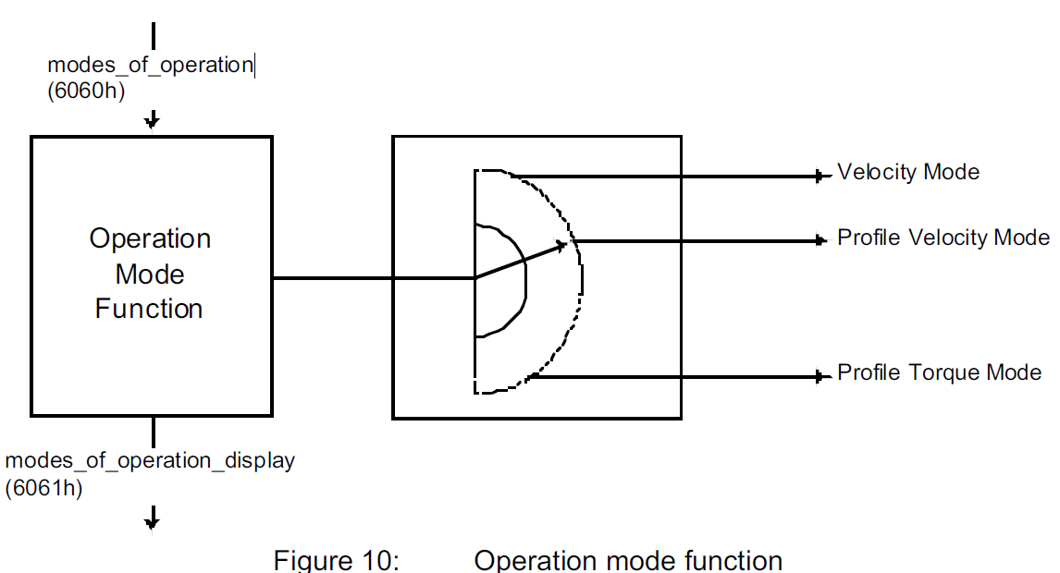

|  |  |  |  |  |  |  |  |
| --- | --- | --- | --- | --- | --- | --- | --- |
| 名称 | Object code | Index  (hex) | Data Type | Access | Category | 描述 | |
| Modes  of operation | VAR | 6060 | INTEGER16 | RW | M | 取值 | 功能 |
| -128 ~~–1 | 设备制造商定义 |
| 0 | 保留 |
| 1 | Profile Position Mode |
| 2 | Velocity Mode |
| 3 | Profile Velocity Mode |
| 4 | Profile Torque Mode |
| 5 | 保留 |
| 6 | Homing Mode |
| 7 | Interpolated Position Mode |
| 8~~127 | 保留 |
| Modes  of operation display | VAR | 6061 | INTEGER8 | **RO** | M | 用于主机读取驱动器的驱动模式；  取值和6060h --Modes of operation 相同；而Modes of operation 也是可以读取的，是不是重复了呢？  **注意：**  **The actual mode is reflected in the modes of operation display (index 6061h), and not in the modes of operation (index 6060h).**  **所以通常，两个Index各司其职**  Modes of operation 仅用来写入驱动模式，  Modes of operation display 仅用来读取驱动模式 | |

An example of exclusive functions are those for position and torque control, which can only control one variable at any one time. The variables can perform at most a limited function. Such hybrids are regarded as the particular characteristics of a mode of operation. Position control operation and encoder profile support can be active at the same time, for example. Consequently encoder profile support is not regarded as a mode of operation.

It is possible for the manufacturer to allow dynamic switching between

different modes of operation at any time or to limit switching for example to the state SWITCHED ON.

Switching can also be limited to the state 'local control'; i.e. not possible via the CAN-network. A

device characteristic listed in the device function list can possible have several modes of operation.

Velocity Mode (AC/DC drives, no feedback)

Profile Velocity Mode (servo drives, feedback)

Torque Profile Mode

Homing Mode

Profile Position Mode

Interpolated Position Mode

With the exception of the ‘Homing Mode’, these listed modes of operation can all be put under the heading of 'set-point setting'.

In parallel to this, manufacturer-specific modes of operation may also be available. These are not limited to set-point settings.

The reference operation is regarded as a special form of a program function. The program function allows the user to run complex of time-critical sequence, e. g. tool change or special reference operations, directly in the device.

The switching between the modes of operation listed above should not incur any automatic reconfiguration of the process data channel. Problems which occur through switching of set-point values during change of operating modes must be monitored by the user. If necessary they can be rectified by prior reconfiguration of the process data channel.

## 运行状态

主机发送控制字来控制驱动器的状态

对驱动器的操作和控制 要在合适的驱动器状态中才能得到有效执行。

|  |  |
| --- | --- |
| 状态名称 | 状态描述 |
| Not ready to switch on | 1.驱动器处于低电压状态  2.驱动器进行初始化和内部自检 |
| Switch On Disabled | 1.驱动器处于低电压状态  Drive initialization is complete.  The drive parameters have been set up.  Drive parameters may be changed.  High voltage may not be applied to the drive, (e.g. for safety reasons).  The drive function is disabled.  开启通信 |
| Ready To Switch On | 1.驱动器处于低电压状态  2.可以配置参数  这是一个过渡状态，Switch On Disabled不能直接进入Switch On，必须先经过Ready To Switch On； |
| Switch On | 1.驱动器处于高电压状态  2.电机处于低电压状态；  2.可以配置参数  这是一个过渡状态，Ready To Switch On不能直接进入Operation Enable，必须先经过Switch On； |
| Operation Enable | 1.驱动器处于高电压状态，处于Drive Function Enable状态(即此时可以控制电机转动)  2.电机处于高电压状态，处于伺服状态；当且仅当驱动器在本状态下，电机才可以转动。  3.该状态下可以修改参数，并且立即生效 |
| Quick stop active | 1.执行快速停止的功能 |
| Fault Reaction Active | 1.执行快速停止的功能 |
| Fault | 1.故障状态 |

|  |  |  |  |  |  |  |  |
| --- | --- | --- | --- | --- | --- | --- | --- |
| 状态字 | | | | | | | |
| 名称 | Object code | Index  (hex) | Data Type | Access | Category | 描述 | |
| Statusword | VAR | 6041 | UNSIGNED16 | **RO** | M | 得到的回复报文：不同的值代表不同的状态 | |
| Value(hex) | 状态 |
| xx 00 | Not Ready To Switch On |
| xx 40 | Switch On Disabled |
| xx 21 | Ready To Switch On |
| xx 23 | Switch On |
| xx 37 | Operation Enable |
| xx 17 | Quick stop active |
| xx 08 | 错误状态 |
|  |  |

|  |  |  |  |  |  |  |  |
| --- | --- | --- | --- | --- | --- | --- | --- |
|  | bit15、14 | bit13 | bit12 | bit11 | bit10 | bit9 | bit8 |
| Profile Velocity | 厂商定义 | \ | 1：当前速度=0  0：当前速度≠0 | Internal limit active | 1：已达到目标速度值  0：正处于加速或减速状态 | Remote | Offset  current  measured |
| Profile Position |  |  |  |
| Homing |  |  |  |

## 状态转换

|  |  |  |
| --- | --- | --- |
| FROM | TO | ACTION |
| Not ready to switch on | Switch On Disable | 初始化和内部自检完成后自动进入Switch On Disabled状态 |
| Fault | 驱动器内部出现故障 |
|  |  |  |
| Switch On Disabled | Ready To Switch On | 收到主机相应的控制字命令 |
| Fault | 驱动器内部出现故障 |
|  |  |  |
| Ready To Switch On | Switch On | 收到主机相应的控制字命令 |
| Switch On Disabled |
| Fault | 驱动器内部出现故障 |
|  |  |  |
| Switch On | Operation Enable | 收到主机相应的控制字命令 |
| Ready To Switch On |
| Switch On Disabled |
| Switch On Disabled |
| Fault | 驱动器内部出现故障 |
|  |  |  |
| Operation Enable | Switch On | 收到主机相应的控制字命令 |
| Ready To Switch On |
| Switch On Disabled |
| Quick stop active |
| Fault | 驱动器内部出现故障 |
|  |  |  |
| Quick stop active | Operation Enable | 收到主机相应的控制字命令 |
| Switch On Disabled |
| Switch On Disabled | Quick stop完毕后自动进入Switch On Disabled状态 |
| Fault Reaction Active | 驱动器内部出现故障 |
|  |  |  |
| Fault | Switch On Disabled | 收到主机相应的控制字命令 |

|  |  |  |  |  |  |  |  |
| --- | --- | --- | --- | --- | --- | --- | --- |
| 控制字 | | | | | | | |
| 名称 | Object code | Index  (hex) | Data Type | Access | Category | 描述 | |
| Controlword | VAR | 6040 | UNSIGNED16 | RW | M | 不同的值代表不同的命令  由主机发送给驱动器，实现对驱动器的控制。 | |
| Value(hex) | 功能 |
| 00 00 | 🡪Switch On Disabled |
| 00 06 | 🡪Ready To Switch On |
| 00 07 | 🡪Switch On |
| 01 0F | 电机停止转动；  🡪Operation Enable |
| 00 0F | 电机转动；  🡪Operation Enable |
| 00 02 | 🡪Quick stop active |
| 00 80 | 解除错误状态 |
|  |  |
|  |  |

|  |  |  |  |  |  |  |  |
| --- | --- | --- | --- | --- | --- | --- | --- |
| 状态转换具体效果控制 | | | | | | | |
| 名称 | Object code | Index  (hex) | Data Type | Access | Category | 描述 | |
| Shutdown option code | VAR | 605B | INTEGER16 | RW | O | 驱动器发生状态转换：Operation Enable →Ready To Switch On.  实际执行的操作  | |
| -32768 ~~–1 | 设备制造商定义 |
| 0 | Disable drive function |
| 1 | Slow down with slow down ramp; disable of the drive function |
| 2~~32767 | 保留 |
|  | | | | | | | |
| Disable operation option code | VAR | 605C | INTEGER16 | RW | O | 驱动器发生状态转换：Operation Enable →Switch On  实际执行的操作 | |
| -32768 ~~–1 | 设备制造商定义 |
| 0 | Disable drive function |
| 1 | Slow down with slow down ramp and then disabling of the drive function |
| 2~~32767 | 保留 |
|  | | | | | | | |
| Quick stop option code | VAR | 605A | INTEGER16 | RW | O | 驱动器发生状态转换：任意状态→Quick Stop  实际执行的操作 | |
| -32768 ~~–1 | 设备制造商定义 |
| 0 | disable drive function |
| 1 | slow down on slow down ramp |
| 2 | slow down on quick stop ramp |
| 3 | slow down on the current limit |
| 4 | slow down on the voltage limit |
| 5 | slow down on slow down ramp and stay in QUICK STOP |
| 6 | slow down on quick stop ramp and stay in QUICK STOP |
| 7 | slow down on the current limit and stay in QUICK STOP |
| 8 | slow down on the voltage limit and stay in QUICK STOP |
| 9~~32767 | 保留 |
|  |  |  |  |  |  |  |  |
| Halt option code | VAR | 605D | INTEGER16 | RW | O | 驱动器收到 **01 0F**的Control Word时，实际执行的操作 | |
| -32768 ~~–1 | 设备制造商定义 |
| 0 | disable drive, motor is free to rotate |
| 1 | slow down on slow down ramp |
| 2 | slow down on quick stop ramp |
| 3 | slow down on the current limit |
| 4 | slow down on the voltage limit |
| 5~~32767 | 保留 |
|  |  |  |  |  |  |  |  |
| Fault reaction option code | VAR | 605E | INTEGER16 | RW | O | 驱动器发生状态转换：任意状态→Fault  实际执行的操作 | |
| -32768 ~~–1 | 设备制造商定义 |
| 0 | disable drive, motor is free to rotate |
| 1 | slow down on slow down ramp |
| 2 | slow down on quick stop ramp |
| 3 | slow down on the current limit |
| 4 | slow down on the voltage limit |
| 5~~32767 | 保留 |

# Velocioty Mode

## 简单结构

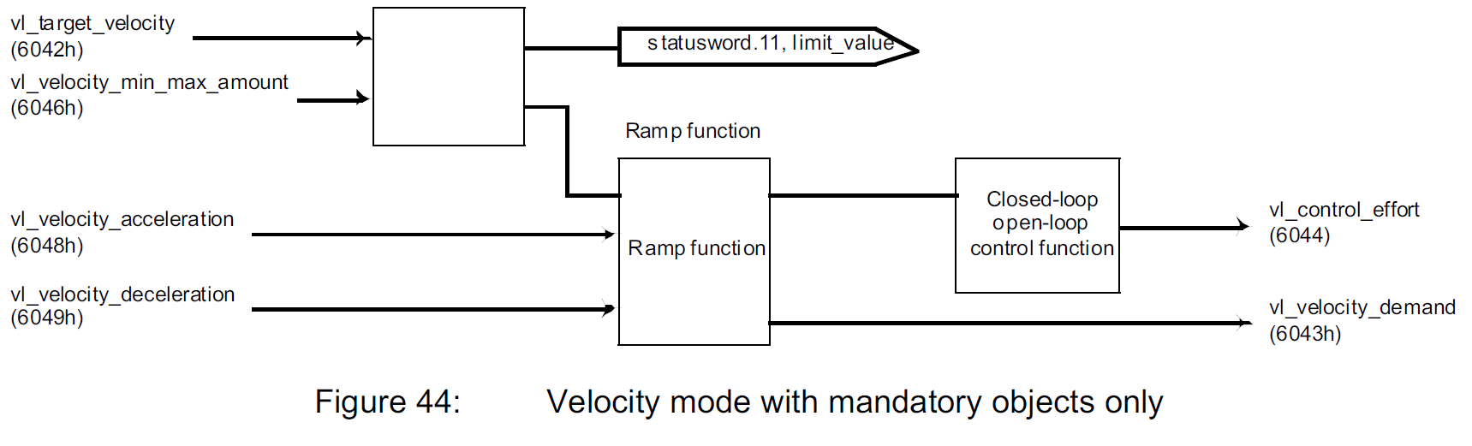

|  |  |  |  |  |  |  |  |
| --- | --- | --- | --- | --- | --- | --- | --- |
| 名称 | Object code | Index  (hex) | Data Type | Access | Category | 描述 | |
| target velocity | VAR | 6042 | INTEGER16 | RW | M | 单位：rpm （转/分）  取值：-32768~~32768  负值表示反向，注意C语言中二进制负数的表示 | |
|  | | | | | | | |
| velocity min max amount | ARRAY | 6046—00 | / | RO | M | 条目数=2 | |
| 6046—01 | INTEGER32 | RW | 限定速度最小值  单位：rpm （转/分）  取值：0 ~~ 4 294 967 295 | |
| 6046—02 | 限定速度最大值  单位：rpm （转/分）  取值：0 ~~ 4 294 967 295 | |
|  | | | | | | | |
| velocity acceleration | RECORD | 6048—00 | / | RO | M | 条目数=2 | |
| 6048—01 | UNSIGNED32 | RW | 变化速度-Delta speed  单位：ms  取值：0~~4 294 967 295 | 加速度数值  =Δv / Δt  =Delta speed/Delta time |
| 6048—02 | UNSIGNED16 | 变化时间-Delta time  单位：ms  取值：0~~65535 |
|  | | | | | | | |
| velocity deceleration | RECORD | 6049—00 | / | RO | M | 条目数=2 | |
| 6049—01 | UNSIGNED32 | RW | 变化速度-Delta speed  取值：0~~4 294 967 295 | 减速度数值  =Δv / Δt  =Delta speed/Delta time |
| 6049—02 | UNSIGNED16 | 变化时间-Delta time  取值：0~~65535 |
| demand velocity | VAR | 6043 | INTEGER16 | RO | M | 单位：rpm （转/分）  取值：-32768~~32768  负值表示反向，注意C语言中二进制负数的表示 | |
| control effort | VAR | 6044 | INTEGER16 | RO | M | 单位：rpm （转/分）  取值：-32768~~32768 | |

## 完整结构

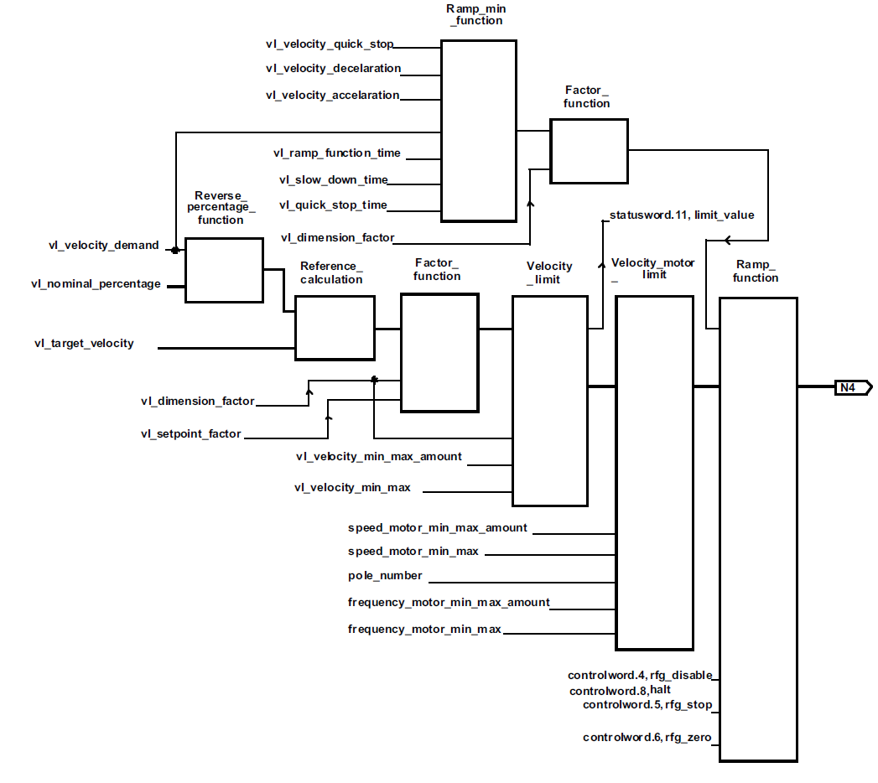

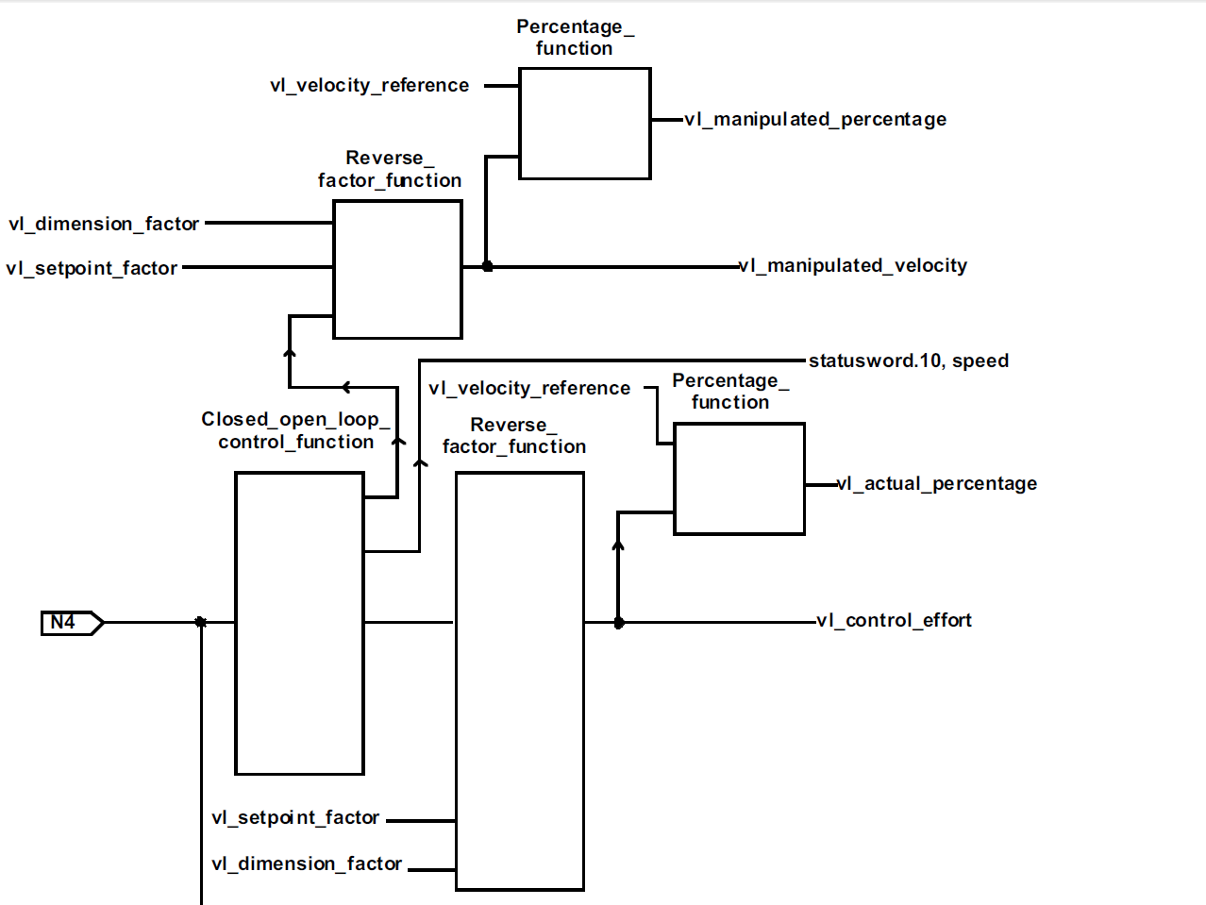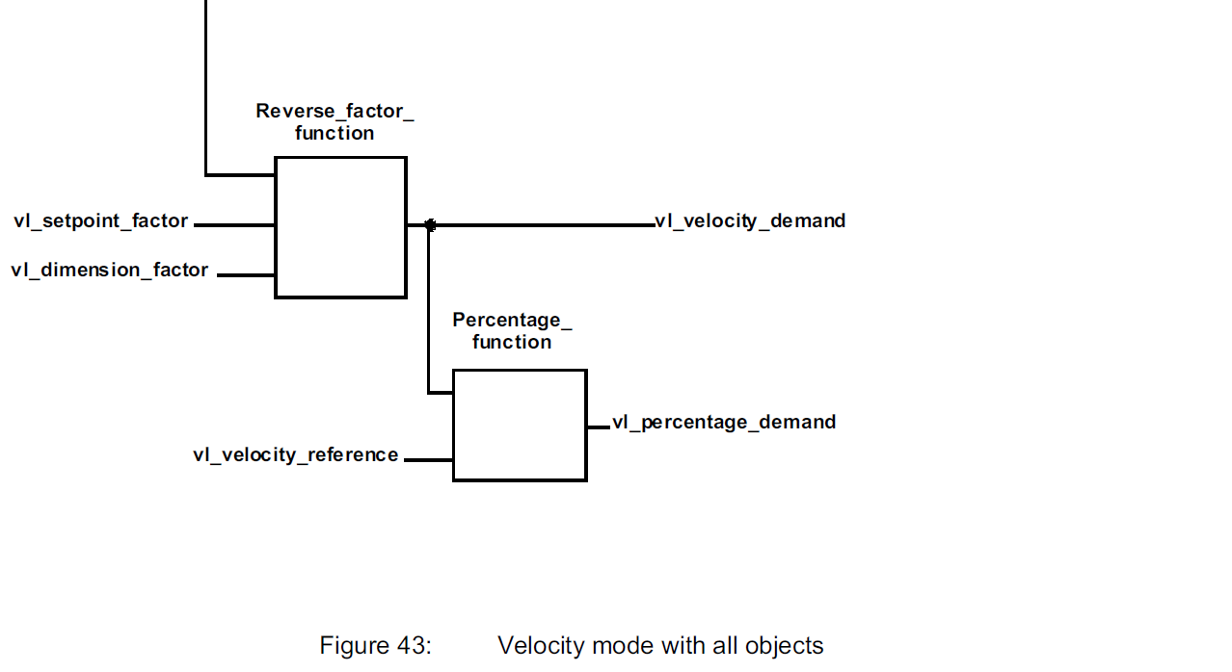

|  |  |  |  |  |  |  |  |
| --- | --- | --- | --- | --- | --- | --- | --- |
| 名称 | Object code | Index  (hex) | Data Type | Access | Category | 描述 | |
| velocity reference | VAR | 604E | INTEGER32 | RW | O | 速度参考值，用于计算速度  取值0~~ 4 294 967 295 | |
|  | | | | | | | |
| set-point factor | ARRAY | 604B--00 | / | RO | O | 条目数=2 | |
| 604B--01 | INTEGER16 | RW | 分子  取值：-32768~~32768  除去0 | 置位点因数  =分子/分母 |
| 604B--02 | INTEGER16 | 分母  取值：-32768~~32768  除去0 |
|  | | | | | | | |
| dimension factor | ARRAY | 604C--00 | / | RO | O | 条目数=2 | |
| 604C--01 | INTEGER32 | RW | 分子  取值：-32768~~32768  除去0 | 规格因数  =分子/分母 |
| 604C--02 | INTEGER32 | 分母  取值：-32768~~32768  除去0 |
|  | | | | | | | |
| pole number | VAR | 604D | INTEGER8 | RW | O |  | |

|  |  |  |  |  |  |  |
| --- | --- | --- | --- | --- | --- | --- |
| nominal percentage | VAR | 6052 | INTEGER16 | RW | O | 百分比--对应manipulated velocity  取值：-32768~~32768  16383对应 100%所以对应的  百分比数值=percentage demand * 16.383 |

|  |  |  |  |  |  |  |  |
| --- | --- | --- | --- | --- | --- | --- | --- |
| 名称 | Object code | Index  (hex) | Data Type | Access | Category | 描述 | |
| velocity min max | ARRAY | 6047—00 | / | RO | O | 条目数=4 |
| 6047—01 | INTEGER32 | RW | 正向速度最小值  取值：0 ~~ 4 294 967 295 |
| 6047—02 | 正向速度最大值  取值：0 ~~ 4 294 967 295 |
| 6047—03 | 反向速度最小值  取值：0 ~~ 4 294 967 295 |
| 6047—04 | 反向速度最大值  取值：0 ~~ 4 294 967 295 |
|  | | | | | | |
| velocity motor min max amount | ARRAY | 6056 |  | RO | O | 条目数=2 |
|  | INTEGER32 | RW | 最小值取值  取值：0 ~~ 4 294 967 295 |
|  | 最大值取值  取值：0 ~~ 4 294 967 295 |
|  | | | | | | |
| velocity motor min max | ARRAY | 6057--00 | / | RO | O | 条目数=4 |
| 6057--01 | INTEGER32 | RW | 正向速度最小值  取值：0 ~~ 4 294 967 295 |
| 6057--02 | 正向速度最大值  取值：0 ~~ 4 294 967 295 |
| 6057--03 | 反向速度最小值  取值：0 ~~ 4 294 967 295 |
| 6057--04 | 反向速度最大值  取值：0 ~~ 4 294 967 295 |
|  | | | | | | |
| frequency motor min max amount | ARRAY | 6058--00 | / | RO | O | 条目数=2 |
| 6058--01 | INTEGER32 | RW | 最小值取值  取值：0 ~~ 4 294 967 295 |
| 6058--02 | 最大值取值  取值：0 ~~ 4 294 967 295 |
|  | | | | | | |
| frequency motor min max | ARRAY | 6059--00 | / | RO | O | 条目数=4 |
| 6059--01 | INTEGER32 | RW | 正向速度最小值  取值：0 ~~ 4 294 967 295 |
| 6059--02 | 正向速度最大值  取值：0 ~~ 4 294 967 295 |
| 6059--03 | 反向速度最小值  取值：0 ~~ 4 294 967 295 |
| 6059--04 | 反向速度最大值  取值：0 ~~ 4 294 967 295 |

|  |  |  |  |  |  |  |
| --- | --- | --- | --- | --- | --- | --- |
| 名称 | Object code | Index  (hex) | Data Type | Access | Category | 描述 |
| ramp function time | VAR | 604F | INTEGER32 | RW | O | 驱动器在状态中  速度从0升到velocity reference的用时  范围：0~~4 294 967 295  单位：ms |
| slow down time | VAR | 6050 | INTEGER32 | RW | O | 驱动器在状态中  速度从velocity reference降到0的用时  范围：0~~4 294 967 295  单位：ms |
| quick stop time | VAR | 6051 | INTEGER32 | RW | O | 驱动器在快速停止状态中  速度从velocity reference降到0的用时  范围：0~~4 294 967 295  单位：ms |

|  |  |  |  |  |  |  |  |
| --- | --- | --- | --- | --- | --- | --- | --- |
| 名称 | Object code | Index  (hex) | Data Type | Access | Category | 描述 | |
| velocity quick stop | RECORD | 604A--00 | / | RO | O | 条目数=2 | |
| 604A--01 | UNSIGNED32 | RW | 变化速度-Delta speed  取值：0~~4 294 967 295 | 用于设定快速停止的减速度数值  减速度数值  =Δv / Δt  =Delta speed/Delta time |
| 604A--02 | UNSIGNED16 | 变化时间-Delta time  取值：0~~65535 |
|  |  |  |  |  |  |  | |
| 快速停止减速 | VAR | 6085 | UNSIGNED32 | RW | O |  | |
| 最大加速度 | VAR | 60C5 | UNSIGNED32 | RW | O |  | |
| 最大减速度 | VAR | 60C6 | UNSIGNED32 | RW | O |  | |
|  |  |  |  |  |  |  | |

|  |  |  |  |  |  |  |
| --- | --- | --- | --- | --- | --- | --- |
| 只读对象 | | | | | | |
| 名称 | Object code | Index  (hex) | Data Type | Access | Category | 描述 |
| demand velocity | VAR | 6043 | INTEGER16 | RO | M | 单位：rpm （转/分）  取值：-32768~~32768  负值表示反向，注意C语言中二进制负数的表示 |
| control effort | VAR | 6044 | INTEGER16 | RO | M | 单位：rpm （转/分）  取值：-32768~~32768 |
| manipulated velocity | VAR | 6045 | INTEGER16 | RO | O |  |
|  |  |  |  |  |  |  |
| percentage demand | VAR | 6053 | INTEGER16 | RO | O | 百分比—用于计算demand velocity  取值：-32768~~32768  16383对应 100%所以对应的  百分比数值=percentage demand * 16.383 |
| actual percentage | VAR | 6054 | INTEGER16 | RO | O | 百分比—对应control effort  取值：-32768~~32768  16383对应 100%所以对应的  百分比数值=percentage demand * 16.383 |
| manipulated percentage | VAR | 6055 | INTEGER16 | RO | O | 百分比--对应manipulated velocity  取值：-32768~~32768  16383对应 100%所以对应的  百分比数值=percentage demand * 16.383 |

# Profile Position Mode

## 概述

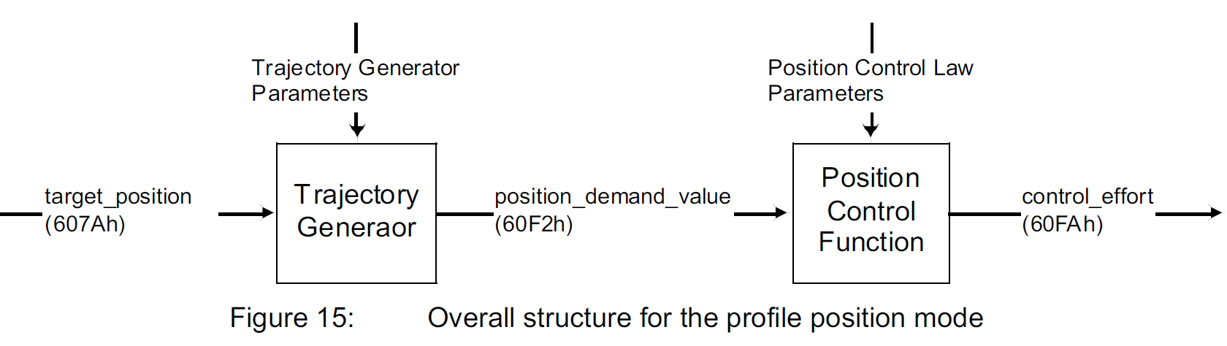

## 位置

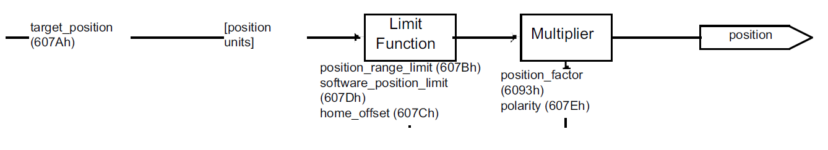

|  |  |  |  |  |  |  |
| --- | --- | --- | --- | --- | --- | --- |
| Position | | | | | | |
| 名称 | Object code | Index  (hex) | Data Type | Access | Category | 描述 |
| Target position | VAR | 607A | INTEGER32 | RW | M |  |
|  |  |  |  |  |  |  |
| Position range limit | ARRAY | 607B—00h | UNSIGNED8 | RO | O | 条目数=2 |
| 607B—01h | INTEGER32 | RW | 默认值-231 |
| 607B—02h | 默认值231-1 |
|  | | | | | | |
| Software position limit | ARRAY | 607D—00h | UNSIGNED8 | RO | O | 条目数=2 |
| 607D—01h | INTEGER32 | RW | 默认值-231 |
| 607D—02h | 默认值231-1 |
|  |  |  |  |  |  |  |
| Polarity | VAR | 607E | UNSIGNED8 | RW | O |  |
|  |  |  |  |  |  |  |
| Position factor | ARRAY | 6093--00 | UNSIGNED8 | RO | O | 条目数=2 |
| 6093--01 | UNSIGNED32 | RW |  |
| 6093--02 |  |

## 速度

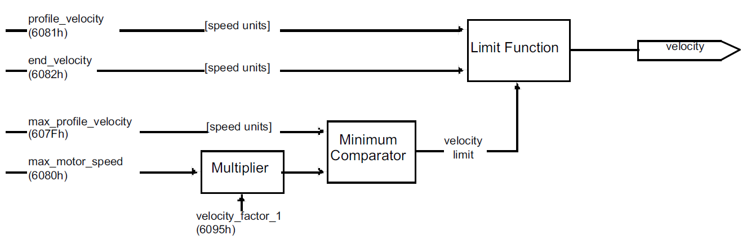

|  |  |  |  |  |  |  |
| --- | --- | --- | --- | --- | --- | --- |
| velocity | | | | | | |
| 名称 | Object code | Index  (hex) | Data Type | Access | Category | 描述 |
| Profile velocity | VAR | 6081 | UNSIGNED32 | RW | Conditional  (M if pp or pv supported) | The profile velocity is the velocity normally attained at the end of the acceleration ramp during a  profiled move and is valid for both directions of motion. The profile velocity is given in user defined  speed units. It is converted to position increments per second using the velocity encoder factor (see  chapter 11). |
| End velocity | VAR | 6082 | UNSIGNED32 | RW | O | The end velocity defines the velocity which the drive must have on reaching the target position.  Normally, the drive stops at the target position, i.e. the end velocity = 0. The end velocity is given in the  same units as profile velocity. |
| Max profile velocity | VAR | 607F | UNSIGNED32 | RW | O |  |
| Max motor speed | VAR | 6080 | UNSIGNED32 | RW | O |  |
| Velocity factor 1 | ARRAY | 6095--00 | UNSIGNED8 | RO | O | 条目数=2 |
| 6095--01 | UNSIGNED32 | RW |  |
| 6095--02 |  |

## 加速度和减速度

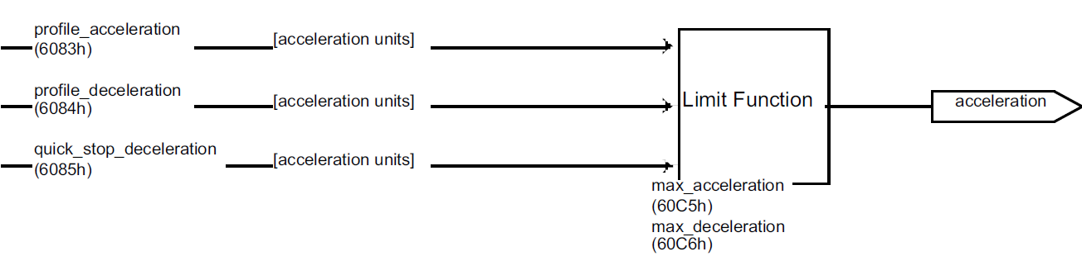

|  |  |  |  |  |  |  |
| --- | --- | --- | --- | --- | --- | --- |
| acceleration | | | | | | |
| 名称 | Object code | Index  (hex) | Data Type | Access | Category | 描述 |
| Profile acceleration | VAR | 6083 | UNSIGNED32 | RW | M | 加速度  单位：由用户指定 |
| Profile deceleration | VAR | 6084 | UNSIGNED32 | RW | O | 减速度  如果该设备没有设置这个对象，那么Profile acceleration的数值同时表示加速度的数值和减速度的数值  单位：和 profile acceleration 相同 |
| Quick stop deceleration | VAR | 6085 | UNSIGNED32 | RW | O | 驱动器收到主机的‘Quick Stop’命令后，电机执行命令时的减速度；  对象quick stop option code (see 605Ah) 的值设置为2时  quick stop deceleration有效；  单位：和 profile acceleration 相同 |
| Max acceleration | VAR | 60C5 | UNSIGNED32 | RW | O | 最大加速度值 |
| Max deceleration | VAR | 60C6 | UNSIGNED32 | RW | O | 最大减速度值 |

## position_demand_value

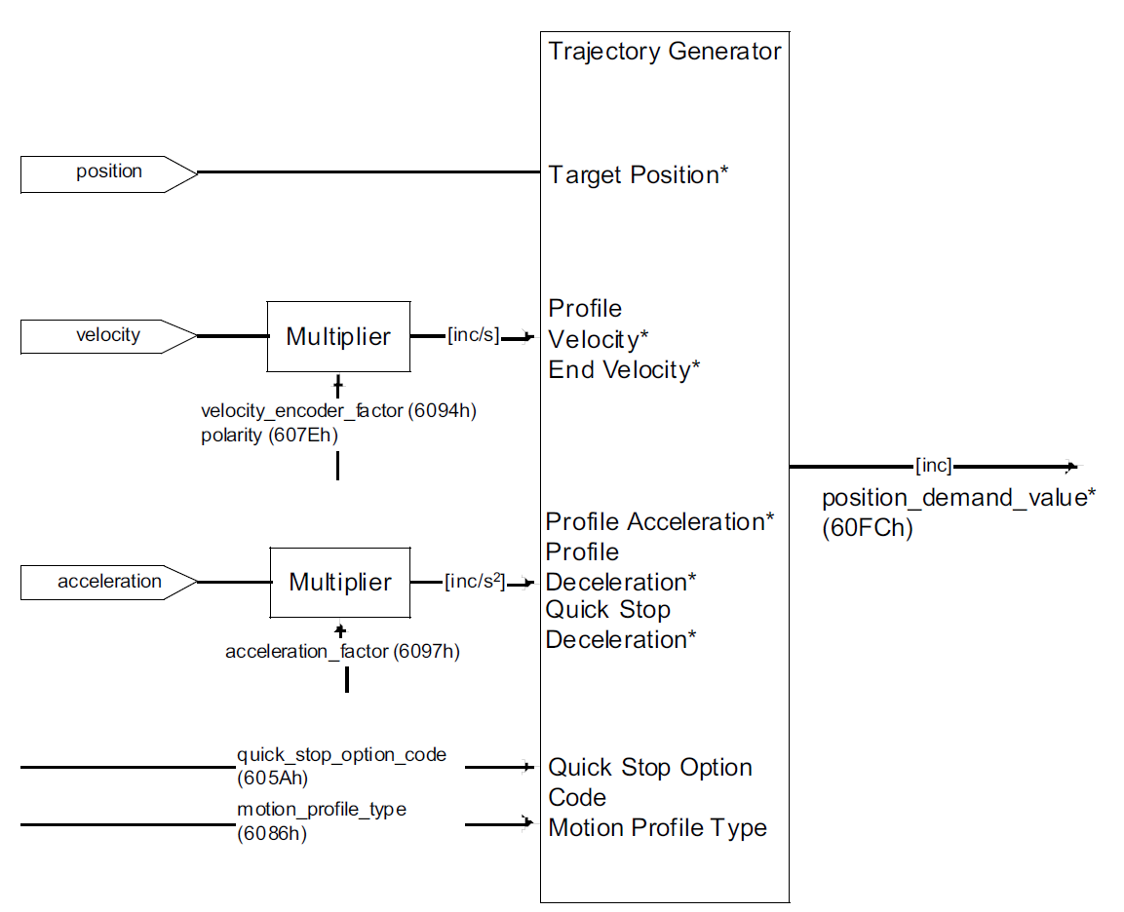

|  |  |  |  |  |  |  |  |
| --- | --- | --- | --- | --- | --- | --- | --- |
| 名称 | Object code | Index  (hex) | Data Type | Access | Category | 描述 | |
| Velocity encoder factor | ARRAY | 6094--00 | UNSIGNED8 | RO | O | 条目数=2 | |
| 6094--01 | UNSIGNED32 | RW |  | |
| 6094--02 |  | |
| Polarity | VAR | 607E | UNSIGNED8 | RW | O |  | |
| Acceleration factor | ARRAY | 6097--00 | UNSIGNED8 | RO | O | 条目数=2 | |
| 6097--01 | UNSIGNED32 | RW |  | |
| 6097--02 |  | |
| Motion profile type | VAR | 6086 | INTEGER16 | RW | O | -32768~~-1 | manufacturer specific |
| 0 | Linear ramp  (trapezoidal profile) |
| 1 | sin2 ramp |
| 2 | Jerk-free ramp |
| 3 | Jerk-limited ramp |
| 4~32767 | Jerk-limited ramp |
| Quick stop deceleration | VAR | 607E | UNSIGNED32 | RW | O | quick stop option code (see 605Ah) 的值设置为2  quick stop deceleration有效，表示驱动器收到主机的‘Quick Stop’命令后，电机执行命令时的减速度  单位：和 profile acceleration 相同 | |
| Position demand value | VAR | 60FC | UNSIGNED32 | RO | O | This output of the trajectory generator in profile position mode is an internal value using increments as  unit what is expressed with an *. To save calculation time for some applications, this object is  additionally introduced to the position demand value (6062h). | |

# Profile Velocioty Mode

## Profile Velocity

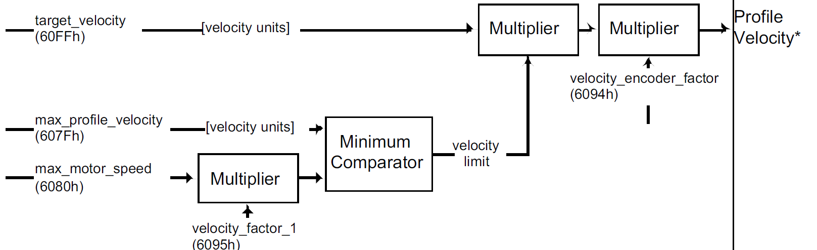

|  |  |  |  |  |  |  |
| --- | --- | --- | --- | --- | --- | --- |
| 名称 | Object code | Index  (hex) | Data Type | Access | Category | 描述 |
| Target velocity | VAR | 60FF | INTEGER32 | RW | M | 用来设定电机的转速  单位：rpm（转/min）  **改变转速的方法：先在60FF对象中写入新的速度值，**  **再在6040控制字对象中写入0F控制字；**  **只改变Target velocity的值是没有用的，还需要触发** |
| Max profile velocity | VAR | 607F | UNSIGNED32 | RW | O | 设定profile velocity 的最大值  单位：rpm（转/min） |
| Max motor  speed | VAR | 6080 | UNSIGNED32 | RW | O | 电机的最大转速，用于保护电机  可以查看驱动所控制的电机的参数，将其写入到该对象中  单位：rpm（转/min） |
| Velocity factor 1 | ARRAY | 6095--00 | UNSIGNED8 | RO | O | 条目数=2 |
| 6095--01 | UNSIGNED32 | RW |  |
| 6095--02 |  |
| Velocity encoder factor | ARRAY | 6094--00 | UNSIGNED8 | RO | O | 条目数=2 |
| 6094--01 | UNSIGNED32 | RW |  |
| 6094--02 |  |

## 加速度与减速度

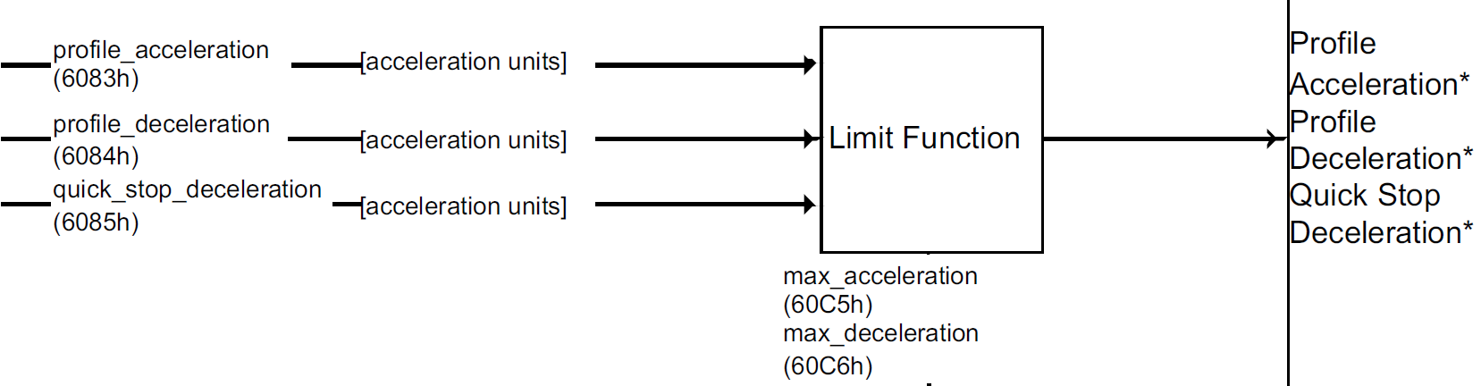

|  |  |  |  |  |  |  |
| --- | --- | --- | --- | --- | --- | --- |
| 名称 | Object code | Index  (hex) | Data Type | Access | Category | 描述 |
| Profile acceleration | VAR | 6083 | UNSIGNED32 | RW | Conditional | It is converted to position  increments per second2 using the normalizing factors (see chapter 11).  单位：由用户指定 |
| Profile deceleration | VAR | 6084 | UNSIGNED32 | RW | O | 如果该设备没有设置这个对象，那么Profile acceleration的数值同时表示加速度的数值和减速度的数值  单位：和 profile acceleration 相同 |
| Quick stop deceleration | VAR | 6085 | UNSIGNED32 | RW | O | q驱动器收到主机的‘Quick Stop’命令后，电机执行命令时的减速度；  对象quick stop option code (see 605Ah) 的值设置为2时  quick stop deceleration有效；  单位：和 profile acceleration 相同 |
| Max acceleration | VAR | 60C5 | UNSIGNED32 | RW | O | 最大加速度值 |
| Max deceleration | VAR | 60C6 | UNSIGNED32 | RW | O | 最大减速度值 |

## Velocity demand value

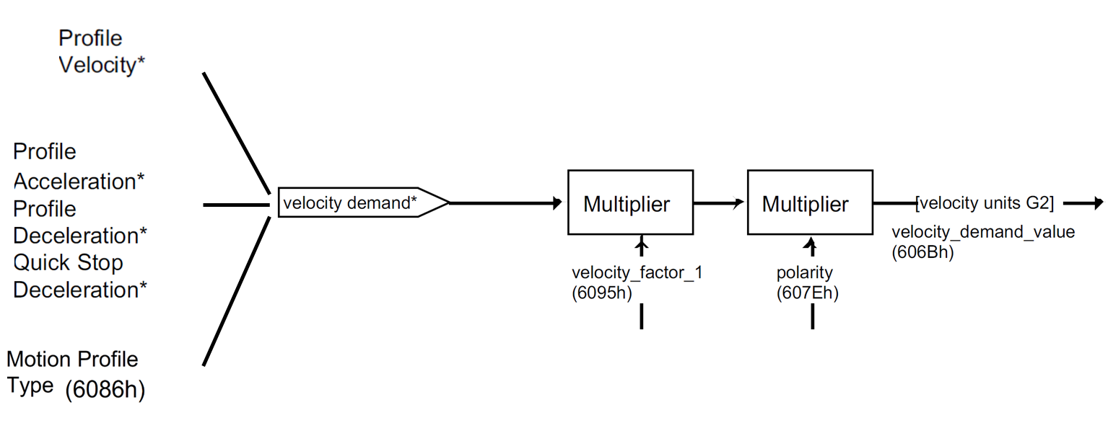

|  |  |  |  |  |  |  |  |
| --- | --- | --- | --- | --- | --- | --- | --- |
| 名称 | Object code | Index  (hex) | Data Type | Access | Category | 描述 | |
| Motion profile  type | VAR | 6086 | INTEGER16 | RW | O | -32768~~-1 | manufacturer specific |
| 0 | Linear ramp  (trapezoidal profile) |
| 1 | sin2 ramp |
| 2 | Jerk-free ramp |
| 3 | Jerk-limited ramp |
| 4~32767 | Jerk-limited ramp |
| Velocity factor 1 | ARRAY | 6095--00 | UNSIGNED8 | RO | O | 条目数=2 | |
| 6095--01 | UNSIGNED32 | RW |  | |
| 6095--02 |  | |
| Polarity | VAR | 607E | UNSIGNED8 | RW | O |  | |
| Velocity demand value | VAR | 606B | INTEGER32 | RO | M | The output value of the trajectory generator may be corrected by the output value of the position  control function. It is then provided as a demand value for the velocity controller and given in the  velocity units. | |

## 读取实际速度

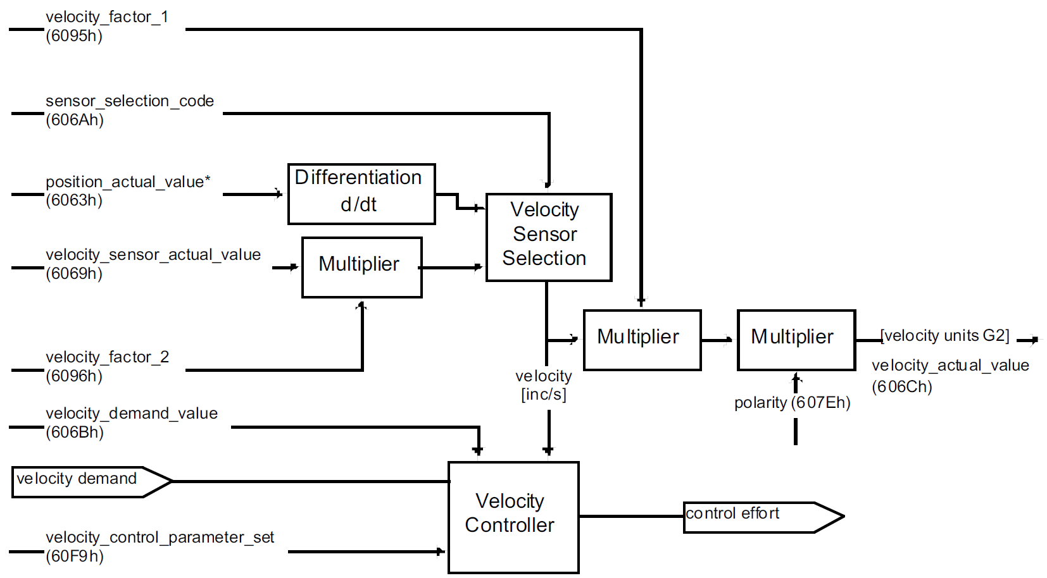

|  |  |  |  |  |  |  |  |
| --- | --- | --- | --- | --- | --- | --- | --- |
| 名称 | Object code | Index(hex) | Data Type | Access | Category | 描述 | |
| Sensor  selection  code | VAR | 606A | INTEGER16 | RW | O | 0000h | Actual velocity value from position encoder |
| 0001h | Actual velocity value from velocity encoder |
| 0002~~  7FFF | 保留 |
| 8000~~  FFFFh | 生产商定义 |
| Position actual value | VAR | 6063 | INTEGER32 | RO | O |  | |
| Velocity sensor actual value | VAR | 6069 | INTEGER32 | RO | M | describes the value read from a velocity encoder (if present) in increments (in the case of encoders) and in increments per second (in the case of tachometers and  AD converters). This value is scaled to the format of the position encoder using the scaling factor  velocity factor 2. | |
| Velocity factor 2 | ARRAY | 6096--00 | UNSIGNED8 | RO | O | 条目数=2 | |
| 6096--01 | UNSIGNED32 | RW |  | |
| 6096--02 |  | |

|  |  |  |  |  |  |  |
| --- | --- | --- | --- | --- | --- | --- |
| Velocity factor 1 | ARRAY | 6095--00 | UNSIGNED8 | RO | O | 条目数=2 |
| 6095--01 | UNSIGNED32 | RW |  |
| 6095--02 |  |
| Polarity | VAR | 607E | UNSIGNED8 | RW | O |  |
| Velocity actual value | VAR | 606C | INTEGER32 | RO | M | The velocity actual valueis also represented in velocity units and is coupled to the velocity used as  input to the velocity controller. |

## control effort

|  |  |  |  |  |  |  |
| --- | --- | --- | --- | --- | --- | --- |
| Velocity demand value | VAR | 606B | INTEGER32 | RO | M |  |
| Velocity control parameter set | ARRAY | \ | UNSIGNED16 | RO | O | 条目数  范围：2~~254 |
| 60F9—01 | RW | PID控制的P值 |
| 60F9—02 | PDI控制的I值 |
| 60F9—03~254 | 生产商定义 |

The source of the velocity sensor actual value can be determined using the sensor selection code.

This determines whether a differentiated position signal or the signal from a separate velocity sensor

has to be evaluated

## ststus word

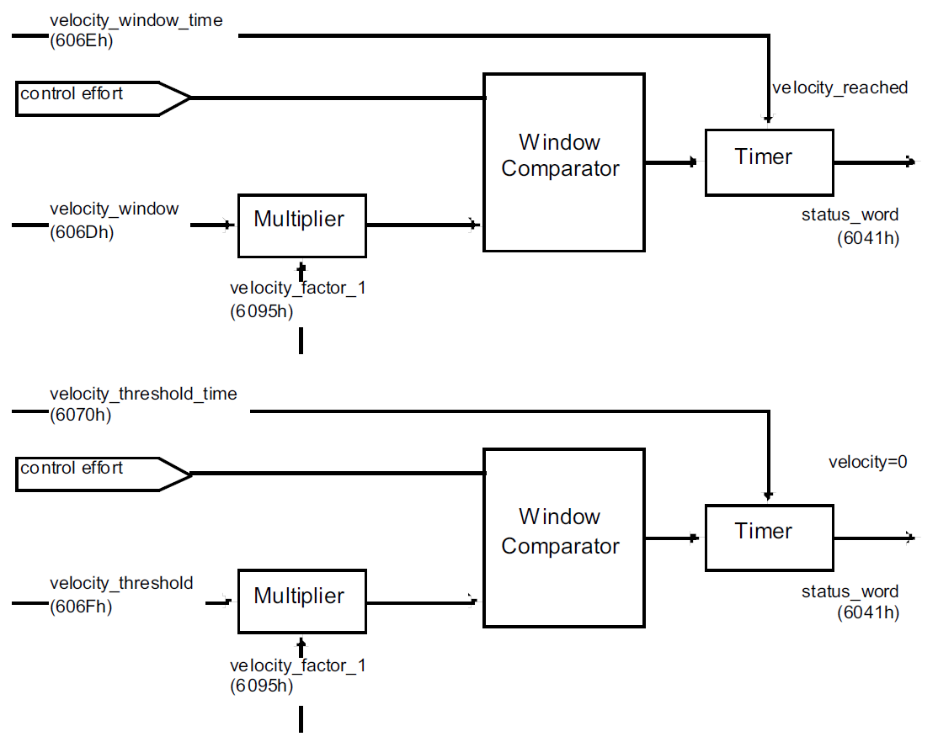

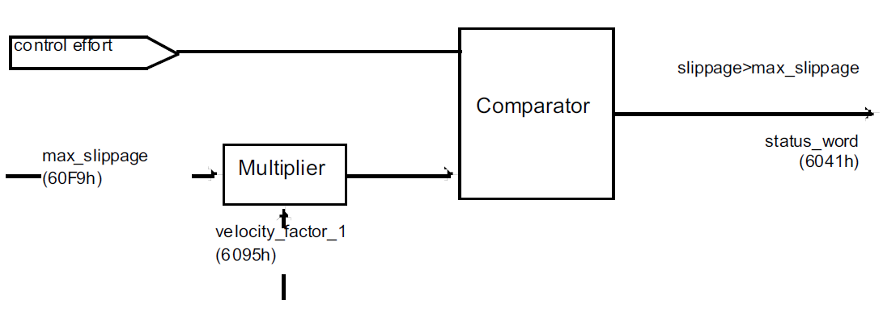

|  |  |  |  |  |  |  |
| --- | --- | --- | --- | --- | --- | --- |
| 名称 | Object code | Index(hex) | Data Type | Access | Category | 描述 |
| Velocity window | VAR | 606D | UNSIGNED16 | RW | O | The velocity window monitors whether the required process velocity has been achieved after an  eventual acceleration or deceleration (braking) phase. It is given in velocity units. |
| Velocity window time | VAR | 606E | UNSIGNED16 | RW | O | The corresponding bit 10 target reached is set in the statusword when the difference between the  target velocity and the velocity actual value is within the velocity window longer than the velocity  window time. The value of the velocity window time is given in multiples of milliseconds |
| Velocity threshold | VAR | 606F | UNSIGNED16 | RW | O | As soon as the velocity actual value exceeds the velocity threshold longer than the velocity threshold  time bit 12 velocity = 0 is reset in the statusword. Below this threshold the bit is set and indicates that  the axle is stationary. The value is given in velocity units |
| Velocity threshold  time | VAR | 6070 | UNSIGNED16 | RW | O | The velocity threshold time is given in multiples of milliseconds (for description see 16.3.7). |
| Velocity factor 1 | ARRAY | 6095--00 | UNSIGNED8 | RO | O | 条目数=2 |
| 6095--01 | UNSIGNED32 | RW |  |
| 6095--02 |  |

|  |  |  |  |  |  |  |
| --- | --- | --- | --- | --- | --- | --- |
| Max  slippage | VAR | 60F8 | INTEGER32 | RW | O |  |

|  |  |  |  |  |  |  |
| --- | --- | --- | --- | --- | --- | --- |
| Target torque | VAR | 6071 | INTEGER16 | RW | Conditional |  |
| Max torque | VAR | 6072 | INTEGER16 | RW | O |  |

# Profile Torque Mode

## CONTROL EFFORT

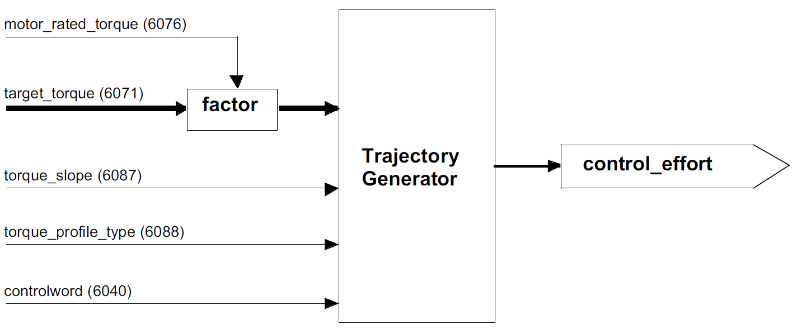

|  |  |  |  |  |  |  |
| --- | --- | --- | --- | --- | --- | --- |
| motor rated torque | VAR | 6076 | UNSIGNED32 | RW | O |  |
| Target torque | VAR | 6071 | INTEGER16 | RW | M | This parameter is the input value for the torque controller in profile torque mode and the value is given  per thousand of rated torque. |
| torque slope | VAR | 6087 | UNSIGNED32 | RW | M | This parameter describes the rate of change of torque in units of per thousand of rated torque per  second. |
| torque profile type | VAR | 6088 | INTEGER16 | RW | M | The *torque profile type* is used to select the type of torque profile used to perform a torque change. |

## 电机控制

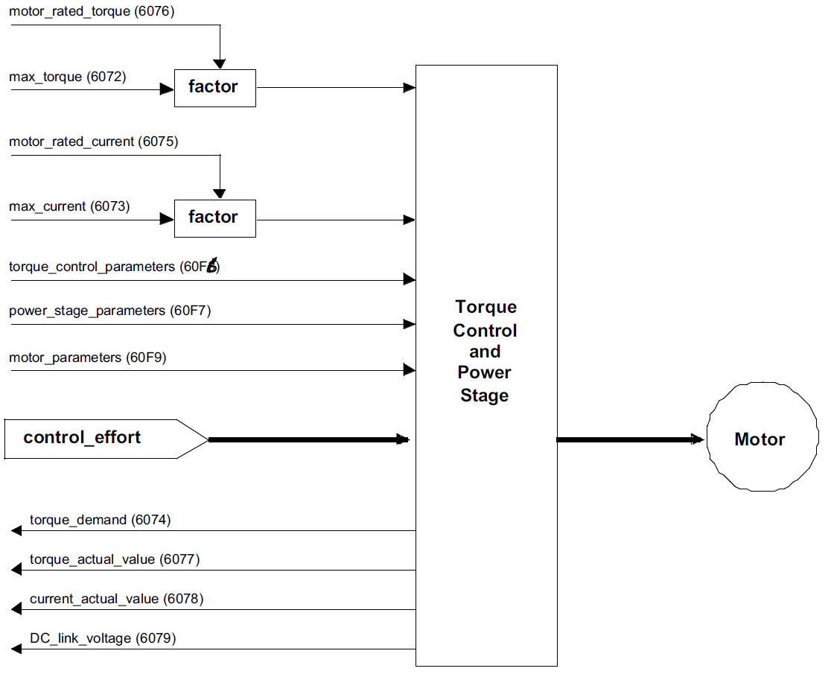

|  |  |  |  |  |  |  |
| --- | --- | --- | --- | --- | --- | --- |
| 名称 | Object code | Index(hex) | Data Type | Access | Category | 描述 |
| motor rated torque | VAR | 6076 | UNSIGNED32 | RW | O | This value is taken from the motor name plate and is entered as multiples of mNm (mill Newtonmeter).  All relative torque data refer to this value.  For linear motors, the object name is not changed, but the motor rated force value must be entered as  multiples of mN (mill Newton). |
| motor rated current | VAR | 6075 | UNSIGNED32 | RW | O | This value is taken from the motor name plate and is entered as multiples of milliamp. Depending on  the motor and drive technology this current may be either DC, peak or rms (root-mean-square)  current. All relative current data refers to this value. |
| Max torque | VAR | 6072 | UNSIGNED16 | RW | O | This value represents the maximum permissible torque in the motor and is given per thousand of rated  torque. |
| max current | VAR | 6073 | UNSIGNED16 | RW | O | This value represents the maximum permissible torque creating current in the motor and is given per  thousand of rated current |

|  |  |  |  |  |  |  |
| --- | --- | --- | --- | --- | --- | --- |
| 名称 | Object code | Index(hex) | Data Type | Access | Category | 描述 |
| torque control parameters | RECORD | 60F6 | 由生产商定义 | RW | O | The torque control parameters object is used to handle (i.e. download) all manufacturer-specific torque  control parameters in a whole, in a standard way. |
| power stage parameters | RECORD | 60F7 | 由生产商定义 | RW | O | The power stage parameters object is used to handle (i.e. download) all manufacturer-specific powerstage  parameters in a whole, in a standard way. |
| motor parameters | RECORD | 60F9 | 由生产商定义 | RW | O |  |

|  |  |  |  |  |  |  |
| --- | --- | --- | --- | --- | --- | --- |
| 名称 | Object code | Index(hex) | Data Type | Access | Category | 描述 |
| torque demand | VAR | 6074 | INTEGER16 | RO | O | This parameter is the output value of the torque limit function (if the torque control and power-stage  function are available). The value is given per thousand of rated torque. |
| torque actual value | VAR | 6077 | INTEGER16 | RO | O | The torque actual value corresponds to the instantaneous torque in the drive motor. The value is given  per thousand of rated torque |
| current actual value | VAR | 6078 | INTEGER16 | RO | O | The current actual value refers to the instantaneous current in the drive motor. The value is given per  thousand of rated current. |
| DC link voltage | VAR | 6079 | UNSIGNED32 | RO | O | This parameter describes the instantaneous DC link current voltage at the drive controller. The value  is given in multiples of mill volts |

# Homing Mode

## 对象

|  |  |  |  |  |  |  |
| --- | --- | --- | --- | --- | --- | --- |
| 名称 | Object code | Index(hex) | Data Type | Access | Category | 描述 |
| Homing method | ARRAY | 6098 | INTEGER8 | RW | M |  |
| Homing speeds | VAR | 6099 | UNSIGNED32 | RW | M |  |
| Home offset | VAR | 607C | INTEGER32 | RW | O |  |
| Homing acceleration | VAR | 609A | UNSIGNED32 | RW | O |  |

# Interpolated Mode

## 对象

|  |  |  |  |  |  |  |
| --- | --- | --- | --- | --- | --- | --- |
| 名称 | Object code | 索引(hex) | 数据类型 | 访问类型 | 对象类型 | 描述 |
| 子模式 | VAR | 60C0 | INTEGER16 | RW | O |  |
| 数据记录 | ARRAY | 60C1 | INTEGER32 | RW | O |  |
| 时长 | RECORD | 60C2 |  | RW | O |  |
| 同步定义 | ARRAY | 60C3 | UNSIGNED8 | RW | O |  |
| 数据配置 | RECORD | 60C4 |  | RW | O |  |