**本文档为测试结果文档。**

**具体展示了图片1的每个主要步骤的可视化结果以及最终位姿变换矩阵。**

**其余测试用例仅展示了配准可视化结果（两个视角下的）和位姿变换矩阵。**

**By kanglang123**

**1**

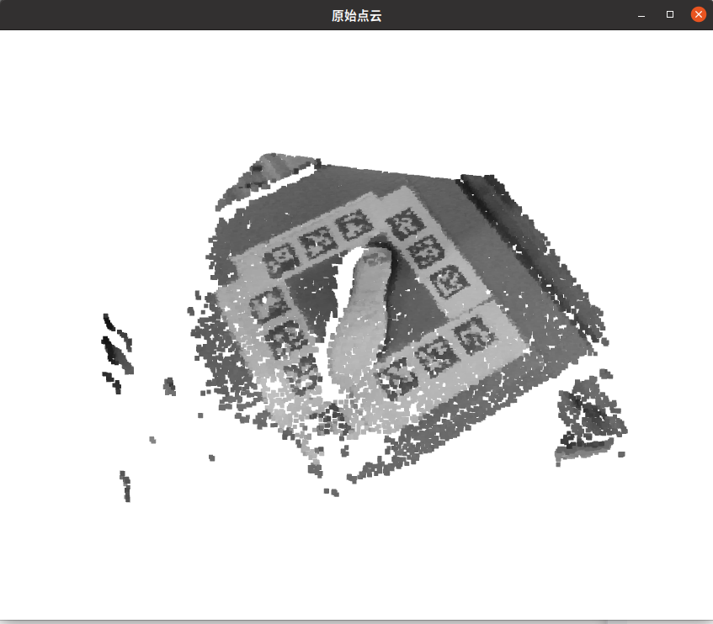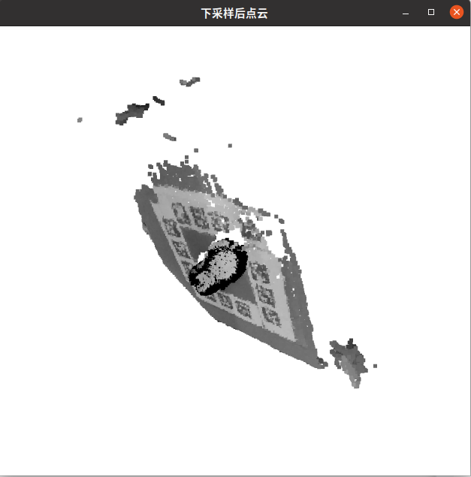

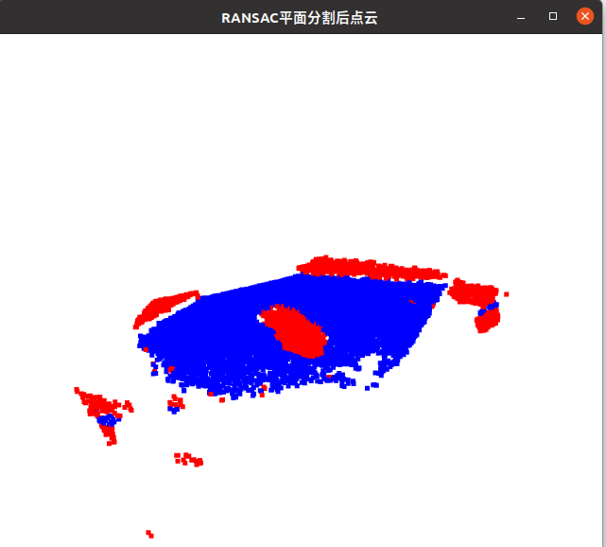

**全局配准后如下图所示：**

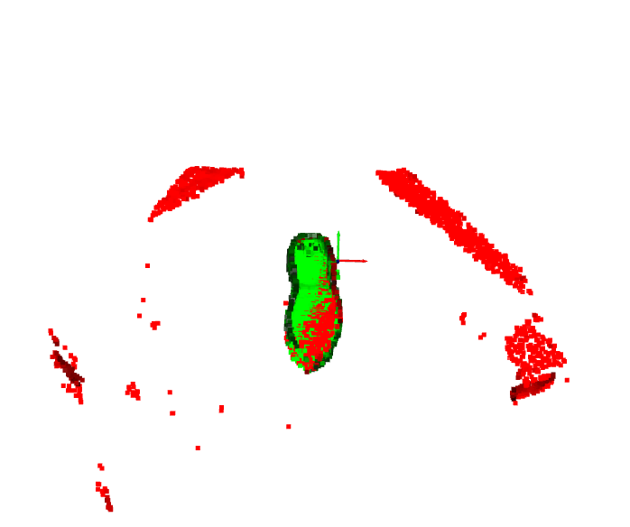

**ICP局部配准优化后如图所示：**

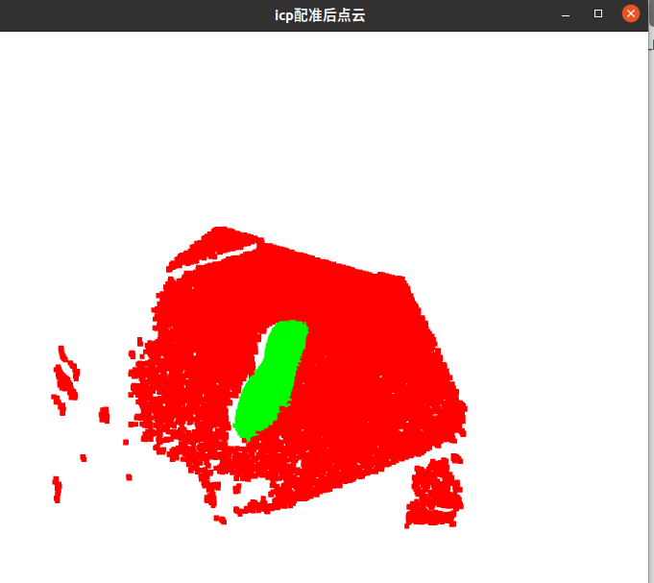

**[ 9.99944317e-01 7.61832226e-03 7.30235604e-03 1.14211385e-03]**

**[-7.61835187e-03 9.99970980e-01 -2.37608010e-05 7.07015946e-04]**

**[-7.30232514e-03 -3.18724399e-05 9.99973337e-01 2.73623593e-03]**

**[ 0.00000000e+00 0.00000000e+00 0.00000000e+00 1.00000000e+00]**

**44**

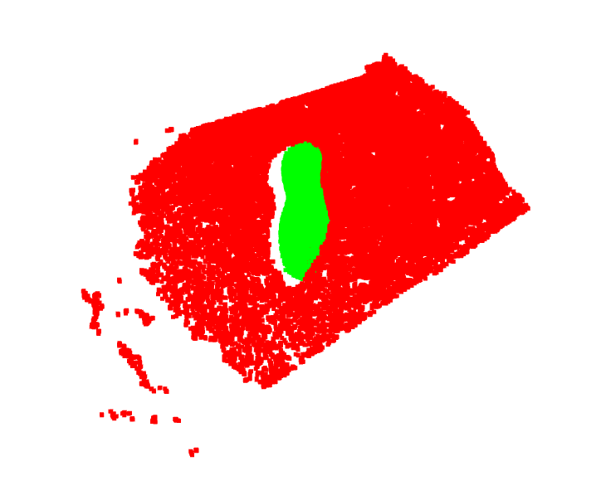

**[ 0.93916095 -0.31956586 -0.12591414 0.09404923]**

**[ 0.33937626 0.9198272 0.19682905 -0.11031249]**

**[ 0.05291941 -0.22758642 0.97231885 0.12207112]**

**[ 0. 0. 0. 1. ]**

**70**





**[ 0.93971001 -0.32446313 -0.10802209 0.10156583]**

**[ 0.33448774 0.80635628 0.48775763 -0.2507099 ]**

**[-0.07115507 -0.49448279 0.86627 0.2249072 ]**

**[ 0. 0. 0. 1. ]**

**111**

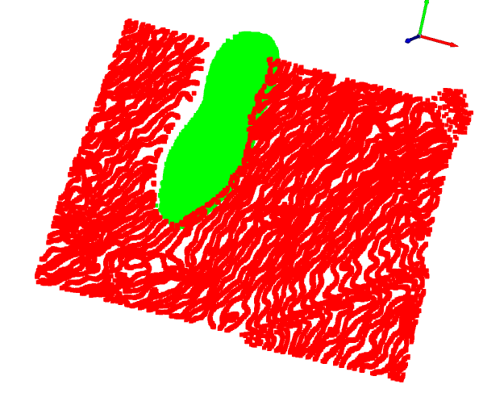

**[ 0.98338206 -0.15419904 0.09582478 0.00895512]**

**[ 0.05424142 0.75325822 0.6554845 -0.40382032]**

**[-0.17325588 -0.63939402 0.74910459 0.42487277]**

**[ 0. 0. 0. 1. ]**

**142**



**[ 0.89893792 0.1657326 0.40551613 -0.21230335]**

**[-0.43122478 0.49783885 0.75246373 -0.40137155]**

**[-0.07717391 -0.85128678 0.51899422 0.58666309]**

**[ 0. 0. 0. 1. ]**

**181**



**[ 0.82779184 0.13819564 0.54374869 -0.29230122]**

**[-0.47864325 0.67956258 0.55596343 -0.20982524]**

**[-0.29267954 -0.72048363 0.62868277 0.46099355]**

**[ 0. 0. 0. 1. ]**

**226**

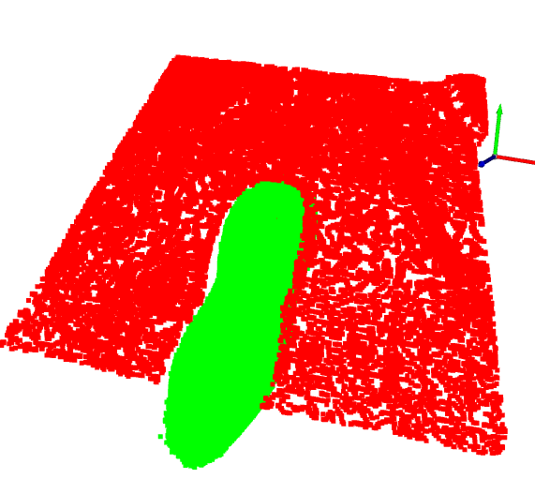

**[ 0.96952356 -0.01797378 0.24433788 -0.13971584]**

**[-0.02621789 0.98396695 0.17641335 0.00913878]**

**[-0.24359122 -0.17744292 0.95350791 0.2917337 ]**

**[ 0. 0. 0. 1. ]**

**274**



**[ 0.85758086 0.46325209 -0.22350072 0.10533544]**

**[-0.47504591 0.87996029 0.00113273 -0.02700827]**

**[ 0.19719649 0.10520169 0.97470311 0.32851216]**

**[ 0. 0. 0. 1. ]**

**366**



**[-0.95792368 -0.25948572 -0.12267591 0.00631396]**

**[ 0.23168401 -0.95133942 0.20316454 -0.0635815 ]**

**[-0.16942473 0.16619407 0.97142925 0.3876442 ]**

**[ 0. 0. 0. 1. ]**

**454**

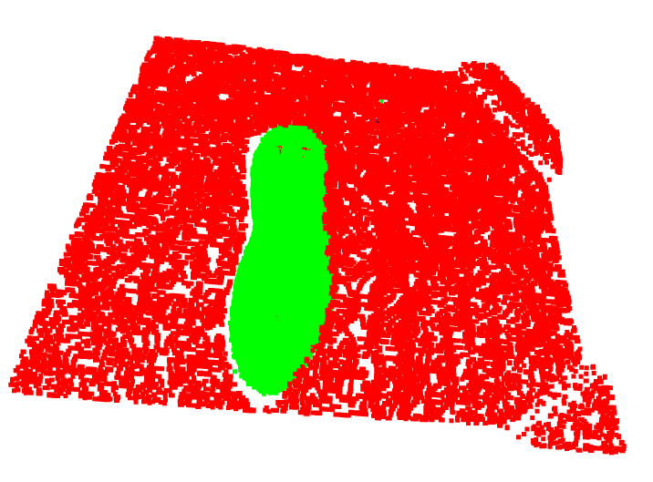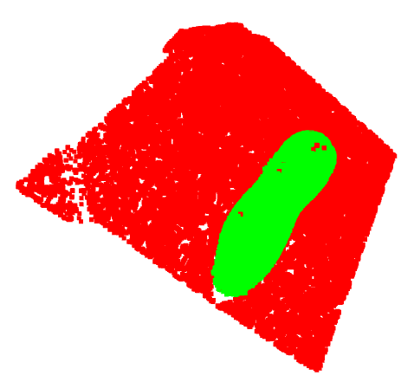

**[ 9.87576215e-01 -2.23309035e-04 1.57140602e-01 -7.44061592e-02]**

**[-5.16624283e-02 9.43949310e-01 3.26022537e-01 -1.40930060e-01]**

**[-1.48405567e-01 -3.30090368e-01 9.32210350e-01 2.51345474e-01]**

**[ 0.00000000e+00 0.00000000e+00 0.00000000e+00 1.00000000e+00]**