# Contents:

1. Background
2. System Architecture
3. Schedule
4. Thermal Controller
5. Power Consumption
6. Liquid Nitrogen Consumption
7. Pressure Relief Valve Design
8. Improved Door Design
9. Checks & Maintenance

# Background

Hashtag is collaborating with government agencies eg. Singapore Food Agency to store frozen foodstuff in thermal storage boxes cooled solely by evaporation of liquid nitrogen. Foodstuff is required to be stored in such storage boxes mounted on standard storage racks for a long periods eg. at least 10 months.

HashTag has commissioned SIT to develop:

1. Closed loop Temperature control system based on release of liquid N2
2. Improved door design for insulated box
3. Pressure relief valve

# System Architecture

Insulated pipe

Cryogenic Control valve

Expansion Value

PressureRelief valve

Temp Sensor

Frozen Pallet

**Insulated Box**

Liquid Nitrogen Tank

Thermal Controller

# Schedule



# Thermal Controller

The Thermal Controller uses an 8-bit microcontroller, a Max485 module to interface to the Temperature Sensor, and a Relay Module to control the Cryogenic Control Valve.

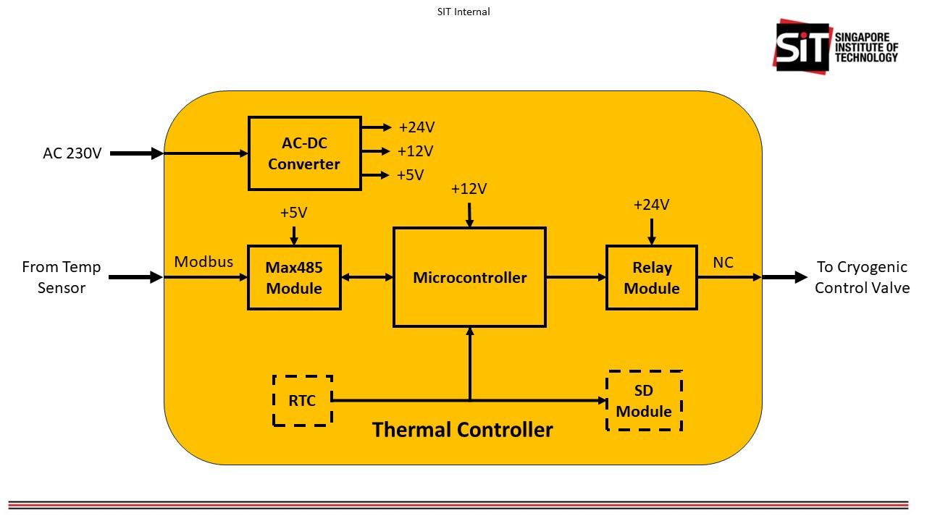

# Power Consumption

Most of the power consumption will be from the cryogenic valve, when it is turned on, allowing liquid nitrogen to flow out. The valve does not consume power when it

Power supply of valve = 24 V

Current to turn value on = 5 A

Power consumption of valve = 24 x 5 = 120 W

Assuming a duty cycle of 50% during the initial cool down period of 2 min.

Energy consumed during initial cool down period = 120 x 0.5 x 2/60 = **2 Wh**

Average power during 2 min initial cool down = **60W**

Assuming that the value turns on 20% of the time during the day to keep the box less than -20 deg cel.

Energy consumed in 1 day = 120 x 0.2 x 24 = **576 Wh**

Average power consumption of temp controller box electronics = **3W**

Hence, average power consumption of one box with one temp controller and one valve = **27 W**

# Liquid Nitrogen Consumption

**Dimensions of box:**

**Box calculations:**

Thickness of box walls: **0.05 m** (L)

Pallet size: 1.5 x 1.2 x 1.1m

Box Top & bottom: 1150 x 2600 = 2.99m2

Box Sides: 1150 x 1700 = 1.955 m2

Box Front & back: 2600 x 1700 = 4.42 m2

Total box internal surface area = (2.99+1.955+4.42) x 2 = **18.73 m2**

**Heat Exchange Calculations:**

Latent heat of vaporization of liquid nitrogen: **1.992 × 105 J/kg**

Specific Heat Capacity of Gaseous Nitrogen: **1040 J/kg.K**

Thermal conductivity of extruded polystyrene: **0.025W/m∙K (k)**

**Assuming ambient temp = 25°C (T2)**

**Temp inside box = -20****°C (T1)**

Rate of heat flow **Q = -k*(T1-T2)/L**

= -0.025*(-20-25)/0.05

= 22.5W/m2

Box Heat Flow Wattage = 22.5 * 18.73 = **421W**

Heat to vaporize 1kg of liquid N2 and bring gas temp up from -196**°C** to -20**°C (176°C difference)** = 199,200 + (1040*176) = **382,240J**

Time to use up 1kg liquid N2 = 382,240/421 = 907sec = **15min** (0.25hr)

Amount of liquid N2 use per day = (24/0.25) **= 96L**

**Notes:**

1. This calculation assumes the box is “flattened” for ease of calculation, it does not take into considerations the “corner” effects of the box, which would likely increase the heat flow into the box.
2. This calculations also does not take into consideration the metal support bar that cuts through the insulated box thereby also increasing the heat flow in, requiring more liquid N2.
3. The door opening is also not considered in this calculation. The door seals will probably not be as good as the ideal situation where the polystyrene is glued together. This will be another additional source of heat gain.

**Recommendations:**

1. Increase the box wall thickness to at least 10cm, that will half the liquid N2 consumption.
2. Reduce the external ambient temperature in the warehouse by trapping the cool gaseous N2 coming out of the cold boxes. Cutting the temp differential by 10**°C** (reducing ambient temp from 25**°C** to 15**°C**) will reduce liquid nitrogen consumption by 22%. However, this creates a dangerous environment in the warehouse whereby ambient oxygen in the warehouse space will be displaced and there will be little or no oxygen in the warehouse.
3. Abut boxes together to reduce the number of surfaces of that can gain heat.

# Pressure Relief Valve Design

The pressure relief valve is design to be insulated such that there is minimal heat gain through the valve. The weight attached the end of venting flap will determine the pressure threshold for venting.

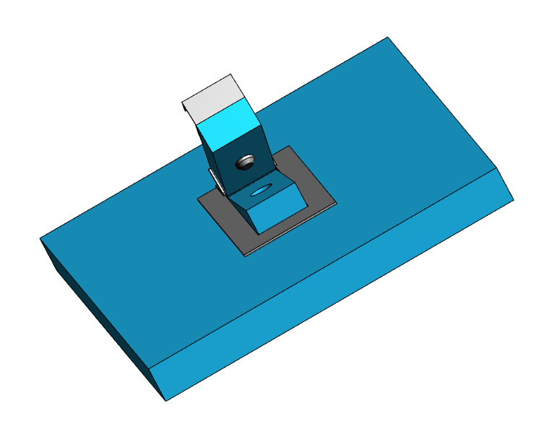

Soft black insulation foam

# Improved Door Design

The improved door design is made light as possible to minimise the strain of workers lifting it and covering on the insulated box



