**Proposal to school of Engineering GMIT**

**Final year Honours degree project**

**B.Eng (Hons) Computing and Electronics**

**Autonomous RC car**

**Padraig Hughes Monteiro**

**G00295142**

**October 2016**

* Table of contents

Table of Contents

Introduction 3

Objectives 3

Scope 3

Project description 3

Project Plans 3

Costs Discussion 4

Conclusions 4

References 5

# Introduction

* + As autonomous cars and driver safety aids are becoming more in demand in recent years from consumers around the world and government agency’s alike. Car manufactures ae looking towards other companies to build and design these systems. One such company is Valeo Vision Systems in Tuam, who design these systems using only computer vision. As I had worked with them during my work placement module for 4th year I got to learn a lot about the industry and how such algorithms are developed and implemented. I would like to develop some similar algorithms for my final year project to further my knowledge on computer vision, python and open CV.s

# Objectives

* + To develop an algorithm that can automatically control a RC using computer vision
  + Further my knowledge on Python programming with Open CV and raspberry Pi interfacing

# Scope

This project covers…

# Project description

* Get a remote controlled car to interface and operate with a Raspberry Pi.
* Develop algorithm to detect various road signs and traffic lights. And stop the car when necessary
* Develop lane tracking so car can follow a predefined lane without user input and will stop when necessary

# Project Plans

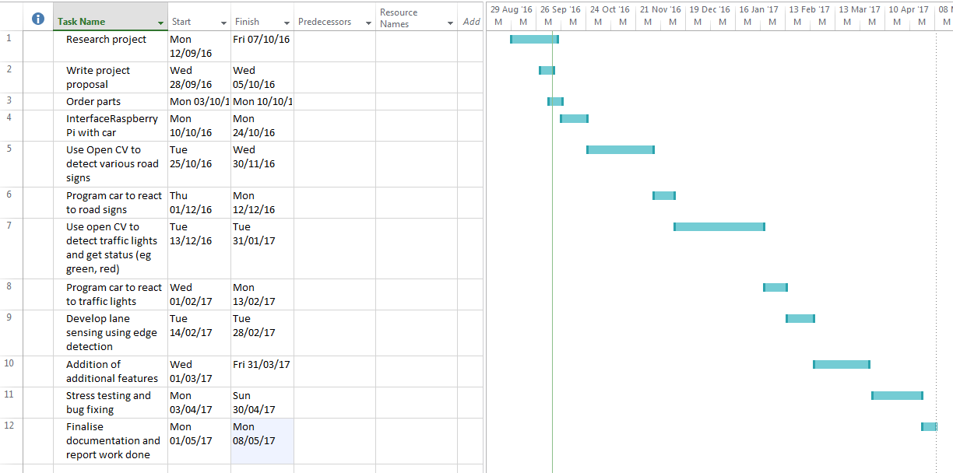

Figure Gantt Chart for project

This is a partial example of a Gantt chart which represents a project plan visually.

## Intellectual Property discussion

There are many patents relating to this. A search on PatBase.com showed 712 relevant patents, however as this is a college project to help me learn about computer vision, I think I will be ok.

## Costs

* Raspberry PI 31.90 Euro
* Raspberry Pi Camera module V2 23.09 Euro
* RC Car 30.00 Euro

# Conclusions

In conclusion I choose this project as it will help me develop my knowledge of Open Cv and computer vision which will help me develop a career after college in this growing field

# References

* <http://ie.rs-online.com>
* <http://opencv.org/>
* <https://www.raspberrypi.org/blog/self-driving-car/>
* <https://www.youtube.com/watch?v=QKJx1_3F2eA>