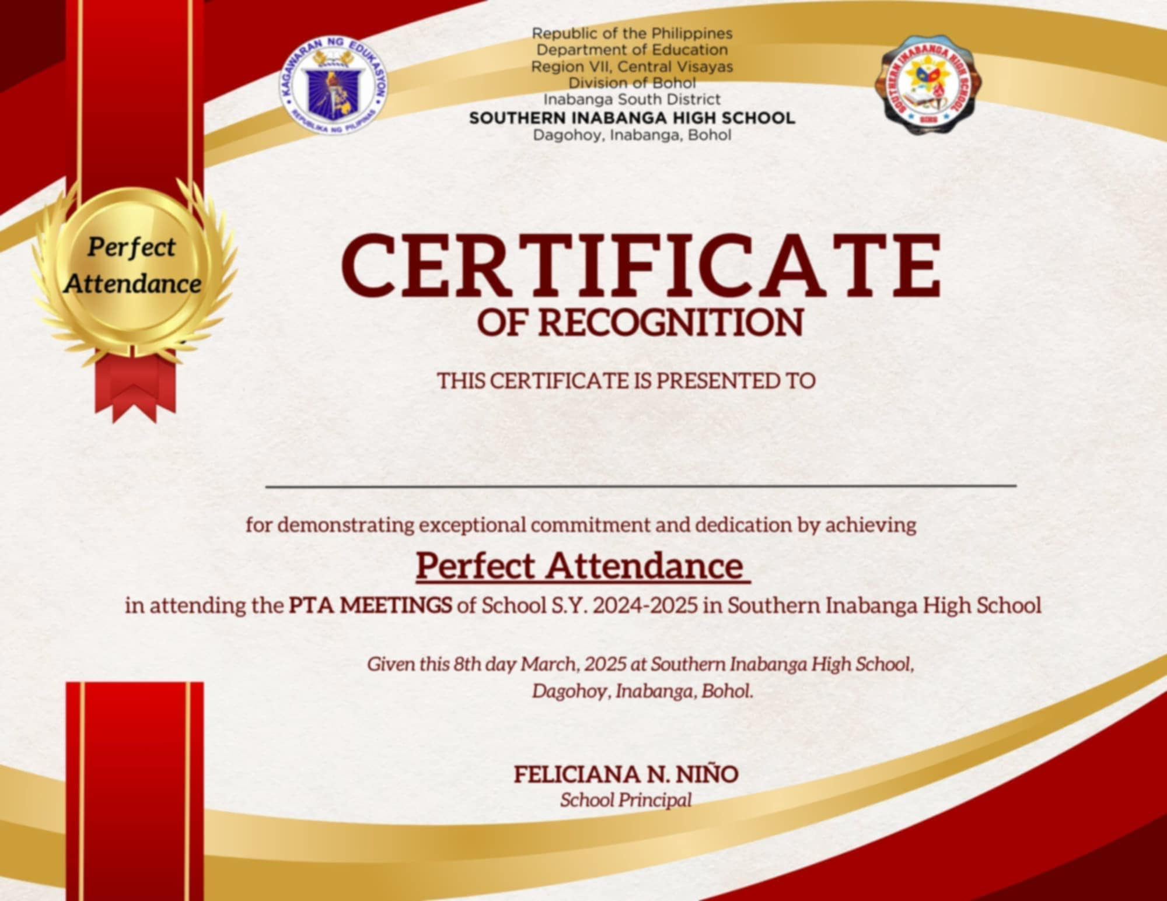

**MRS. FLORENTINA LAPEÑA**

*SSC G-8 Adviser*

**MARICRIS A. GUDITO**