1**. Conjunction** tells us, “Both… are the case.” Conjunctions are only true when both conjuncts are true and only false when both conjuncts are false.

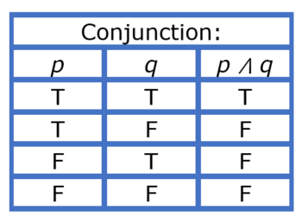

2. **Disjunction** tells us that, “At least one is the case… ” Disjunctions are only false when both disjuncts are false.

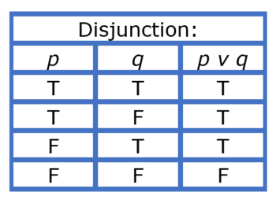

3. **Negation** tells us, “It is not the case that..”

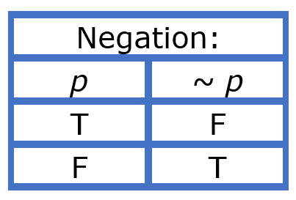

4. Exclusive p or q.

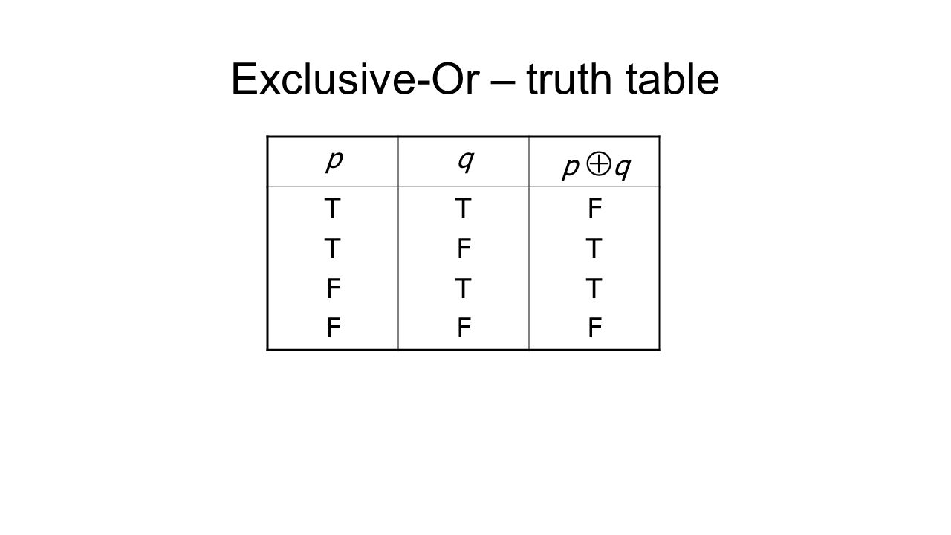

5. A **conditional statement** tells us that if the antecedent is true, the consequent cannot be false. Thus, a conditional statement is only false when a true antecedent implies a false consequent.

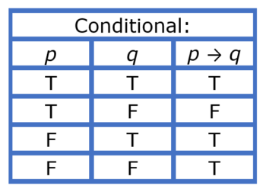

6. NAND- P nand q. NOR – P nor q.

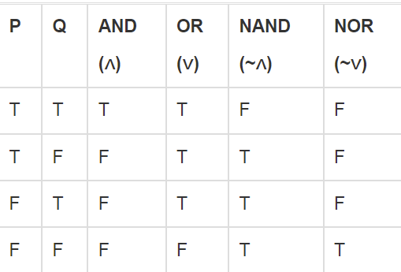

7. The **biconditional** tells us that, “Either both are the case, or neither is… ” Thus, a biconditional statement is true when both statements are true, or both are false.

