# Updated Online File Distribution

### Activity Starter

The MIT App Inventor Platform (AI2) has been updated. This has lead to the occurrence of a bug when downloading a file from the cloud and using the share component to save the file elsewhere.

We are now advising that you use the activity starter to gain access to a file that resides on the cloud.

The activity starter is a component, which sends commands to the Android operating system kernal, informing it what to do. With proper configuration, the activity starter can be used to start any activity/application installed on the phone.

Using the activity starter to view an online document is simple:

First, we setup the required configuration for the activity we want to launch. In this case, the action is set to “android.intent.action.VIEW” and the DataUri should contain the shareable link to the file you wish to view.

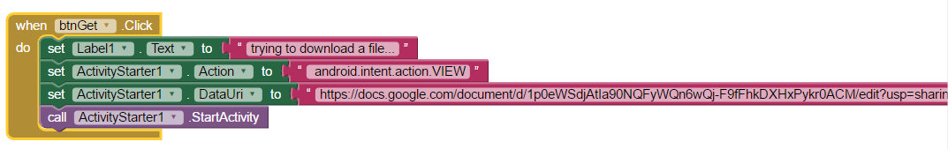

Once configured, you can make a call to start the activity. This will launch the program required to view the document, so that users can save it to their phone.

Note: This method has a dependency. When using this method to access online files, the phone will need to have a required viewing application installed. For example, a pdf reader will need to be installed on the phone, if a pdf file is being accessed.