**Extraction of GRIB2 data for auto-population of forecast fields in the Shipping Bulletin, and enhancement to user interface for generation of product**

Overview

* Start with converting the grib2 files (Atmospheric model and Ocean Wave model) from the MSS server(192.168.4.85) root/nas44/ecmwf/
* Filenames are in format: eg. N1D12010000120100001
* Converting to NetCDF file can be done using the command ‘ncl_convert2nc’ in linux on the server
* The downloading and converting of files could be automated in the future, maybe twice daily, just before the forecaster does the forecast
* After the files are ready in NetCDF format, the python script can read in the input files for both the atmospheric wave and ocean models
* The python script outputs a XML file containing the generated forecast
* The html then uses the XML file to display a generated forecast in the textbox in the browser
* Forecasters can use the drop-down boxes or edit in the textbox
* Upon submission, the HTML makes an archive of the forecast in XML format and sends the HTML form to the server

Details

* Filenames: eg. N1D12010000120100001/ N1P12010000120100001, the N1D stands for the atmospheric model and the N1P represents data for the Ocean wave model. The numbers are in the format MMDDTTTTMMDDTTTT1. The second half of the numbers represent the time it is forecasted for, could be for 3 hours later, or 6 hours later, etc, while the first half represents the time when it is forecasted.
* Filename of python script: <directory>/GenerationofForecast.py
* Filename of XML script generated by python script: <directory>/FORECAST.xml
* Filename of HTML file: <directory>/marineforecast.html

Logic for the criteria

* Wind Direction
* Convert the u & v winds to the respective direction for each grid in the region and, by looking at the percentages across time, take the two most frequent directions that is in the threshold. So basically, each grid in the region is assigned a direction, according to it’s u & v winds, and we will look at the region across the 8 time periods to determine which two wind directions have the most occurences.
* Wind Speed
* Do a vectorial average of all the u & v winds to get the wind speeds. The average is taken to be the lower range value while the maximum value of the wind speed will be taken to be the upper range value in the forecast.
* Sea State
* Look at the maximum significant wave height and the proportions of the height of waves to determine sea state. Look at the example provided below by the sea swell.
* Sea Swell
* Look at the maximum swell height and the proportions of the height of swells to determine sea swell. Eg, If the maximum sea swell falls into the high category, and more than half of the swells are in the moderate category, we would forecast the sea swell to be ‘moderate to high’. If more than half of the swells are also in the high category, the swell would just be forecasted as ‘high’.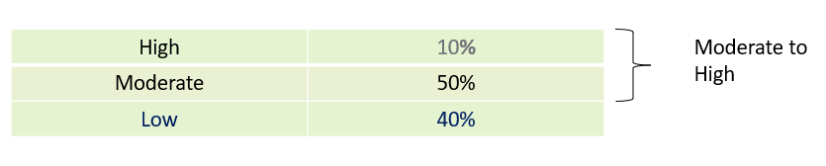

Things to work and improve on

* Automation of conversion of grib2 files
* Automation of the python script to generate the forecast twice daily before the forecaster does their forecast
* Criteria and classification, improve on the simple criteria set in the python script
* Archiving of the actual forecast in the HTML
* Submitting of the HTML form to the server