오픈소스기초설계(나) Lab2 결과보고서

20213057 강세륜

Lab 2- 0

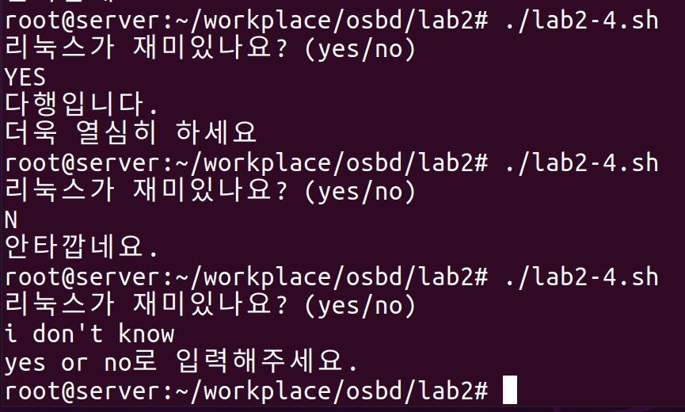

Lab 2-

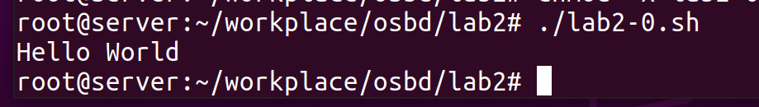

Lab 2-

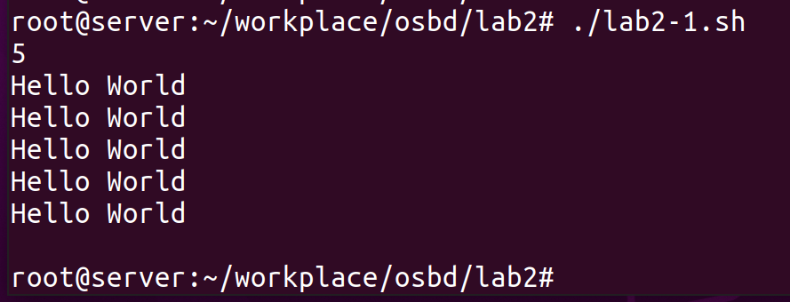

Lab 2-

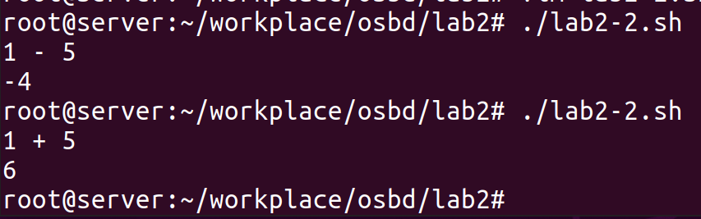

Lab 2-

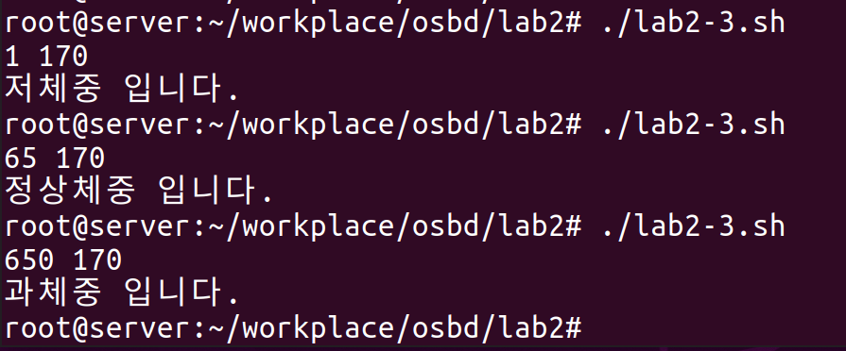

Lab 2-

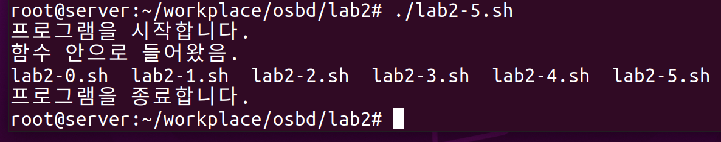

Lab 2-

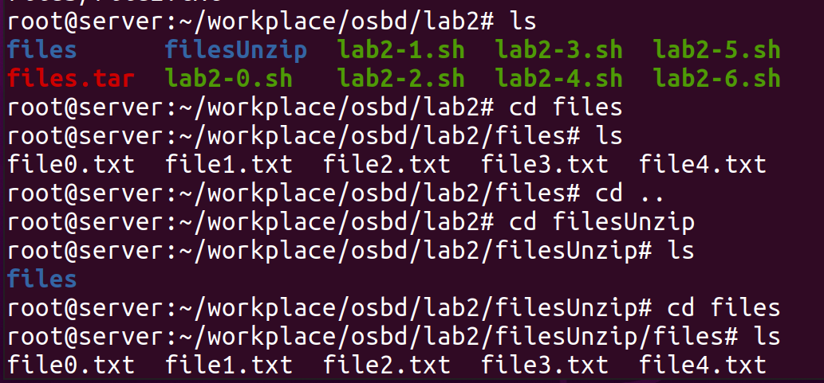

Lab 2-

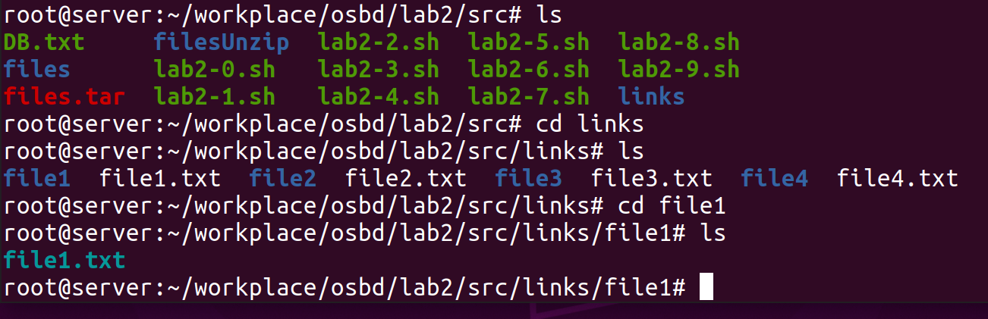

Lab 2-

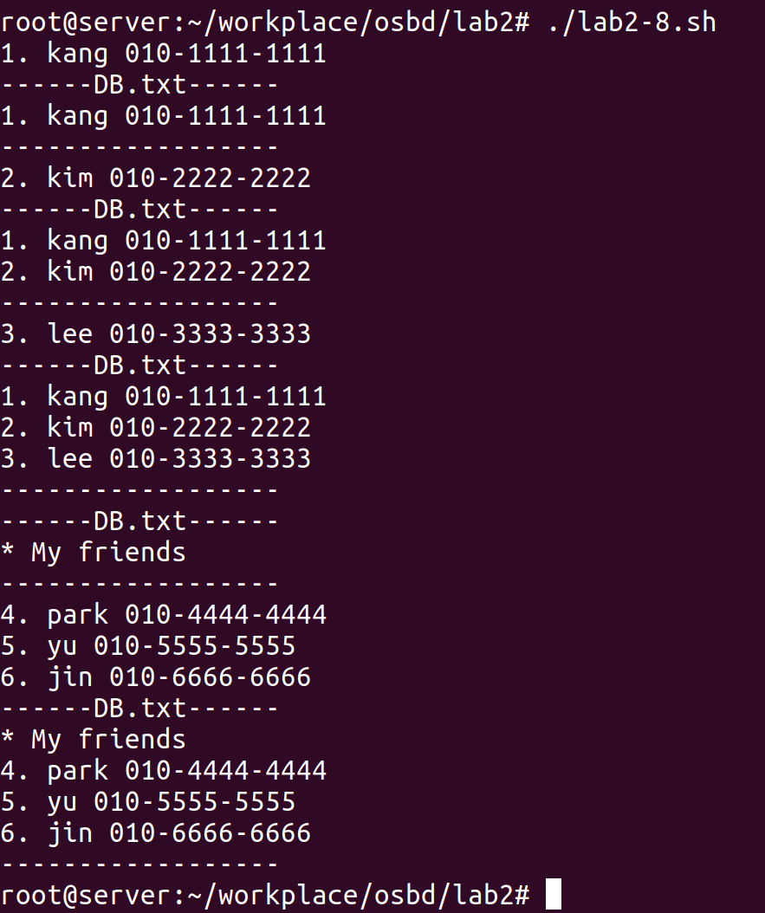

Lab 2-

