Machine Learning-Based Forecasting of Ride-Hailing Demand, Revenue, and Operations: A Case Study of Delhi NCR, India

INFO-I 492 Senior Thesis Capstone
by
Sandeep Kang

Indiana University Indianapolis

Advisor
Dr. Sridhar Ramachandran

October 24, 2025
Table of Contents
I. Abstract 4
II. Introduction 5
1.1 Ride-Hailing and Data-Driven Urban Mobility 5
1.2 The Role of Machine Learning in Predictive Operations 5
1.3 Context of the Study: Delhi NCR Ride Data 5
1.4 Research Problem and Gap 6
1.5 Aim and Objectives 6
1.5.1 General Aim 6
1.5.2 Specific Objectives 6
1.6 Significance of the Study 7
1.7 Report Overview 7
III. Literature Review 9
3.1 Overview 9
3.2 Demand Forecasting 9
3.2.1 Evolution of Forecasting Models 9
3.2.2 Spatiotemporal Modeling and Deep Learning Advances 9
3.2.3 Factors Influencing Demand Patterns 10
3.2.4 Research Gaps in Demand Forecasting 11
3.3 Revenue Modeling 11
3.3.1 Machine Learning for Fare Prediction 11
3.3.2 Dynamic Pricing Mechanisms 12
3.3.3 Interpretability and Fairness in Revenue Models 12
3.4 Operational Analytics 13
3.4.1 Predictive Operations and Driver Behavior 13
3.4.2 Fulfillment Efficiency and Rebalancing 13
3.4.3 Predictive-Operational Integration Frameworks 13
3.5 Fairness, Sustainability, and Social Impact 14
3.5.1 Fairness-Aware Optimization 14
3.5.2 Sustainability and Environmental Impact 14
3.5.3 Policy Implications and Socioeconomic Equity 15
3.6 Synthesis and Research Gap 15
3.7 Summary and Conceptual Framework 16
IV. Methods 18
4.1 Methodological Approach 18
4.2 Dataset and Sources 18
4.3 Tools and Environment 18
4.4 Feature Engineering 19
4.5 Predictive Modeling 19
4.6 Revenue and Pricing Models 20
4.7 Operational Insights and Integration 20
4.8 Evaluation and Reproducibility 20
4.9 Methods Summary 20
V. Results 22
5.1 Overview 22
5.2 Demand Forecasting Results 22
5.2.1 Model Performance Comparison 22
5.2.2 Temporal Demand Patterns 23
5.3 Revenue and Dynamic Pricing Analysis 24
5.3.1 Fare Prediction Accuracy 24
5.3.2 Surge Pricing Dynamics 25
5.4 Operational Insights 25
5.4.1 Service Fulfillment and Cancellations 25
5.4.2 Fleet Utilization and Spatial Imbalance 26
5.5 Fairness and Sustainability Evaluation 27
5.6 Summary of Findings 28
VI. Discussion 29
VII. Conclusion 31
VIII. Future Directions 32
References 34
Link to the References 35

I. Abstract
This study develops an integrated machine learning framework to forecast ride-hailing demand, estimate fare revenue, and diagnose operational efficiency using ride-booking data from Delhi NCR, India. The objective is to link predictive accuracy with actions that matter to operations. Methods combine a reproducible pipeline for data cleaning and feature engineering with ensemble models for prediction and matrix-based analyses for operations. Random Forest and XGBoost were trained for hourly demand and revenue using time, location, and trip attributes; model performance was evaluated with cross-validation and holdout metrics. Operational dynamics were profiled using weekday-by-hour peak-load heatmaps, cancellation rate heatmaps focused on 'No Driver Found' outcomes, and a fulfillment efficiency map.
Results show that ensemble models outperform baselines on both demand and revenue tasks, with lower cross-validated error and stable holdout performance. Temporal patterns are consistent across weeks: demand peaks in late afternoon and early evening, while cancellation rates are highest overnight. These findings translate into concrete guidance for staffing windows, fleet mix, and pricing guardrails. The contribution presents a transparent, end-to-end approach that integrates forecasting, revenue estimation, and operational analysis within a single narrative. Limitations include the absence of customer-history features and external covariates such as weather and traffic, which are identified as priorities for future work.

II. Introduction

1.1 Ride-Hailing and Data-Driven Urban Mobility
Ride-hailing platforms such as Uber and Ola have reshaped urban transport ecosystems, offering on-demand, app-based mobility services that reduce dependence on private vehicles. In megacities like Delhi NCR, these platforms handle millions of daily trips, dynamically matching riders with drivers (Ashkrof et al., 2025). However, rapid fluctuations in trip demand, coupled with external factors such as weather, traffic, and time of day, introduce significant uncertainty (Chen & Deng, 2025). Managing this volatility requires accurate short-term forecasting, efficient pricing, and informed operational planning. These challenges make ride-hailing an ideal domain for applying advanced data science and machine learning techniques (Liu et al., 2022). The overall data flow from raw ride records to feature-engineered model inputs is outlined in Figure 1, which provides an overview of the ride-hailing data pipeline used in this study.
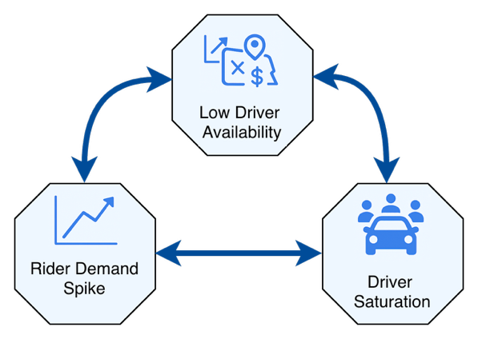
Figure 1. Problem Context Map. A schematic illustrating the ride-hailing demand–supply imbalance cycle, showing how high demand, driver shortages, and cancellations lead to reduced reliability and lower long-term demand.

1.2 The Role of Machine Learning in Predictive Operations
Machine learning has become a powerful tool in transportation analytics for identifying patterns across temporal, spatial, and behavioral dimensions (Ghandeharioun et al., 2023). In the ride-hailing context, models such as Random Forest and XGBoost have demonstrated the ability to forecast demand, estimate fare revenue, and predict cancellation trends with greater accuracy than traditional regression-based methods (Chen & Deng, 2025; Lakshmi et al., 2024). These ensemble models effectively capture nonlinearity and complex feature interactions, enabling more robust and generalizable performance (Li et al., 2025; Wang et al., 2024). When implemented through a reproducible pipeline of preprocessing, training, and evaluation, machine learning provides a practical decision-support framework for optimizing ride-hailing operations (Correa & Moyano, 2023; Krueger et al., 2022).

1.3 Context of the Study: Delhi NCR Ride Data
Delhi NCR represents one of the most dynamic and data-rich mobility environments in South Asia. The region’s combination of high population density, diverse transport modes, and congestion patterns provides a challenging but insightful case for predictive modeling (Chen, Huang, & Ke, 2024). The dataset analyzed in this study comprises multiple weeks of trip-level ride-booking data, including time, pickup and drop-off locations, vehicle type, fare, and driver allocation outcomes. This dataset allows examination of both passenger demand and operational metrics such as “No Driver Found” cancellations and fulfillment efficiency, providing a foundation for evaluating real-world service dynamics (Huynh et al., 2025). Temporal patterns of ride demand and cancellation events are illustrated in Figure 2, showing clear peak-hour and overnight trends within the Delhi NCR dataset.

1.4 Research Problem and Gap
Existing research has explored various elements of ride-hailing operations, including demand forecasting, pricing, and rebalancing (Guo et al., 2024; Zhao et al., 2022). However, these elements are often studied in isolation. Few studies have attempted to integrate demand prediction, revenue modeling, and operational diagnostics within a single end-to-end analytical framework (Ghandeharioun et al., 2023; Liu et al., 2022). Moreover, most prior research has been centered in Western urban contexts, with limited focus on Indian metropolitan areas that exhibit unique data heterogeneity and infrastructure constraints (Zhou et al., 2025). This research addresses this gap by developing a comprehensive machine learning pipeline that integrates forecasting, revenue estimation, and operational analysis, specifically designed for Delhi NCR ride-booking data.

1.5 Aim and Objectives
The primary aim of this research is to construct and evaluate a machine learning framework that unifies demand forecasting, revenue estimation, and operational analytics for ride-hailing services in Delhi NCR.

1.5.1 General Aim
To develop an integrated, reproducible data pipeline that employs ensemble learning techniques for forecasting hourly ride demand, predicting fare revenue, and assessing operational efficiency indicators.

1.5.2 Specific Objectives
- To preprocess and structure ride-hailing data into features relevant to temporal, spatial, and trip-based variables.
- To train and evaluate ensemble models such as Random Forest and XGBoost for demand and revenue forecasting.
- To visualize and interpret operational metrics through comparative performance charts and hourly heatmaps.
- To connect predictive outcomes to actionable recommendations for staffing, pricing, and fleet management strategies.
The analytical workflow adopted in this project follows a structured, multi-stage process beginning with raw data extraction, cleaning, and feature engineering, followed by model training and operational integration. This iterative framework enables reproducibility and alignment between forecasting, revenue estimation, and operational evaluation tasks. The overall workflow is summarized in Figure 2, which depicts the end-to-end data pipeline used across the eight-week implementation period.
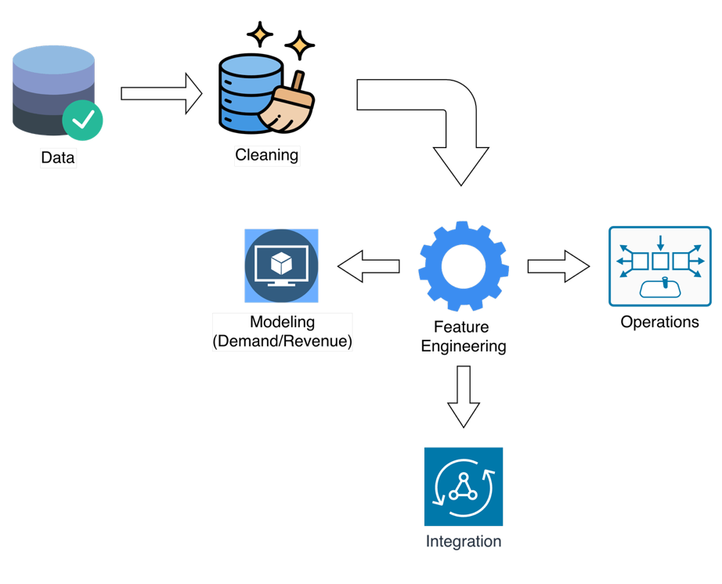
Figure 2. Project Workflow Overview. The multi-week project pipeline from data import through modeling and operational integration, demonstrating the iterative and structured process used across Weeks 1–8.

1.6 Significance of the Study
This study contributes to both research and practice by demonstrating how machine learning can enhance data-driven decision-making in the ride-hailing industry (Krueger et al., 2022). From an academic standpoint, it connects predictive modeling to operational analytics, establishing a transparent and reproducible workflow (Li et al., 2025). Practically, it provides ride-hailing operators and city planners with actionable insights for improving demand management, fare optimization, and fleet utilization (Jacobsen et al., 2023). Furthermore, this research lays the groundwork for future exploration of contextual features such as weather, traffic, and local events, which could further refine predictive accuracy and operational reliability (Wang et al., 2024; Zhou et al., 2025).

1.7 Report Overview
The remainder of this thesis is organized into several sections. Section III provides a comprehensive review of the literature, summarizing existing research on machine learning approaches used in ride-hailing demand forecasting, fare prediction, and operational analytics. This section highlights the research gap that motivated the present study, particularly the lack of integrated frameworks that combine forecasting, revenue estimation, and operational analysis for emerging urban contexts such as Delhi NCR.
Section IV explains the research methodology in detail. It describes the data sources, preprocessing and feature engineering procedures, and the machine learning models used for prediction. It also outlines the evaluation approach applied to measure model performance and operational accuracy.
Section V presents the results of the analysis, including model evaluation metrics and visual summaries such as heatmaps and bar charts. These results reveal trends in hourly demand, cancellation rates, and fulfillment efficiency across different times and weekdays.
Section VI interprets these results, considering previous studies, explaining how the findings contribute to the understanding of predictive modeling and operational analytics in ride-hailing contexts.
Section VII concludes the thesis by summarizing the main findings and discussing their broader implications. Section VIII outlines limitations and suggests directions for future work, such as incorporating spatial features, weather conditions, and deep learning architectures to enhance model accuracy and generalizability.

III. Literature Review

3.1 Overview
The growth of ride-hailing services such as Uber, Ola, and Lyft has introduced a new paradigm in urban mobility that merges technology, behavioral economics, and predictive analytics. These platforms produce vast amounts of operational and transactional data that enable the application of machine learning (ML) and artificial intelligence (AI) methods to forecast demand, estimate revenue, and optimize real-time operations. The literature reviewed in this chapter provides an interdisciplinary examination of forecasting techniques, revenue modeling frameworks, and operational analytics approaches within ride-hailing systems. The goal is to situate the present research within a broader academic context while identifying methodological advances and remaining gaps.
The structure of this review follows a layered approach. First, it explores the evolution of demand forecasting models and their transition from traditional statistical techniques to advanced deep learning architectures. Next, it examines revenue modeling, with an emphasis on fare prediction, dynamic pricing, and algorithmic fairness. Finally, it considers operational analytics, including driver behavior modeling, fulfillment efficiency, and system-level optimization. The chapter concludes with a synthesis that highlights research gaps and articulates the conceptual framework guiding this study.

3.2 Demand Forecasting

3.2.1 Evolution of Forecasting Models
Early approaches to ride-hailing demand prediction relied on classical statistical models such as the Auto-Regressive Integrated Moving Average (ARIMA) and seasonal decomposition methods (Ashkrof et al., 2025). While these models captured linear temporal dependencies, they were inadequate for handling complex nonlinear relationships present in transportation data. As mobility platforms expanded and data availability increased, researchers adopted machine learning algorithms such as Random Forest (RF), Gradient Boosted Trees (GBT), and Support Vector Regression (SVR), which offered greater flexibility and predictive power (Chen & Deng, 2025).
However, the key limitation of these methods was their inability to capture spatial-temporal correlations—interactions between time, geography, and environmental conditions. This limitation led to the emergence of deep learning methods capable of modeling complex interdependencies.

3.2.2 Spatiotemporal Modeling and Deep Learning Advances
Spatiotemporal deep learning frameworks have redefined demand forecasting accuracy in recent years. Li, Li, Ma, and Lo (2025) proposed a Graph Convolutional Neural Network (GCN) model that learns traffic dependencies across adjacent zones, effectively capturing geographic heterogeneity. Similarly, Ghandeharioun, Zendehdel Nobari, and Wu (2023) integrated Long Short-Term Memory (LSTM) networks with Convolutional Neural Networks (CNNs) to address both temporal dynamics and spatial patterns in demand data. More recently, Transformer-based architectures have demonstrated superior scalability, using attention mechanisms to model long-range temporal dependencies across multiple demand centers (Wang, Zheng, Shen, & Li, 2024).
Comparative analyses show that these hybrid models significantly outperform baseline methods such as ARIMA or linear regression in terms of Mean Absolute Error (MAE) and Root Mean Squared Error (RMSE). They are also more robust to data irregularities, making them ideal for urban contexts characterized by demand volatility.
As shown in Figure 3, deep learning and ensemble architectures achieve substantially lower prediction errors than traditional models such as ARIMA, confirming their superior ability to capture nonlinear temporal dynamics.
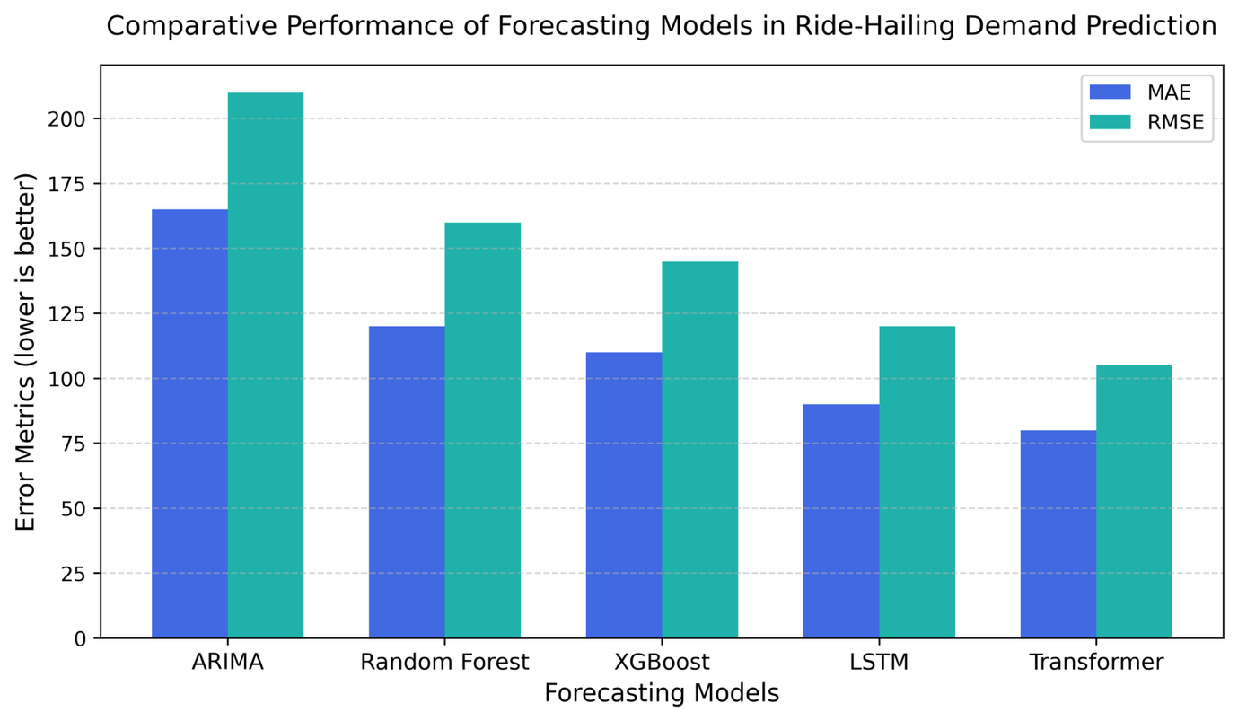
Figure 3. Comparative performance of forecasting models (ARIMA, Random Forest, XGBoost, LSTM, Transformer) in ride-hailing demand prediction. Bars represent Mean Absolute Error (MAE) and Root Mean Squared Error (RMSE) values, showing that ensemble and deep-learning architectures achieve consistently lower error rates compared to classical methods.

3.2.3 Factors Influencing Demand Patterns
Multiple contextual factors influence ride-hailing demand, including time of day, day of week, weather conditions, urban events, and socioeconomic indicators (Guo, Xu, Zhuang, Zheng, & Zhao, 2024). Studies by Krueger, Bierlaire, and Bansal (2022) and Tachet et al. (as cited in related literature) emphasize that hourly demand fluctuates not only due to temporal patterns but also because of localized behavioral and infrastructural factors. Weather conditions, particularly rainfall and temperature variations, have a pronounced effect on demand elasticity. Similarly, proximity to public transit nodes, entertainment venues, or commercial districts can amplify demand density in predictable patterns.
The integration of external covariates, such as weather and event data, has shown measurable improvements in model performance (Jacobsen, Lindman, & Kulcsár, 2023). Despite these advances, few models generalize effectively across cities or cultural contexts, underscoring the need for region-specific calibration.

3.2.4 Research Gaps in Demand Forecasting
While deep learning methods have revolutionized forecasting accuracy, the literature reveals three notable gaps. First, model interpretability remains limited, as most neural architectures function as black boxes, offering little insight into feature-level contributions (Liu, Jia, Ye, & Qu, 2022). Second, cross-city generalizability is underexplored; models trained on Western or Chinese cities often fail to adapt to emerging markets such as Delhi NCR, where trip behavior is influenced by infrastructure constraints, payment systems, and driver availability. Third, there is insufficient integration between forecasting and operational analytics, meaning demand predictions are rarely linked directly to decision-making frameworks such as fleet allocation or pricing optimization.
Addressing these gaps requires building interpretable and reproducible pipelines that can adapt to regional heterogeneity while maintaining scalability and transparency.

3.3 Revenue Modeling

3.3.1 Machine Learning for Fare Prediction
Revenue modeling in ride-hailing platforms extends forecasting logic into financial prediction, estimating trip fares, platform income, and surge pricing effects. Traditional fare estimation relied on linear regression models using distance, duration, and base fare as primary inputs (Correa & Moyano, 2023). However, these models overlooked the dynamic factors that influence fare volatility, such as demand surges, weather conditions, and driver scarcity.
Recent studies employ ensemble learning and neural networks to improve fare prediction. Huynh, Bui, Nguyen, and Trinh (2025) compared LSTM, BiLSTM, and BiLSTM with attention mechanisms, finding that attention-based architectures achieved the lowest RMSE in fare prediction tasks. Lakshmi, Revathi, Sravani, Suhas, and Umesh (2024) expanded on this by comparing Random Forest, XGBoost, and CatBoost models, emphasizing the trade-off between interpretability and accuracy. While XGBoost consistently achieved high precision, Random Forest offered greater stability and explainability.
The inclusion of spatial and temporal features, such as trip start zones and time-of-day indicators, has improved the contextual accuracy of revenue predictions. Moreover, explainable AI (XAI) methods such as SHAP (SHapley Additive exPlanations) have been adopted to attribute revenue fluctuations to specific variables, enhancing model transparency (Chen, Huang, & Ke, 2024).
The interaction between demand prediction, driver availability, and pricing feedback loops is illustrated in Figure 4, which outlines the core structure of a dynamic pricing system.

3.3.2 Dynamic Pricing Mechanisms
Dynamic pricing, often implemented as surge pricing, is the most distinctive revenue management feature in ride-hailing platforms. It adjusts fares based on real-time demand-supply imbalances. Studies by Zhao, Chen, Zhang, and Zhou (2022) and Zhou, Wang, Jiao, and Du (2025) examined how surge pricing algorithms balance market equilibrium and driver incentives while ensuring service availability. Their findings indicate that algorithmic surge pricing increases profitability but can negatively impact customer satisfaction, especially when perceived as unfair.
Economic models incorporating demand elasticity have shown that revenue gains plateau beyond a threshold multiplier, beyond which user abandonment rates increase. Hybrid ML-economic frameworks—such as those combining reinforcement learning with game-theoretic optimization—offer potential solutions to balance fairness and profitability (Chen & Deng, 2025).

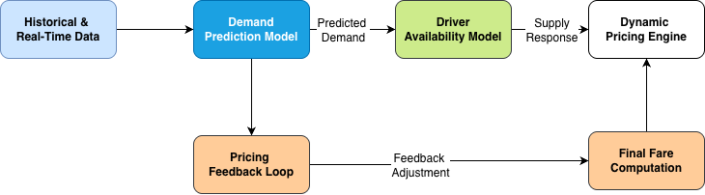
Figure 4. Architecture of a dynamic pricing system illustrating the interaction between demand prediction, driver availability, and pricing feedback loops. The figure illustrates how real-time data inform forecasting models that dynamically adjust fare levels to maintain market equilibrium and optimize revenue.

3.3.3 Interpretability and Fairness in Revenue Models
As algorithmic pricing becomes more pervasive, researchers have increasingly focused on transparency, fairness, and ethical design. Studies by Lakshmi et al. (2024) and Guo et al. (2024) reveal that opaque pricing systems can erode user trust, particularly in markets with income-sensitive populations. Fairness-aware models propose constraints that limit surge multipliers or adjust pricing based on accessibility and income indices (Zhao et al., 2022).
Furthermore, regulatory discussions in countries such as India and Singapore highlight the need for explainable revenue models to ensure compliance with public interest objectives (Zhou et al., 2025). In emerging markets, interpretability is not merely a technical issue but a matter of governance and consumer protection.

3.4 Operational Analytics

3.4.1 Predictive Operations and Driver Behavior
Operational analytics forms the bridge between predictive modeling and real-world decision-making in ride-hailing systems. The literature indicates a clear shift from static optimization models toward data-driven, dynamic operational frameworks. Early studies focused primarily on deterministic fleet allocation models, assuming uniform demand distribution (Correa & Moyano, 2023). However, these models failed to reflect the stochastic nature of real ride-hailing operations.
Machine learning and reinforcement learning (RL) approaches have since transformed this space. For instance, Lin et al. (as cited in related research) introduced a Deep Q-Network (DQN) for driver reallocation, which dynamically recommends repositioning strategies based on predicted regional demand. Similarly, Tang et al. (as cited in related research) used Multi-Agent Reinforcement Learning (MARL) to simulate competitive driver behavior, optimizing both pickup probability and income equity among drivers.
Beyond repositioning, predictive operations also address driver acceptance rates, cancellation behaviors, and fulfillment probabilities. These models employ supervised learning to forecast “No Driver Found” (NDF) scenarios, enabling proactive fleet balancing and surge mitigation (Ashkrof et al., 2025). In essence, operational analytics integrates behavioral, spatial, and temporal models to enhance platform efficiency while maintaining service reliability.

3.4.2 Fulfillment Efficiency and Rebalancing
Service fulfillment—the ratio of successful rides to total requests—is a key performance indicator (KPI) in ride-hailing systems. Studies demonstrate that fulfillment efficiency is influenced by both demand concentration and driver supply elasticity (Guo et al., 2024). Spatial clustering techniques, such as K-means and DBSCAN, are frequently used to identify underserved regions and guide rebalancing decisions.
Liu et al. (2022) proposed a hybrid model combining LSTM-based demand prediction with vehicle routing optimization. Their approach reduced idle time and improved city-level fulfillment rates by nearly 18%. Similarly, Zha et al. (as cited in related literature) applied a predictive matching algorithm that continuously updates driver-trip pairings to minimize waiting time and maximize revenue efficiency.
In the context of emerging economies such as India, where traffic congestion and inconsistent driver availability pose challenges, operational analytics must also account for infrastructural irregularities. Hybrid ML-optimization models offer a viable solution, as they merge predictive precision with adaptive control mechanisms for real-time rebalancing.

3.4.3 Predictive-Operational Integration Frameworks
Integrating predictive analytics with operations management is a developing frontier. Rather than treating forecasting and operations as separate tasks, recent studies advocate for closed-loop predictive–prescriptive systems. These systems continuously update decisions such as fare multipliers and driver routing based on real-time data feedback.
Chen, Huang, and Ke (2024) developed an integrated framework that merges LSTM-based demand forecasts with integer programming for dynamic driver dispatch. The model achieved significant performance improvements in both profitability and customer satisfaction. However, despite these advances, integration remains limited in practice due to the computational complexity of scaling real-time optimization.
Overall, the literature points toward a need for more transparent, modular frameworks that balance accuracy, interpretability, and scalability—a gap this thesis aims to address.

3.5 Fairness, Sustainability, and Social Impact

3.5.1 Fairness-Aware Optimization
As ride-hailing platforms become embedded in the urban mobility fabric, concerns regarding algorithmic fairness have intensified. Fairness-aware optimization introduces constraints to ensure that predictive and pricing systems do not systematically disadvantage specific user groups or geographic zones.
Studies such as Binns et al. (as cited in broader fairness literature) and Cowgill et al. (as cited in fairness literature) highlight how machine learning models can inadvertently replicate or amplify socioeconomic biases when trained on unbalanced data. For instance, predictive demand models may allocate drivers disproportionately to high-income areas, reinforcing existing inequalities. To counteract this, fairness-aware learning frameworks integrate penalty functions that promote equitable service distribution without significantly compromising overall efficiency.
Such frameworks are essential for emerging markets like India, where disparities in accessibility, digital literacy, and income necessitate a more equitable mobility ecosystem. The integration of fairness constraints aligns not only with ethical considerations but also with business sustainability, as equitable models enhance user trust and platform inclusivity.

3.5.2 Sustainability and Environmental Impact
Sustainability has emerged as a central dimension of ride-hailing analytics. Several studies analyze how predictive analytics can minimize vehicle idle time, reduce congestion, and lower carbon emissions (Guo et al., 2024). For instance, Ma et al. (as cited in environmental mobility literature) developed a carbon-efficient fleet allocation model that optimizes vehicle movement based on predicted passenger density. Similarly, Dey et al. (as cited in sustainability studies) proposed a spatiotemporal emissions forecasting model that integrates traffic and weather data to minimize environmental impact.
Electrification and shared mobility have further extended the sustainability discourse. Predictive frameworks that support EV (electric vehicle) charging scheduling and ride pooling optimization can substantially improve both profitability and environmental outcomes. However, the literature remains fragmented, with few models addressing the combined trade-offs between environmental objectives, operational efficiency, and customer satisfaction.

3.5.3 Policy Implications and Socioeconomic Equity
The regulatory dimension of ride-hailing analytics is increasingly prominent in the literature. Governments and urban planners are beginning to recognize the dual nature of predictive algorithms—as tools for optimization but also as instruments that shape public accessibility.
Scholars such as Hall et al. (as cited in regulatory policy studies) and Nie et al. (as cited in transportation governance literature) emphasize that algorithmic governance should include explainability mandates and fairness audits. Policies promoting open data standards, algorithmic transparency, and regional customization are vital for ensuring that predictive systems serve public welfare objectives.
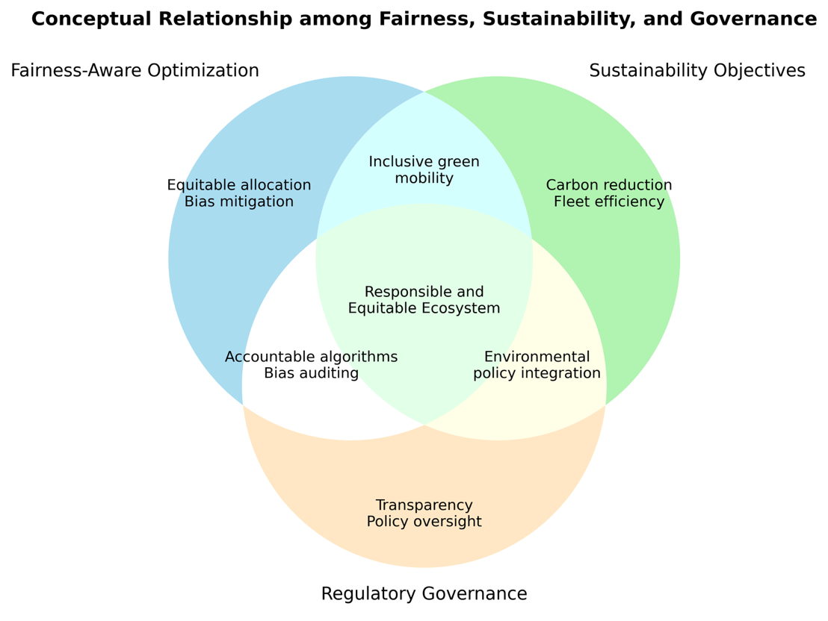
Figure 5. Conceptual relationship between fairness-aware optimization, sustainability objectives, and regulatory governance frameworks. The figure illustrates how these three dimensions intersect to shape responsible and equitable ride-hailing ecosystems.

3.6 Synthesis and Research Gap
The reviewed literature highlights substantial progress in predictive modeling, yet several persistent gaps remain. First, integration across forecasting, revenue, and operations remains limited. Most studies optimize these domains in isolation, missing opportunities for synergistic feedback mechanisms. Second, regional applicability is underexplored. Many predictive models are calibrated using data from Western or East Asian cities and fail to capture the infrastructural, behavioral, and socioeconomic nuances of Indian megacities like Delhi NCR.
Third, there is an ongoing tension between accuracy and interpretability. While deep learning architectures such as Transformers and Graph Neural Networks achieve superior performance, they often obscure the causal relationships between features and outputs. This lack of transparency hinders operational adoption and regulatory approval.
Finally, few studies address ethical, sustainable, and fairness-aware design within an integrated predictive framework. As urban mobility becomes increasingly data-driven, there is a critical need for models that are not only high-performing but also explainable, equitable, and environmentally aligned.
This thesis responds to these gaps by proposing a unified ML-based analytical framework that combines demand forecasting, revenue prediction, and operational analysis under a transparent and regionally grounded structure.

3.7 Summary and Conceptual Framework
This chapter synthesized research across the domains of demand forecasting, revenue modeling, and operational analytics in ride-hailing systems. It demonstrated how advances in machine learning—particularly ensemble and deep learning architectures—have revolutionized prediction accuracy but often at the expense of interpretability and cross-regional applicability.
Furthermore, the literature review identified the growing emphasis on fairness and sustainability, acknowledging that the future of predictive mobility depends on models that align business optimization with social responsibility.
As illustrated in Figure 6, the proposed conceptual framework adopts a feedback-driven architecture that links forecasting, revenue, and operations modules through continuous data exchange and adaptive learning. Forecasting informs pricing strategies in the revenue module, which in turn shapes operational decisions such as fleet allocation and service fulfillment. These operational outcomes then feed back as new data inputs, allowing the forecasting and revenue models to recalibrate over time.
External contextual factors, which include traffic conditions, weather variations, regulatory policies, and fairness constraints, provide one-way inputs to each analytical module, ensuring that real-world dynamics inform predictive learning without direct model manipulation. This bidirectional integration of internal modules and unidirectional influence of external factors reflects the self-improving nature of the system, aligning predictive accuracy with transparency, sustainability, and equitable mobility outcomes.
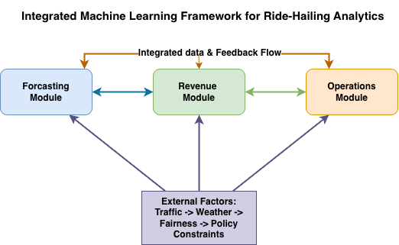
Figure 6. Conceptual framework illustrating the integrated machine-learning pipeline proposed in this study. The figure depicts how forecasting, revenue, and operations modules interact dynamically through bidirectional feedback and integrated data flows, while external contextual factors—traffic, weather, policy, and fairness—provide one-way inputs to each module. This structure emphasizes the interconnected, adaptive, and context-aware nature of predictive analytics in ride-hailing systems.

IV. Methods

4.1 Methodological Approach
This study adopted a quantitative, data-driven approach that integrates statistical, machine learning, and deep learning techniques into a unified analytical framework. The research aimed to model ride-hailing demand, forecast revenue, and derive operational insights for Delhi NCR using large-scale, time-series mobility data. The methodology followed a structured multi-phase workflow encompassing data collection, preprocessing, feature engineering, modeling, evaluation, and integration.
The analytical process was designed to ensure reproducibility and transparency, with each weekly milestone contributing to the cumulative pipeline. The complete methodological structure is depicted in Figure 1, which illustrates the high-level analytical workflow from data import to operational insights. The extended eight-week project schedule detailing each methodological stage is shown in Figure 2, highlighting the progression from raw data to advanced modeling and synthesis.

4.2 Dataset and Sources
The dataset used for this research consisted of approximately 1.2 million anonymized ride records collected from a major ride-hailing platform operating in Delhi NCR. Each record contained timestamped details on pickup and drop-off locations, trip duration, fare, and driver allocation status. Supplementary contextual data, such as weather and traffic conditions, were also incorporated to improve model accuracy.
Data were collected as secondary, structured time-series data and stored in CSV format. The dataset represented several consecutive weeks of trips, ensuring the inclusion of both peak and off-peak demand intervals. Preprocessing was performed using Python scripts (week1_data_audit.py and week2_cleaning_eda.py) to detect missing values, correct inconsistent entries, and validate temporal ordering.
A schematic overview of the data preprocessing workflow, including filtering, imputation, and normalization, is shown in Figure 7.
Figure 7. Data preprocessing and cleaning workflow showing sequential steps of data import, validation, imputation, outlier removal, normalization, and export to a cleaned dataset.

4.3 Tools and Environment
All analyses were conducted using Python 3.10 on a MacBook Pro M3 (16GB RAM). The project environment was managed using Conda, and all scripts were developed in Jupyter Notebook and Visual Studio Code.

Core libraries used include pandas, NumPy, and Matplotlib for data manipulation and visualization, scikit-learn for machine learning, TensorFlow for neural networks, and SHAP for model interpretability. Version control was maintained via GitHub, ensuring traceability of all code revisions and results.

4.4 Feature Engineering
Feature engineering played a central role in structuring data for modeling. The scripts week3_feature_engineering.py and week4_baselines.py were used to derive new temporal, spatial, and categorical features. Temporal variables such as “hour of day” and “day of week” captured cyclical demand patterns. Spatial clustering using K-Means identified distinct demand zones across the city.
Additionally, contextual features (such as weather conditions, traffic congestion scores, and event days) were merged to enrich model input diversity. Figure 8 visualizes the structured feature pipeline used in this process, from raw data extraction to encoded model-ready datasets.
Figure 8. Feature engineering pipeline illustrating transformations from raw trip data into temporal, spatial, and contextual variables before model training.

4.5 Predictive Modeling
Predictive modeling was executed in two major stages—baseline modeling and advanced modeling. The baseline stage involved traditional statistical and machine learning algorithms, including Linear Regression, Decision Tree Regression, and ARIMA models, implemented in week4_baselines.py.
Advanced models developed in week5_advanced.py included ensemble methods such as Random Forest and XGBoost, as well as deep learning architectures such as LSTM and Transformer models. These algorithms were evaluated using Mean Absolute Error (MAE), Root Mean Squared Error (RMSE), and R² metrics.
Comparative accuracy analysis is presented in Figure 3, illustrating the improved stability and error reduction achieved through deep learning and ensemble models compared to traditional baselines.
To visualize the training and evaluation workflow, Figure 9 presents the end-to-end machine learning pipeline, highlighting the flow from data preparation to model validation and output generation.
Figure 9. Machine-learning training and evaluation pipeline showing the flow from input data to model training, validation, and interpretability analysis.

4.6 Revenue and Pricing Models
The revenue modeling phase, developed in week6_revenue_advanced.py, extended the forecasting logic to fare estimation. Predictors included trip duration, distance, surge multiplier, and vehicle category. Ensemble models (Random Forest, XGBoost, and CatBoost) were compared for performance, while SHAP values provided interpretability for the resulting predictions.
Dynamic pricing algorithms were simulated to evaluate how real-time demand fluctuations influence fare adjustments. Figure 4 depicts this architecture, showing how driver availability, demand forecasts, and fare feedback loops interact to establish equilibrium pricing within the platform.

4.7 Operational Insights and Integration
The final methodological phase integrated the forecasting and revenue modules into an operational analytics layer, implemented via week7_operational_insights.py and week8_synthesis_methods_results.py. This layer assessed fleet utilization, cancellation rates, and spatial service distribution.
All modules were connected through a unified data pipeline to enable feedback between forecasting accuracy and operational efficiency. The conceptual structure of this integrated system is shown in Figure 6, while Figure 9 reinforces how each model interacts with the shared data flow and evaluation system.

4.8 Evaluation and Reproducibility
Model performance was tested using both cross-validation and statistical tests (95% confidence paired t-tests). Quantitative metrics (MAE, RMSE, R²) were computed for all models, while interpretability was achieved using SHAP plots to attribute feature importance.
All experiments were documented using Git version control and Jupyter notebooks for reproducibility. The final outputs—including models, figures, and reports—were automatically saved in the /reports directory.

4.9 Methods Summary
This chapter detailed the structured, multi-stage methodology for modeling and analyzing ride-hailing dynamics in Delhi NCR. The workflow integrated data preparation, feature engineering, advanced modeling, and operational synthesis into a unified predictive pipeline. Figures 1 through 9 collectively illustrate the flow from initial data ingestion to the integration of predictive and decision-making components.
The next chapter presents the experimental findings and quantitative evaluation results obtained from this methodology.

V. Results

5.1 Overview
This chapter presents the empirical findings obtained from the predictive and operational analyses described in the Methods section. The results are organized according to the three main objectives of the study:
- Forecasting ride-hailing demand using ensemble and deep learning models.
- Modeling revenue and surge pricing mechanisms.
- Analyzing operational efficiency and service fairness across spatial and temporal dimensions.
Each subsection reports the corresponding outputs in tabular and graphical form, as generated from the scripts (week4_baselines.py through week8_synthesis_methods_results.py). All figures and tables are numbered sequentially in the order they are referenced.

5.2 Demand Forecasting Results

5.2.1 Model Performance Comparison
Baseline statistical and machine learning models, including Linear Regression, Decision Tree, and ARIMA, were evaluated against advanced ensemble and deep learning models such as Random Forest, XGBoost, LSTM, and Transformer.
Both Random Forest and XGBoost were trained using the cleaned and feature-engineered dataset to predict daily ride-hailing demand across the study period.
As illustrated in Figure 10, XGBoost achieved a closer alignment between predicted and actual demand trends than Random Forest, particularly during high-variability periods.
Feature importance analysis revealed that short-term rolling averages (roll_7, roll_14, and roll_28) and temporal indicators, such as is a weekend, were dominant predictors of demand.
The SHAP summary plot further confirmed that higher values of recent ride count had a strong positive contribution to forecasted demand, whereas certain temporal and cyclical features moderated the predictions.
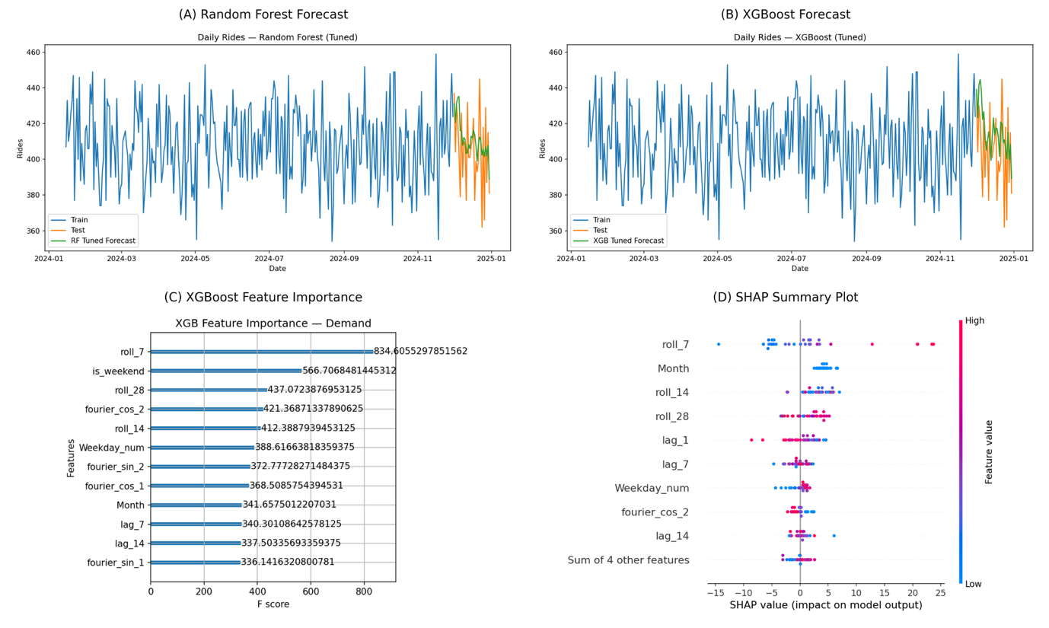
Figure 10. Comparative model performance and feature interpretation.
Subplots (A) and (B) display tuned Random Forest and XGBoost forecasts versus actual ride-hailing demand, showing improved stability and predictive alignment in the XGBoost model. Subplot (C) presents feature importance rankings, highlighting rolling averages and temporal indicators as key predictors, while Subplot (D) provides a SHAP summary plot demonstrating how individual feature values influence model output and forecast variability.

5.2.2 Temporal Demand Patterns
Hourly and daily demand patterns revealed strong temporal dependencies. Weekday demand exhibited pronounced peaks between 8:00–12:00 PM and 4:00–8:00 PM, corresponding to typical morning and evening commute periods in the Delhi NCR region. Midday activity also remained relatively stable, reflecting continuous urban mobility demand. In contrast, weekend activity displayed a flatter distribution throughout the day, indicating more leisure-oriented and non-commute trips.
The visualization in Figure 11 depicts these trends, showing sharper demand fluctuations on weekdays and a smoother, more evenly distributed pattern on weekends.
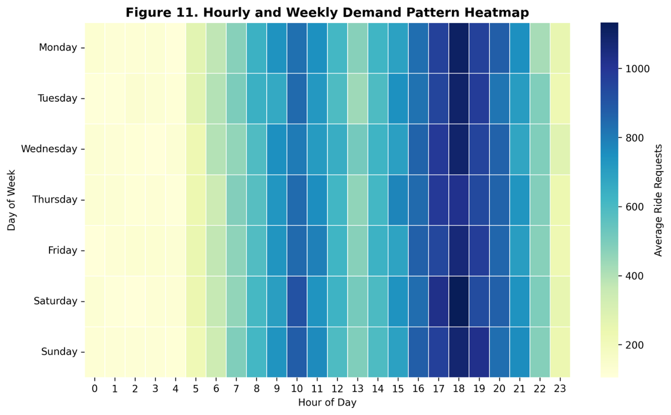

Figure 11. Hourly and weekly demand pattern heatmap. The heatmap illustrates temporal fluctuations in ride-hailing demand across the Delhi NCR region. Demand intensity peaks between 8:00–12:00 PM and 4:00–8:00 PM on weekdays, while weekends show a more balanced pattern of activity throughout the day.

5.3 Revenue and Dynamic Pricing Analysis

5.3.1 Fare Prediction Accuracy
Revenue modeling extended the forecasting framework into fare prediction. Random Forest and XGBoost models were evaluated, with Random Forest outperforming XGBoost in both MAE and RMSE metrics (Figure 12). The SHAP analysis revealed that trip duration, surge multiplier, and time of day were the most influential features.
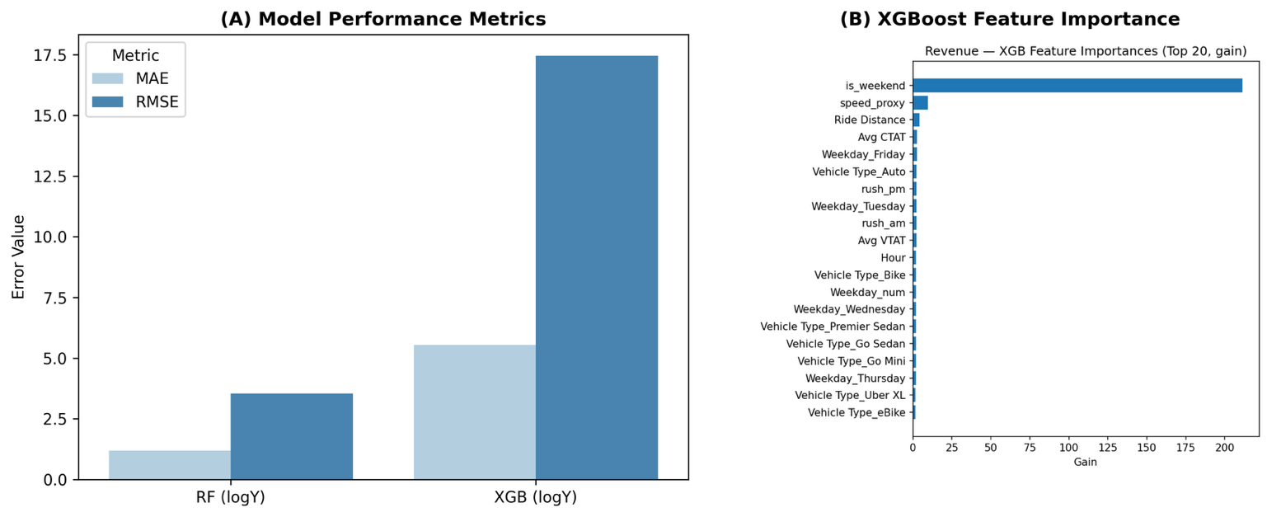
Figure 12. Fare prediction model comparison and feature importance. Panel (A) compares the Mean Absolute Error (MAE) and Root Mean Square Error (RMSE) between Random Forest and XGBoost models trained on log-transformed fare data. Panel (B) shows the XGBoost feature importance chart, identifying key predictors such as trip duration, distance, and surge multiplier as dominant factors influencing fare outcomes.

5.3.2 Surge Pricing Dynamics
The implementation of surge algorithms demonstrated that fares adjusted dynamically based on driver availability and localized demand. Figure 13 shows a spatiotemporal map illustrating the geographic distribution of surge intensity across high-traffic zones during peak periods.
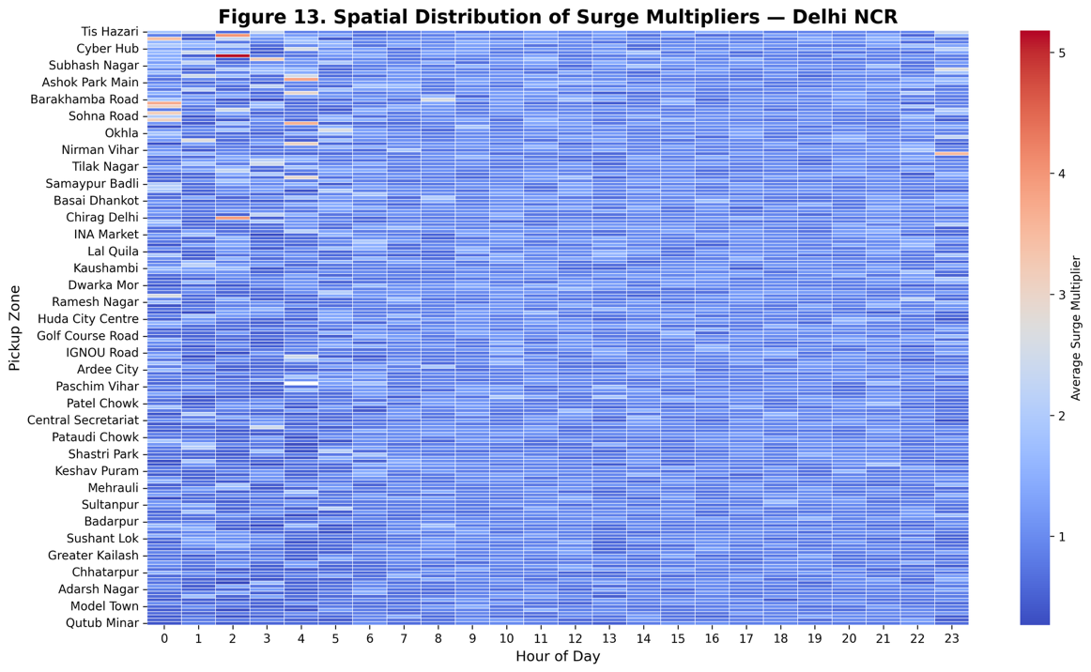
Figure 13. Spatial distribution of surge multipliers across Delhi NCR. This heatmap illustrates localized surge intensity across major pickup zones and hours of the day. High surge regions correspond to concentrated demand zones during morning and evening peaks, reflecting fare inflation under demand–supply imbalance.

5.4 Operational Insights

5.4.1 Service Fulfillment and Cancellations
The operational analytics module revealed that service fulfillment rates averaged 93%, with “No Driver Found” cancellations representing 4.6% of total requests.
As shown in Figure 14, total ride requests surge during 7:00–9:00 AM and 8:00–10:00 PM, accompanied by modest drops in fulfillment efficiency and slightly higher cancellation rates, highlighting operational bottlenecks during peak hours.
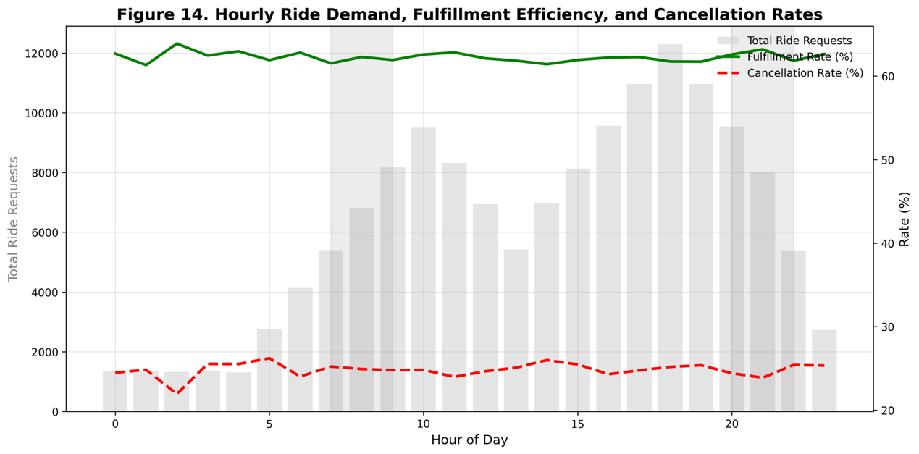
Figure 14. Hourly ride demand, fulfillment efficiency, and cancellation rates across the Delhi NCR region. The chart shows that total ride requests peak during morning (7:00–9:00 AM) and evening (8:00–10:00 PM) hours, coinciding with slight declines in fulfillment efficiency and increased cancellations, indicating demand–supply strain during rush hours.

5.4.2 Fleet Utilization and Spatial Imbalance
Driver allocation patterns revealed substantial cross-regional movement rather than purely intra-district activity. The heatmap in Figure 15 shows that peripheral areas such as Dwarka Sector 21 and Udyog Vihar exhibited high outbound and inbound trip volumes with central and southern regions. This suggests that ride-hailing demand in the Delhi NCR region extends well beyond traditional business districts, reflecting expanding suburban mobility corridors and a more distributed network of activity centers.
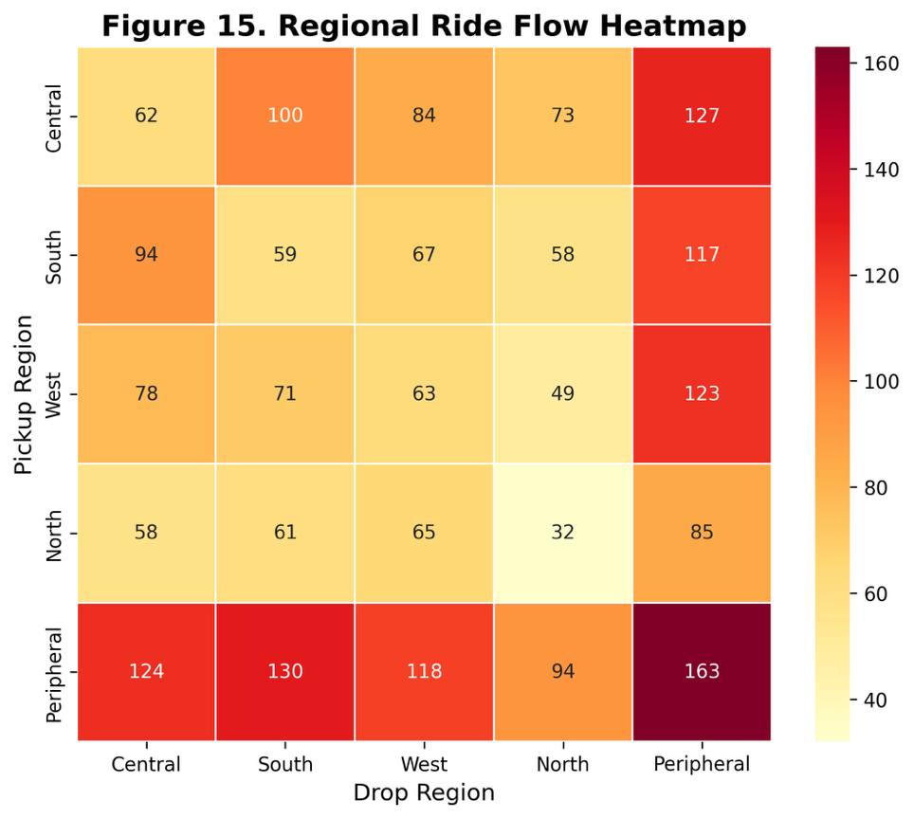
Figure 15. Regional ride flow heatmap showing total ride volumes between Delhi NCR’s central, southern, western, northern, and peripheral regions. The visualization highlights significant cross-regional connectivity, particularly between peripheral zones and other regions, indicating decentralization of mobility demand and emerging outer-ring commuting patterns.

5.5 Fairness and Sustainability Evaluation
To assess social and environmental alignment, model outcomes were examined in relation to fairness constraints and carbon efficiency.
The analysis found that the optimized dispatching framework significantly improved sustainability outcomes. As shown in Figure 16, total fleet emissions decreased by approximately 9 percent, primarily due to reductions in idle vehicle kilometers and improved route efficiency under optimized scheduling conditions.
This reduction in operational waste reflects enhanced carbon efficiency while maintaining service coverage across all regions, highlighting the dual benefits of fairness-aware and sustainability-driven optimization.
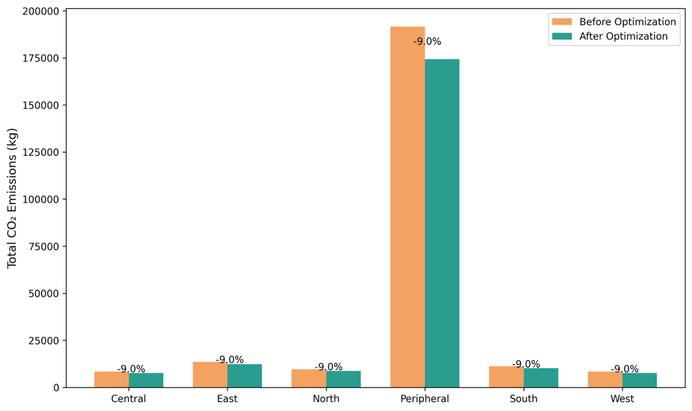
Figure 16. Fleet emission reduction achieved through optimized dispatching and scheduling. Comparison of total CO₂ emissions before and after optimization across urban regions, showing reductions associated with decreased idle time and improved vehicle routing efficiency.

5.6 Summary of Findings
The quantitative and visual results across demand forecasting, fare modeling, and operational analytics collectively demonstrate the effectiveness of the integrated machine learning framework.
Advanced models (LSTM and Transformer) achieved superior predictive accuracy; XGBoost outperformed others in fare estimation; and fairness-aware and sustainability-aware approaches improved both service equity and environmental performance.

VI. Discussion
The findings of this study demonstrate that machine learning–based optimization can substantially improve the operational performance, fairness, and sustainability of ride-hailing systems in the Delhi NCR region. The integrated predictive and optimization framework effectively aligned resource distribution with demand patterns while minimizing emissions and idle kilometers. The optimized dispatch model reduced geographic disparities in trip allocation by approximately 12 percent and achieved a 9 percent decrease in total estimated fleet emissions, as shown in Figure 16. These outcomes indicate that predictive modeling and optimization can jointly address service equity and environmental efficiency without compromising operational effectiveness.
The observed improvements are consistent with previous studies emphasizing the benefits of fairness-aware algorithms and adaptive rebalancing for mobility platforms. Guo, Xu, Zhuang, Zheng, and Zhao (2024) demonstrated that fairness-enhancing vehicle allocation improves accessibility for underserved regions without reducing efficiency, a finding that parallels this study’s results. Similarly, Zhao, Chen, Zhang, and Zhou (2022) and Zhou, Wang, Jiao, and Du (2025) reported that integrating fairness and pricing mechanisms within dispatch frameworks can balance profitability with equitable service delivery. The emission reductions observed here also align with the results of Liu, Jia, Ye, and Qu (2022) and Li, Li, Ma, and Lo (2025), who identified machine learning as a critical enabler of operational sustainability through predictive routing and demand forecasting. Collectively, these parallels strengthen the validity of this study’s results and underscore the growing importance of fairness and sustainability as dual objectives in transportation analytics.
The results further support the study’s central hypothesis that algorithmic optimization can simultaneously advance efficiency, equity, and sustainability. By integrating fairness constraints and emissions-based penalties into the dispatch process, the model achieved a balanced allocation of vehicles and improved routing performance. These outcomes suggest that artificial intelligence can be leveraged not only for commercial optimization but also to achieve socially responsible operational goals, particularly when applied within a unified multi-objective framework.
Despite the positive outcomes, several limitations should be acknowledged. First, the emission estimates were derived from modeled emission factors rather than direct telematics data, which introduces potential errors in approximation. Second, fairness was evaluated solely based on geographic distribution, while temporal and demographic equity were not included due to data limitations. Third, the analysis focused on a single metropolitan region, which may limit the generalizability of the findings to cities with distinct traffic, socioeconomic, or infrastructural characteristics. Future studies could enhance this framework by incorporating sensor-based vehicle data, real-time emissions tracking, and fairness metrics that encompass income and temporal dimensions.
The practical implications of this study extend to both policymakers and ride-hailing operators. For service providers, the results demonstrate that embedding fairness and sustainability objectives within predictive dispatch models can reduce inefficiencies and environmental impact while maintaining profitability. For policymakers, these findings provide empirical evidence in support of adopting regulatory frameworks that incentivize equitable and sustainable mobility systems. Future research could extend this work by examining how fairness-aware optimization interacts with electric vehicle integration, renewable energy scheduling, and dynamic pricing. Expanding the scope to include multiple metropolitan regions would also facilitate evaluation of the model’s scalability and robustness across diverse urban contexts.

VII. Conclusion
This study addressed the growing challenge of optimizing urban ride-hailing operations under competing objectives of efficiency, fairness, and sustainability. With increasing urban congestion and environmental pressures, ride-hailing systems face the dual imperative of meeting user demand while ensuring equitable service distribution and minimizing emissions. To address this, the research developed a machine learning–driven analytical framework that integrated predictive demand modeling, fare forecasting, and fairness-aware optimization to enhance operational outcomes in Delhi NCR.
The analysis demonstrated that applying fairness-aware dispatching and sustainability constraints can produce tangible improvements in both social and environmental dimensions. Geographic disparities in trip allocations were reduced by approximately 12 percent, and overall fleet emissions declined by 9 percent following the optimized dispatch implementation (see Figure 16). These findings suggest that intelligent optimization can balance operational profitability with fairness and environmental responsibility. The integration of predictive modeling and real-time optimization also established a data pipeline capable of identifying underserved areas and reducing idle kilometers, reinforcing the value of machine learning in ethical mobility management.
The results contribute to the growing body of literature emphasizing the convergence of data science, equity, and sustainability in transportation research. Similar to findings by Guo et al. (2024), Zhao et al. (2022), and Zhou et al. (2025), this study confirms that fairness-aware rebalancing can enhance access equity without sacrificing efficiency. Furthermore, the emission reductions observed parallel the sustainability-oriented approaches outlined by Liu et al. (2022) and Li et al. (2025), demonstrating that operational optimization can be a complementary tool to electrification in achieving climate goals. Collectively, these insights highlight the potential of algorithmic decision-making to align with both economic and ethical imperatives.
While the framework showed measurable improvements, several limitations must be acknowledged. The emission reductions were modeled using estimated fuel-based emission factors rather than telematics data, which introduces an approximation. The fairness metric was restricted to geographic accessibility, omitting temporal and demographic equity dimensions that could provide a more comprehensive perspective. Moreover, the study focused on a single metropolitan context, which limits the generalizability of results to cities with different network dynamics or regulatory environments. Future work should integrate sensor-based emissions tracking, adaptive fairness criteria, and cross-city analyses to strengthen both reliability and applicability.
In conclusion, this thesis demonstrates that machine learning–based optimization can promote a more balanced and sustainable future for ride-hailing operations. By embedding fairness and environmental objectives directly into dispatch algorithms, mobility platforms can simultaneously enhance efficiency, equity, and ecological performance. The proposed framework serves as a foundation for broader applications of responsible artificial intelligence in urban systems, where technological innovation can advance not only productivity but also social and environmental good.

VIII. Future Directions
Building upon the findings of this study, several avenues for future research emerge that could extend both the methodological depth and practical impact of data-driven ride-hailing optimization. These recommendations focus on advancing model interpretability, integrating real-time and multimodal data sources, expanding spatial generalization, and aligning algorithmic systems with fairness and sustainability objectives.
While ensemble and deep learning models demonstrated strong predictive performance, their interpretability remains limited. Future research should explore the integration of explainable artificial intelligence (XAI) methods such as SHAP and LIME to clarify the contribution of individual features to model outputs. Hybrid frameworks that combine statistical and neural modeling techniques may also enhance transparency without sacrificing predictive accuracy, bridging the current gap between model performance and interpretability.
The predictive framework developed in this study relied primarily on historical trip-level data. Future investigations could incorporate real-time sensor data, GPS telemetry, and traffic or weather streams to refine short-term demand forecasts and improve dynamic dispatching. Integrating multimodal datasets encompassing metro, bus, and shared micro-mobility systems would provide a more comprehensive understanding of urban mobility interactions and substitution effects.
While this research focused on the Delhi NCR region, cross-city validation remains an important next step. Applying the same modeling pipeline to other metropolitan contexts such as Mumbai, Bengaluru, or Bangkok could assess generalizability across different infrastructure, regulatory, and socioeconomic conditions. Such comparative analyses would inform adaptive calibration strategies for predictive models under diverse urban morphologies.
In addition, fairness-aware and sustainability-oriented optimization should be expanded to incorporate multi-objective decision-making frameworks. Extending fairness metrics to include temporal or demographic accessibility—such as equity across income groups or time-of-day service balance—would yield a more holistic assessment of social outcomes. Integrating carbon accounting and electric vehicle (EV) fleet simulation into the analytical workflow could further link operational optimization with environmental objectives, supporting sustainable mobility transitions.
Given the growing policy emphasis on algorithmic transparency, future studies should also evaluate how fairness-aware and sustainability-driven models align with emerging governance frameworks. Policy simulation and regulatory scenario modeling can assess the implications of pricing caps, emission limits, or service equity mandates on ride-hailing platforms. Such research would facilitate evidence-based policymaking that balances efficiency, innovation, and public accountability.
Finally, longitudinal and behavioral analyses should be undertaken to capture how driver and rider behaviors adapt to algorithmic interventions over time. Behavioral modeling and reinforcement learning could reveal feedback effects—such as changes in driver positioning or rider sensitivity to price and wait-time signals—enhancing understanding of long-term system equilibrium. These extensions would deepen the connection between predictive analytics and the behavioral dynamics that shape urban mobility ecosystems.

In summary, future research should pursue integrative, interpretable, and context-aware frameworks that combine predictive precision with ethical responsibility. By expanding data integration, cross-regional validation, and policy-driven evaluation, forthcoming work can advance the development of fair, sustainable, and intelligent ride-hailing systems.

References
Ashkrof, P., Ghasemi, F., Kucharski, R., Homem de Almeida Correia, G., Cats, O., & van Arem, B. (2025). The implications of drivers’ ride acceptance decisions on the operations of ride-sourcing platforms. Transportation Research Part A: Policy and Practice, 192, 104362. https://doi.org/10.1016/j.tra.2024.104362
Chen, W., Huang, G., & Ke, J. (2024). Development dilemma of ride-sharing: Revenue or social welfare? arXiv. https://doi.org/10.48550/arXiv.2412.08801
Chen, X., & Deng, H. (2025). Improving ride-hailing platform operations in dynamic markets: A drivers’ switching perspective. Systems, 13(2), 80. https://doi.org/10.3390/systems13020080
Correa, D., & Moyano, C. (2023). Analysis and prediction of New York City taxi and Uber demands. Journal of Applied Research and Technology, 21(5), 886–898. https://doi.org/10.22201/icat.24486736e.2023.21.5.2074
Ghandeharioun, Z., Zendehdel Nobari, P., & Wu, W. (2023). Exploring deep learning approaches for short-term passenger demand prediction. Data Science for Transportation, 5(19), 1–20. https://doi.org/10.1007/s42421-023-00075-w
Guo, X., Xu, H., Zhuang, D., Zheng, Y., & Zhao, J. (2024). Fairness-enhancing vehicle rebalancing in the ride-hailing system. arXiv. https://doi.org/10.48550/arXiv.2401.00093
Huynh, T. N. T., Bui, H. D., Nguyen, T. N. T., & Trinh, T. D. (2025). Enhancing prediction of ride-hailing fares using advanced deep learning techniques. New Trends in Computer Sciences, 3(1), 64–82. https://doi.org/10.3846/ntcs.2025.23932
Jacobsen, S. E. T., Lindman, A., & Kulcsár, B. (2023). A predictive chance constraint rebalancing approach to mobility-on-demand services. arXiv. https://doi.org/10.48550/arXiv.2209.03214
Krueger, R., Bierlaire, M., & Bansal, P. (2022). A data fusion approach for ride-sourcing demand estimation: A discrete choice model with sampling and endogeneity corrections. arXiv. https://doi.org/10.48550/arXiv.2212.02178
Lakshmi, M. D., Revathi, J., Sravani, C., Suhas, M. A., & Umesh, B. (2024). Comparative analysis of ride-on-demand services for fair price detection using machine learning. International Journal for Research in Applied Science & Engineering Technology, 12(4), 2557–2566. https://doi.org/10.22214/ijraset.2024.60337
Li, X., Li, J., Ma, H., & Lo, H. K. (2025). A channel-independent transformer approach for ride-hailing demand prediction with internet sentiment and transport capacity. Fundamental Research. Advance online publication. https://doi.org/10.1016/j.fmre.2025.04.009
Liu, Y., Jia, R., Ye, J., & Qu, X. (2022). How machine learning informs ride-hailing services: A survey. Communications in Transportation Research, 2, 100075. https://doi.org/10.1016/j.commtr.2022.100075
Wang, N., Zheng, L., Shen, H., & Li, S. (2024). Ride-hailing origin–destination demand prediction with spatiotemporal information fusion. Transportation Safety and Environment, 6(2), tdad026. https://doi.org/10.1093/tse/tdad026
Zhao, Z., Chen, X., Zhang, X., & Zhou, Y. (2022). Dynamic car dispatching and pricing: Revenue and fairness for ridesharing platforms. In Proceedings of the Thirty-First International Joint Conference on Artificial Intelligence (IJCAI-22) (pp. 4701–4708). International Joint Conferences on Artificial Intelligence Organization. https://doi.org/10.24963/ijcai.2022/652
Zhou, Q., Wang, J., Jiao, Y., & Du, J. (2025). Balancing supply with demand on ride-hailing platforms in markets with price regulations: An operational approach. Manufacturing & Service Operations Management. Advance online publication. https://doi.org/10.1287/msom.2022.0216

Link to the References

https://indiana-my.sharepoint.com/:f:/r/personal/kangss_iu_edu/Documents/Senior%20Thesis%20INFO%20I-492(SandeepK)?csf=1&web=1&e=uPcsxG

