To store the api and time of scheduling of the api has to be stored in the database when url and time is sent into the parameter.

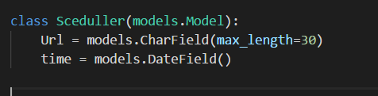

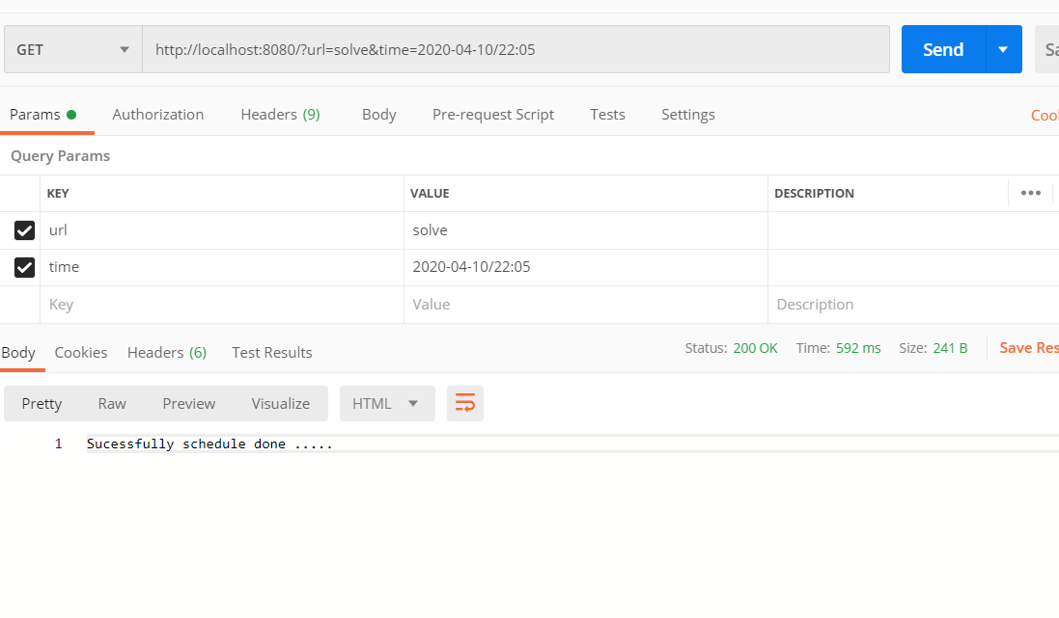

When APi is hit with parameter of url and time ,it send response of success

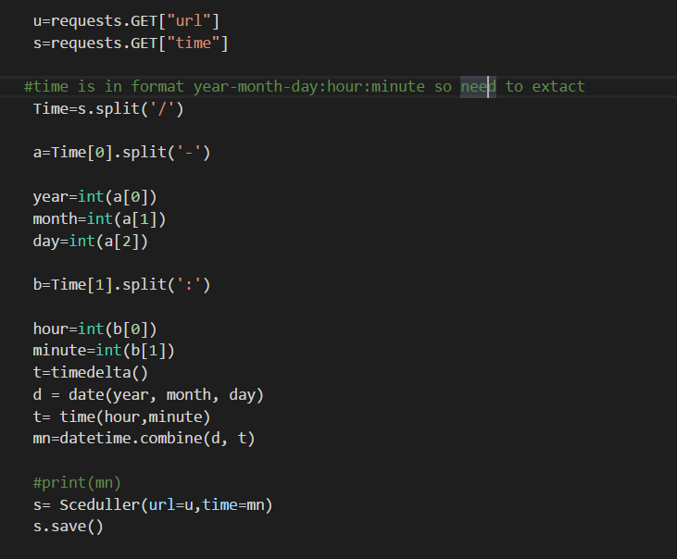

The sceduller model is saves as it get extaracted

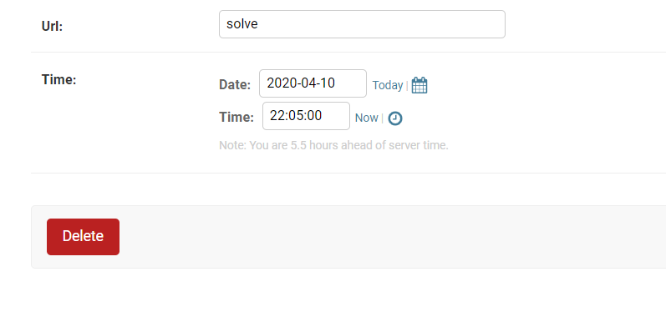

Model in admin panel.

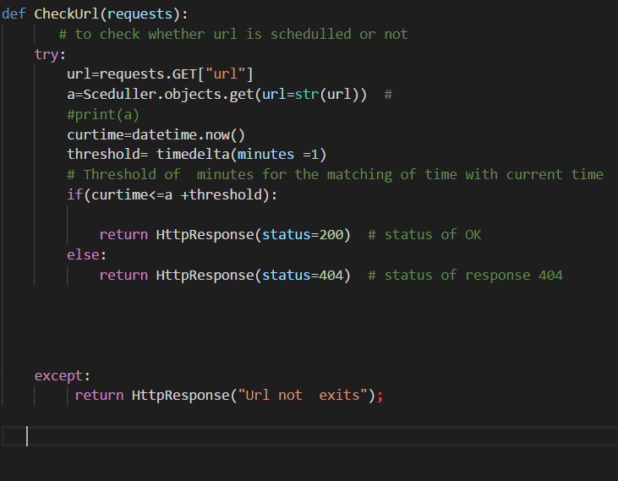

There is gap of 1 minute is maintained for minimum difference of 1 minute which is tolerable and send the status of 200 which is ok else status code of 404.

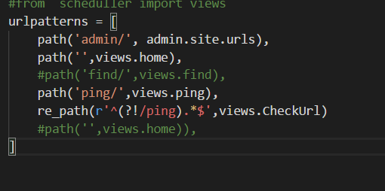

This is the url pattern last url is of regular expression of be excepted as url expect ping as general.