Lab – 02

Name – Kanhaiya Roll No- 244CA022

Q1. Input the points as array “int points[3][2] = {{50,100},{75,150},{100,200}};”. Use loops to traverse and draw the lines.

Code ->

#include <GL/glut.h>

int points[3][2] = {

{50, 100},

{75, 150},

{100, 200}

};

void display() {

glClear(GL_COLOR_BUFFER_BIT);

glColor3f(1.0, 1.0, 1.0);

glBegin(GL_LINE_STRIP);

for (int i = 0; i < 3; i++) {

glVertex2iv(points[i]);
}

glEnd();

glFlush();

}

void init() {

glClearColor(0, 0, 0, 1);

glMatrixMode(GL_PROJECTION);

gluOrtho2D(0, 200, 0, 200);

}

int main(int argc, char** argv) {

glutInit(&argc, argv);

glutInitDisplayMode(GLUT_SINGLE | GLUT_RGB);

glutInitWindowSize(500, 500);

glutCreateWindow("Line Drawing using Points Array");

init();

glutDisplayFunc(display);

glutMainLoop();

return 0;

}
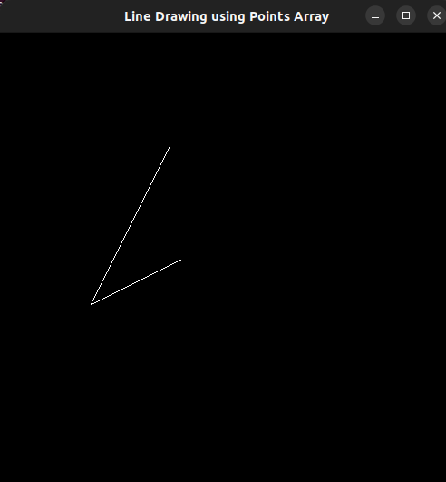
Output ->

Q2. Define an array of points and connect them in sequence using lines. Ensure that the last point connect back to the first point to form

