**Database Management System Lab**

**Assignment - 3**

**Name :- Harsh Singh**

**Roll No. :- 244CA018**

1. **List all students with a total credit count of 0.**

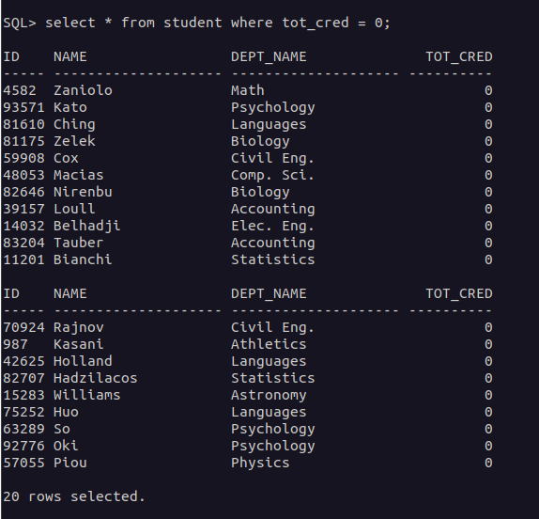

1. **Find the names of all courses offered by the "Physics" department.**

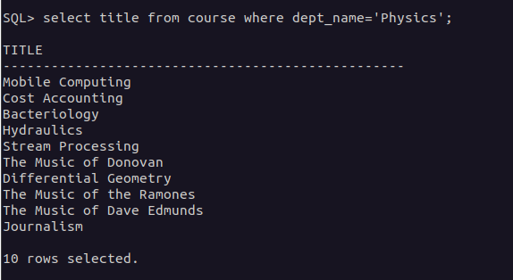

1. **Retrieve the names of all instructors who earn exactly ₹50,000.**

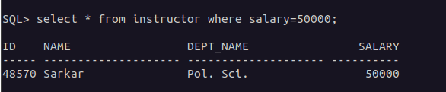

1. **List all classrooms with a capacity of exactly 100.**

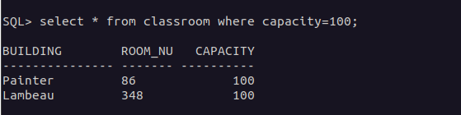

1. **Find the total number of courses offered in the "Summer" semester.**

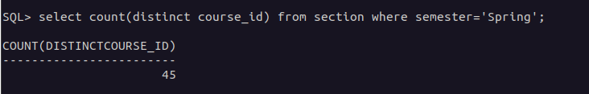

1. **List all students who have taken exactly 30 total credits.**

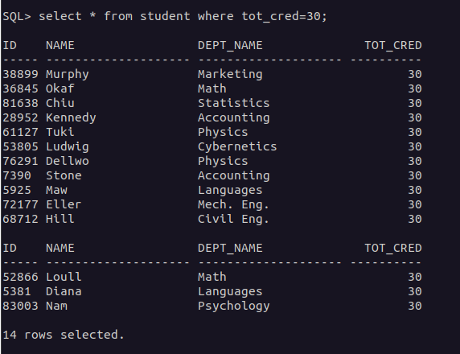

1. **Find the names of all courses offered by the "Chemistry" department.**

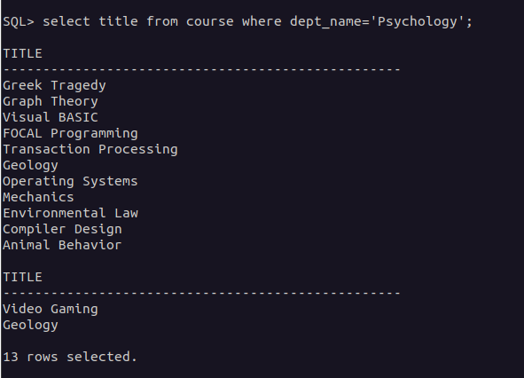

1. **Retrieve the names of all instructors who earn more than ₹100,000.**

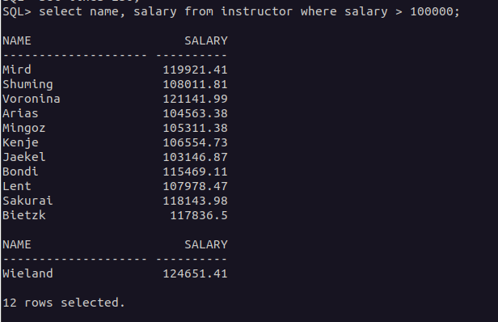

1. **List all classrooms located in the "Taylor" building.**

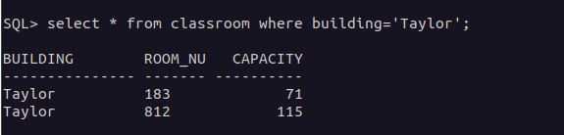

1. **Find the total number of courses offered in the "Winter" semester.**

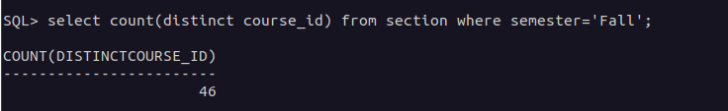

1. **List all students who have taken courses with a grade of "C" or lower.**

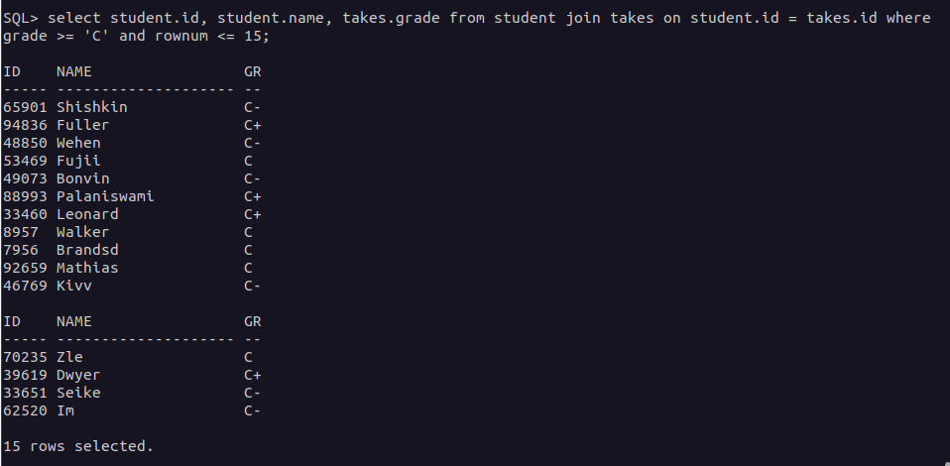

1. **Retrieve the names of instructors who have taught in the "Fall" semester of 2022.**

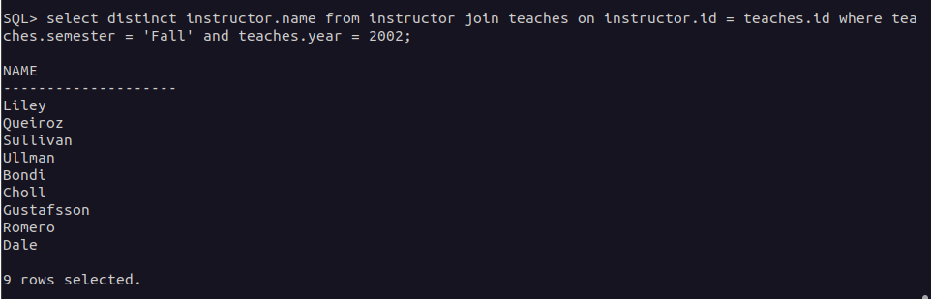

1. **Find the average capacity of classrooms in each building.**

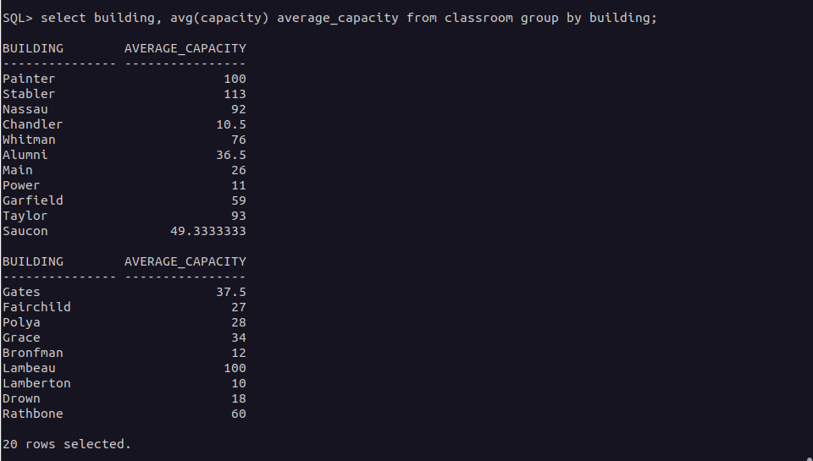

1. **List all courses that have more than 3 credits.**

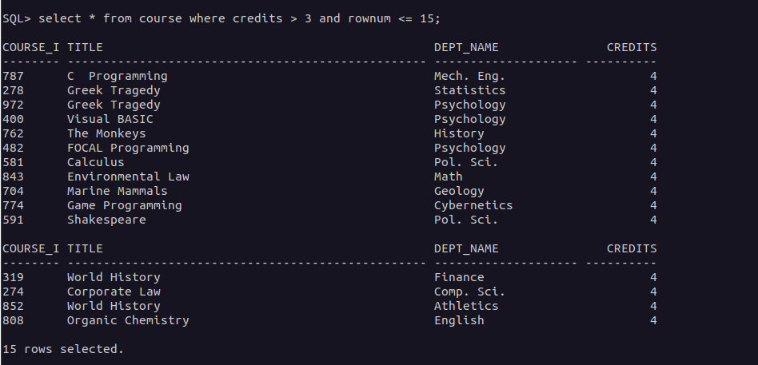

1. **Retrieve the names of students who have taken courses in the "Watson" building.**

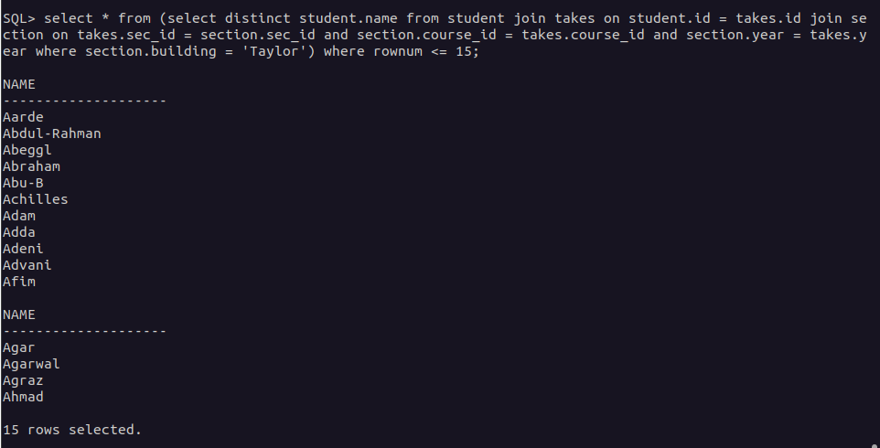

1. **Find the total number of students advised by each instructor.**

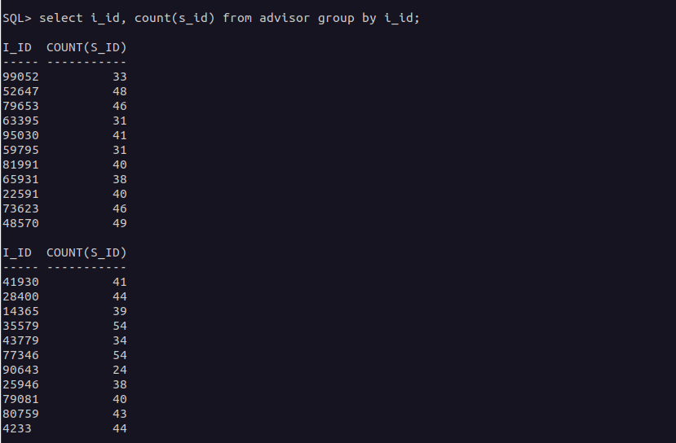

1. **List all sections that do not have a classroom assigned.**

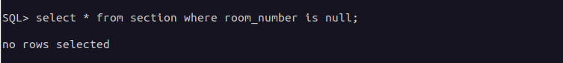

1. **Retrieve the names of students who have taken courses with the highest number of credits.**

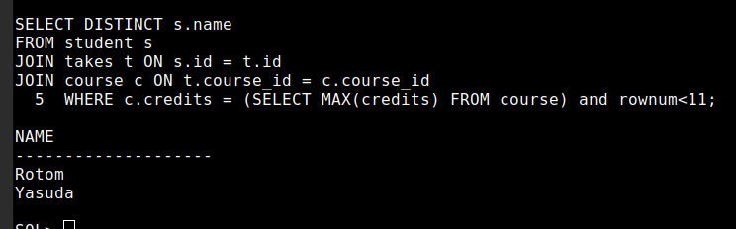

**19. Find the departments with the highest average instructor salary.**

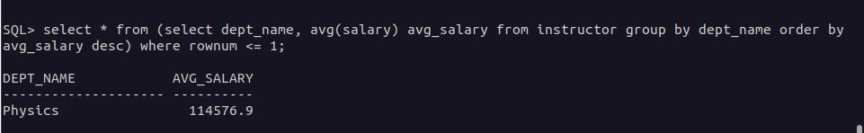

1. **List all courses that have been taught by more than one instructor.**

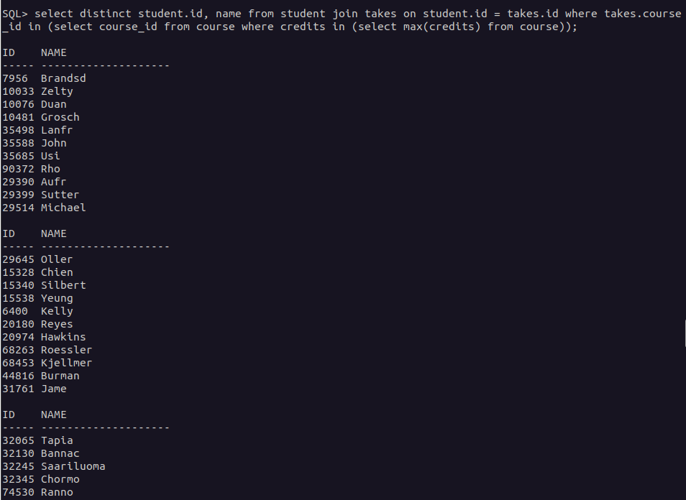

1. **List all students who have taken courses with a grade of "A" in the "Fall" semester of 2022.**

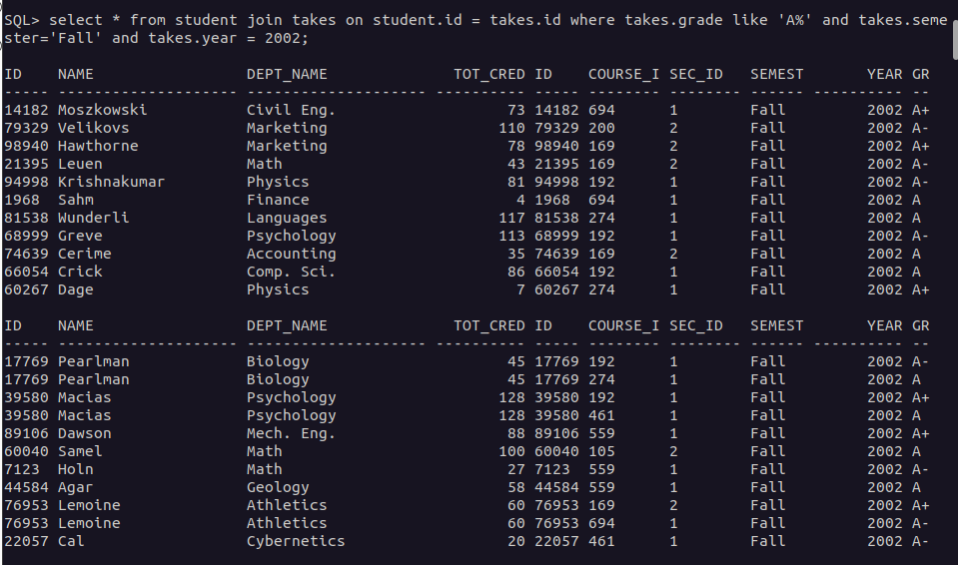

1. **Retrieve the names of instructors who have taught in the "Spring" semester of 2023.**

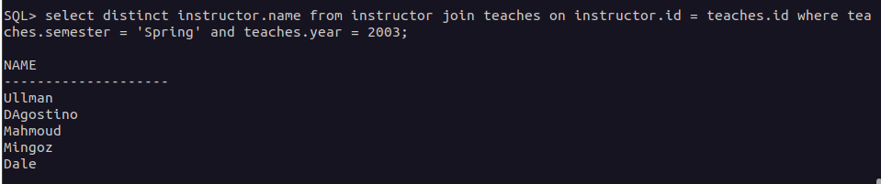

1. **Find the average number of students enrolled in each course.**

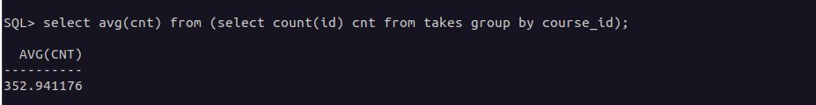

1. **List all courses that have exactly 4 credits.**

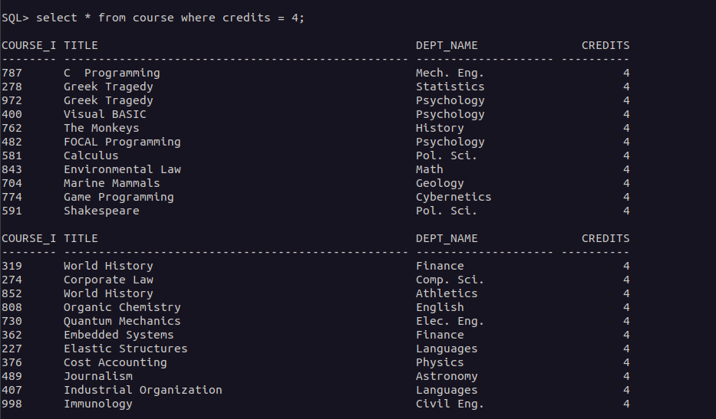

1. **Retrieve the names of students who have taken courses in the "Packard" building.**

