**Database Management System Lab**

**Assignment - 4**

**Name :- Harsh Singh**

**Roll No. :- 244CA018**

1. **List all students who have taken exactly 60 total credits.**

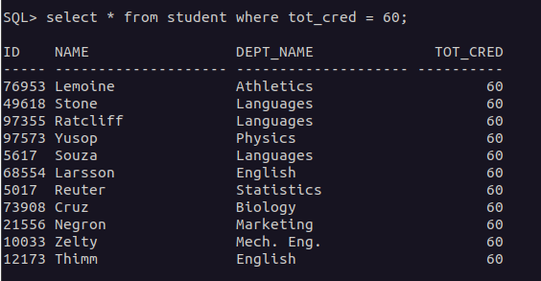

1. **Find the names of all courses offered by the "Electrical Engineering" department.**

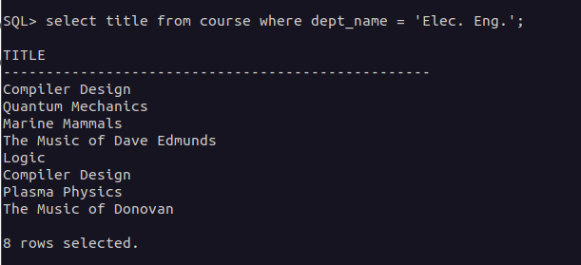

1. **Retrieve the names of all instructors who earn less than ₹40,000.**

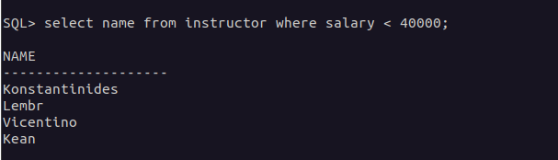

1. **List all classrooms located in the "Main" building.**

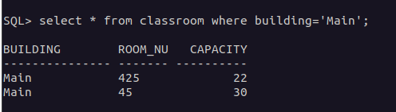

1. **Find the total number of courses offered in the "Fall" semester.**

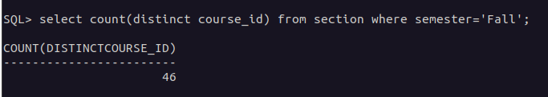

1. **List all students who have taken exactly 90 total credits.**

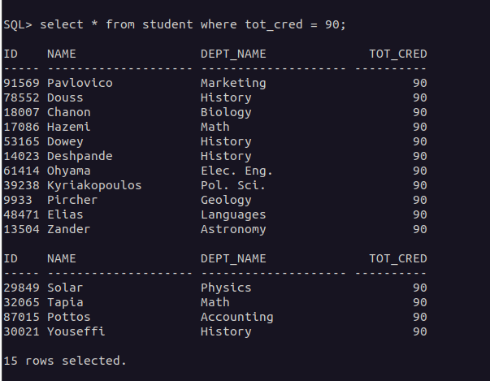

1. **Find the names of all courses offered by the "Mechanical Engineering" department.**

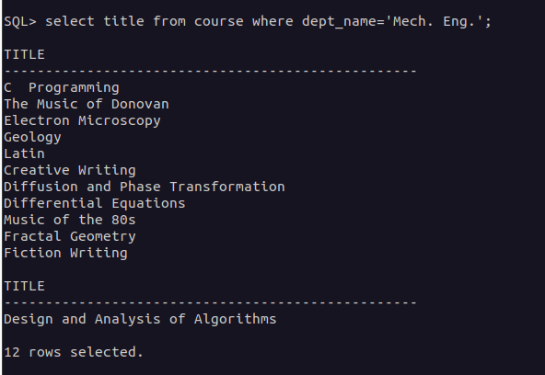

1. **Retrieve the names of all instructors who earn exactly ₹75,000.**

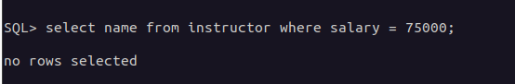

1. **List all classrooms located in the "Lambert" building.**

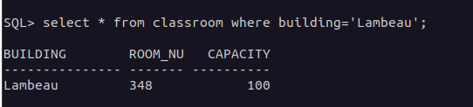

1. **Find the total number of courses offered in the "Spring" semester.**

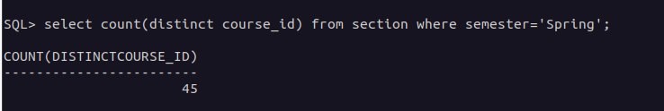

1. **List all students who have taken courses with a grade of "B" in the "Spring" semester of 2023.**

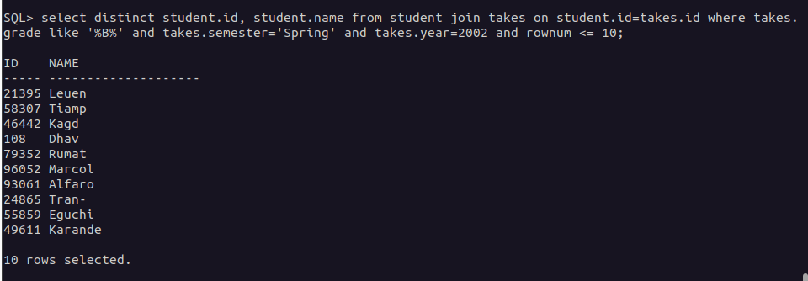

1. **Retrieve the names of instructors who have taught in the "Summer" semester of 2022.**

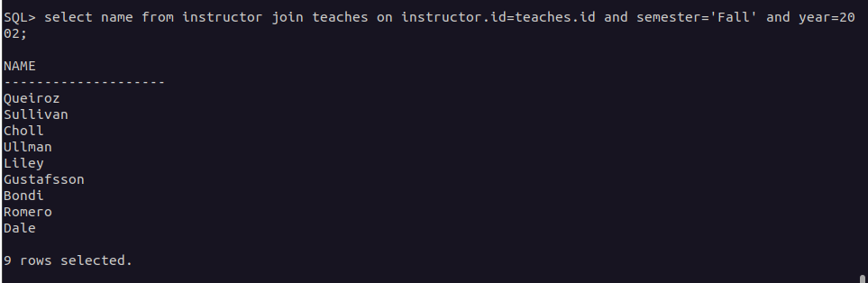

1. **Find the average number of credits offered by each department.**

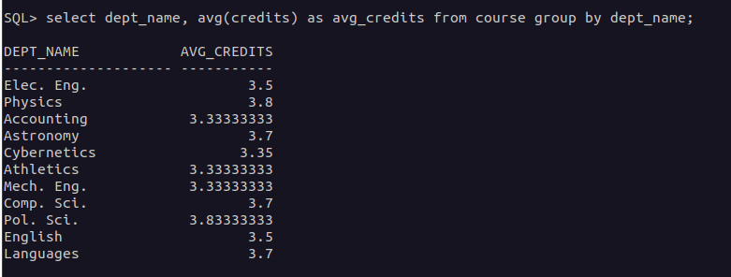

1. **List all courses that have exactly 1 credit.**

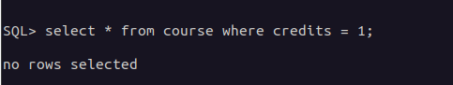

1. **Retrieve the names of students who have taken courses in the "Painter" building.**

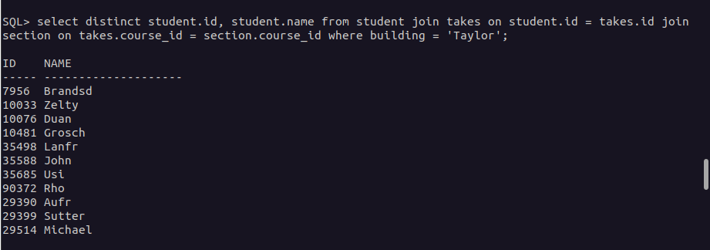

1. **Find the total number of students enrolled in each course.**

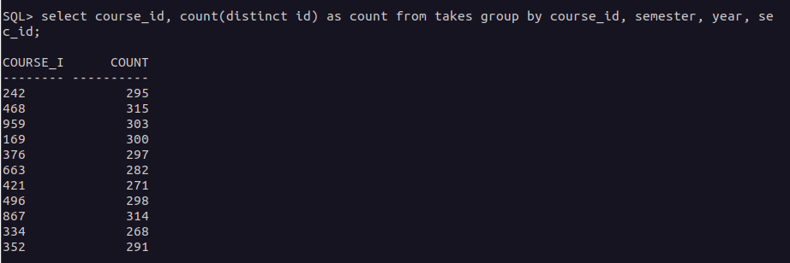

1. **List all sections that are held in rooms with a capacity of more than 100.**

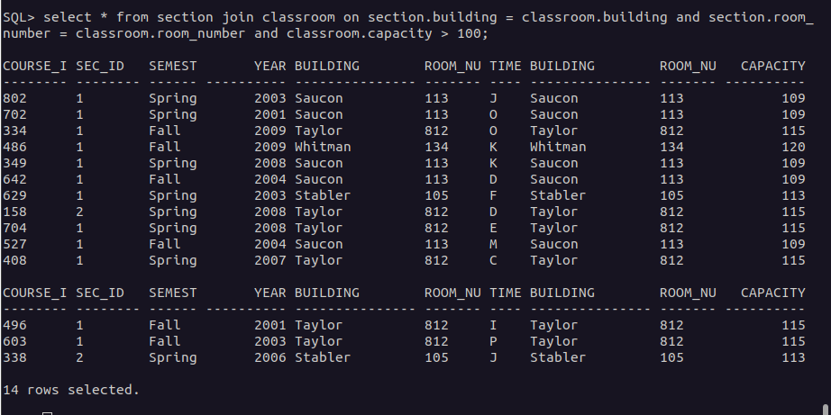

1. **Retrieve the names of students who have taken courses with the highest number of credits in their department.**

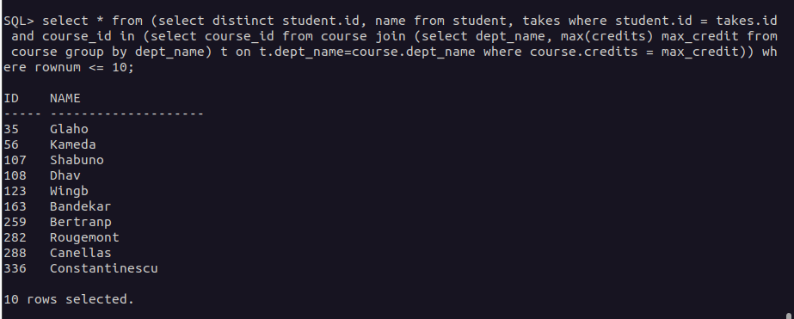

1. **Find the departments with the highest total budget.**

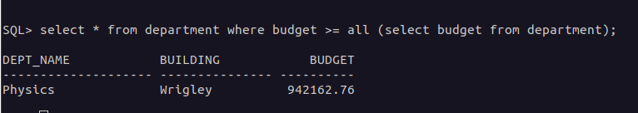

1. **List all courses that have been taught by more than 2 instructors.**

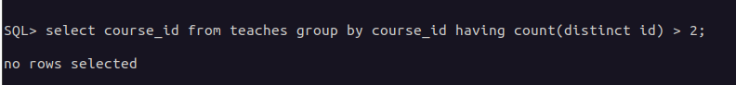

1. **List all students who have taken courses with a grade of "C" in the "Winter" semester of 2023.**

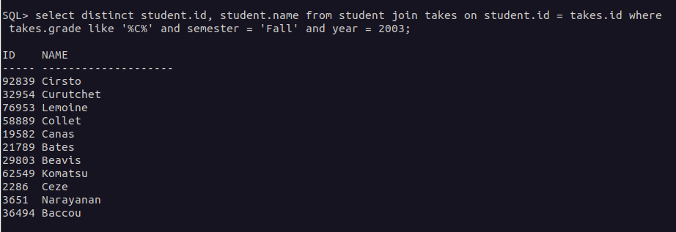

1. **Retrieve the names of instructors who have taught in the "Fall" semester of 2021.**

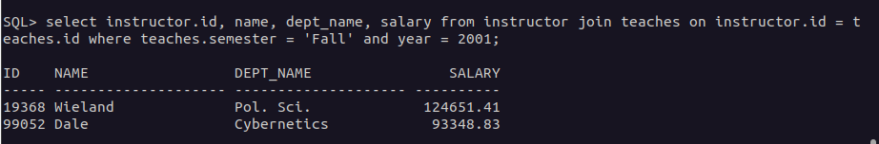

1. **Find the average number of sections taught per course.**

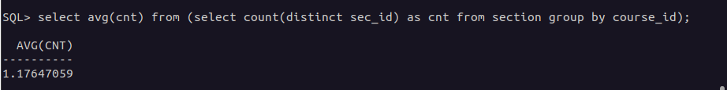

1. **List all courses that have exactly 2 credits.**



1. **Retrieve the names of students who have taken courses in the "Taylor" building.**

