Assignment 2,
Name – Kanhaiya
Roll No- 244CA022

- Retrieve the names of all instructors who teach at least one course in the 'Computer Science' department.

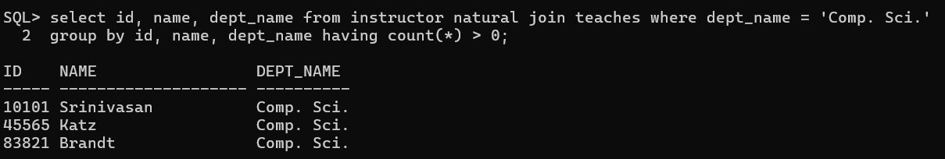

- List all students who have taken at least one course in 'Fall' and 'Spring' semesters in the same year.

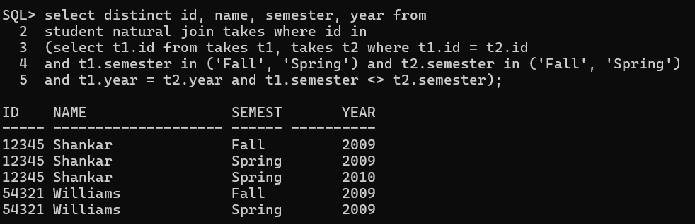

- Find all classrooms that have a capacity of more than 100 but are not assigned to any section.

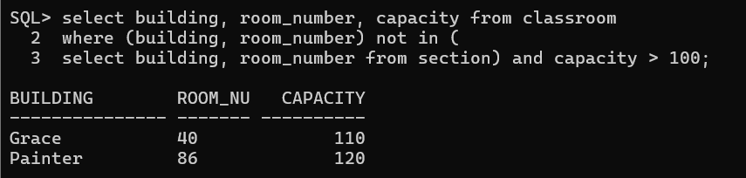

- Display all courses along with their prerequisites, including courses that have no prerequisites.
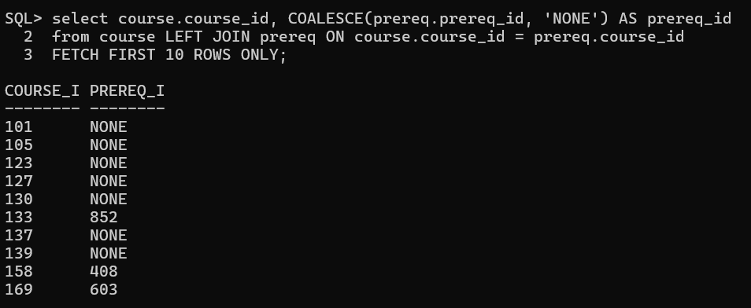

- Retrieve the list of instructors who have never taught a course.

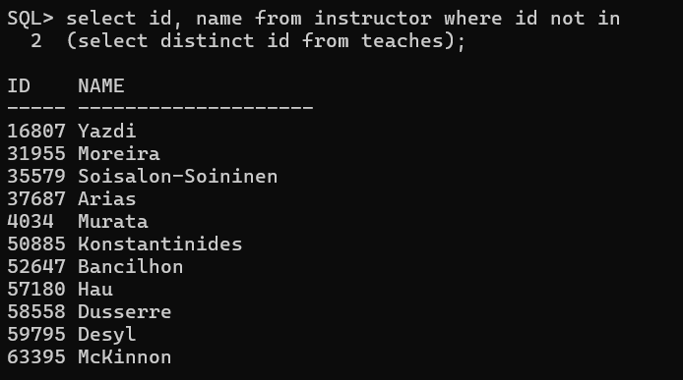

- Find the total budget allocated to all departments that have at least one instructor earning more than ₹100,000.
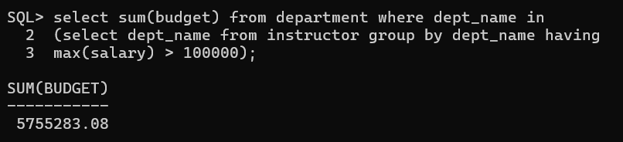

- Find the average salary of instructors grouped by department but only include departments with more than 5 instructors.

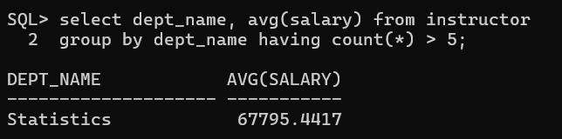

- Find the total number of students enrolled in each course for every semester, and sort by semester and number of students (descending).

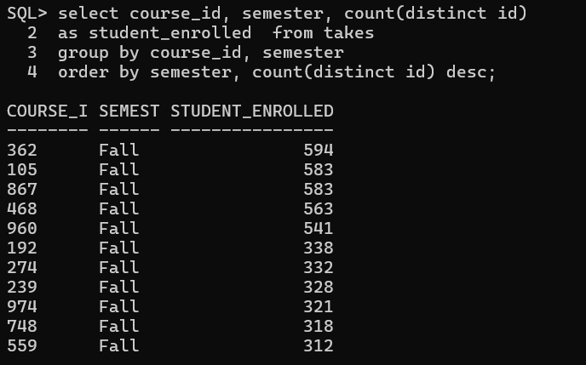

- Determine which department has the highest average course credit.

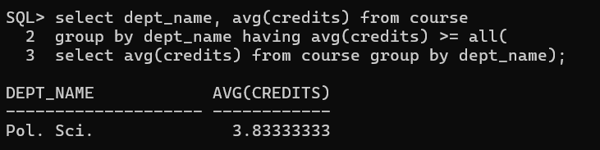

- Find the top 3 courses with the most students enrolled across all semesters.
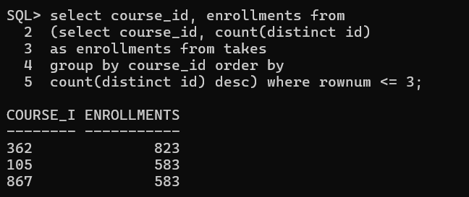

- Find all students who have taken every course taught by the instructor 'John Doe'.

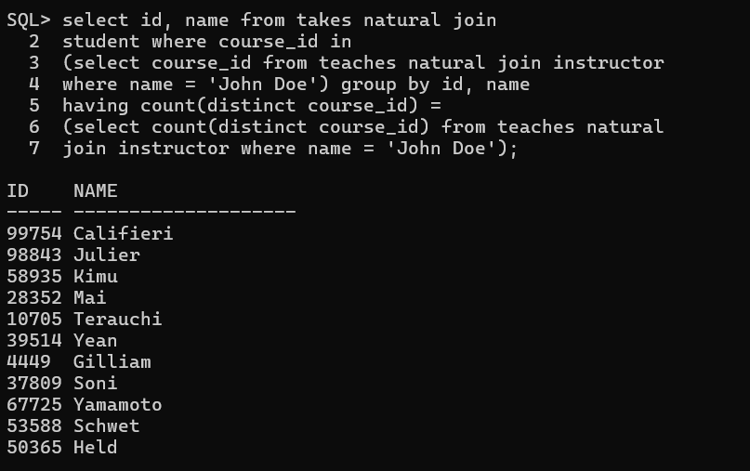
- Retrieve the names of students who have the same name as their advisor.

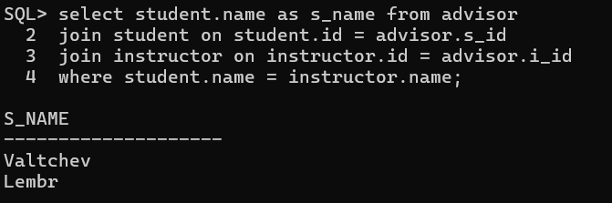

- Find all instructors who have taught at least one course that they did not belong to the department of.

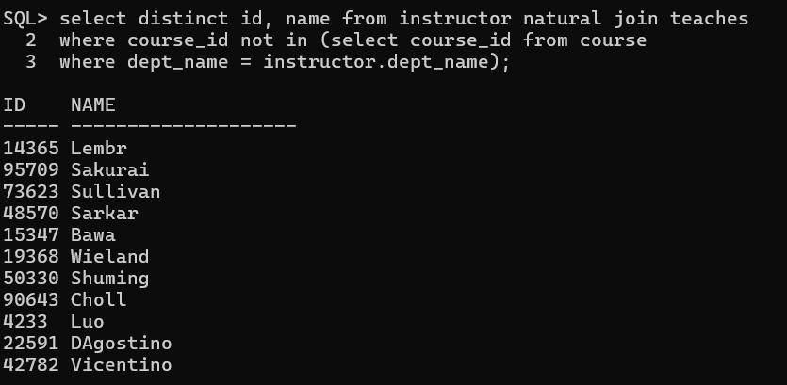

- List all students who have taken a course in a classroom that has a capacity less than the number of students enrolled.

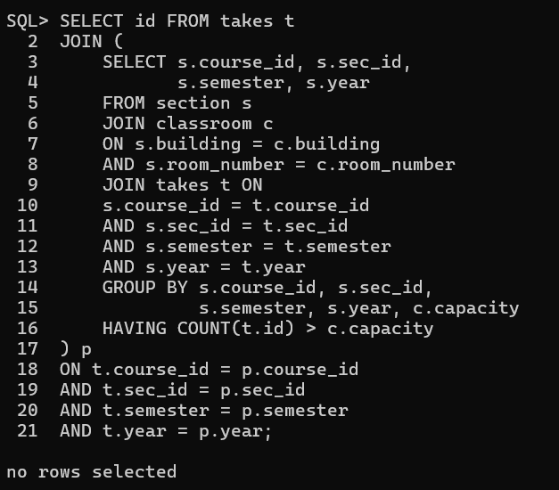

- Find students who have taken every course offered by their department.

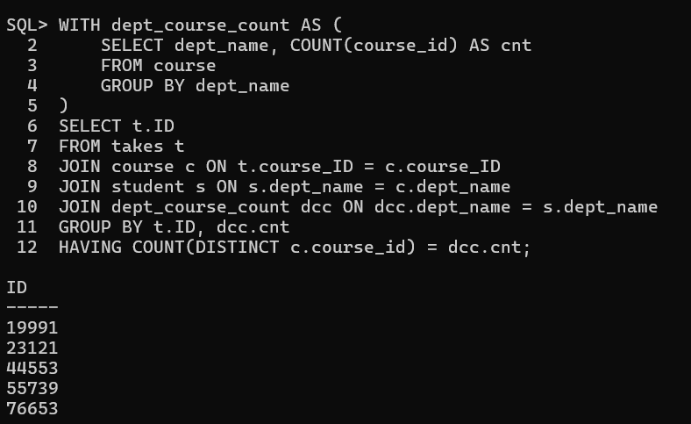
- Identify the department(s) with the largest number of distinct courses offered.

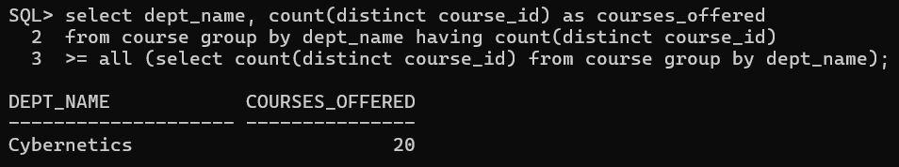

- Find students who have taken a course but have not received a grade.

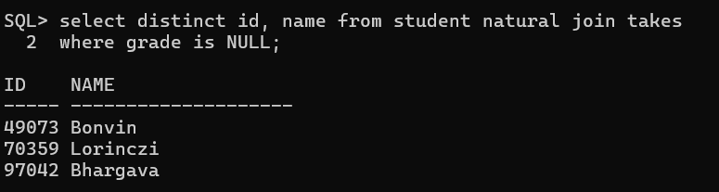

- Retrieve the details of instructors who have the exact same salary as another instructor.
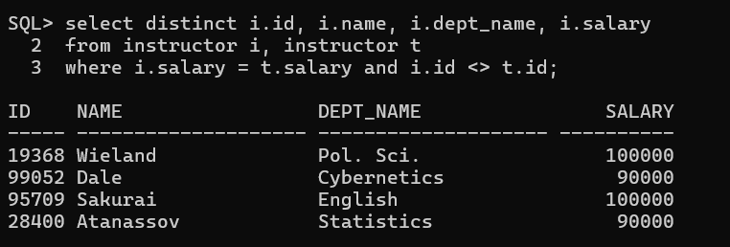

- Identify all courses that have prerequisites, but the prerequisite itself has no
prerequisite.
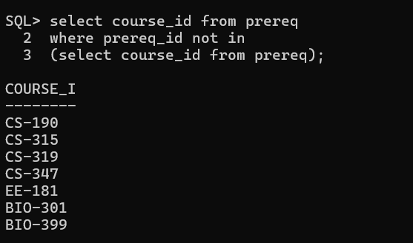

- Find all students who have taken courses in every semester (Fall, Spring)
at least once.
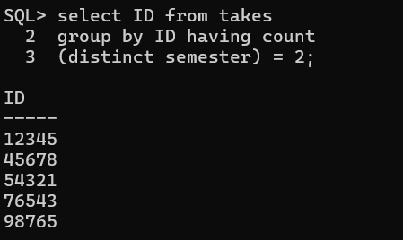

- Identify students who have taken a course whose prerequisite they have never
taken.
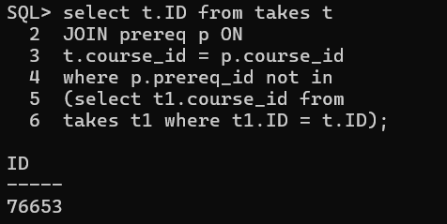

- Find all instructors who have taught a course that has another course as a
prerequisite.
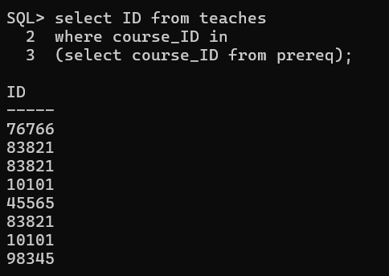

- Find all students who have the same total credits as another student in a different
department.

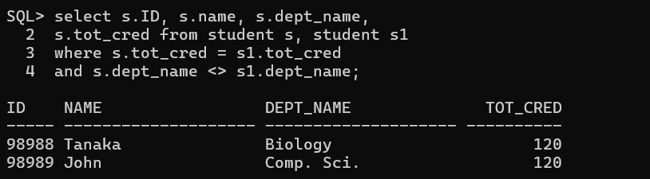

- Identify instructors who have the highest salary in their department but still earn
less than the highest salary in another department.

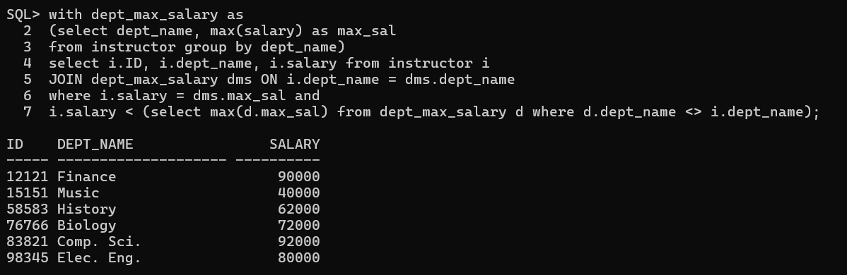

- List all departments where the highest-paid instructor earns more than the total
department budget divided by the number of instructors.

