ASSIGNMENT - 1
Name: Kanhiya Lavaniya
Roll No.: 30
Section: SB
Subject: Web Development

1. Explain the difference between frontend, backend, and full-stack development with suitable real-world examples.
Frontend development focuses on the part of a website that users can see and interact with. It includes the design, layout, navigation menus, buttons, forms, images, animations, and responsive design. Frontend developers mainly use HTML, CSS, and JavaScript along with frameworks such as React, Angular, or Vue.
Backend development focuses on the server side of a website. It handles business logic, user authentication, data processing, APIs, and communication with databases. Backend developers commonly use Java, Python, PHP, Node.js, or C#.
Full-stack development combines both frontend and backend development. A full-stack developer can build an entire web application, from the user interface to the server and database.
Example: In Amazon, the product page, search bar, and shopping cart are frontend features. Payment processing, order management, and user login are handled by the backend. A developer who works on both is called a full-stack developer.

2. Create a simple diagram showing how the client-server model works in web architecture.
Diagram:
+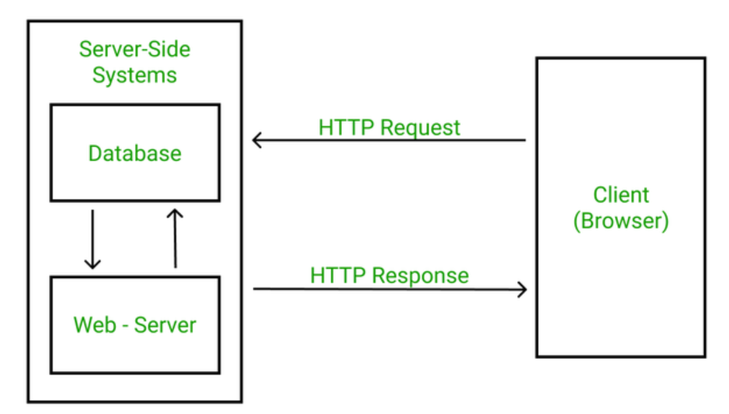
Explanation:
The browser (client) sends a request to the web server. The server processes the request, accesses the required files or database if necessary, and sends the response back to the browser, which displays the webpage.

3. Describe how a browser requests and displays a web page from a web server.
1. The user enters a URL in the browser.
2. DNS converts the domain name into an IP address.
3. The browser sends an HTTP/HTTPS request to the web server.
4. The server processes the request and may communicate with a database.
5. The server returns HTML, CSS, JavaScript, images, and other files.
6. The browser builds the Document Object Model (DOM), applies CSS styling, executes JavaScript, and finally renders the webpage on the screen.

4. Identify and list the tools required to set up a web development environment. Explain the purpose of each.
Visual Studio Code (VS Code): Used to write and edit source code.
- Web Browser: Used to test and view web pages.
- Live Server Extension: Automatically refreshes the page after saving changes.
- Node.js: Runs JavaScript outside the browser and provides npm.
- Git: Tracks changes in source code.
- GitHub: Stores projects online and supports collaboration.
- Terminal/Command Prompt: Executes development commands.
- Browser Developer Tools: Helps inspect and debug HTML, CSS, JavaScript, and network requests.

5. Explain what a web server is and give examples of commonly used servers.
A web server is software or hardware that stores website files, receives requests from browsers, processes those requests, and sends the requested web pages back using HTTP or HTTPS.
Common examples are Apache HTTP Server, Nginx, Microsoft IIS, LiteSpeed, and Node.js with Express. Large websites often use Nginx or Apache because they are fast, reliable, and scalable.

6. Define the roles of a frontend developer, backend developer, and database administrator in a project.
Frontend Developer: Designs and develops the user interface using HTML, CSS, and JavaScript. Ensures the website is responsive and user-friendly.
Backend Developer: Builds server-side logic, develops APIs, manages authentication, and connects the application with databases.
Database Administrator (DBA): Designs, secures, backs up, maintains, and optimizes the database to ensure data is stored safely and efficiently.

7. Install VS Code and configure it for HTML, CSS, and JavaScript development. Take a screenshot of the setup.
Steps:
1. Download and install Visual Studio Code. 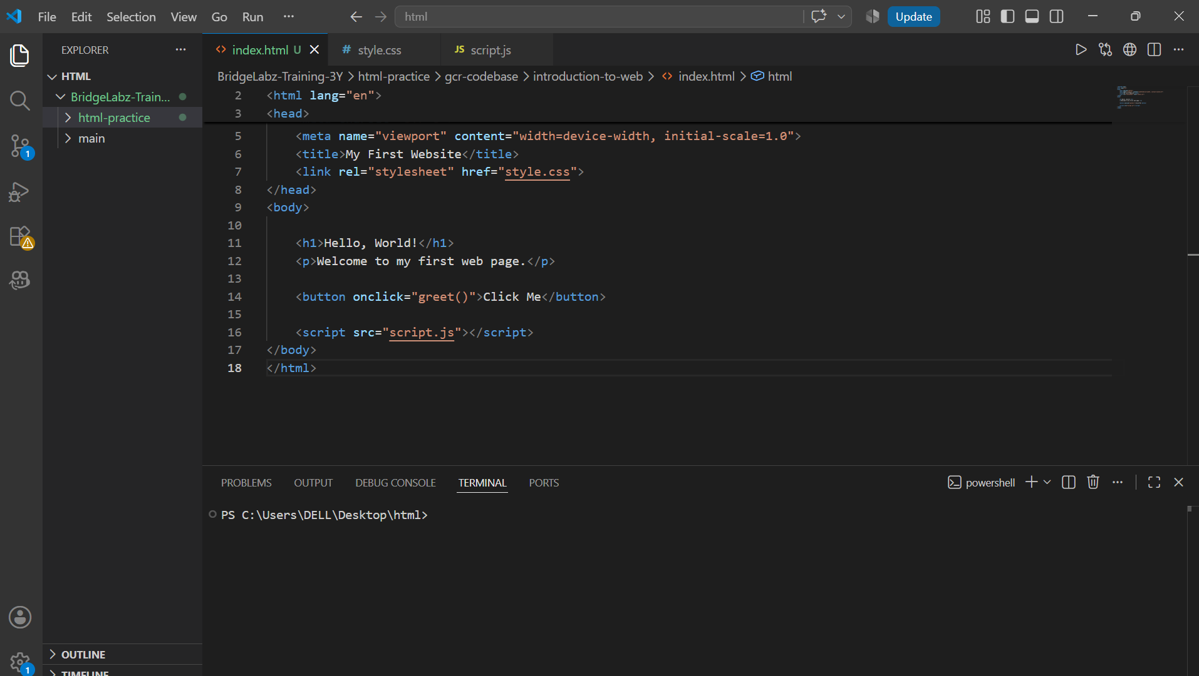
2. Install extensions: Live Server, HTML CSS Support, JavaScript (ES6) Snippets, Prettier, and Auto Rename Tag.
3. Create a project folder containing index.html, style.css, and script.js.
4. Open index.html with Live Server to run the project.
Note: Paste your VS Code setup screenshot below this answer before submitting the assignment.

8. Explain the difference between static and dynamic websites. Provide an example of each.
A static website displays the same content to every visitor and is mainly built using HTML and CSS. It is simple, fast, and does not require a database. Example: A personal portfolio website.
A dynamic website displays different content depending on user input or database information. It uses backend programming languages and databases. Examples: Amazon, Facebook, Gmail, and online banking websites.

9. Research and list five web browsers. Explain how rendering engines differ between them.
Google Chrome – Blink
Microsoft Edge – Blink
Mozilla Firefox – Gecko
Apple Safari – WebKit
Opera – Blink
A rendering engine converts HTML, CSS, and JavaScript into the webpage displayed on the screen. Blink focuses on speed and performance, Gecko emphasizes standards and privacy, while WebKit is optimized for Apple devices.

10.
Diagram:
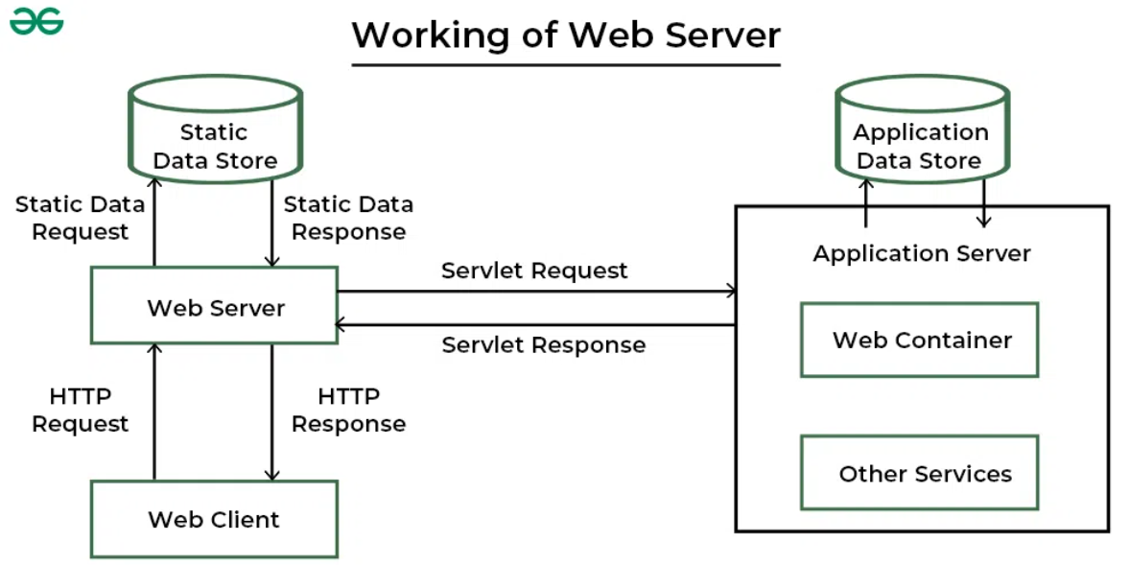
Explanation:
The browser sends a request to the web server. The server communicates with APIs and the database, processes the request, and returns the response to the browser. The browser then renders the webpage for the user.

