ASSIGNMENT – 1

* **OVERVIEW OF IT INDUSTRY**
* **WHAT IS SOFTWARE ENGINEERING.**

Software is a set of programs that that instruct computer what to do. It mainly comprises code, algorithms, and data structure necessary to operate a computer system. software is a set of instruction that tells a computer or other device how to perform. Software is made up programs, procedures, and routines that are written programming language.

Here some examples of software

1. Operating system: such as windows, which manage hardware resources and provide a platform for application run.
2. Application programs: such as photo editors, which perform specific task for user.

* **What is software engineering**

Software engineering is an engineering approach to software development. A practitioner, called a software engineer, applies the engineering design process to develop software. The term programmer and coder, software engineer.

A software engineer applies a software development process. Which involves defining, implementing, testing, managing, and maintain software systems and, creating and modifying the developing process.

**DESIGN**

Software design is the process of making high-level plans for the software.

Design is divided into:

* (1) Interface design: there will be a first step of software program. Fist we plan the upper face design. (2) architectural design: planes the major components of system, includes their responsibilities, properties, and interfaces between them. Detailed design: plans internal elements, including their properties, relationships, algorithms and data structures.

**Construction**

Software construction typically involves programming, unit testing, integration testing, and debugging so as to implement the design. Testing during this phase is generally performed by the programmer and with the purpose to verify that the code behaves as designed and to know when the code is ready for the next level of testing.

**Testing**

Software testing is an empirical, technical investigation conducted to provide stakeholders with information about the quality of the software under test. vWhen described separately from construction, testing typically is performed by test engineering quality assurance   instead of the programmers who wrote it. It is performed at the system and is considered an aspect of software quality.

**Maintenance**

Software maintenance refers to supporting the software after release. It may include but is not limited to: error correction, optimization, deletion of unused and discarded features, and enhancement of existing features.

* **Types of software**
* **There are mainly two types of software**

1. Operating system
2. Application software

User

Application software

Hardware

Operating system

1 operating system are “the layer of software that manages a computer’s resources for its users and their applications”. There are three main purposes that an operating system fulfils.

1. Allocating resources between different applications, deciding when they will receive central processing units time or space in memory.
2. Providing an interface that abstracts the details of accessing hardware details to make things easier for programmers.
3. Offering common service, such as an interface for accessing network and disk devices. This enables an application to be run on different hardware without needing to rewritten.

(2) application software runs on top of the operating systems and uses the computer’s resources to perform a task. There are many different types of application software because the rang of tasks that can be modern computer so large.

* **What is SDLC**. (SOFTWARE DEVLOPMENT LIFE CYCLE)
* Software development life cycle is a structured process that is used to design, develop, and test good quality software.
* SDLC or software development life cycle, is a methodology that defines the entire procedure of software development step-by-step.

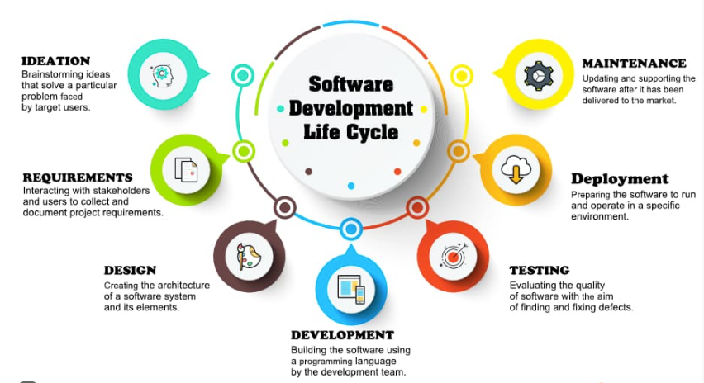

* **Explain each phase of SDLC.**
* **Planning:** Requirement analysis is the most important and fundamental stage in SDLC. It is performed by the senior members of the team with inputs from the customer, the sales department, market surveys and domain experts in the industry. This information is then used to plan the basic project approach and to conduct product feasibility study in the economical, operational and technical areas.
* **Designing the Product Architecture**: SRS is the reference for product architects to come out with the best architecture for the product to be developed. Based on the requirements specified in SRS, usually more than one design approach for the product architecture is proposed and documented in a DDS - Design Document Specification.
* **Developing the Product:** In this stage of SDLC the actual development starts and the product is built. The programming code is generated as per DDS during this stage. If the design is performed in a detailed and organized manner, code generation can be accomplished without much hassle.
* **Testing:** This stage is usually a subset of all the stages as in the modern SDLC models, the testing activities are mostly involved in all the stages of SDLC. However, this stage refers to the testing only stage of the product where product defects are reported, tracked, fixed and retested, until the product reaches the quality standards defined in the SRS.
* **Maintenance:** Once the product is tested and ready to be deployed it is released formally in the appropriate market. Sometimes product deployment happens in stages as per the business strategy of that organization. The product may first be released in a limited segment and tested in the real business environment.
* **What is DFD?**
* Data Flow Diagram (DFD) represents the flow of data within information systems. Data Flow Diagrams (DFD) provide a graphical representation of the data flow of a system that can be understood by both technical and non-technical users. The models enable software engineers, customers, and users to work together effectively during the analysis and specification of requirements.
* **DFD diagram on flipkart.**



**Level-0**

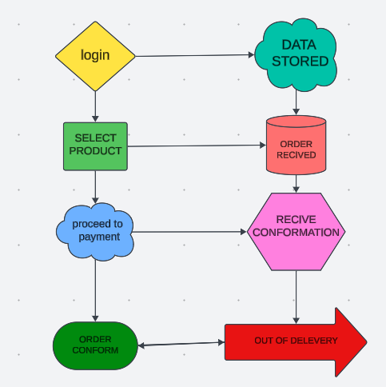

**Level-1**

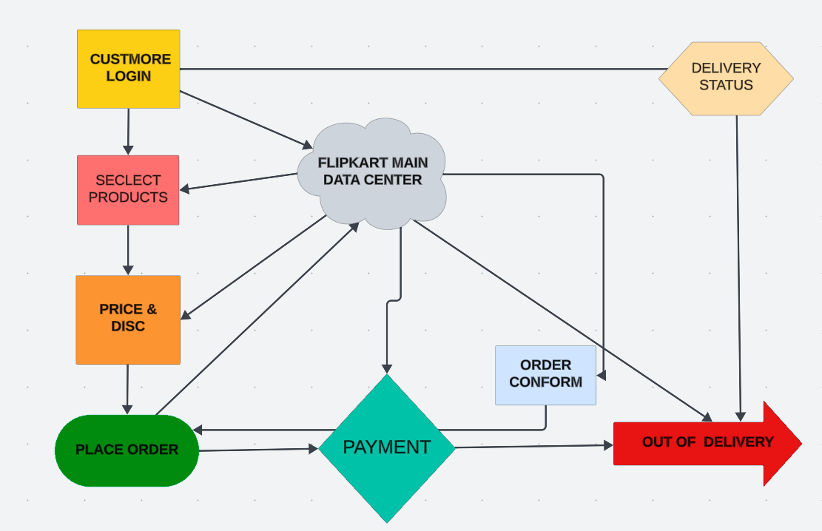

* **What is flow chart? And create a flowchart to make additional of two numbers.**
* A flowchart is a type of diagram that represents a workflow or process. A flowchart can also be defined as a diagrammatic representation of an algorithm, a step-by-step approach to solving a task the flowchart shows the steps as boxes of various kinds, and their order by connecting the boxes with arrows. This diagrammatic representation illustrates a solution model to a given problem. Flowcharts are used in analysing, designing, documenting or managing a process or program in various fields.

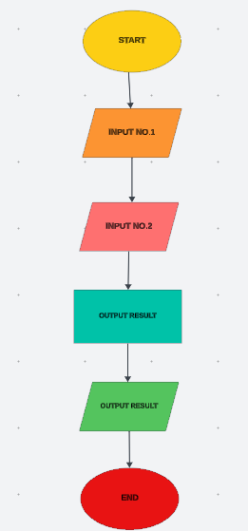

* **What is use case diagram? Create a use- case on bill payment.**
* A use case diagram is a visual representation of how users interact with a system, and is a key tool in the early stages of system design and development. It helps everyone involved understand how the system will function, and is used in the Unified Modelling Language.

**Diagram**

