Game Design Document
Fill up the Following document

- Write the title of your project.
Ron-The Savior

- What is the goal of the game?
Ron should kill the hunters in order to save the birds.

- Write a brief story of your game?

There is bird flu all around the country, hunters are also hunting for birds but there is one activist Ron who decides to save the birds by giving the two hunters a lesson by killing them.

- Which are the playing characters of this game?
- Playing characters are the ones which respond to the user based on the input from the user
- Cars, monkeys, dinos, wizards etc, are the playing characters in the game.
Number | Character Name | What can this character do?
1 | Ron | Shoot the hunter
2 | Hunter 1 | Shoot the birds
3 | Hunter 2 | Shoot the birds
4
5
6
7
8

- Which are the Non-Playing Characters of this game?
- Non-Playing characters are the ones which don't have an action or a behavior when the user interacts with the game.
- Hurdles, stones, bananas, coins, etc are non-playing characters in the game.
Number | Character Name | What can this character do?
1 | Bird 1 | Sitting on the tree
2 | Bird 2 | Sitting on the tree
3 | Bird 3 | Sitting on the tree
4 | Bird 4 | Sitting on the tree
5
6
7
8

Draw your imagination of this game. What does this game look like?
- Draw the game either on your computer or on paper,
- Add images of scenes of the game to show each of the playing and non-playing characters at least once. 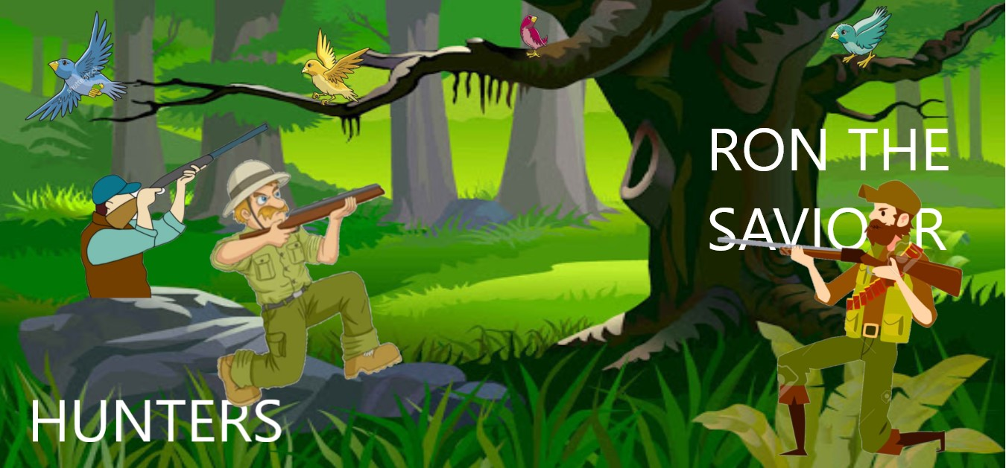

How do you plan to make your game engaging?

I plan to make my game engaging by giving good graphics and also by making people understand humanity. It will teach people how to preserve nature and be like Ron and save & preserve nature

