Application Specific Access Policies Using Zscaler Private Access (ZPA)

COLLEGE NAME : Shri Nehru Maha Vidyalaya College of Arts and Science
TEAM ID : SWTID-2026-1028
TEAM LEADER : Suseendra kanimozhi .T
EMAIL ID : 23bcasuseendrakanimozhi@gmail.com
TEAM MEMBER : Beula.S
EMAIL ID : beulakrishnaveni03@gmail.com
TEAM MEMBER : Janarthanan.S
EMAIL ID : sivakumarjanarthanab06@gmail.com
TEAM MEMBER : Pradeep.G
EMAIL ID : 23bcapradeep.g@gmail.com

PROJECT TITLE
Application Specific Access Policies Using Zscaler Private Access (ZPA)
Overview of the project

This project focuses on implementing secure, application-level access control using a Zero Trust Architecture (ZTA) approach. Instead of granting users full network access, access is restricted to specific applications based on identity, context, and policies.
Using ZPA, organizations can ensure that only authorized users can access internal applications, without exposing the network to the internet.
This project implements a cybersecurity framework where each access request is evaluated in real time using multiple security parameters, including:

- Implement Zero Trust Network Access (ZTNA) principles
- Provide secure remote access to internal apps
- Replace traditional VPN-based access
- Enforce granular, application-specific policies
- Improve security posture and user experience

Based on these factors, the system dynamically enforces security decisions such as granting access, limiting access, requiring additional verification, or completely blocking suspicious requests.For example, a legitimate employee accessing a low-risk application from a secured corporate device may be granted seamless access. However, if the same user attempts to access critical systems from an untrusted device or unusual location, the system will enforce stricter authentication or deny access altogether.This approach significantly enhances cybersecurity by minimizing the attack surface, preventing lateral movement within the network, and protecting against credential theft and insider threats. Additionally, it provides centralized monitoring, logging, and policy management, enabling security teams to detect and respond to threats more effectively.Ultimately, this project aims to develop a robust, scalable, and intelligent cybersecurity solution that ensures secure access to organizational resources while supporting a flexible and modern digital work environment. By leveraging ZTNA with Zscaler, organizations can achieve stronger protection, better control, and improved user experience in today’s threat landscape.

ABSTRACT

In today’s rapidly evolving digital environment, organizations face increasing cybersecurity challenges due to the widespread adoption of cloud computing, remote work, and mobile devices. Traditional security models that rely on perimeter-based defenses are no longer sufficient to protect sensitive data and critical systems. This project presents the implementation and management of a Zero Trust Network Access (ZTNA) framework using the cloud security platform Zscaler to enhance modern cybersecurity practices.The proposed system is based on the Zero Trust principle of “never trust, always verify,” where every user, device, and access request is continuously authenticated and authorized. By leveraging solutions such as Zscaler Private Access (ZPA) and Zscaler Internet Access (ZIA), the project ensures secure, application-level access without exposing the internal network.The system evaluates multiple contextual factors, including user identity, device security posture, application sensitivity, and network conditions, to make real-time access decisions. Based on the risk level, access can be granted, restricted, or denied, thereby minimizing unauthorized access and reducing the overall attack surface.This project aims to provide a scalable, secure, and efficient access control solution that improves visibility, strengthens data protection, and supports a flexible work environment. By adopting ZTNA, organizations can effectively mitigate cyber threats, prevent data breaches, and establish a robust cybersecurity framework aligned with modern security requirements.
Use Case Scenarios

Scenario 1: Secure Remote Employee Access to Internal Application A full-time employee needs to access an internal HR management system while working from home. The user connects using a company-managed laptop and launches the ZTNA client provided by Zscaler Private Access (ZPA). The user authenticates through the organization’s Identity Provider with Multi-Factor Authentication (MFA). The system verifies the user’s identity, role, and device compliance (updated OS, antivirus enabled).
Output:
• User authenticated and verified based on identity and device posture
• Secure micro-tunnel established directly to the HR application
• Internal network remains hidden and inaccessible
Scenario 2: Access Attempt from Unmanaged Device
An employee attempts to access a sensitive internal database from a personal laptop that is not managed by the organization. When connecting through Zscaler, the system performs device posture checks and detects missing security controls such as antivirus and system updates.
Output:
• Device identified as non-compliant and high risk
• Access denied or restricted based on security policies
• User prompted to switch to a secure, managed device
Scenario 3: Access from Suspicious Geographic Location
A user tries to log in to a financial application from a foreign country where they do not usually operate. The system flags this as an unusual login attempt and increases the risk score. Additional verification steps are triggered.
Output:
• User identity verified with additional MFA challenge
• Access either restricted or blocked based on risk level
• Security alert generated for monitoring suspicious activity
Scenario 4: Third-Party Vendor Limited Access
A third-party vendor is given temporary access to a specific internal application for maintenance purposes. The vendor logs in using assigned credentials and is authenticated via the identity provider. Access policies ensure that the vendor can only reach the required application.
Output:
• Vendor authenticated with role-based access control
• Access limited strictly to one application
• No visibility or access to other internal systems
Scenario 5: Protection Against Compromised Credentials
An attacker attempts to access the system using stolen user credentials from an unknown device and network. The system evaluates multiple contextual signals including device, behavior, and location, and detects anomalies.
Output:
• Access request flagged as high-risk and unauthorized
• Connection blocked before reaching the application
• Incident logged and security team notified

Stage – 1
Title: OWASP TOP 10

Overview

The OWASP Top 10 is a globally recognized list of the most critical security risks to web applications, maintained by the Open Web Application Security Project (OWASP), aimed at helping developers, security teams, and organizations prioritize protections. It identifies the most common vulnerabilities, starting with Broken Access Control, where improper
enforcement of user permissions allows unauthorized actions, and Cryptographic Failures, which involve weak encryption or mishandling of sensitive data. Injection flaws, such as SQL or command injection, occur when untrusted input is sent to interpreters, while Insecure Design arises from missing security considerations in the development process. Security Misconfiguration refers to improper setup of systems or software, and Vulnerable and Outdated Components highlight the dangers of using libraries or frameworks with known security issues. Identification and Authentication Failures include weak passwords, session flaws, or missing multi-factor authentication, and Software and Data Integrity Failures involve unverified updates or unsafe deserialization. Security Logging and Monitoring Failures can prevent timely detection of breaches, and Server-Side Request Forgery (SSRF) allows attackers to manipulate servers into accessing unintended internal resources. Collectively, the OWASP Top 10 provides a practical baseline for secure coding, risk assessment, proactive monitoring, and mitigation strategies, helping organizations reduce the likelihood and impact of web application attacks while fostering a culture of security-aware development.

List of vulnerability

S.No | Vulnerability Name | CWE/CVE No
1 | Absolute Path Traversal | CWE 36
2 | Sensitive Cookie in HTTPS Session Without 'Secure' Attribute | CWE-614
3 | Dependency on Vulnerable Third-Party Component | CWE-1395
4 | Missing Cryptographic Step | CWE-325
5 | Improper Input Validation | CWE-20
6 | Trust Boundary Violation | CWE-501
7 | Weak Password Requirements | CWE-521
8 | Missing Support for Integrity Check | CWE-353
9 | Information Loss or Omission | CWE-221
10 | Unchecked Return Value | CWE-252

Report:
1) Vulnerability Name: Absolute Path Traversal
CWE NO: CWE 36
OWASP Category: A01:2025 Broken Access Control
Description: Absolute Path Traversal happens when a web application accepts user-supplied input as a file path and directly uses it to access files on the system. If the application does not properly validate or sanitize this input, an attacker can provide a full absolute path (starting from the root directory) to read or sometimes modify sensitive files on the server.Instead of being limited to the intended directory, the attacker can access files anywhere on the server’s file system.
Business Impact: Absolute Path Traversal may allow attackers to access sensitive files such as configuration files, credentials, or system data. This can lead to data breaches, unauthorized system access, and exposure of confidential information. The vulnerability may cause service disruption, reputational damage, financial loss, and potential legal or regulatory consequences for the organization.

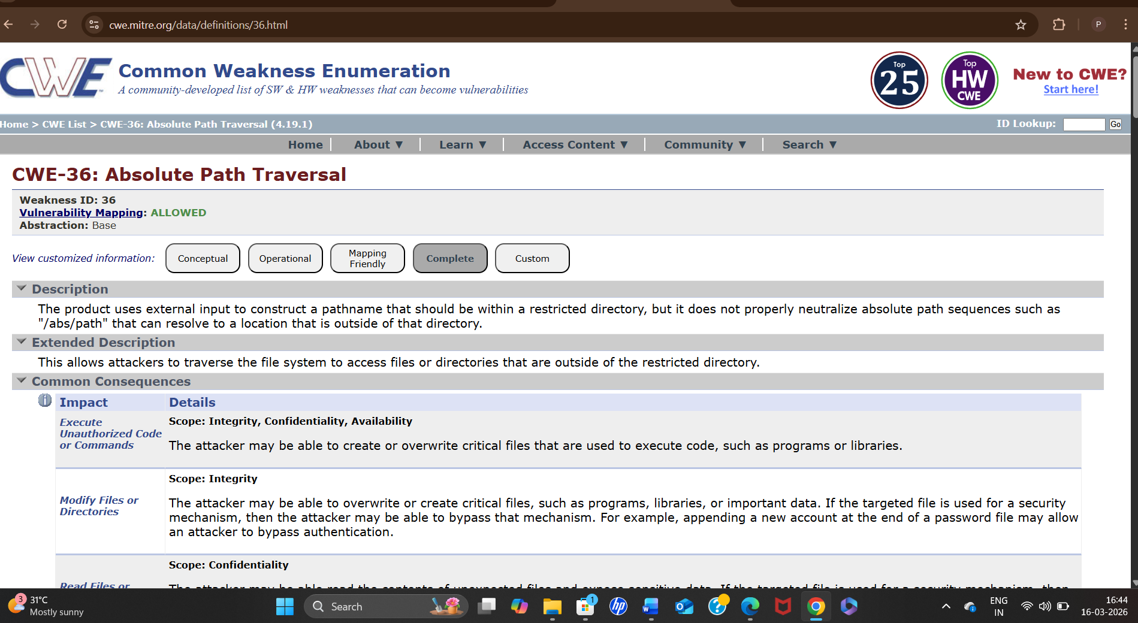

2)Vulnerability Name: Sensitive Cookie in HTTPS Session Without 'Secure' Attribute
CWE NO: CWE 614
OWASP Category: A02:2025 Security Misconfiguration
Description: The Sensitive Cookie in HTTPS Session Without 'Secure' Attribute vulnerability occurs when a web application sets cookies containing sensitive information (such as session IDs or authentication tokens) without enabling the Secure attribute.The Secure attribute ensures that cookies are transmitted only over HTTPS connections. When this attribute is missing, the browser may send the cookie over an unencrypted HTTP connection, even if the user initially accessed the application through HTTPS.This behavior exposes sensitive session cookies to potential interception through man-in-the-middle (MITM) attacks, network sniffing, or insecure network environments. If an attacker captures the session cookie, they may use it to hijack the user’s session and gain unauthorized access to the application without needing valid credentials.
Business Impact: Missing the Secure attribute on sensitive cookies may allow attackers to intercept session cookies over insecure connections. This can lead to session hijacking, unauthorized account access, and exposure of sensitive user data. Such incidents may result in data breaches, financial losses, reputational damage, and potential legal or regulatory compliance issues for the organization.

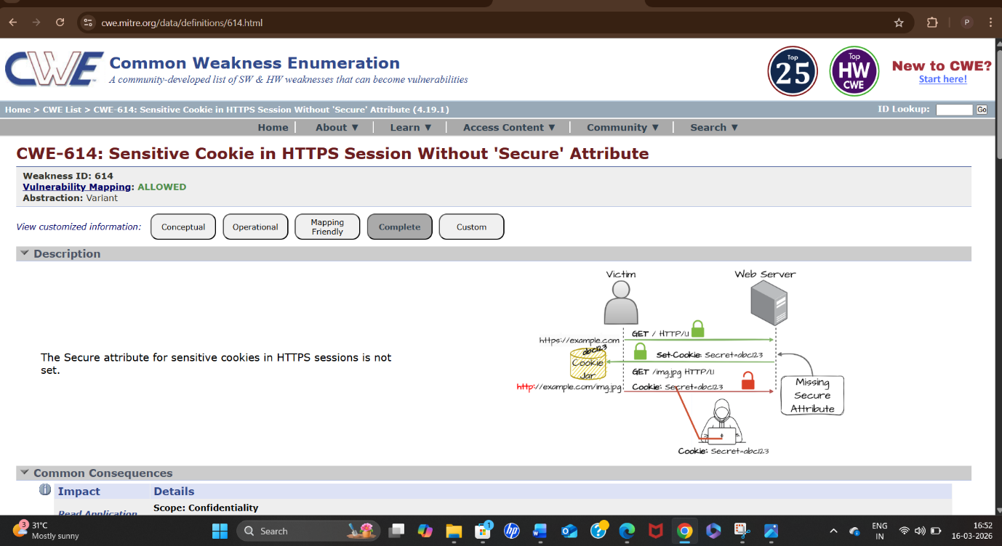

3)Vulnerability Name: Dependency on Vulnerable Third-Party Component
CWE NO: CWE 1395
OWASP Category: A03:2025 Software Supply Chain Failures
Description: Dependency on Vulnerable Third-Party Component is a security vulnerability that occurs when an application uses external libraries, frameworks, plugins, or software components that contain known security flaws.Modern applications commonly rely on third-party components to speed up development and provide additional functionality. However, if these components are outdated or contain known vulnerabilities, attackers may exploit those weaknesses to compromise the application.These vulnerabilities are often publicly documented in security databases such as the Common Vulnerabilities and Exposures (CVE) and monitored through the National Vulnerability Database. If developers fail to regularly update or patch these components, the application inherits the security risks associated with them.
Business Impact: Using vulnerable third-party components may expose the application to known security flaws that attackers can exploit. This can lead to unauthorized access, data breaches, system compromise, or service disruption. Such incidents may result in financial losses, operational downtime, reputational damage, and potential legal or regulatory compliance issues for the organization.
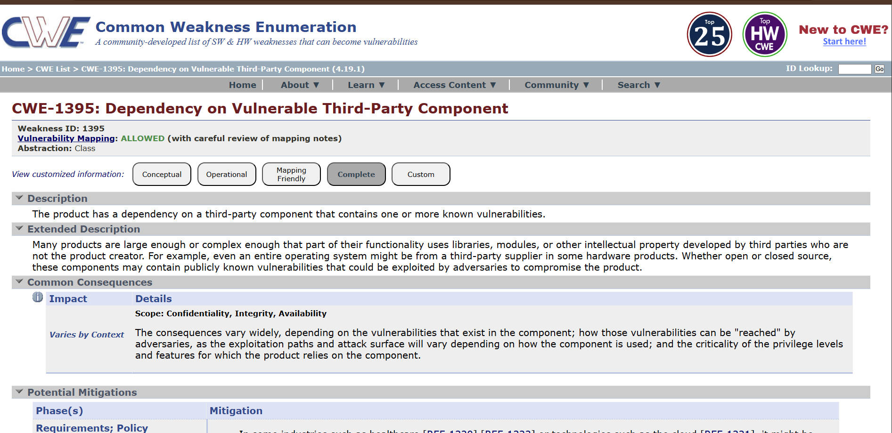

4)Vulnerability Name: Missing Cryptographic Step
CWE NO: CWE-325
OWASP Category: A04:2025 Cryptographic Failures
Description: Missing Cryptographic Step is a security vulnerability that occurs when an application fails to apply necessary cryptographic protections, such as encryption, hashing, or digital signing, during data processing or transmission.Cryptographic mechanisms are essential for protecting sensitive information such as passwords, session tokens, and confidential data. When a required cryptographic step is omitted, the data may be stored or transmitted in plain text or with weak protection.This weakness can expose sensitive information to attackers through interception, unauthorized access, or data manipulation. As a result, attackers may be able to read, modify, or misuse sensitive data
Business Impact: Missing cryptographic protection may expose sensitive data such as passwords, personal information, or financial details in plain text. Attackers could intercept or manipulate this data, leading to unauthorized access and data breaches. This may cause financial losses, regulatory penalties, operational disruption, and reputational damage, ultimately reducing customer trust in the organization.

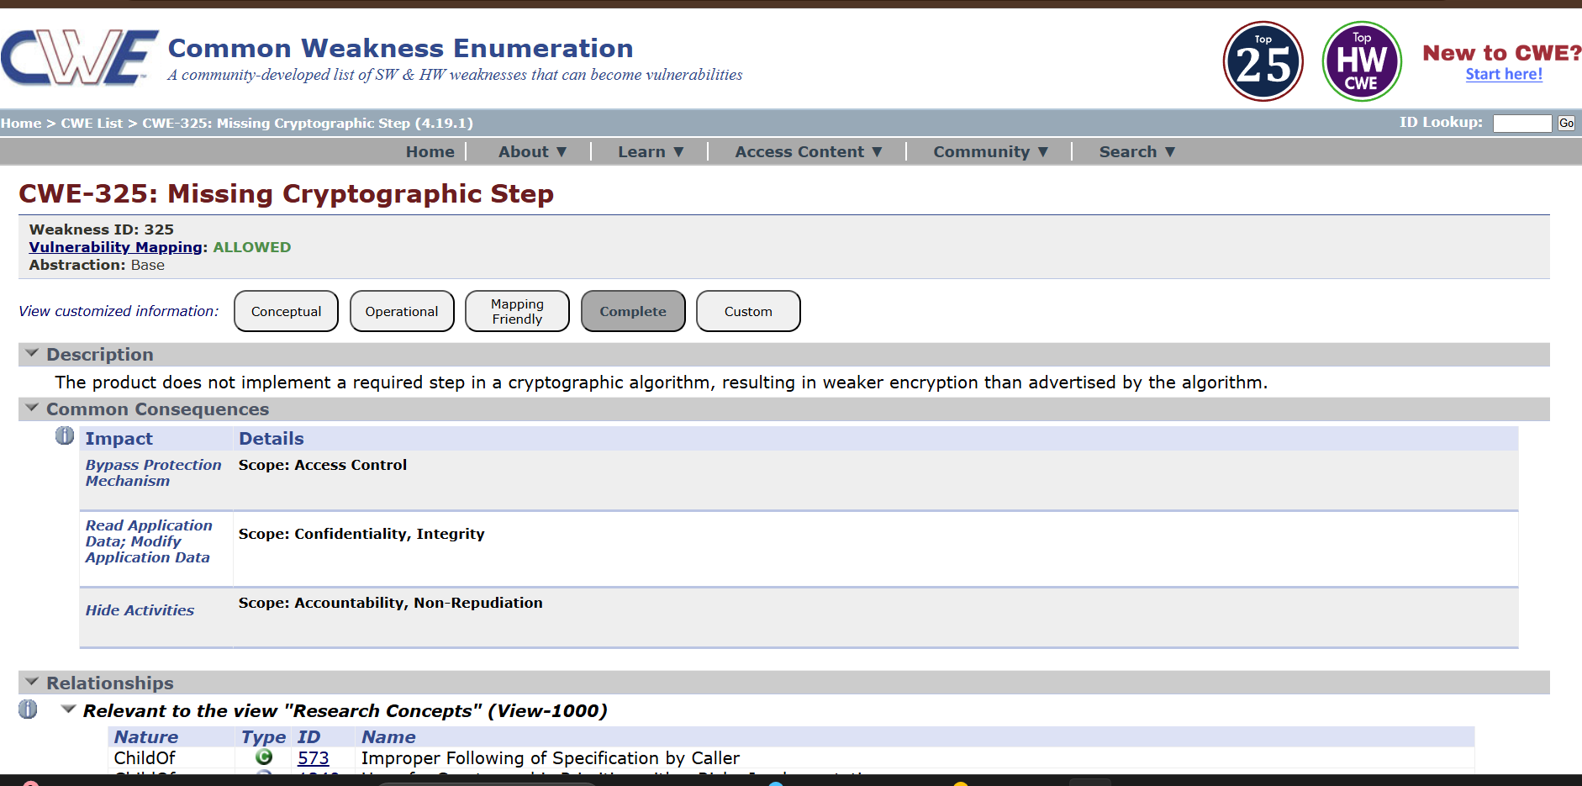

5)Vulnerability Name: Improper Input Validation
CWE NO: CWE-20
OWASP Category: A05:2025 Injection
Description: Improper Input Validation is a security vulnerability that occurs when an application fails to properly validate or sanitize user-supplied input before processing it. Applications often accept input from users through forms, URLs, cookies, or APIs, and if this input is not properly checked, attackers may submit malicious data.Without proper validation, the application may process unexpected or harmful input, which can lead to various attacks such as injection attacks, unauthorized data access, or manipulation of application logic.This vulnerability can affect multiple parts of an application, including databases, file systems, and system commands. Attackers may exploit it to bypass security controls, access restricted resources, or disrupt normal application functionality.
Business Impact: Improper Input Validation can allow attackers to inject malicious data, bypass security controls, or manipulate application behavior. This may lead to data breaches, unauthorized access, service disruption, or financial fraud. The organization risks regulatory penalties, operational downtime, reputational damage, and loss of customer trust due to compromised application security.

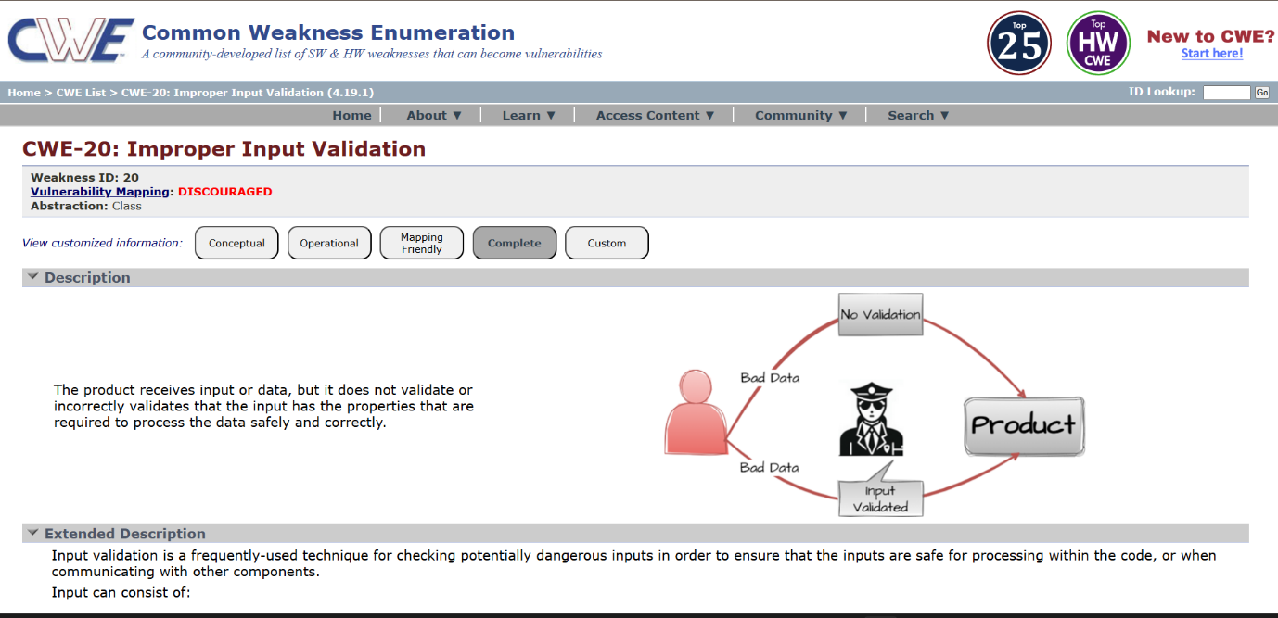

6)Vulnerability Name: Trust Boundary Violation
CWE NO: CWE-501
OWASP Category: A06:2025 Insecure Design
Description: A Trust Boundary Violation is a type of security vulnerability that occurs when data or control flows cross a trust boundary in a system without proper validation or verification. A trust boundary is the point at which different levels of trust exist—for example, between user input and server-side logic, between different subsystems, or between a client and a server. Violating this boundary can allow attackers to manipulate data, bypass security controls, or execute unauthorized actions.
Business Impact: A Trust Boundary Violation occurs when untrusted data crosses a system’s trust boundary without proper validation or verification. From a business perspective, it can have serious consequences. Sensitive customer or corporate data may be exposed, leading to data breaches and regulatory fines. Attackers can manipulate transactions or bypass security controls, causing financial loss. Exploited vulnerabilities may disrupt operations, resulting in downtime and reduced productivity. Publicized incidents damage brand reputation and customer trust. Additionally, organizations face compliance risks and potential legal action. Overall, trust boundary violations pose a high strategic, operational, and financial risk to any business.

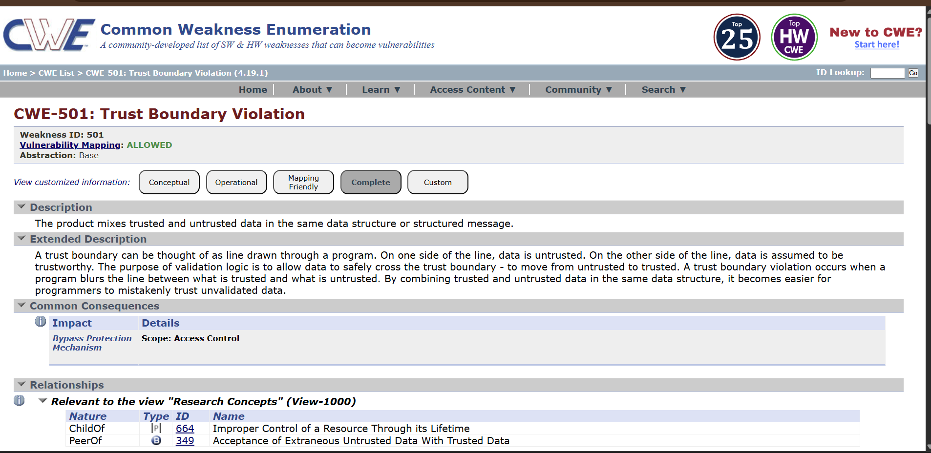

7)Vulnerability Name: Weak Password Requirements
CWE NO: CWE-521
OWASP Category : A07:2025 Authentication Failures
Description: A Weak Password Requirements vulnerability arises when a system allows users to create easily guessable or simple passwords. This includes short passwords, common words, predictable patterns, or lack of character diversity, making accounts susceptible to brute-force, dictionary, or credential-stuffing attacks. Exploiting this vulnerability can lead to unauthorized access, data theft, account compromise, and potential lateral movement within an organization’s systems. Examples include passwords like “12345” or “password” and no enforcement of complexity rules or reuse restrictions. Prevention involves enforcing strong password policies, requiring a mix of letters, numbers, and symbols, implementing multi-factor authentication, and encouraging regular password updates.
Business Impact: A Weak Password Requirements vulnerability poses significant business risks. Weak passwords make it easier for attackers to compromise user accounts, leading to unauthorized access to sensitive corporate or customer data. This can result in data breaches, regulatory fines, and legal penalties. Account compromises may allow fraud, financial loss, or manipulation of critical systems, disrupting operations and causing downtime. Public disclosure of such incidents harms brand reputation and erodes customer trust. Additionally, organizations face compliance risks if password policies fail to meet standards like GDPR, HIPAA, or PCI-DSS. Overall, weak password enforcement threatens financial, operational, and strategic business stability.

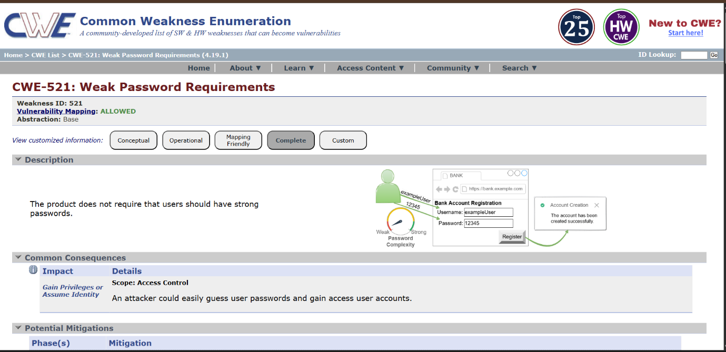

8) Vulnerability Name: Missing Support for Integrity Check
CWE NO: CWE-353
OWASP Category : A08:2025 Software or Data Integrity Failures
Description: A Missing Support for Integrity Check vulnerability occurs when a system fails to verify that data has not been altered, corrupted, or tampered with during storage or transmission. Integrity checks ensure that information remains accurate and trustworthy, typically using mechanisms like checksums, hashes, or digital signatures.
Business Impact: A Missing Support for Integrity Check vulnerability can have serious business consequences. Without integrity verification, data can be altered, corrupted, or tampered with without detection, leading to unauthorized changes in critical information. This can result in financial losses, fraud, or operational errors idecisions are made based on compromised data. It may also damage customer trust if sensitive information is affected and lead to regulatory or compliance violations in industries with strict data protection standards. Additionally, attackers could inject malicious code or manipulate software updates, causing system downtime, reputational damage, and strategic risks for the organization.

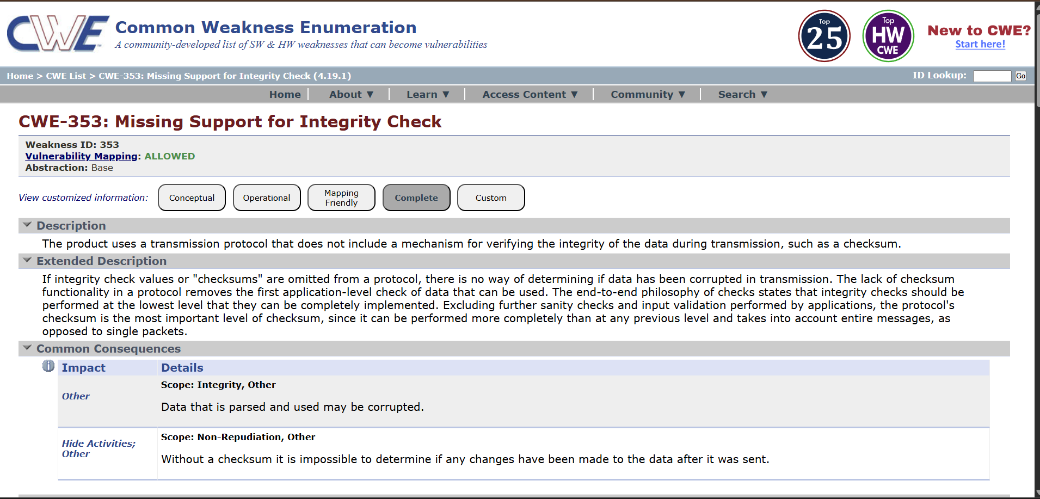

9)Vulnerability Name: Information Loss or Omission
CWE NO: CWE-221
OWASP Category: A09:2025 Security Logging & Alerting Failures
Description: A Information Loss or Omission vulnerability occurs when a system fails to capture, store, transmit, or present critical information accurately. This can result from software bugs, improper error handling, incomplete logging, or flawed data processing. Such gaps mean that important data may be missing, corrupted, or never recorded, potentially causing incorrect decisions or system failures. Examples include financial transactions not being recorded, logs failing to capture security events, or data being truncated during transmission. Prevention involves robust error handling, regular data validation, secure storage, and auditing mechanisms. This vulnerability undermines data reliability, operational integrity, and business trust.
Business Impact: A Information Loss or Omission vulnerability can have serious business consequences. Missing or incomplete data can lead to incorrect decisions, operational errors, and financial losses. Critical transactions or records may be lost, resulting in regulatory non-compliance and potential legal penalties. Failure to capture security events or audit logs can weaken security monitoring, increasing the risk of undetected breaches. Additionally, customer trust may be eroded if important information is lost or mishandled, harming the organization’s reputation. Overall, information loss or omission undermines data reliability, disrupts operations, exposes the business to compliance risks, and can create long-term strategic and financial impacts.

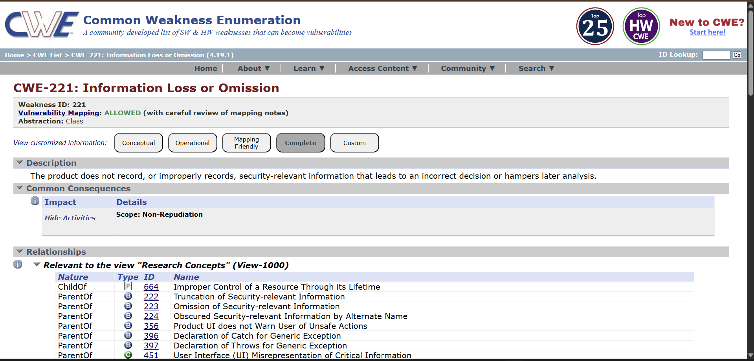

10)Vulnerability Name: Unchecked Return Value
CWE NO :CWE-252
OWASP Category: A10:2025 Mishandling of Exceptional Conditions
Description: A Unchecked Return Value vulnerability occurs when a program calls a function or method but fails to verify or handle its return value. Many functions return status codes, error messages, or results that indicate success, failure, or unexpected conditions. Ignoring these return values can lead to unhandled errors, incorrect program behavior, or security weaknesses.
Business Impact: A Unchecked Return Value vulnerability can have significant business consequences. Ignoring function or method return values may lead to program errors, crashes, or data corruption, disrupting business operations. It can allow attackers to exploit unhandled errors, potentially resulting in unauthorized access, privilege escalation, or security breaches. Missed errors in critical processes may cause financial losses, regulatory non-compliance, or operational delays. Additionally, repeated failures or undetected issues can damage customer trust and brand reputation. Overall, failing to handle return values undermines system reliability, exposes sensitive data, increases operational risk, and creates both financial and strategic impacts for the organization.

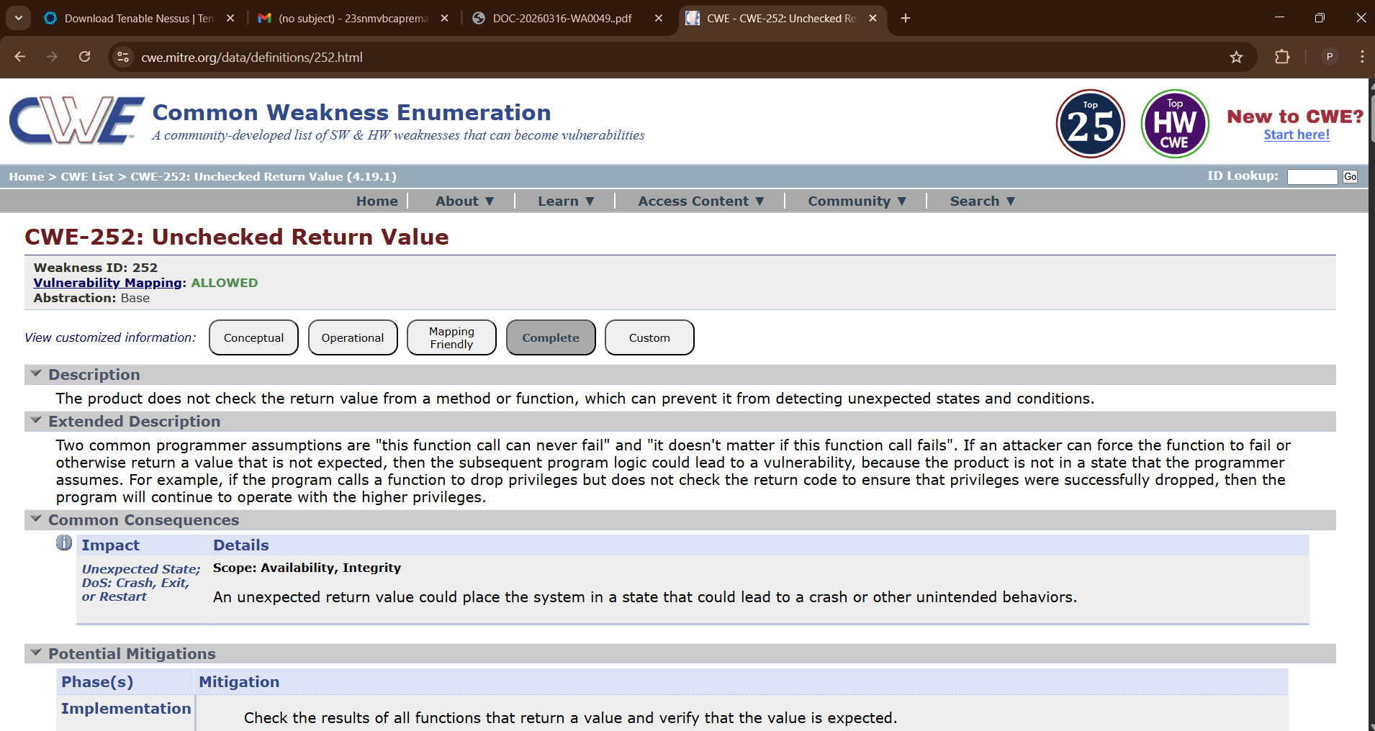

Stage 2:
Title: Nessus scan

Overview

Nessus is a widely used vulnerability assessment tool developed by Tenable. It is designed to help organizations identify security weaknesses in their IT infrastructure, including servers, networks, databases, and applications. Nessus is commonly used by security professionals, system administrators, and ethical hackers to proactively detect vulnerabilities before attackers can exploit them.
At its core, Nessus performs automated scans of systems and compares findings against a continuously updated database of known vulnerabilities, misconfigurations, and compliance issues. It supports thousands of plugins, which are regularly updated to detect new threats such as malware, unpatched software, weak passwords, and open ports. Nessus can also identify issues related to regulatory compliance standards like PCI-DSS, HIPAA, and CIS benchmarks.
One of the key strengths of Nessus is its ease of use. It provides a user-friendly web interface where users can configure scans, view reports, and prioritize risks based on severity levels. The tool categorizes vulnerabilities into levels such as Critical, High, Medium, and Low, helping organizations focus on the most urgent threats first. It also offers detailed remediation guidance, enabling faster resolution of security issues.
Nessus supports multiple scan types, including credentialed scans (which provide deeper system insights) and non-credentialed scans (which simulate external attacker perspectives). It can be deployed on various platforms and integrates with other security tools for enhanced threat management.
In summary, Nessus is a powerful and reliable vulnerability scanning solution that plays a crucial role in modern cybersecurity strategies. By continuously identifying and assessing risks, it helps organizations strengthen their security posture and reduce the likelihood of cyberattacks.

S.NO | Vulnerability Name | Severity | Plugins
1 | Nessus SYN Scanner | INFO | 11219
2 | Service Detection | INFO | 29642
3 | J Query Detection | INFO | 106658
4 | Additional DNS Hostname | INFO | 46180
5 | Device type | INFO | 54615
6 | SSL Version 2 and 3 Protocol Detection | CRITICAL | 2007
7 | Apache Tomcat SEoL (7.0.x) | CRITICAL | 171351
8 | SSL DROWN Attack Vulnerability (Decrypting RSA with Obsolete and Weakened eNcryption | MEDIUM | 89058
9 | SSL/TLS Diffie-Hellman Modulus <= 1024 Bits (Logjam) | LOW | 83875
10 | SSL Medium Strength Cipher Suites Supported (SWEET32 | HIGH | 42873

REPORT:
1)Vulnerability: Nessus SYN Scanner
Severity: INFO
Plugin: 11219
Description: The Nessus SYN Scanner plugin performs a TCP SYN scan to identify open TCP ports on a target host.
It sends a SYN packet to a port and analyzes the response:
- SYN/ACK → Port is open
- RST → Port is closed
- No response / filtered → Port may be filtered by a firewall
This method is commonly called a “half-open scan” because the TCP connection is not fully established. Nessus uses it to quickly detect running services and exposed ports on the target system.
Solution: Since this plugin is informational, it mainly reports network discovery results, but reviewing exposed services is still important for security.
Bussiness Impact: This is not a vulnerability by itself, but it indicates that:
- The scanner successfully identified open ports and services.
- Unnecessary or exposed services may increase the attack surface.
- Attackers could use similar scanning techniques to discover services and potential entry points.
- If critical services are exposed (e.g., SSH, FTP, databases), they could be targeted for exploitation
2)Vulnerability: Service Detection
Severity: INFO
Plugin: 29642
Description: This plugin identifies services running on open ports of the target system. Nessus analyzes responses from the ports to determine the type of service and sometimes the version (for example: HTTP, SSH, FTP, SMTP).
Solution: • Review the detected services and ensure they are necessary.
• Disable or close unused services and ports.
• Update and patch services regularly.
• Use firewalls or access controls to restrict service access to trusted users or networks.
Bussiness Impact: This is not a vulnerability, but it shows which services are exposed on the network. Attackers could use this information to identify potential targets for attacks if the services are outdated or misconfigured.
3)Vulnerability: J Query Detection
Severity: INFO
Plugin: 106658
Description: This plugin detects the presence of the jQuery JavaScript library on the web application. It identifies the version of jQuery being used by analyzing the website’s source code
Solution: • Check the detected jQuery version.
• If it is outdated, upgrade to the latest stable version of jQuery.
• Regularly update third-party libraries used in the application.
• Monitor security advisories for new vulnerabilities affecting jQuery.
Bussiness Impact: This is informational, but if the detected jQuery version is outdated, it may contain known security vulnerabilities. Attackers could exploit these vulnerabilities to perform attacks such as Cross-Site Scripting (XSS) or other client-side attacks
4)Vulnerability: Additional DNS Hostname
Severity: INFO
Plugin: 46180
Description: This plugin reports additional DNS hostnames that resolve to the same IP address as the scanned target. It means the server may be hosting multiple domains or subdomains on the same system.
Solution: Review the listed DNS hostnames to ensure they are expected and authorized.
Remove unused or unnecessary DNS records.
Apply proper security controls and updates to all hosted domains and services.
Bussiness Impact: This is not a vulnerability, but it reveals other hostnames associated with the server. Attackers could use this information to discover additional websites or services hosted on the same server and target them for attacks
5)Vulnerability:Device type
Severity: INFO
Plugin: 54615
Description: The Device Type plugin identifies the type of device running at the scanned IP address. Nessus analyzes network responses and determines whether the device is a server, workstation, router, firewall, printer, or other network device.
Solution: verify that the detected device type is correct and expected.
Ensure the device is properly secured and updated.
Apply appropriate security configurations based on the device type (e.g., firewall rules, access controls, firmware updates).
Bussiness Impact: This is informational only and does not indicate a vulnerability. However, knowing the device type helps security teams understand the network environment and identify which devices may require security controls or monitoring
6)Vulnerability: SSL Version 2 and 3 Protocol Detection
Severity: CRITICAL
Plugin:2007
Description: The scan detected that the server supports SSLv2 and/or SSLv3 protocols. These are outdated and insecure encryption protocols that have known vulnerabilities (such as POODLE attack). Attackers can exploit these weaknesses to decrypt sensitive data or perform man-in-the-middle attacks.
Solution: • Disable SSLv2 and SSLv3 protocols on the server.
• Enable only secure protocols such as TLS 1.2 and TLS 1.3.
• Update the web server or SSL/TLS configuration.
• Use strong cipher suites and follow modern security standards.
Bussiness Impact: • Sensitive information (login credentials, session cookies, or personal data) could be intercepted or decrypted.
• Attackers may perform Man-in-the-Middle (MITM) attacks.
• This can lead to data breaches, compliance violations, and loss of customer trust.
7)Vulnerability: Apache Tomcat SEoL (7.0.x)
Severity: CRITICAL
Plugin: 171351
Description: The scan detected that the server is running Apache Tomcat version 7.0.x, which has reached End of Life (EoL). This means the vendor no longer provides security updates or patches for this version. As a result, any newly discovered vulnerabilities will not be fixed, leaving the system exposed.
Solution: Upgrade Apache Tomcat to a supported version such as Tomcat 9.x, 10.x, or later.
- Apply the latest security patches and updates.
- Regularly monitor vendor advisories for new vulnerabilities and updates.
- After upgrading, rescan the system to verify the vulnerability is resolved.
Bussiness Impact: • The server may contain known or future unpatched vulnerabilities.
• Attackers could exploit these weaknesses to gain unauthorized access, execute remote code, or compromise the web application.
• This may lead to data breaches, system compromise, service disruption, and compliance issues.

8)Vulnerability: SSL DROWN Attack Vulnerability (Decrypting RSA with Obsolete and Weakened eNcryption
Severity: MEDIUM
Plugin: 89058
Description: The scan detected that the server is vulnerable to the DROWN attack, which occurs when a server supports the obsolete SSLv2 protocol or shares the same private key with another server that supports SSLv2. Attackers can exploit this weakness to decrypt secure HTTPS connections, even if modern TLS protocols are used.
Solution: • Disable SSLv2 completely on all servers.
• Ensure the server only supports secure protocols such as TLS 1.2 and TLS 1.3.
• Update and patch the web server and SSL/TLS libraries (e.g., OpenSSL).
• Avoid reusing the same SSL private key on servers that support weak protocols.
• After applying fixes, run another vulnerability scan to confirm the issue is resolve
Bussiness Impact: • Attackers may decrypt sensitive encrypted traffic such as login credentials or personal data.
• This can lead to Man-in-the-Middle (MITM) attacks.
• It may result in data breaches, loss of confidentiality, and compliance violations

9)Vulnerability: SSL/TLS Diffie-Hellman Modulus <= 1024 Bits (Logjam)
Severity: LOW
Plugin: 83875
Description: The scan detected that the server supports weak Diffie-Hellman (DH) key exchange parameters with a modulus size of 1024 bits or less. This vulnerability is known as the Logjam attack. Attackers may exploit weak DH parameters to downgrade the connection and decrypt secure communications.
Solution: • Configure the server to use strong Diffie-Hellman parameters (2048 bits or higher).
• Disable weak cipher suites that use small DH key sizes.
• Enable modern TLS protocols such as TLS 1.2 or TLS 1.3.
• Update the web server and cryptographic libraries (e.g., OpenSSL) to the latest versions.
• After applying changes, restart the server and perform a new vulnerability scan to confirm the issue is resolved
- Bussiness Impact: Attackers may intercept and decrypt encrypted SSL/TLS traffic.
- Sensitive information such as login credentials, session cookies, and confidential data could be exposed.
- This can lead to Man-in-the-Middle (MITM) attacks, data breaches, and loss of data confidentiality.

10)Vulnerability: SSL Medium Strength Cipher Suites Supported (SWEET32
Severity: HIGH
Plugin: 42873
Description: The scan detected that the server supports medium-strength SSL/TLS cipher suites, specifically 64-bit block ciphers such as 3DES. These ciphers are vulnerable to the SWEET32 attack, which allows attackers to exploit the small block size and potentially recover sensitive information from encrypted sessions
Solution: • Disable weak and medium-strength cipher suites, especially 3DES.
• Configure the server to allow only strong cipher suites (e.g., AES-GCM).
• Enable modern TLS protocols such as TLS 1.2 and TLS 1.3.
• Update the web server and SSL/TLS libraries to the latest versions.
• Re-run the vulnerability scan after applying the changes to verify the fix.

Stage 3:
Title: Application Specific Access Policies Using Zscaler Private Access ( ZPA )

Overview

In today’s highly dynamic and distributed IT environments, organizations are increasingly vulnerable to cyber threats due to remote work, cloud adoption, and the use of unmanaged devices. Traditional security mechanisms such as VPNs rely on perimeter-based trust models, where users inside the network are implicitly trusted. This model is no longer effective, as attackers can exploit compromised credentials to gain broad network access and move laterally across systems.To overcome these limitations, this project implements a Zero Trust Network Access (ZTNA) model using Zscaler. The Zero Trust approach eliminates implicit trust and ensures that every access request is verified based on identity, device, and context before granting access.The project primarily utilizes Zscaler Private Access (ZPA) to provide secure, direct, and application-specific connectivity. Instead of connecting users to the network, ZPA creates micro-segmented connections between users and applications, ensuring that the internal network remains completely hidden from external exposure.By implementing ZTNA, this project enforces strict access controls, minimizes the attack surface, and provides a scalable and cloud-native security solution for modern enterprises.
Identity
Modern security frameworks emphasize identity-driven and context-aware access control, which goes beyond traditional role-based permissions. Instead of granting access solely based on a user’s role or credentials, systems evaluate multiple factors to determine whether a user should be allowed to access specific resources. User identity is the primary anchor, verifying who is requesting access. Device posture examines the security state of the device, such as whether it has up-to-date patches, antivirus protection, or is managed by the organization. Location provides contextual insight, restricting or flagging access from unusual or high-risk geographies, public networks, or untrusted environments. Application and transaction risk further fine-tunes access decisions by considering the sensitivity of the requested operation, historical user behavior, or anomalous patterns.

Device Posture
Device posture refers to the security state and compliance of a device requesting access to a system or application. When implementing context-aware access controls, evaluating device posture ensures that only devices meeting organizational security requirements are granted access. This includes checking whether the device is managed or unmanaged, whether it has up-to-date operating system patches, whether antivirus or endpoint protection is active, if disk encryption is enabled, and whether it is free from known malware or vulnerabilities.
By integrating device posture into access control decisions, organizations can reduce the risk of compromised devices accessing sensitive resources. For example, a corporate system may allow access only from company-managed laptops with current patches and security agents installed, while restricting or requiring additional verification for personal or out-of-date devices. Device posture, combined with user identity, location, and application risk, enables dynamic, context-aware security policies that adapt in real time to changing conditions, ensuring both security and usability.

Application Risk
Application risk refers to the level of potential threat or sensitivity associated with a specific application, resource, or operation when a user attempts to access it. In context-aware access control, assessing application risk allows security systems to make dynamic access decisions based not just on who the user is or what device they’re using, but also on how critical or sensitive the target application or action is. High-risk applications—such as financial systems, HR databases, or administrative consoles—may require stricter verification, multi-factor authentication, or access restrictions based on other contextual factors. Conversely, low-risk applications, like general information portals, might allow more flexible access.
Application risk assessment considers factors such as data sensitivity, regulatory requirements, potential impact of a breach, and recent threat intelligence. By incorporating application risk into access decisions alongside user identity, device posture, and location, organizations can implement adaptive, intelligent security policies that protect critical resources while minimizing friction for legitimate users. This ensures that high-risk actions or sensitive applications receive stronger protection and reduces the likelihood of data breaches or unauthorized access.

Context Aware Access
Context-aware access is a security approach that dynamically determines whether a user should be granted access to a system or resource based on multiple contextual factors rather than just static credentials. Unlike traditional access control models that rely solely on username, password, or predefined roles, context-aware access evaluates real-time information about the user, their device, location, and the risk associated with the requested application or action.
Key components include:
- User identity: Confirms who is requesting access and ensures their authentication aligns with their role and privileges.
- Device posture: Checks the security state of the device, including patch levels, endpoint protection, and compliance with organizational policies.
- Location: Assesses whether the access request originates from trusted or unusual geographic locations or networks.
- Application risk: Evaluates the sensitivity or potential impact of the application or action being accessed.
By combining these factors, context-aware access enables adaptive and intelligent access decisions, such as requiring multi-factor authentication, limiting high-risk actions, or denying access from non-compliant devices. This approach strengthens security, reduces the risk of breaches, and maintains usability by providing flexible access tailored to the situation.

Conclusion:
Stage 1: The OWASP Top 10 serves as an essential benchmark for understanding and addressing the most critical web application security risks. By identifying vulnerabilities such as broken access control, injection flaws, cryptographic weaknesses, and insecure design, it provides organizations and developers with a prioritized roadmap for securing applications. The list emphasizes that modern web security is not just about fixing individual bugs, but about adopting a holistic approach that integrates secure coding practices, threat modeling, continuous monitoring, and proactive risk management throughout the software development lifecycle.
Implementing the guidance from the OWASP Top 10 reduces the likelihood of data breaches, unauthorized access, and other security incidents, while also helping organizations comply with regulatory standards and protect user trust. It highlights the importance of context-aware strategies, such as considering user identity, device posture, location, and application risk when designing access controls, and encourages continuous vigilance in updating components and monitoring for emerging threats.
Ultimately, the OWASP Top 10 is more than a list of vulnerabilities—it is a framework for cultivating a security-aware development culture. By internalizing these principles, organizations can move from reactive security measures to proactive defense, creating resilient applications that withstand evolving cyber threats.

Stage 2: A Nessus scan provides a comprehensive assessment of an organization’s IT environment, identifying vulnerabilities, misconfigurations, and potential security risks across systems, networks, and applications. The scan evaluates devices for missing patches, outdated software, weak configurations, and known vulnerabilities, assigning severity levels to help prioritize remediation efforts. By analyzing the results, organizations gain visibility into their attack surface, understand which assets are most at risk, and can make informed decisions about patching, hardening, or isolating vulnerable systems.
The conclusion from a Nessus scan should emphasize the overall security posture, highlighting trends such as recurring vulnerabilities, high-severity exposures, or areas of non-compliance with organizational or regulatory security standards. It should also recommend actionable steps, such as immediate remediation of critical vulnerabilities, continuous patch management, and configuration improvements, along with the implementation of ongoing vulnerability scanning to detect new threats.
Ultimately, Nessus scans are a proactive tool for risk management, enabling organizations to reduce the likelihood of exploitation, maintain system integrity, and ensure compliance. Regular scanning, combined with structured remediation, strengthens cybersecurity defenses, provides measurable security improvements over time, and supports a culture of continuous vigilance against emerging threats.

Stage 3: Designing and implementing context-aware access controls represents a modern and proactive approach to securing applications and sensitive data. Unlike traditional access models that rely solely on static credentials or role-based permissions, context-aware access evaluates multiple factors in real time to determine whether a user should be granted access. Central to this approach is user identity, which ensures that only authenticated and authorized individuals can access systems or data. However, identity alone is insufficient in today’s complex IT environments, where compromised credentials or insider threats can bypass traditional security measures.
Device posture adds another layer of assurance by assessing the security state of the device requesting access. This includes checking for updated operating systems, active endpoint protection, device compliance with corporate policies, and the absence of malware. By verifying device integrity, organizations can prevent insecure or unmanaged devices from becoming a gateway for attacks.
Location plays a critical role by identifying unusual or high-risk access attempts. Requests originating from untrusted geographic regions, public networks, or anomalous locations can trigger additional authentication measures or be temporarily blocked, mitigating the risk of unauthorized access. Application risk further refines access decisions by evaluating the sensitivity of the resource or action being requested. High-risk applications, such as financial systems or administrative portals, may require multi-factor authentication or stricter access controls, whereas low-risk applications can be accessed more freely.
By combining these factors, context-aware access controls enable organizations to implement adaptive, risk-based policies that balance security with usability. They reduce the likelihood of unauthorized access, data breaches, and insider threats while allowing legitimate users to access resources efficiently. In increasingly cloud-based, mobile, and hybrid IT environments, this approach provides a forward-looking, resilient security framework that adapts to emerging threats and ensures continuous protection of critical assets.

Future Scope:
Stage 1: The OWASP Top 10 has long served as a foundational framework for identifying and mitigating the most critical web application security risks. As technology continues to evolve, its future scope is increasingly focused on emerging threats, complex architectures, and advanced development paradigms. One significant area is the growth of cloud-native applications, microservices, and API-driven systems, which introduce new attack surfaces and require updated security controls. OWASP is expected to expand guidance around API security, serverless functions, containerized environments, and supply chain risks, reflecting the shift from monolithic applications to distributed systems.
Another key future direction is the integration of context-aware, risk-based security approaches, including identity-driven access controls, device posture verification, and adaptive authentication. As AI, machine learning, and automation become more prevalent in software development and operations, the Top 10 may incorporate threat modeling and vulnerability prioritization frameworks that leverage real-time analytics to identify high-risk components proactively.
OWASP is also likely to emphasize privacy, regulatory compliance, and secure DevOps practices (DevSecOps), bridging the gap between development speed and security assurance. Continuous monitoring, automated scanning, and early security integration into the software lifecycle are expected to be highlighted.
In essence, the future scope of the OWASP Top 10 is not only to remain a baseline for traditional web security but also to adapt to emerging technologies, evolving threat landscapes, and proactive risk management strategies, ensuring organizations can build resilient, secure, and compliant applications in increasingly complex digital ecosystems.

Stage 2: Nessus, as one of the most widely used vulnerability assessment tools, has become a critical component of proactive cybersecurity strategies. Its future scope is closely tied to the evolving threat landscape, increasing complexity of IT environments, and the growing emphasis on automation and continuous monitoring. Traditional vulnerability scanning will continue to expand into cloud environments, hybrid networks, containers, and serverless architectures, where assets are dynamic and ephemeral. Nessus will need to enhance its ability to detect vulnerabilities across these rapidly changing infrastructures, including cloud workloads, APIs, microservices, and IoT devices.
Another key area of development is integration with automated security and DevSecOps workflows. By embedding Nessus scans into CI/CD pipelines, organizations can identify and remediate vulnerabilities earlier in the software development lifecycle, reducing the window of exposure. Advanced features such as risk prioritization, predictive analytics, and AI-driven vulnerability assessment are likely to become standard, enabling security teams to focus on high-impact threats rather than volume-based alerts.
Additionally, regulatory compliance and audit readiness will drive Nessus to provide deeper reporting, real-time dashboards, and actionable remediation guidance. Future enhancements may also include integration with threat intelligence feeds to detect zero-day exploits and contextualize vulnerabilities based on active threat landscapes.
In summary, the future of Nessus scanning will focus on automation, intelligence-driven assessments, cloud and hybrid environment coverage, and seamless DevSecOps integration, positioning it as a critical tool for organizations seeking continuous, adaptive, and proactive cybersecurity defenses in an increasingly complex IT ecosystem.

Stage 3: The future of context-aware access control is closely aligned with the growing complexity of IT environments, cloud adoption, mobile and remote work, and the rise of sophisticated cyber threats. Traditional static access control models are no longer sufficient, as they cannot dynamically respond to evolving risk factors or user behavior. The next generation of access control systems will increasingly leverage real-time analytics, artificial intelligence, and machine learning to continuously evaluate context and adapt permissions automatically.
User identity will evolve beyond simple authentication to include behavioral biometrics, risk-based profiling, and federated identity management across multi-cloud and hybrid environments. Device posture assessments will become more sophisticated, encompassing IoT devices, mobile endpoints, and unmanaged hardware, with automated remediation for non-compliant or compromised devices. Location awareness will expand to include network context, geofencing, and anomaly detection to identify unusual access patterns. Application risk evaluation will incorporate dynamic threat intelligence, transaction sensitivity, and regulatory requirements to prioritize access restrictions in real time.
The future also emphasizes integration with Zero Trust and DevSecOps frameworks, allowing organizations to enforce granular, adaptive, and continuous access policies across all digital assets. Automation and AI-driven decision-making will reduce administrative overhead while improving security effectiveness. Ultimately, context-aware access control will evolve into a predictive and intelligent system, providing seamless, secure access while proactively mitigating risks and insider threats in increasingly complex, cloud-native, and distributed IT ecosystems.
Topics Explored: : OWASP TOP 10, Scanning, Vulnerability, Awareness, Identity, User Identity, Device Posture, Location, Application Risk, Context-Aware Access Control Design, Implementation Considerations

Tools Explored: Zscaler, Nessus, OWSAP, Hackthissite

Stage 1
title: owasp to10
Overview

s.no | Vulnerability name | CWE/CVE NO.
1 | Absolute Path Traversal | CWE 36
2 | Sensitive Cookie in HTTPS Session Without 'Secure' Attribute | CWE 614
3 | Use of Unmaintained Third Party Components | CWE 1104

REPORT:
VULNERABILITY NAME Absolute Path Traversal
CWE/CVE NO :CWE 36
OWASP CATEGORY
DESCRIPTION
BUSSINESS IMPACT

