Q. Which one of these declarations is a valid method declaration?
Select the one correct answer.
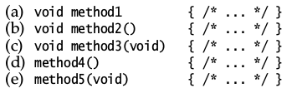
Q. Which statements, when inserted at (1), will not result in compile-time errors?
Select the three correct answers.
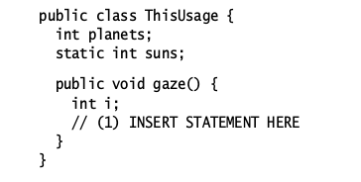
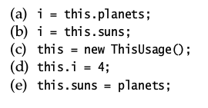
Q. Given the following pairs of method declarations, which statements are true?
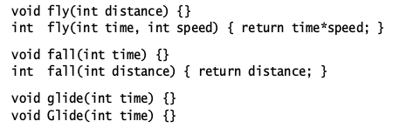
Select the two correct answers.
(a)The first pair of methods will compile, and overload the method name fly .
(b) The second pair of methods will compile, and overload the method name fall .
(c) The third pair of methods will compile, and overload the method name glide .
(d) The second pair of methods will not compile.
(e) The third pair of methods will not compile.

Q. Given a class named Book , which one of these constructor declarations is valid for
the class Book ? Select the one correct answer.
(a)Book(Book b) {}
(b) Book Book() {}
(c) private final Book() {}
(d) void Book() {}
(e) public static void Book(String[] args) {}
(f) abstract Book() {}

Q. Which statements are true? Select the two correct answers.
a) A class must define a constructor.
b) A constructor can be declared private .
c) A constructor can return a value.
d) A constructor must initialize all fields when a class is instantiated.
e) A constructor can access the non-static members of a class.

Q.What will be the result of compiling the following program?
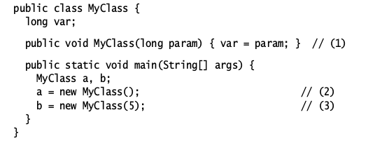
Select the one correct answer.
(a) A compilation error will occur at (1), since constructors cannot specify a
return value.
(b) A compilation error will occur at (2), since the class does not have a default
constructor.
(c) A compilation error will occur at (3), since the class does not have a constructor that takes one argument of type int .
(d) The program will compile without errors.

Q. Given the following declaration, which expression returns the size of the array,
assuming the array has been initialized?
int[] array;
Select the one correct answer.
(a) array[].length()
(b) array.length()
(c) array[].length
(d) array.length
(e) array[].size()
(f) array.size()

Q.Is it possible to create arrays of length zero? Select the one correct answer.
a)Yes, you can create arrays of any type with length zero.
b)Yes, but only for primitive data types.
c)Yes, but only for arrays of reference types.
d)No, you cannot create zero-length arrays, but the main() method may be passed
a zero-length array of String s when no program arguments are specified.
e) No, it is not possible to create arrays of length zero in Java.

Q. Which one of the following array declaration statements is not legal?
Select the one correct answer.
(a) int []a[] = new int [4][4];
(b) int a[][] = new int [4][4];
(c) int a[][] = new int [][4];
(d) int []a[] = new int [4][];
(e) int [][]a = new int [4][4];

Q. Which of these array declaration statements are not legal?
Select the two correct answers.
(a) int[] i[] = { { 1, 2 }, { 1 }, {}, { 1, 2, 3 } };
(b) int i[] = new int[2] {1, 2};
(c) int i[][] = new int[][] { {1, 2, 3}, {4, 5, 6} };
(d) int i[][] = { { 1, 2 }, new int[ 2 ] };
(e) int i[4] = { 1, 2, 3, 4 };

Q.What would be the result of compiling and running the following program?
// Filename: MyClass.java
class MyClass {
public static void main(String[] args) {
int size = 20;
int[] arr = new int[ size ];
for (int i = 0; i < size; ++i) {
System.out.println(arr[i]);
}
}
}
Select the one correct answer.
(a) The code will not compile, because the array type int[] is incorrect.
(b) The program will compile, but will throw an ArrayIndexOutOfBoundsException
when run.
(c) The program will compile and run without error, but will produce no output.
(d) The program will compile and run without error, and will print the numbers
0 through 19.
(e) The program will compile and run without error, and will print 0 twenty
times.
(f) The program will compile and run without error, and will print null twenty
times.

Q. What would be the result of compiling and running the following program?
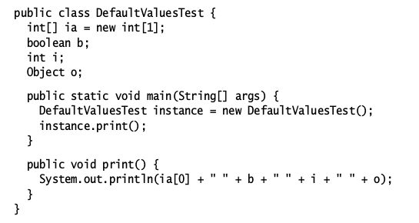
Select the one correct answer.
a)The program will fail to compile because of uninitialized variables.
b)The program will throw a java.lang.NullPointerException when run.
c)The program will print: 0 false NaN null .
d)The program will print: 0 false 0 null .
e)The program will print: null 0 0 null .
f)The program will print: null false 0 null .

Q. What will be printed when the following program is run?
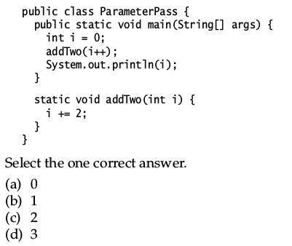
Q. What will be the result of compiling and running the following program?
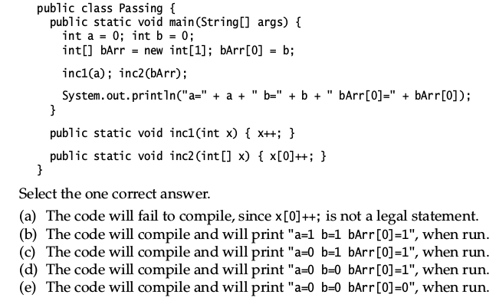
Q. Which statements, when inserted at (1), will cause a compilation error?
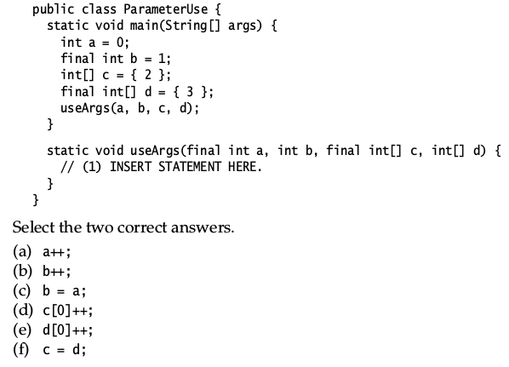
Q. Which method declarations are valid declarations?
Select the three correct answers.
(a) void compute(int... is) { }
(b) void compute(int is...) { }
(c) void compute(int... is, int i, String... ss) { }
(d) void compute(String... ds) { }
(e) void compute(String... ss, int len) { }
(f) void compute(char[] ca, int... is) { }

Q. Given the following co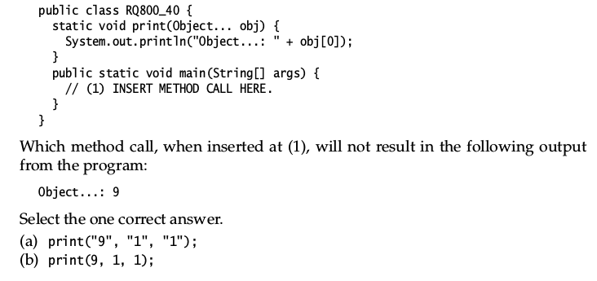
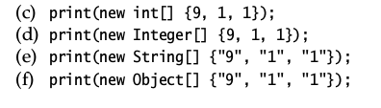
Q. What will be the result of compiling and running the following program?
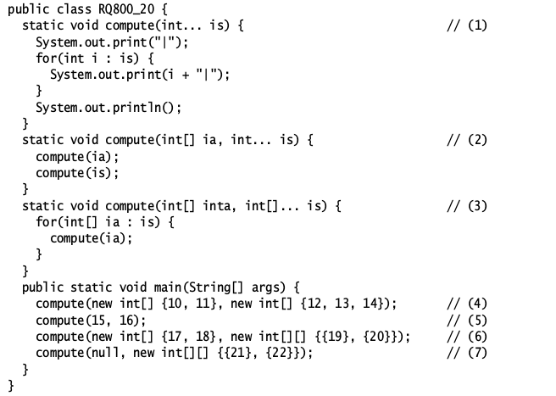
Select the one correct answer.
(a) The program does not compile because of errors in one or more calls to the
compute() method.
(b) The program compiles, but throws a NullPointerException when run.
(c) The program compiles and prints:
|10|11|
|12|13|14|
|15|16|
|19|
|20|
|21|
|22|
(d) The program compiles and prints:
|12|13|14|
|15|16|
|10|11|
|19|
|20|
|21|
|22|

Q. Which of these method declarations are valid declarations of the main() method
that would be called by the JVM in order to start the execution of a Java applica-
tion?
Select the three correct answers.
(a) static void main(String[] args) { /* ... */ }
(b) public static int main(String[] args) { /* ... */ }
(c) public static void main(String args) { /* ... */ }
(d) final public static void main(String[] arguments) { /* ... */ }
(e) public int main(Strings[] args, int argc) { /* ... */ }
(f) static public void main(String args[]) { /* ... */ }
(g) static public void main(String... args) { /* ... */ }

Q. Given the class
// File name: Args.java
public class Args {
public static void main(String[] args) {
System.out.println(args[0] + " " + args[args.length-1]);
}
}
what would be the result of executing the following command line?
>java Args In politics stupidity is not a handicap

Select one correct answer

a)The program will throw an ArrayIndexOutOfBoundsException .
b)The program will print "java handicap" .
c)The program will print " Args handicap" .
d)The program will print "In handicap" .
e)The program will print " Args a" .
f)The program will print "In a" .

