***Scenario-1***

1. Create the Infra components first like a RSG, ASP, Web App, Web API, Key Vault in Azure.
2. Create a Repo in Azure devops.
3. Create branches according to the branching strategy.
4. Push the code to the branch (master in this case).

**Situation 1. The build should trigger as soon as anyone in the dev team checks in code to master branch.**

**Ans:** Add the build step in pipeline for dotnet code and go the triggers tab and enable continuous integration for master branch.

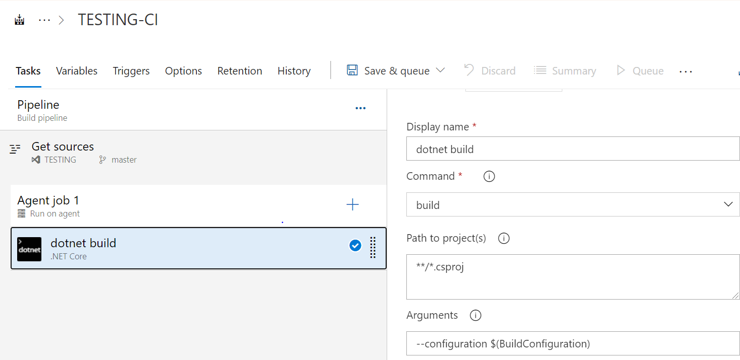

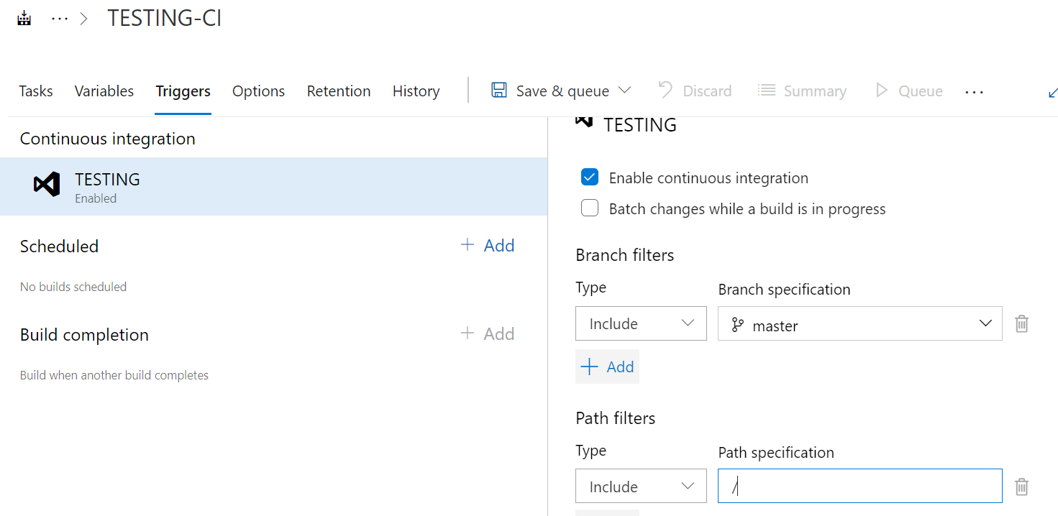

**Situation 2: There will be test projects which will create and maintained in the solution along the Web and API. The trigger should build all the 3 projects - Web, API and test. The build should not be successful if any test fails.**

Add the dot net test task, add command as build, test, publish and add the project paths to be build and test and

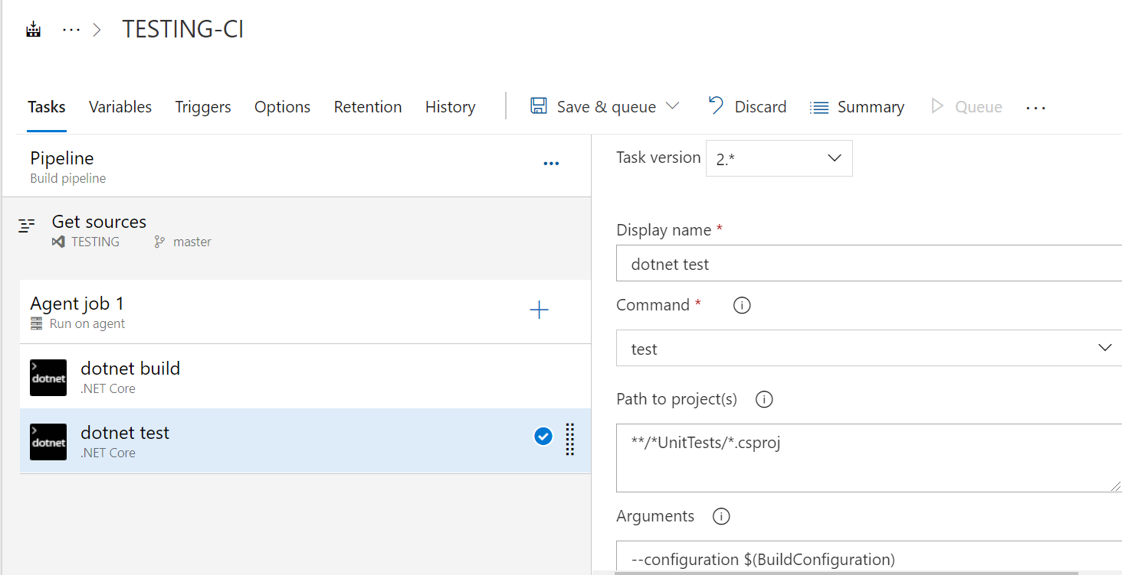

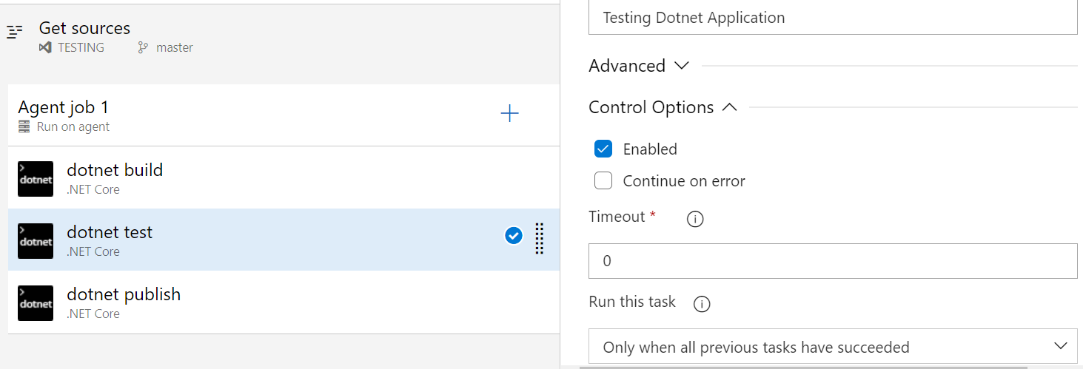

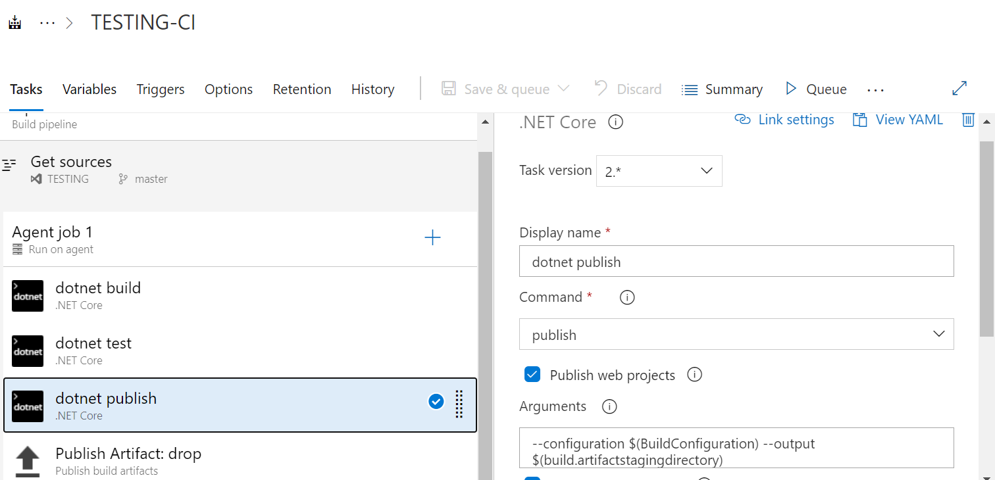

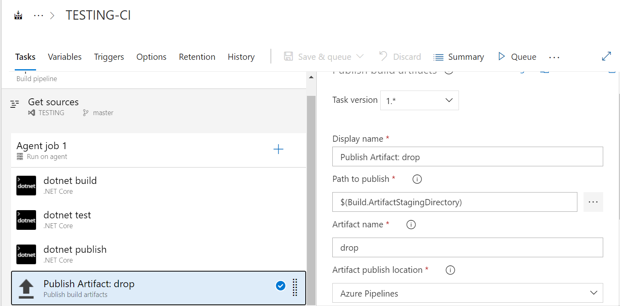

**Situation 3: The deployment of code and artifacts should be automated to Dev environment.**

**Ans:** Create a release pipeline having task of ‘Azure Web App deployment’ which will pick the artifact and deploy to the Dev Azure Web App. Add the artifacts and choose the default version as latest from the build. Enable continuous deployment trigger in the release pipeline.

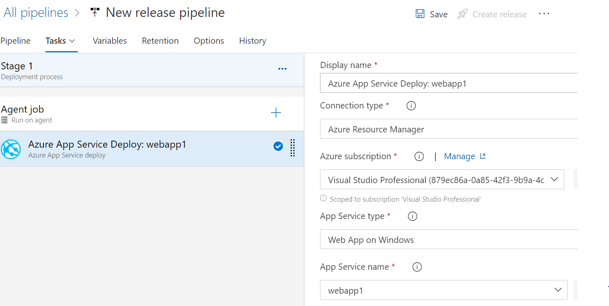

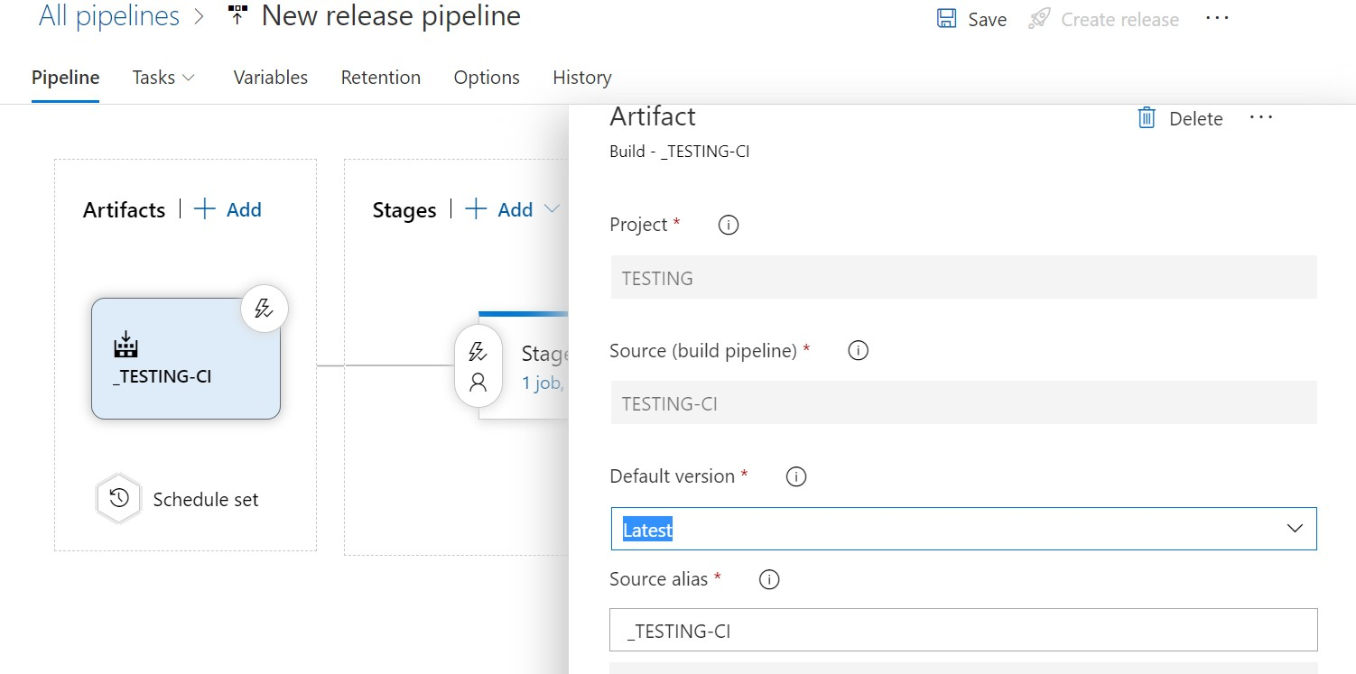

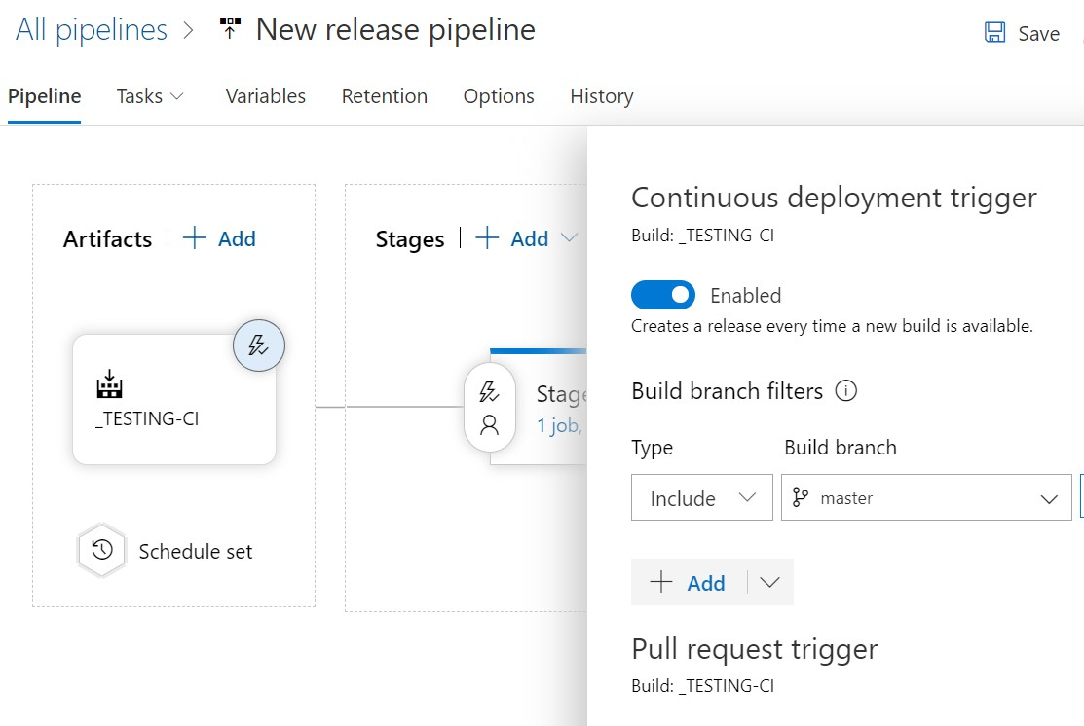

**Situation 4**. Upon successful deployment to the Dev environment, deployment should be easily promoted to QA and Prod through automated process.

**Answer:** Clone the stages as of dev and change the web app credentials and subscription in the tasks. Choose the pre- deployment conditions as after stage as ‘dev’ and choose ‘QA‘ for prod pre deployment condition.

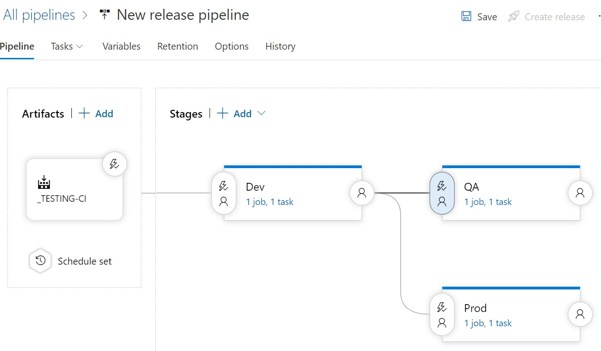

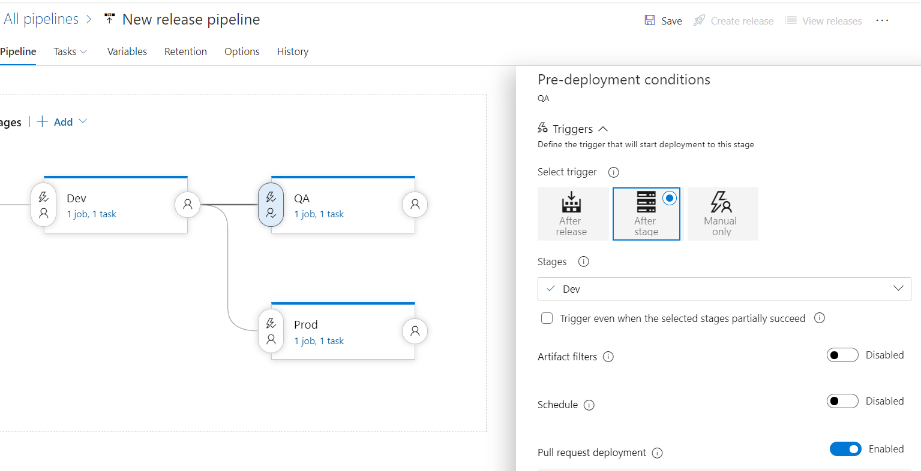

**Situation 5: The deployments to QA and Prod should be enabled with Approvals from approvers only.**

In the pre deployment conditions, choose pre-deployment approvals and add the approvers name in both QA and Prod settings and we can choose other settings like timeout and policy.

