# JSON Config

If you enabled JSON config for Performer or Dispatcher. You can specify the environment as well to segregate two separate configs. The below is an example from a prior project delivered by Centric India.

We had 2 Assets for JSON config: one each for Dev (**Inmar_Config_DEV**) and Prod (**Inmar_Config_PROD**). There is another asset ‘**Inmar_Config_PROD**’ whose value defines whether Dev config will be picked or Prod config.

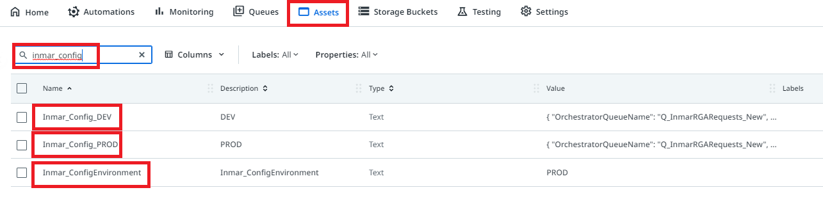

## **How to view?**

Navigate to Assets in Orchestrator and search for Dev or Prod config and click on Edit asset.

Select the text value and open any JSON viewer such as [JSON Online Validator and Formatter - JSON Lint](https://jsonlint.com/) and paste the JSON text in the field and click on ‘Validate JSON’ button.

This will make JSON appear in readable ‘**key:value’** pair combination.

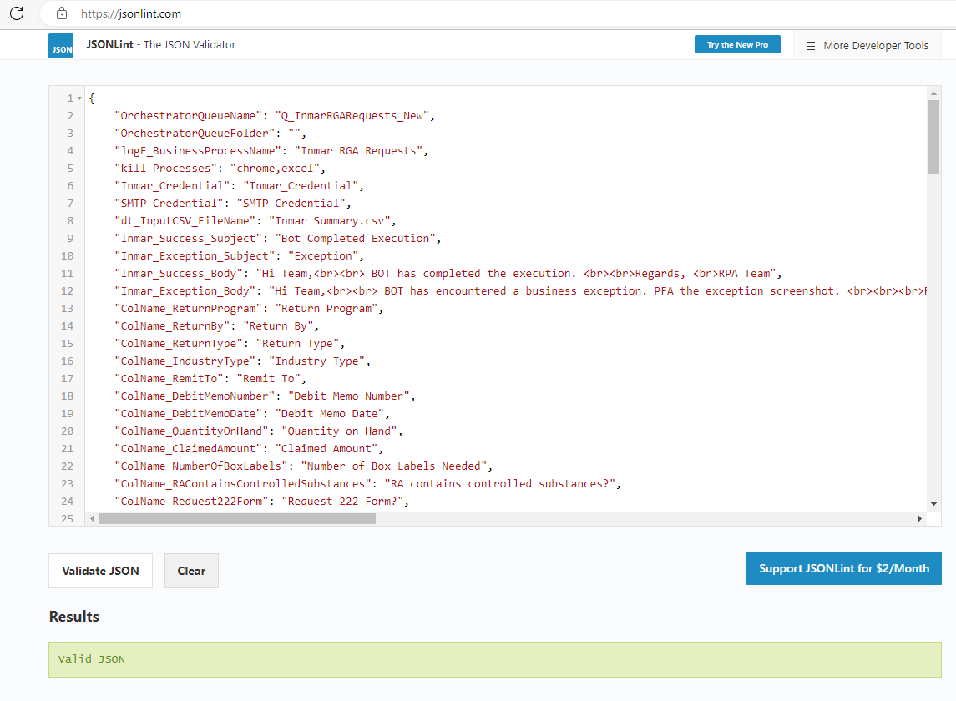

## **How to make changes?**

You can make changes directly in this window or copy-paste the JSON in any text editor such as notepad or notepad++ for making any changes.

Post the changes are done, don’t forget to get the JSON validated by clicking on ‘Validate JSON’ button again, this will ensure a correct JSON is getting updated in Orchestrator Asset.

In case there is any syntax error then the line number and error reason will appear in the ‘Results’ field in red color once you hit the ‘Validate JSON’ button. In case of no error, it will show ‘Valid JSON’ in green color.

**SAMPLE JSON CONFIG**

{

"OrchestratorQueueName": "Q_Pharmalink",

"TargetAppName": "chrome",

"OrchestratorQueueFolder": "",

"logF_BusinessProcessName": "Pharma Link",

"InputFolderPath": "Z:\\Pharmalink\\Input\\",

"OutputFolderPath": "Z:\\Pharmalink\\Output\\",

"PdfPath": "PdfPath",

"strSheetName": "Sheet1",

"strMappingSheetName": "Sheet1",

"strColumnManufacture": "Manufacturer",

"MaxRetryNumber": "0",

"ExScreenshotsFolderPath": "Exceptions_Screenshots",

"SMTP_Credential": "SMTP_Credential",

"EmailRecipients_Business": "utkarsh.khandelwal@centricconsulting.com",

"EmailRecipients_Support": "utkarsh.khandelwal@centricconsulting.com",

"EmailBody_Success": "BOT ran successfully. <br/><br/> Thanks",

"EmailBody_Exception": "BOT encountered exception. <br/><br/> Thanks",

"SummaryNoticeTemplatePath": "<p>The process '{{ProcessName}}' has completed execution. Summary results for Queue:'{{Q_Name}}', for the day are captured below. </p><br/><p>Total Records: {{TotalRecords}}<br>Successful: {{TotalSuccessful}}<br>Business Exception: {{TotalBE}}<br>Failed: {{TotalFailed}}"

}