International Assignment Record
Three employees start long-term assignments in July 2026. Tax equalisation is handled under case GM-2026-0193 and allowances follow policy HR-MOB-004.

Assignees
Name | Employee ID | Host location | Start date | Date of birth
Daniel Okafor | EMP-41207 | Warsaw | 01/07/2026 | 04/03/1979
Agnieszka Wójcik | EMP-41388 | Pune | 15/07/2026 | 22/11/1990
Priya Raman | EMP-41412 | Chicago | 03/08/2026 | 09/06/1985

Identity and tax details
Daniel Okafor stays on UK payroll under National Insurance number QQ 12 34 56 C.
Agnieszka Wójcik (PESEL 90112207561) keeps her home address at ul. Lipowa 14/3, 00-950 Warszawa for tax purposes.
Priya Raman holds Aadhaar 4831 7290 5127 and PAN AFKPR7741M. For US payroll she was issued Social Security number 219-09-9999; her address in the US is 2250 North Clark Street, Apt 5B, Chicago, IL 60614.

Corporate cards
- Daniel Okafor: Visa 4111 1111 1111 1111, monthly limit £5,000
- Priya Raman: American Express 3782 822463 10005, monthly limit $8,000
- Agnieszka Wójcik: card to be issued in August 2026

Work permit
Work permit confirmation (screenshot):
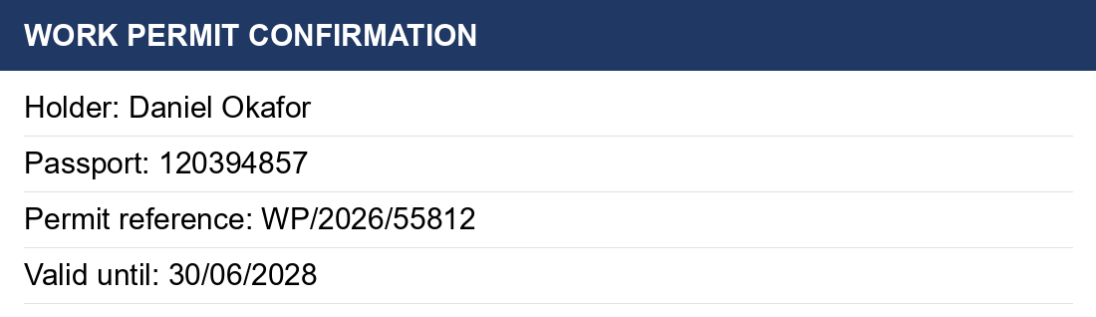

Contacts
Questions go to the mobility adviser, Fiona MacLeod, at fiona.macleod@example.org or +1 (312) 555-0164.

