ASSIGNMENT 3

NAME: KANIKA MIDHA
ROLL NO: 201301037

RESULTS OF I NEAREST NEIGHBOUR CLASSIFIER:

Accuracy: 9540/10000 = 95.4 %
Time to run: 24 hrs

KNN | Neaural Netwoks
Easy to code | Complex to code
Lazy classifier-major time is classification time | Eager classifier-Training time is high
High Dimension input features causes knn to take a lot of time | Much Faster than knn even with large amount of data
Knn can be retrained. | Neural networks cannot be retrained. If you add data later, this is almost impossible to add to an existing network

NEURAL NETWORKS

1) FIRST FOLD CONFUSION MATRIX FOR FIVE FOLD CROSS VALIDATION

1077 | 2 | 8 | 6 | 0 | 21 | 58 | 0 | 0 | 3
0 | 1361 | 5 | 3 | 1 | 3 | 6 | 0 | 0 | 1
17 | 134 | 808 | 43 | 26 | 2 | 100 | 27 | 9 | 5
9 | 59 | 32 | 1076 | 2 | 21 | 37 | 7 | 0 | 16
0 | 40 | 6 | 3 | 942 | 0 | 63 | 1 | 0 | 108
21 | 73 | 10 | 269 | 21 | 520 | 113 | 10 | 1 | 58
5 | 21 | 5 | 0 | 4 | 14 | 1112 | 0 | 0 | 1
9 | 85 | 25 | 7 | 14 | 0 | 3 | 989 | 0 | 78
3 | 277 | 16 | 200 | 26 | 35 | 71 | 5 | 397 | 135
19 | 64 | 16 | 29 | 115 | 3 | 6 | 37 | 0 | 929

Accuracy: 76
Senstivity: 76.76
Precision:76.76
Speceficity:97.4
Error Rate: 23.23

2) CONFUSION MATRIX FOR SECOND FOLD IN FIVE FOLD CROSS VALIDATION

1143 | 0 | 5 | 15 | 5 | 0 | 16 | 2 | 20 | 0
0 | 1313 | 3 | 7 | 1 | 1 | 3 | 1 | 21 | 1
18 | 44 | 898 | 70 | 52 | 0 | 35 | 9 | 49 | 1
4 | 24 | 18 | 1115 | 4 | 2 | 11 | 10 | 36 | 4
5 | 15 | 6 | 5 | 1090 | 0 | 15 | 1 | 26 | 21
38 | 28 | 7 | 349 | 39 | 228 | 48 | 5 | 298 | 8
20 | 8 | 13 | 4 | 11 | 3 | 1132 | 0 | 17 | 0
12 | 61 | 17 | 26 | 45 | 0 | 0 | 1046 | 15 | 57
13 | 38 | 9 | 130 | 13 | 1 | 19 | 2 | 895 | 7
23 | 16 | 11 | 45 | 210 | 1 | 1 | 46 | 77 | 763

Accuracy: 80.19
Senstivity: 80.19
Precision:80.19
Speceficity:97.7
Error Rate: 19.8

3) CONFUSION MATRIX FOR THIRD FOLD IN FIVE FOLD CROSS VALIDATION

1142 | 0 | 6 | 3 | 2 | 0 | 17 | 6 | 30 | 0
0 | 1305 | 4 | 0 | 1 | 3 | 2 | 3 | 32 | 1
19 | 47 | 950 | 9 | 37 | 2 | 23 | 24 | 65 | 0
7 | 31 | 37 | 935 | 1 | 52 | 11 | 32 | 116 | 6
5 | 15 | 12 | 0 | 1000 | 3 | 17 | 11 | 38 | 83
14 | 23 | 7 | 67 | 16 | 656 | 28 | 17 | 213 | 7
11 | 9 | 17 | 0 | 5 | 13 | 1126 | 2 | 25 | 0
10 | 29 | 10 | 1 | 15 | 3 | 0 | 1174 | 9 | 28
11 | 27 | 14 | 18 | 7 | 18 | 21 | 6 | 998 | 7
16 | 11 | 4 | 14 | 45 | 4 | 1 | 164 | 73 | 861

Accuracy: 84.55
Senstivity: 84.55
Precision: 84.55
Speceficity:98.28
Error Rate: 15.44

4) CONFUSION MATRIX FOR FOURTH FOLD IN FIVE FOLD CROSS VALIDATION

1132 | 1 | 14 | 4 | 1 | 1 | 26 | 6 | 7 | 14
0 | 1327 | 5 | 1 | 1 | 1 | 1 | 2 | 8 | 5
9 | 54 | 1016 | 6 | 18 | 2 | 19 | 13 | 19 | 20
5 | 50 | 51 | 984 | 0 | 26 | 11 | 29 | 25 | 47
0 | 22 | 20 | 0 | 634 | 0 | 20 | 1 | 3 | 484
15 | 48 | 29 | 92 | 13 | 668 | 31 | 12 | 63 | 77
9 | 26 | 30 | 1 | 2 | 14 | 1117 | 1 | 5 | 3
8 | 49 | 12 | 0 | 4 | 0 | 0 | 1065 | 2 | 139
11 | 104 | 28 | 43 | 3 | 25 | 21 | 3 | 810 | 79
11 | 20 | 7 | 13 | 3 | 2 | 2 | 39 | 5 | 1091

Accuracy: 82.033
Senstivity: 82.03
Precision:82.03
Speceficity:98
Error Rate: 17.96

5) CONFUSION MATRIX FOR FIFTTH FOLD IN FIVE FOLD CROSS VALIDATION

1140 | 0 | 9 | 2 | 1 | 1 | 45 | 2 | 5 | 1
0 | 1317 | 9 | 1 | 1 | 0 | 5 | 2 | 12 | 4
17 | 31 | 1024 | 4 | 11 | 0 | 49 | 10 | 20 | 10
8 | 35 | 74 | 955 | 0 | 34 | 28 | 20 | 38 | 36
0 | 17 | 15 | 0 | 801 | 1 | 61 | 1 | 5 | 283
39 | 28 | 26 | 69 | 8 | 672 | 87 | 6 | 70 | 43
9 | 9 | 17 | 0 | 1 | 8 | 1161 | 0 | 3 | 0
14 | 45 | 17 | 0 | 9 | 1 | 4 | 1054 | 2 | 133
19 | 73 | 38 | 28 | 3 | 26 | 51 | 3 | 841 | 45
21 | 19 | 12 | 14 | 10 | 2 | 3 | 34 | 6 | 1072

Accuracy: 83.64 %
Senstivity: 83
Precision:83
Speceficity:98.1
Error Rate: 16.35

RESULTS (Mean of all five folds)

- Accuracy across five folds = 82 %
- Average Error Rate : 18 %
- Standard Deviation : 2.7
- Senstivity: 81
- Specificity: 98
- Precision: 81

For Test Data

Confusion Matrix:

949 | 0 | 4 | 13 | 1 | 0 | 32 | 1 | 1 | 0
0 | 1102 | 5 | 7 | 0 | 1 | 7 | 2 | 2 | 1
19 | 35 | 773 | 48 | 25 | 1 | 59 | 15 | 14 | 2
4 | 20 | 16 | 937 | 2 | 4 | 16 | 18 | 7 | 8
2 | 14 | 6 | 3 | 878 | 0 | 44 | 5 | 2 | 26
41 | 33 | 5 | 247 | 18 | 405 | 76 | 7 | 22 | 9
6 | 7 | 9 | 2 | 2 | 8 | 980 | 0 | 0 | 0
12 | 38 | 10 | 9 | 20 | 2 | 2 | 947 | 2 | 28
21 | 82 | 17 | 146 | 9 | 14 | 59 | 6 | 573 | 17
25 | 16 | 4 | 33 | 94 | 3 | 6 | 92 | 2 | 703

Accuracy : 83.1 %
Precision : 82.47 %
Speceficity: 98.40%
sensitivity: 82.47%
Error Rate: 16.9%

Features used:

28 X 28 pixels sized image = 784 features

Plot of number of Features V/S Error Rates

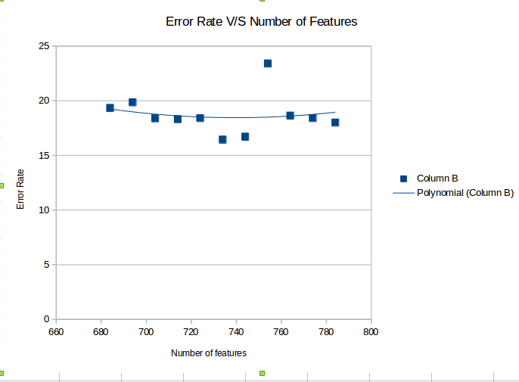

x = [684,694,704,714,724,734,744,754,764,774,784]

y =
[19.3327777778,19.8505555556, 18.3827777778, 18.3086111111 , 18.4102777778 , 16.4361111111 , 16.7061111111 , 23.4011111111 , 18.6316666667 , 18 ]

Adding noise

Adding regularization term of weight decay

Accuracy:

Accuracy for fold 1 84.55
Error Rate for fold 1 15.45
Accuracy for fold 2 83.70
Error Rate for fold 2 17.391
Accuracy for fold 3 80.1
Error Rate for fold 3 19.93
Accuracy for fold 4 83.983
Error Rate for fold 4 17.016
Accuracy for fold 5 85.825
Error Rate for fold 5 15.175

Accuracy for fold 84.5 %
Error Rate for fold 15.5 %

