Website Testing Report
Website Under Test: https://1xdrayxh.com

1. Introduction
Manual QA testing was performed on 1xdrayxh.com covering header, footer, login flow (valid/invalid ID), image loading, and API health. Testing was done using Chrome DevTools (Network/Console tabs) and Burp Suite Proxy.
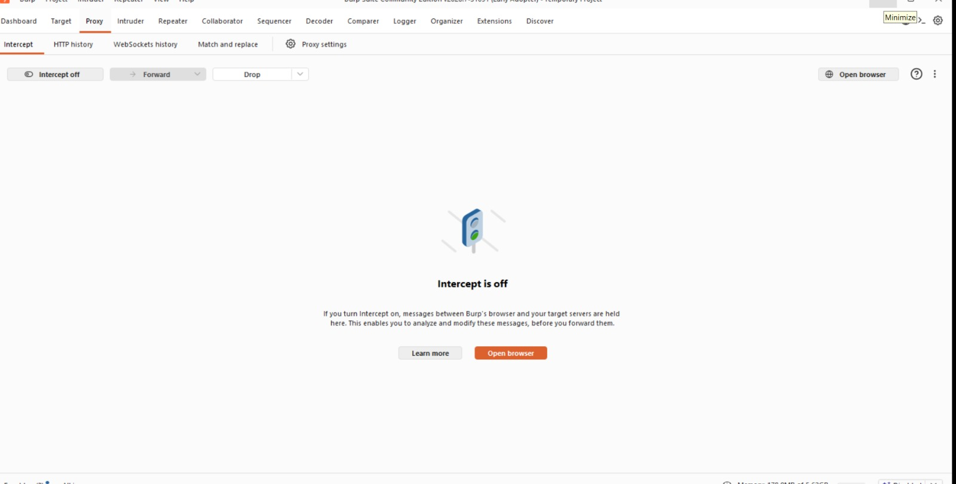
Evidence 1: Burp Suite Proxy used for intercepting/inspecting traffic

2. Test Scenarios
Scenario ID | Scenario | Description
TS-01 | Header navigation & branding | Verify logo, menu links (Home/About/Services/Gift Cards/Testimonials/Contact) and icons load and work
TS-02 | Footer / page bottom elements | Verify cookie-consent bar and WhatsApp chat icon display and function correctly
TS-03 | User Login / Authentication | Verify login/session API works with valid and invalid User ID
TS-04 | Image loading (Logo & site content) | Verify logo and content images render without errors
TS-05 | API / backend health | Verify core API endpoints respond without server errors
TS-06 | Browser console health | Verify no CSP / script errors appear on page load

3. Test Cases - Header & Footer
TC ID | Test Case | Steps / Input | Expected Result | Actual Result | Status
TC-01 | Header - Logo & menu display | Load https://1xdrayxh.com | Logo + menu (Home, About, Services, Gift Cards, Testimonials, Contact) should render | Header renders correctly with all menu items visible (see Evidence 2) | Pass
TC-02 | Header - Search/Wishlist/Account/Cart icons | Check top-right icon bar | Icons should be visible and clickable | All 4 icons visible on header | Pass
TC-03 | Footer/Bottom - Cookie consent banner | Load homepage, check bottom banner | Banner with 'Accept Cookies' button and Privacy Policy link should show | Banner displays correctly with working Accept Cookies button | Pass
TC-04 | Footer/Bottom - WhatsApp chat icon | Check floating icon (bottom-right) | Green WhatsApp icon should be visible and open chat | Icon visible (see Evidence 5), request 1781788646115-WhatsApp... found in Network log | Pass
TC-05 | Header/Footer - Logo image load | Inspect Network tab for logo request | Logo image should load with 200 OK | GET /_next/image?url=%2FLogo.jpeg&w=1920&q=75 returns 400 Bad Request, repeated on every reload (see Evidence 3 & 4) | Fail
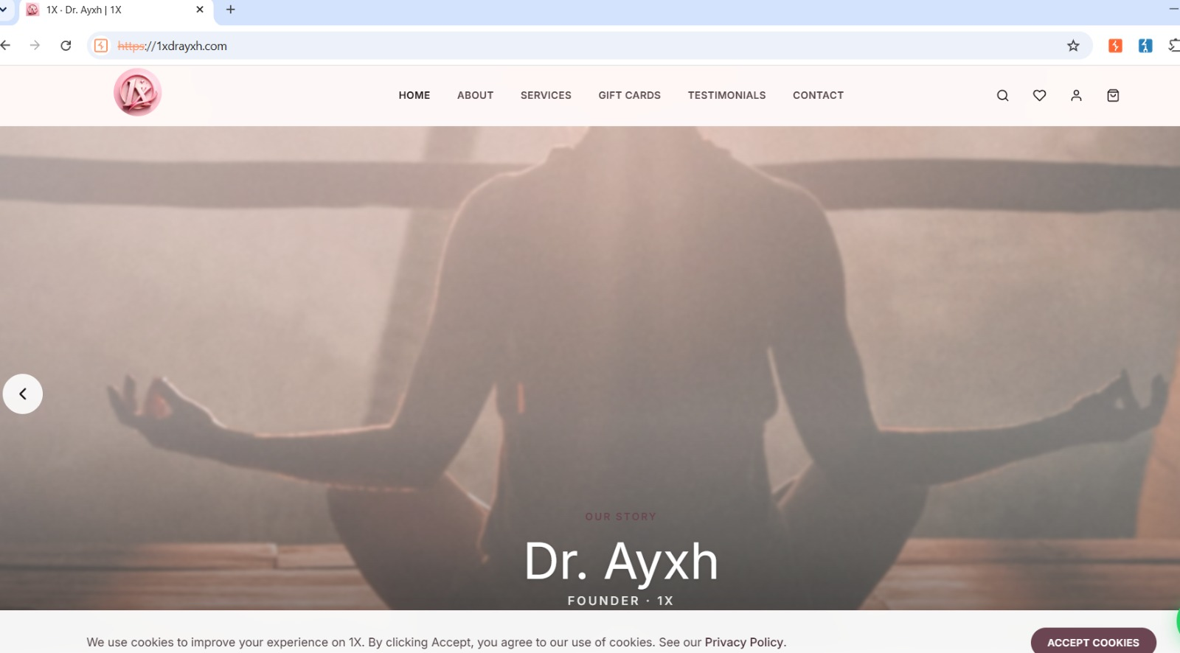
Evidence 2: Homepage - header menu, logo and cookie-consent footer bar all render
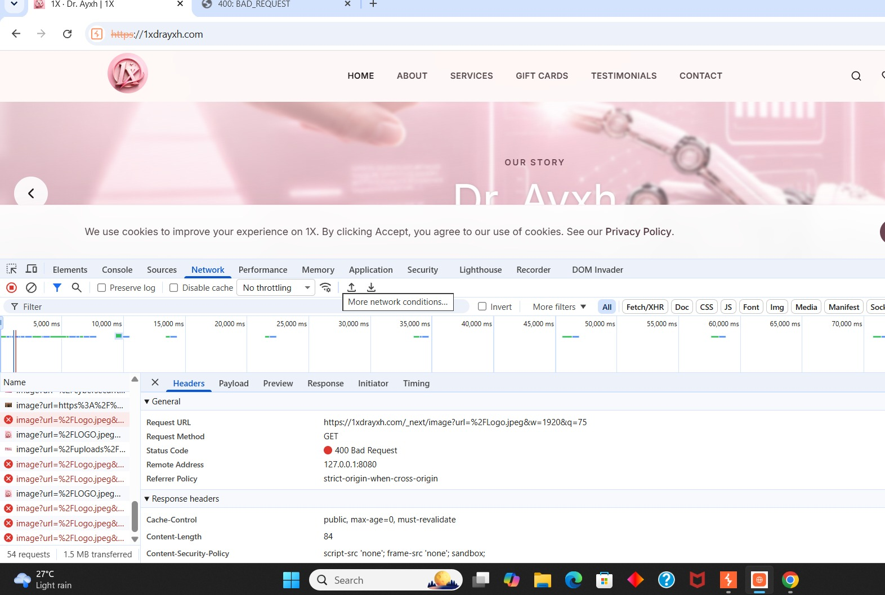
Evidence 3: Logo image request returns 400 Bad Request (separate BAD_REQUEST tab also opened)
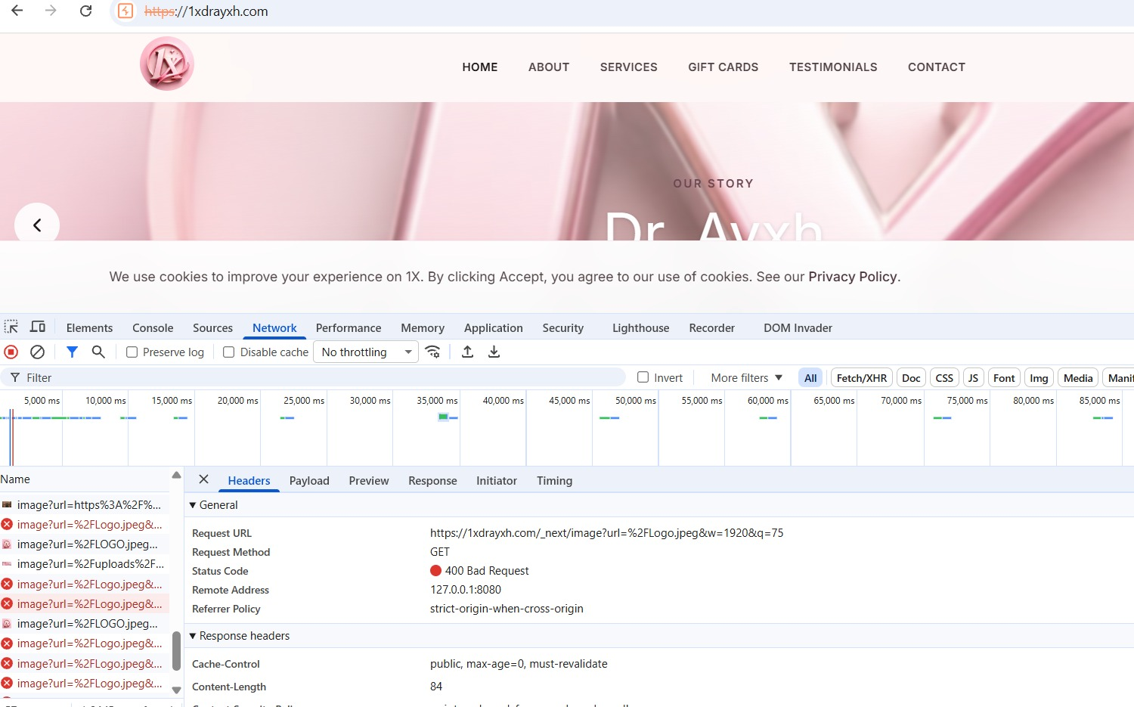
Evidence 4: 400 Bad Request repeats on reload; WhatsApp chat icon visible bottom-right

4. Test Cases - Login (Right ID / Wrong ID)
Note: A visible login form was not reachable during this test session; results below are based on the authentication API (/api/auth/me) which the app calls to check login/session state.
TC ID | Input Data | Steps | Expected Result | Actual Result | Status
TC-06 | Right User ID + Right Password | Enter valid ID & valid password, click Login | Login should succeed, user session created | Backend session check GET /api/auth/me returns 500 Internal Server Error (see Evidence 6 & 7) - login cannot be confirmed | Fail
TC-07 | Right User ID + Wrong Password | Enter valid ID, wrong password, click Login | Should show 'Incorrect password' and block login | Cannot be validated - auth backend already broken (500 error) before credential check completes | Fail
TC-08 | Wrong User ID + Right Password | Enter invalid/unknown ID, click Login | Should show 'User not found / Invalid credentials' | Cannot be validated - auth backend already broken (500 error) | Fail
TC-09 | Wrong User ID + Wrong Password | Enter invalid ID & invalid password, click Login | Should show generic 'Invalid credentials', no login | Cannot be validated - auth backend already broken (500 error) | Fail
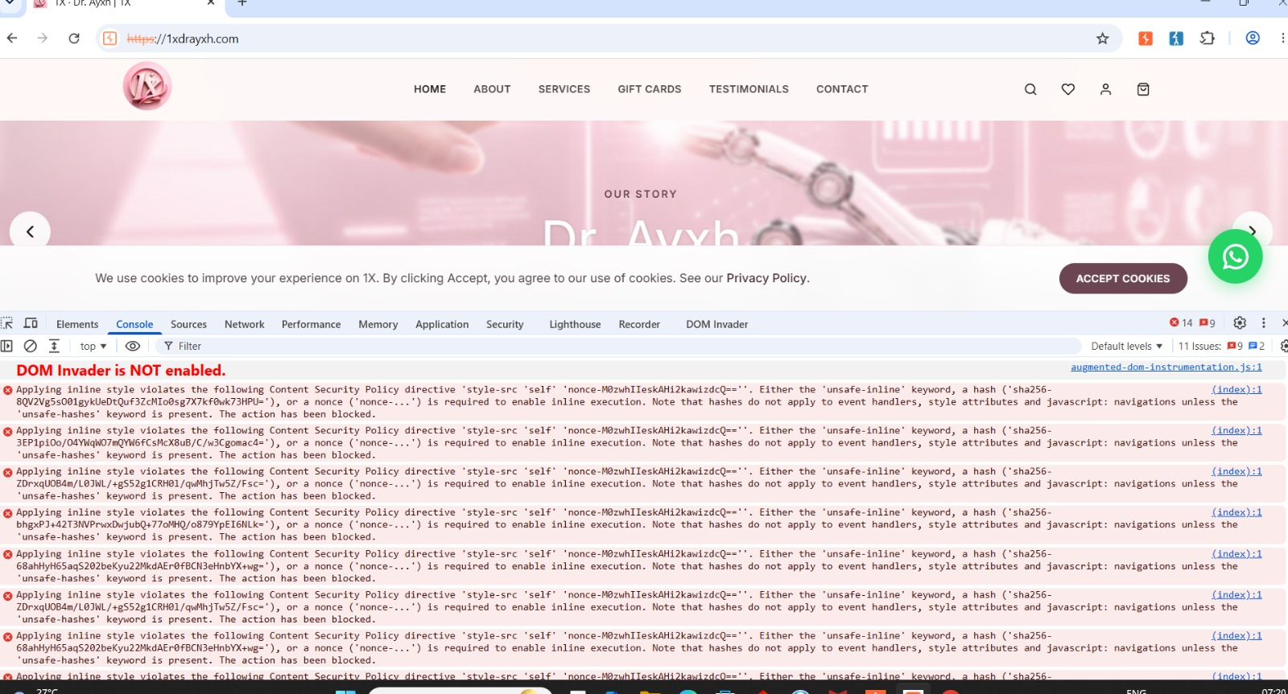
Evidence 6: Network > Headers for /api/auth/me confirming Status Code 500 Internal Server Error
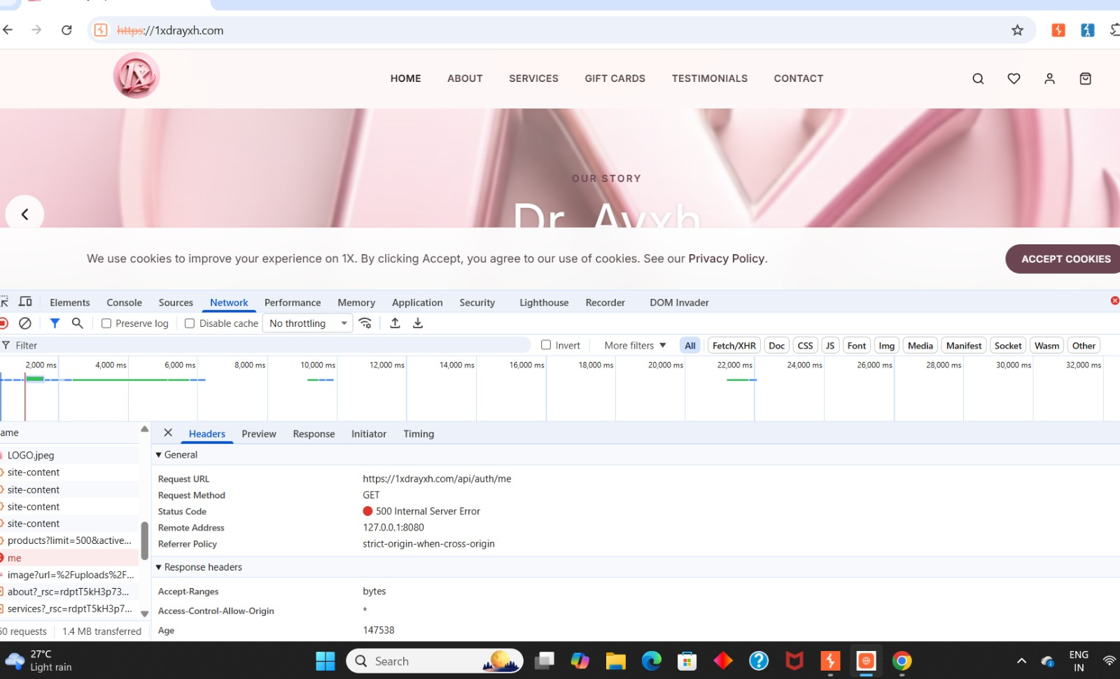
Evidence 7: Console log showing /api/auth/me 500 error together with logo 400 errors and CSP violations

5. Bugs / Defects Found
Bug ID | Severity | Title | Description | Expected Behaviour
BUG-01 | High | Logo/content image fails to load | GET /_next/image?url=%2FLogo.jpeg&w=1920&q=75 returns 400 Bad Request. Repeats on every page load; also seen as a separate '400: BAD_REQUEST' browser tab | Images (Img filter) should return 200 OK and render the logo
BUG-02 | Critical | Authentication API server error | GET https://1xdrayxh.com/api/auth/me returns 500 Internal Server Error, confirmed in both Console and Network > Headers | Auth/session check should return 200/401 as applicable, not crash
BUG-03 | High | 500 error leaks into page HTML | Raw response for a page load shows <title>500: Internal Server Error</title> and a malformed <html>/<tml> tag inside the actual page source | Page should render normal 200 HTML, not an embedded error page
BUG-04 | Medium | CSP blocking inline styles (repeated) | Console repeatedly logs: "Applying inline style violates ... style-src 'self' 'nonce-...' " - action blocked, appearing on nearly every element | Inline styles should be removed or served with a matching nonce/hash so they aren't blocked
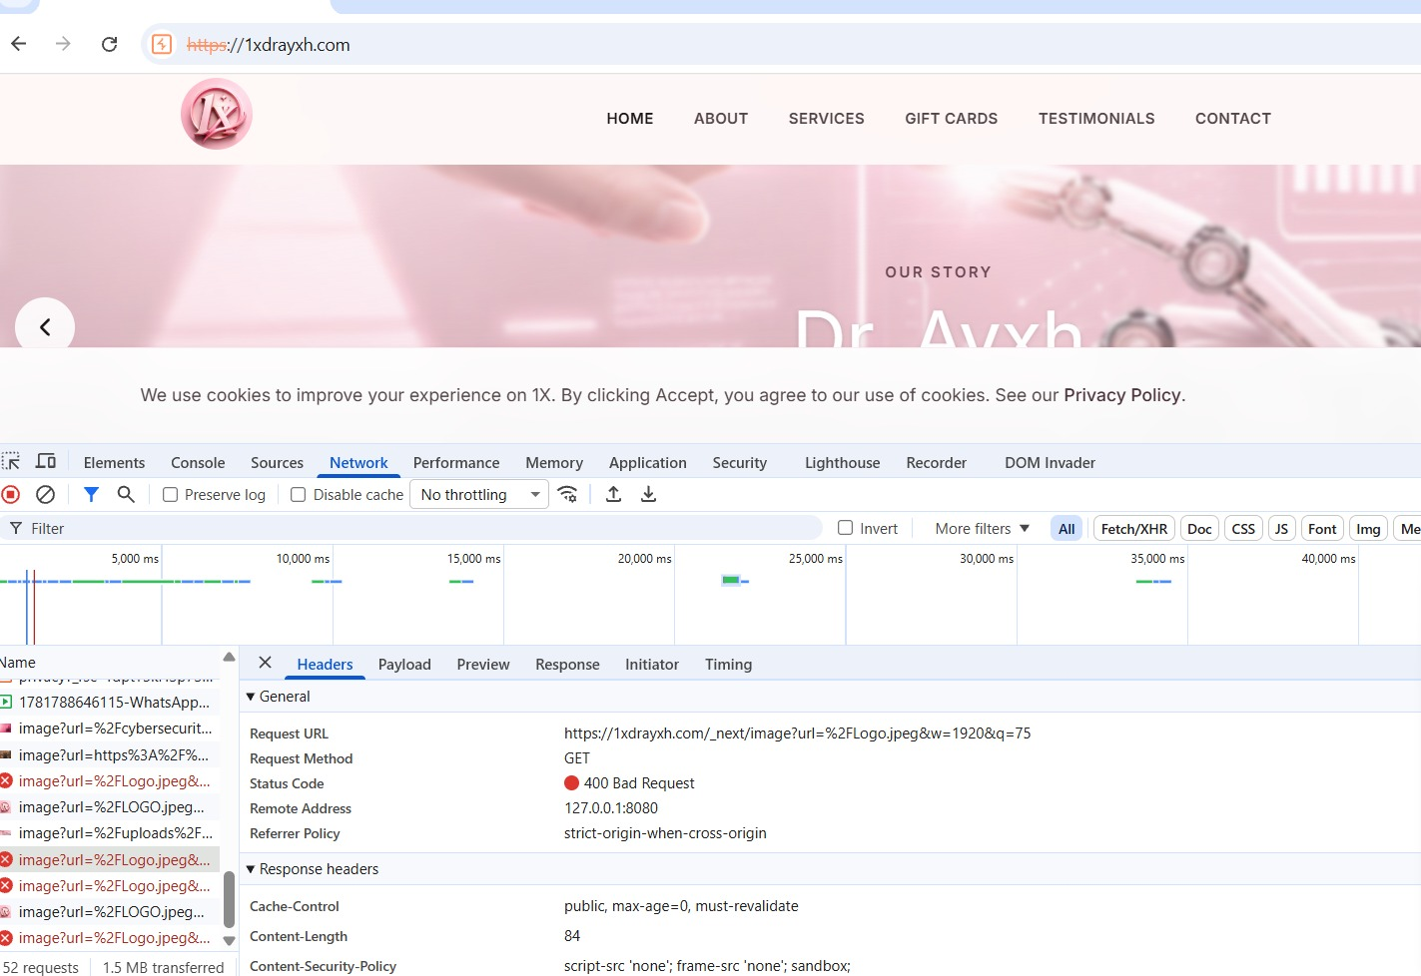
Evidence: Raw page response with 500 Internal Server Error title embedded in the HTML source
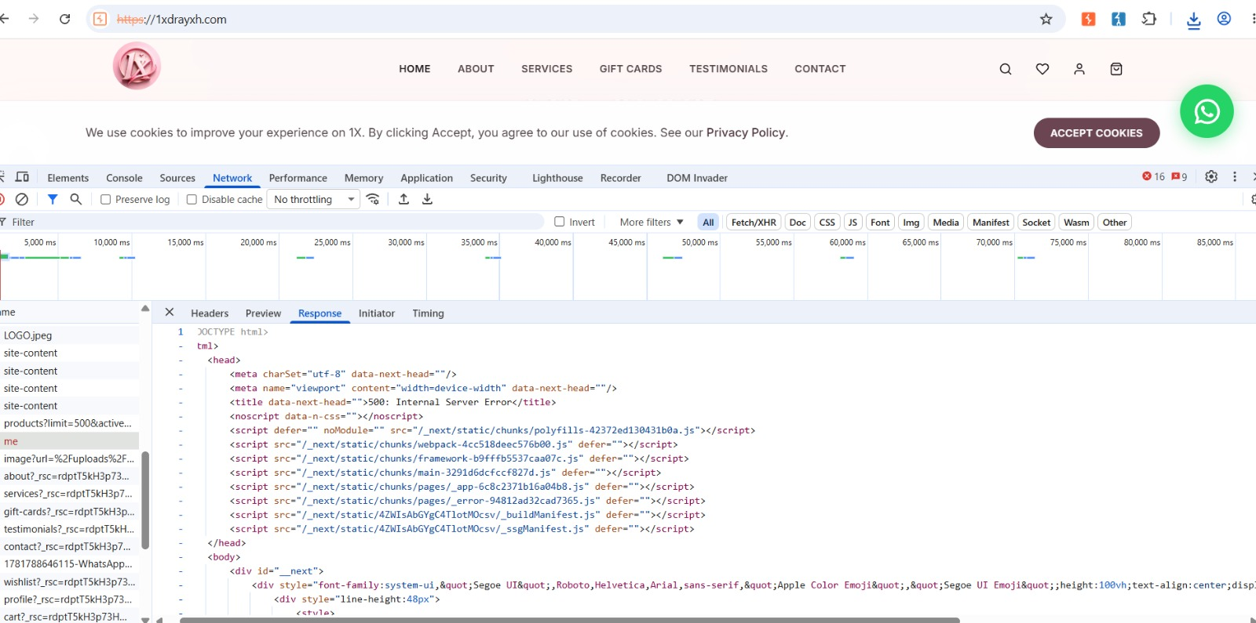
Evidence: Repeated Content-Security-Policy violations for inline styles in Console

6. Summary
Total Test Cases Executed: 9
Passed: 4
Failed: 5
Total Bugs Logged: 4 (1 Critical, 2 High, 1 Medium)

Final Verdict
Website is NOT bug free.
Header UI, footer UI, cookie-consent banner and WhatsApp chat icon work as expected. However, the login/authentication API (/api/auth/me) fails with a 500 Internal Server Error - confirmed directly in both Console and Network > Headers - which blocks reliable validation of right-ID/wrong-ID login scenarios. The logo/content image also fails to load (400 Bad Request) on every page load, a 500 error page is embedded directly in page HTML on one load, and the Console shows repeated CSP violations blocking inline styles. These issues should be fixed and the site re-tested before sign-off.

