GLORY TEXTILES
Inventory Management System

Problem Statement
A “Glory Textiles” industry needs an application to maintain and track its inventory. The proposed solution is an Inventory Management System (IMS). The client expects a quick working product, so the solution follows Agile methodology and supports Continuous Delivery through DevOps.
Objectives
- Provide a single application workspace for vendor information, material information, purchase entry and purchase reporting.
- Implement the supplied participant TODOs across the VendorService, MaterialService and InventoryManagementSystem modules.
- Expose REST endpoints that can be consumed by the React frontend.
- Persist vendor, material and purchase information using MySQL and Spring Data JPA.
- Use Gitea, Jenkins, SonarQube and Tomcat as part of the VM-based DevOps workflow.
- Provide a user interface for Inventory management system.
Technology Stacks Used
Area | Technology
Backend | Java 17 + Spring Boot 2.7.3
Build | Maven
Persistence | Spring Data JPA + Hibernate
Database | MySQL
Frontend | React + Vite
HTTP client | Axios
Routing | React Router
Source control | Gitea / Git
CI/CD | Jenkins
Quality | SonarQube
Application server | Apache Tomcat

Implementation Completed
VendorService
- VendorController#getVendorDetails calls VendorServiceImpl#getVendorDetails() and returns ResponseEntity.ok(list).
- VendorServiceImpl retrieves all VendorEntity records with vendorDAO.findAll().
- Each VendorEntity is mapped to VendorBean including vendorId, vendorName, vendorAddress, contactPerson and contactNumber.
- The endpoint is exposed as GET /controller/getVendors.
MaterialService
- Material category controller methods retrieve all categories and retrieve a category by categoryId.
- Material type controller methods retrieve all types and filter types by categoryId.
- Unit controller methods retrieve all units and filter units by categoryId.
- MaterialServiceImpl maps MaterialCategoryEntity objects to MaterialCategoryBean objects.
- MaterialTypeServiceImpl maps type entities and carries the related categoryId into the bean.
- UnitServiceImpl maps unit entities and carries the related categoryId into the bean.
- MaterialTypeDAO and UnitDAO contain category-based Spring Data finder methods.
InventoryManagementSystem
- PurchaseBean includes validation annotations for mandatory vendor, category, type, brand, unit, quantity, purchase amount and purchase date fields.
- PurchaseEntryController uses @Valid for the addPurchaseDetail request.
- The controller calls PurchaseService.addPurchaseDetails(), stores the saved PurchaseBean in the HTTP session and returns a success payload.
- PurchaseServiceImpl generates a transaction ID and delegates persistence to PurchaseDataAccess.
- PurchaseDataAccess maps PurchaseBean to PurchaseEntity, persists it and maps the saved entity back to PurchaseBean.
Transaction ID logic
- The implemented transaction ID generator removes spaces from the vendor/category values, takes up to the first three characters of each, formats the purchase date as MMddyyyy, converts the prefixes to uppercase, and creates an ID in the form:

P_<VENDOR_PREFIX>_<MMDDYYYY>_<CATEGORY_PREFIX>

- Example pattern: a vendor beginning with “ABC”, a purchase date of 09/06/2026 and a category beginning with “THR” would produce a transaction ID following the pattern P_ABC_09062026_THR.

Local service base URLs
VendorService http://localhost:8087
MaterialService http://localhost:8088
InventoryManagement http://localhost:8085
React/Vite frontend http://localhost:5173
Quick endpoint reference

LOCAL
VendorService: http://localhost:8087/controller/getVendors
Material categories: http://localhost:8088/material/controller/getMaterialCategories
Material types: http://localhost:8088/type/controller/getTypeDetails
Units: http://localhost:8088/unit/controller/getUnitDetails
IMS health: http://localhost:8085/health
Purchase entry: http://localhost:8085/purchaseEntry
TOMCAT / VM
Vendor context: http://<VM-IP>:8081/vendor/
Material context: http://<VM-IP>:8081/material/
IMS context: http://<VM-IP>:8081/inventory/

Key commands to Run
# VendorService
cd VendorService
mvn clean install
mvn spring-boot:run
# MaterialService
cd MaterialService
mvn clean install
mvn spring-boot:run
# InventoryManagementSystem
cd InventoryManagementSystem
mvn clean install
mvn spring-boot:run
# Frontend
cd ims-frontend
npm install
npm run dev
# Frontend production build
npm run build

Initial IMS User Creation
- When the application is used for the first time, an IMS user must be created through the frontend. The user should navigate to the Sign Up / Create an Account page and provide the required user details. The frontend handles the user registration process and creates the initial IMS user account.

- Once the account is created successfully, the user can return to the Sign In page and log in using the registered credentials. After successful authentication, the user is redirected to the Glory Textiles Inventory Management System dashboard.

Jenkins Endpoint
VendorService — Jenkins deployment URL
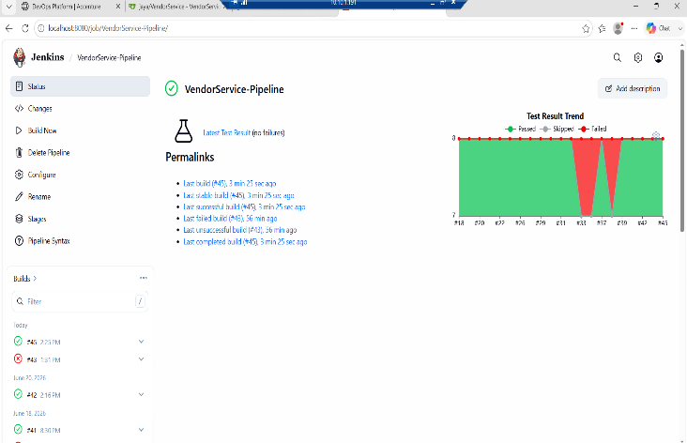
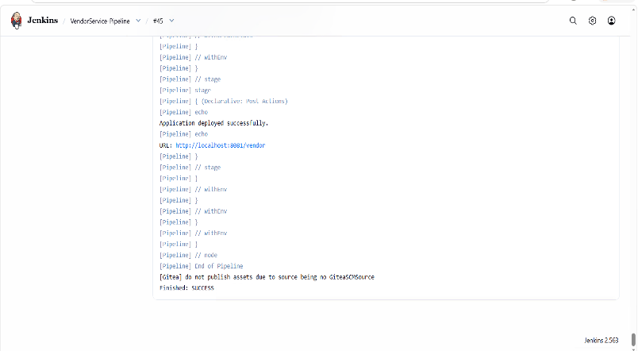
Endpoint observed in the supplied capstone guide: 10.10.1.191:8081/vendor/ . Replace/confirm this with the exact endpoint displayed in your Jenkins Console Output.

MaterialService — Jenkins deployment URL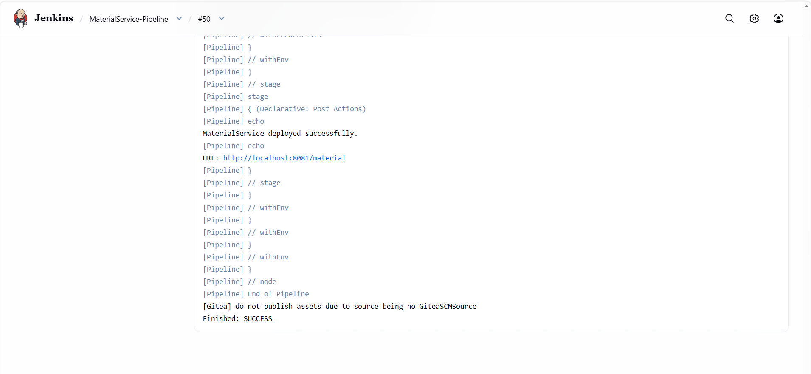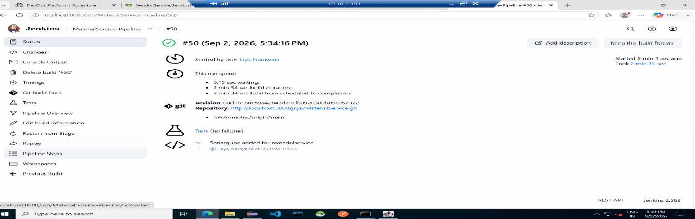

InventoryManagementSystem — Jenkins deployment URL
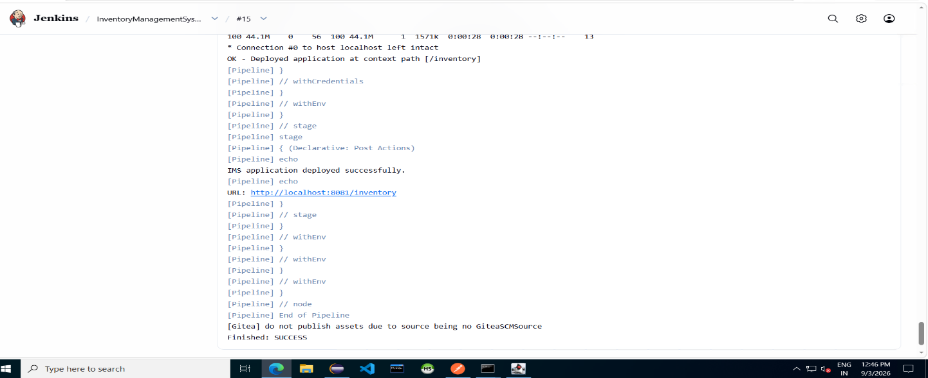

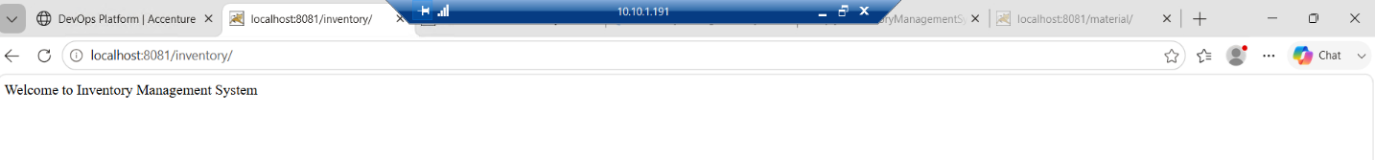
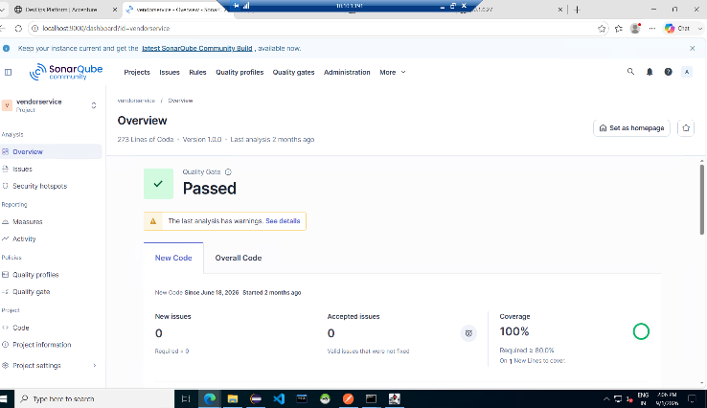
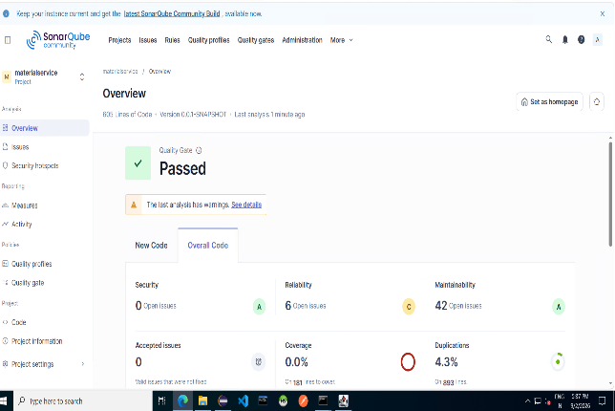
SonarQube
User Interface
Login page
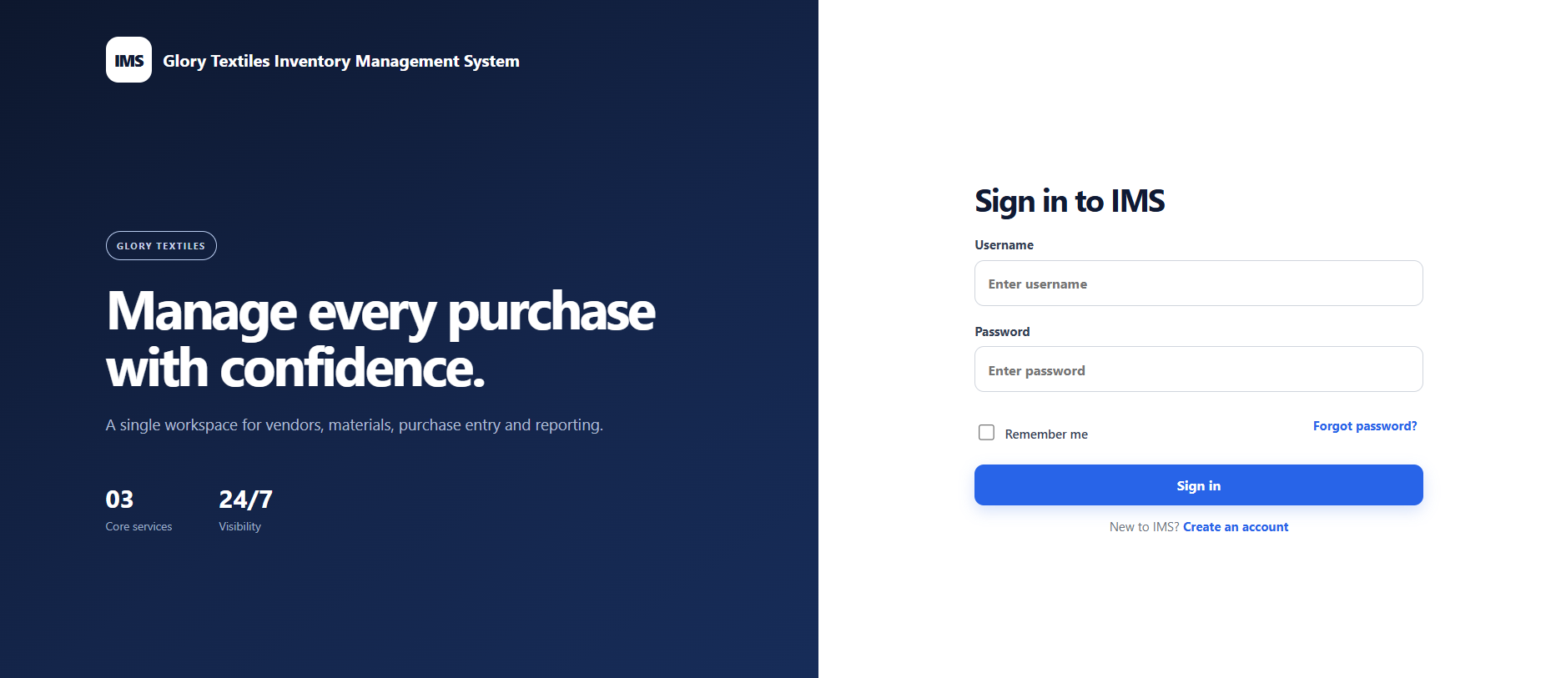
Dashboard
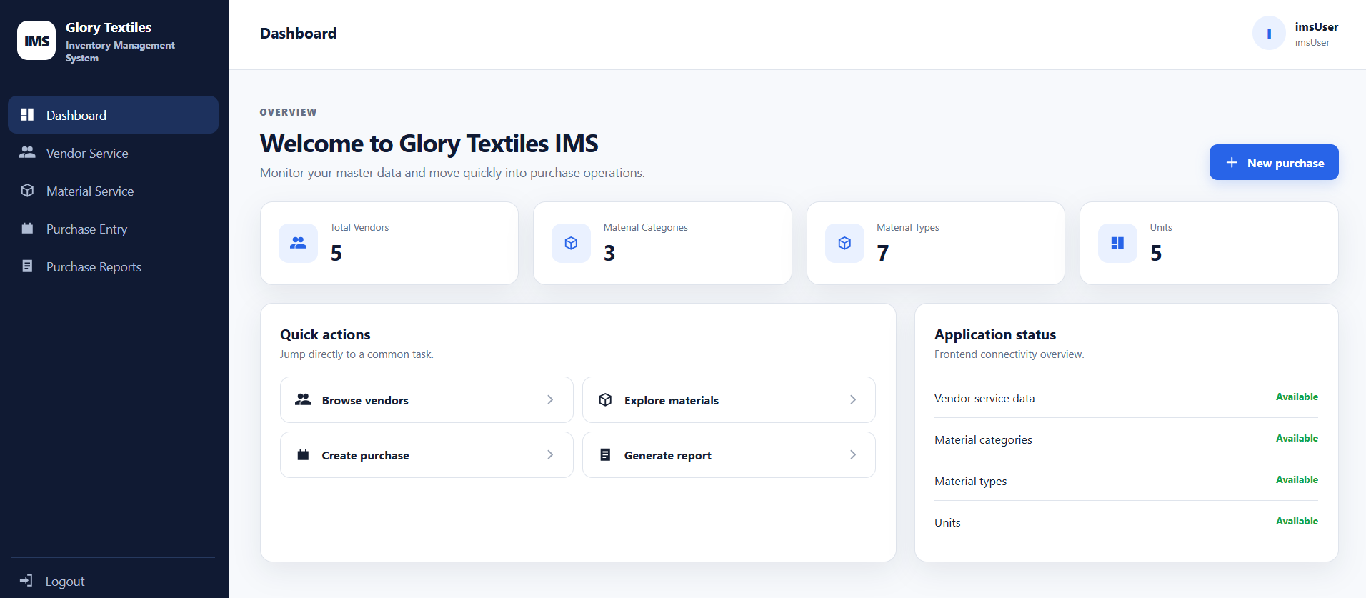
Vendor Data
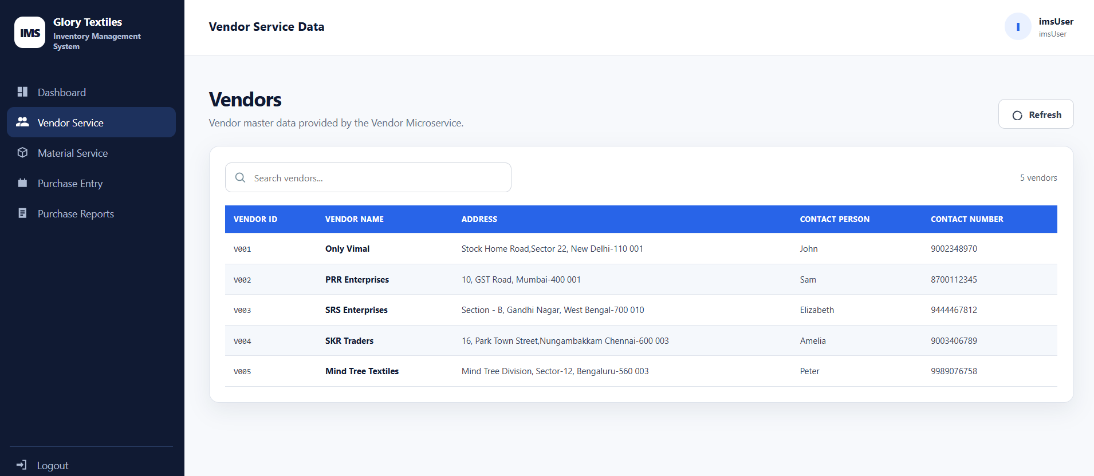
Material Data
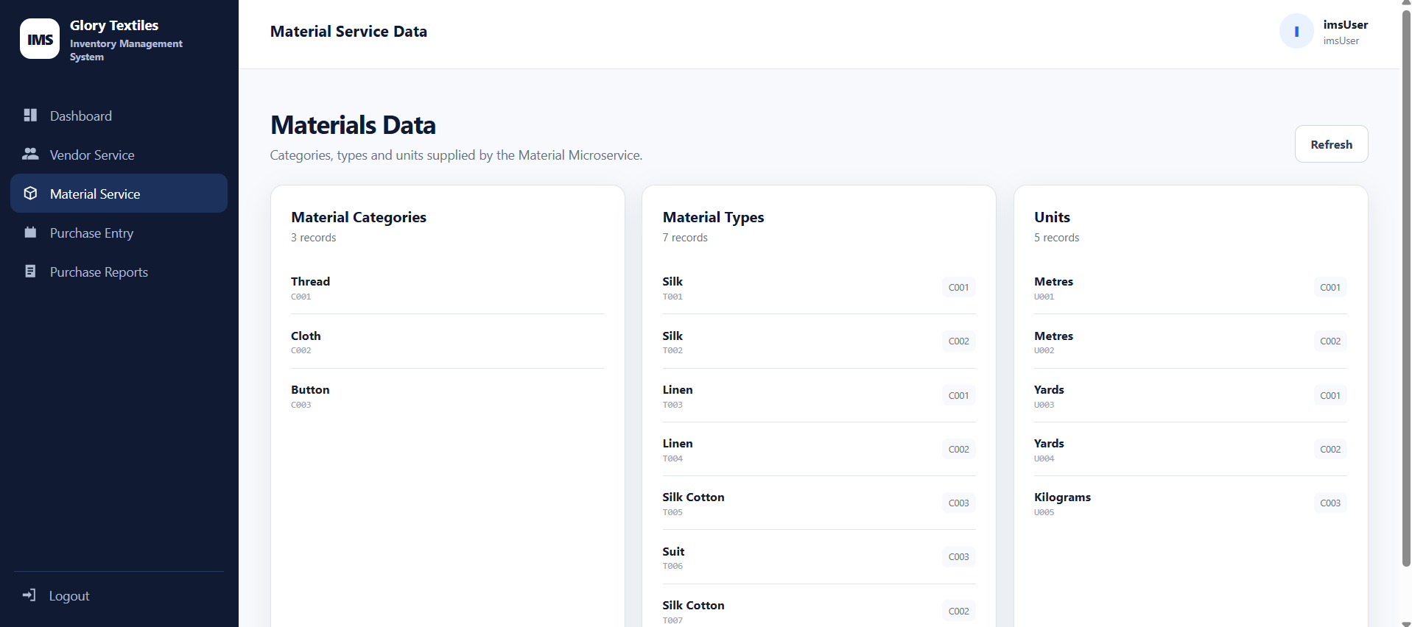

Material Purchase Entry Page
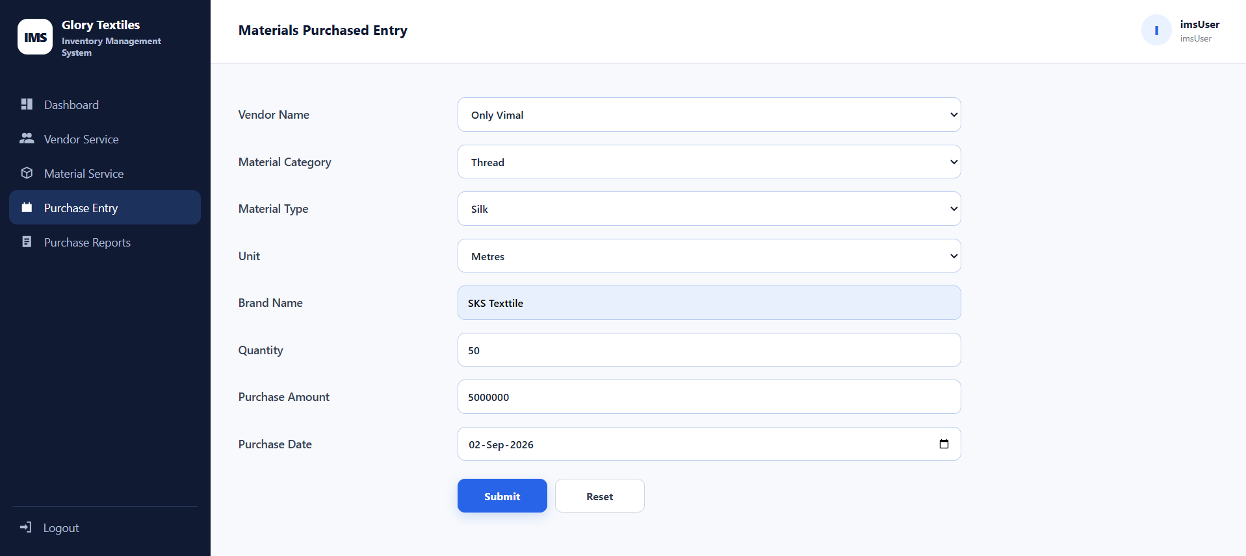
Purchase Success Page
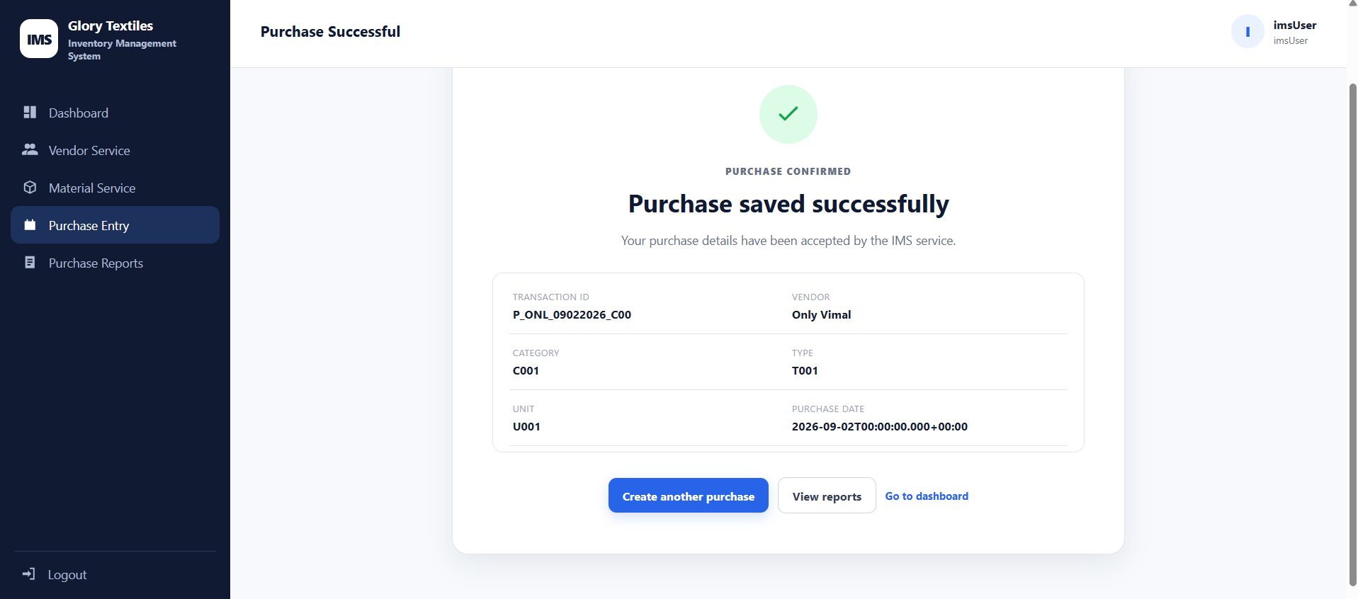

Report Page
