**BestParking.com – eParking Service**

**IS/HCC 636 Project Report**

**Prof. Dr. Anthony F. Norcio**



**Group 6**

**Kanika Danke**

**Neetu Menon**

**Nitin Basvekar**

**Poonam Gada**

**Table of Contents**

1. Project Proposal: 4

1.1 Organizational Focus: 4

1.2 General Goals of the Proposed Project: 4

1.3 Tasks Assignment: 5

2. Preliminary Analysis: 6

2.1 Description of the Current System: 6

2.2 Problems with Current System: 7

3. Feasibility Analysis: 7

3.1 Technical Feasibility: 7

3.2 Organizational Feasibility: 8

3.3 Economic Feasibility: 8

3.4 Schedule Feasibility: 9

3.5 Legal Feasibility: 9

4. Requirements Analysis: 9

4.1 Functional Requirements: 10

4.1.1 Process Oriented Functional Requirements: 10

4.1.2 Information-Oriented Functional Requirements: 11

4.2 Non-Functional Requirements: 11

4.2.1 Operational Requirements: 11

4.2.2 Performance Requirements: 11

4.2.3 Security Requirements: 12

4.2.4 Cultural & Political Requirements: 12

5. Use Case Diagrams: 12

6. Data Flow Diagram: 16

7. Network Organization: 18

8. Data Storage and Organization: 18

8.1 ER Diagram: 19

9. Program Organization: 20

10. User Interface Design: 20

10.1 Desktop User Interface: 21

10.2 Mobile User Interface: 23

11. Testing, Implementation and Maintenance: 24

11.1 Testing: 24

11.1.1 Unit Testing: 24

11.1.2 Integration Testing: 25

11.1.3 Systems Testing: 25

11.1.4 Acceptance Testing: 25

11.2 Implementation: 26

11.3 Maintenance: 27

12. References: 28

# **Project Proposal:**

# **1.1 Organizational Focus:**

Bestparking.com [1] is an application that provides E-Parking service. This application allows users to book or reserve the parking space before reaching the destination anywhere in the country. In addition to this parking service, it allows users to compare daily or monthly rates between different parking facilities and thereby saving hundreds of dollars. The parking slot can be located using either city or airport parameters. Motorists can also search for the parking slots using the Address, Cross Street, Attraction or the Neighborhood. The system allows users to input the arrival and departure date and time. Depending upon the input provided by the user, the system provides the available parking space results to the user. The system covers all possible pricing variations like holiday parking, extra overnight charges and evening parking.

# **1.2 General Goals of the Proposed Project:**

The aim of the project is to enhance an existing application to solve the various parking problems in the United States like peak-time parking, out-of-town parking, lack of parking spaces available in overcrowded locations. Our goal is to enhance the existing system by providing the reserved parking spots for the physically challenged public and veterans. It will also help a user to narrow down the parking search by providing distance radius option.

# **1.3 Tasks Assignment:**

|  |  |  |  |  |
| --- | --- | --- | --- | --- |
| **Meeting Number** | **Tasks** | **Attendees** | **Tasks Assignment** | **Status** |
| 1 | Project Proposal | All 4 Team Members | All | Completed |
| 2 | Preliminary Analysis | All 4 Team Members | All | Completed |
| 3 | Identifying the current system architecture | All 4 Team Members | All | Completed |
| 4 | Identifying the shortcoming of the existing application | All 4 Team Members | All | Completed |
| 5 | Identifying the Current Feasibility analysis of the system (Might change as the project progresses) | All 4 Team Members | Nitin Basvekar  Kanika Danke | Completed |
| 6 | Analyzing the Current System Requirements as well as the changes needed to address the shortcomings | All 4 Team Members | Neetu Menon  Poonam Gada | Completed |
| 7 | Identifying the Use Case Diagrams | All 4 Team Members | Nitin Basvekar  Poonam Gada  Neetu Menon | Competed |
| 8 | Data and Process Modelling | All 4 Team Members | Nitin Basvekar  Poonam Gada | Competed |
| 9 | User Interface Design | All 4 Team Members | Kanika Danke  Nitin Basvekar | Completed |
| 10 | Identifying the Network Architecture | All 4 Team Members | Poonam Gada | Completed |
| 11 | Data Storage, Program and Data Organization | All 4 Team Members | Nitin Basvekar | Completed |
| 12 | Testing Maintenance and Implementation | All 4 Team Members | Neetu Menon | Completed |

# **Preliminary Analysis:**

## **2.1 Description of the Current System:**

Population growth and the number of vehicles is showing a proportional growth in the last few years (as shown in the below figure). This has caused traffic problems, parking issues causing the vehicle infrastructure difficult to handle the incursion of vehicles on road.

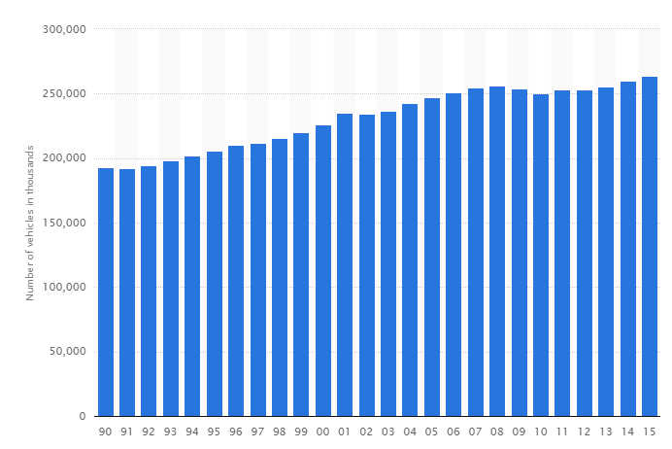

Fig [2]: Graph of number of vehicles in US between 1990 - 2015

With the world going techno-savvy, the biggest challenges BestParking faced was to figure out the payment and parking verification method. The hardware system of BestParking has attached to the gateway mechanism which allows the app users to find out the nearby parking lots within a given distance. This will be done via Parking Guidance and Information System (PGIS) [3] and Global Positioning System (GPS).  BestParking being successful in 100 cities and 115 Airports in North America, it allows users to pre-book parking space before reaching the destination. Currently, the system allows the users to provide its inputs as arrival date, departure date, time frame and location. It also allows users to expand its search with fields such as nearby landmarks, museums and theaters to provide better accuracy for their location and nearby parking spaces. The system outputs the current parking rates ranging from lowest parking rates to highest parking rates along with the contact information of the owners of parking lots.

## **2.2 Problems with Current System:**

With our analysis on the existing system, we identified that BestParking.com fails to address few problems, such as:

* Bestparking.com fails to reserve parking spots for physically challenged public as well as for people belong to Veteran Status.
* While providing an input in the BestParking app, we, as users were not able to look for parking spots with our given range. For Eg: If our current location is Halethorpe Station and we want to look for a parking spot within 1 mile range, we found parking spots that were more than 1 mile range.
* Apart from this, we were not able to identify guests parking spots or student parking spots within the university campus. For Eg: We were not able to check for parking spots in UMBC campus. It showed the search as ‘We do not Cover Parking Facilities in this Area’.
* Offline access to the application should also be included (if GPS is on) in case of poor network coverage/availability.
* Vehicle users are unaware of such Parking apps. Promotion/Marketing of such apps will help to reduce traffic and improve ease of parking.

# **Feasibility Analysis:**

We conducted feasibility analysis of the system to check whether the new changes which we are planning to introduce do not outweigh the budget which we have set for our system and to proceed with the changes or not.

We have currently shortlisted below feasibilities for our project:

## **Technical Feasibility:**

* + Technical feasibility will help us to assess the extent to which our system can be enhanced successfully along with its designing, development, and implementation.
  + Enhancement of existing system will require conversion and any type of conversion will incur risks if new technologies are implemented. We made sure that the risks were managed properly.
  + We have planned for new technologies like Parking Guidance and Information Systems (PGIS) to be incorporated with GPS which will address the compatibility issues with the old architecture and the new architecture.

## **Organizational Feasibility:**

It tells how well the system would be accepted by the end users.

* + We made sure that the user interface is friendly for tracking the destination and identifying vacant parking spots.
  + To identify whether the application is scalable, robust and flexible with the growing requirements so that multiple users can access the application at the same time and any new changes can be incorporated easily.

## **Economic Feasibility:**

It will help us to identify the costs and benefits associated with the application.

* + Development and operating costs which include the enhancement of features in the website, mobile application, and hardware to meet the user needs.
  + Intangible costs and benefits for improved customer support & service to address the problems faced by the users and to attain better position in market.
  + Identifying the cost to investigate the architecture of existing system and parallely build a new system to incorporate new modules.
  + Addressing the maintenance cost and allocating an infrastructure support team for a certain period post the go-live of the system with also incur costs.

## **Schedule Feasibility:**

* Schedule of each deliverable, each phase of the project milestone is very important and it should be ensured that the deliverables are completed on time.
* Improper schedule would result into waste of money as well as resources.
* Incorporating the changes suggested by users of the application as quickly as possible so that the application is always updated.

## **Legal Feasibility:**

While creating the application, and addressing the shortcomings, we need to make sure that the Parking Laws and Traffic Laws are addressed as below:

* Adhere to Traffic laws and State laws. Eg: corporate parking and public parking.
* Denial of parking in property of State Educational Institution or silent zones such as hospital areas.
* Vehicles without permits must be parked in visitor parking lots or near to parking meters.

# **Requirements Analysis:**

We are gathering the requirements with the help of following elicitation techniques:

* **Surveys/ Questionnaires:** Surveys posted by New York Times, Travel Channel, The Wall Street Journal, Daily News analyses the pros and cons of such cost cutting apps and gives the users. We have also analyzed the feedback and reviews posted on the website as well as on Appstore given by users who already have used it. [4]
* **Beta Version Release**: A beta version of the application can be released to observe some users while they use the application and then analyzing their feedback and making changes in the application accordingly.
* **Benchmarking:** Informal benchmarking can be done to see what the competitors are doing and if useful incorporating it in the application to keep it updated. We have tried to build network with individuals who are using other parking application and learning from them.
* **Document Analysis:** To enhance this system we must elicit information from the existing document. We have studied and understand relevant documents like contracts, business rules, emails, memos, etc. Maintaining proper documentation about the application to accommodate updates in the future.

## **4.1 Functional Requirements:**

Functional requirements of the Best Parking System can be classified as follow.

### **4.1.1 Process Oriented Functional Requirements:**

* Access to the Best Parking System
* All Users must have valid credentials to login to the system.
* Availability of Parking Lots
* User should be able to login to the system.
* After successful login, user should able to see availability of parking lots by selecting city or Airport, Location, Arrive & Depart time, selecting range.
* All Available parking lots with their price should be visible online to the users.
* Booking a parking lot
* Users should be able to book a lot after checking availability.
* Users should see selected parking lot details like address, photo, rates before booking a lot and get the option to reserve.
* Payment
* User should reserve a parking lot and make a payment through debit/credit card.
* An online as well as an email confirmation with an E-receipt should be triggered to the user.
* Feedback
* The system should have a feature of recording feedbacks given by users which would help in the analysis of the changes or updates in the application, and if needed can be modified for any loopholes present in the application.
* User-feedback should be recorded in the system and notified to the admin.

### **4.1.2 Information-Oriented Functional Requirements:**

* The system must retain users booking history for at least 6 months.
* The system must always show real-time available parking lots.
* The system must include budgeted and actual sales and expense amounts for current year and three previous years.

## **4.2 Non-Functional Requirements:**

### **4.2.1 Operational Requirements:**

* The objective of the proposed system is to provide cheapest & most convenient parking facilities by enhancing existing application.
* This system will be used by desktop users over web environment as well as by smartphone users supports Android, IOS, Windows.
* Users should be able to perform tasks such as availability-check, booking, payment etc. and all services are always available to the users.

### **4.2.2 Performance Requirements:**

* An interaction time between user and system should be very minimal.
* System should have minimal response time if it is being used by multiple users at a same time.
* System should not take long time to authorize the users and the card details.

### **4.2.3 Security Requirements:**

* User login details like email, password shall be secured under security laws and should not be shared with any other organizations.
* All booking payments/requests shall be secured by SSL security layer.
* System includes all available safeguards and firewall to protect the application from viruses, worms, Trojan horses, etc.

### **4.2.4 Cultural & Political Requirements:**

* Personal information of users should be protected in compliance with the Data Protection Act.
* The application must ensure that the Traffic and Security Laws should also be addressed.

# **Use Case Diagrams:**

We have identified three different use cases for this system.

* User_Registration
* Parking_Availibility
* Booking_Slot

Following are the use cases on which we have worked upon.

* **User_Registration**: The use case describes how new users register online for BestParking.com

|  |  |  |  |
| --- | --- | --- | --- |
| **Use Case Name:** User_Registration | **ID**: UC01 | | **Importance** **Level**: High |
| **Primary** **Actor**: User | | | |
| **Short** **Description**: The use case describes how new users register online for BestParking.com | | | |
| **Trigger**: User inputs requested details for registering into the system  **Type**: External | | | |
| **Inputs** | | **Outputs** | |
| Name, Email ID and Phone number of New User | | Validation of user against the system | |
|  | | Message displayed for new user creation | |
|  | | Message displayed if user already exists in the database | |
| **Major Steps Performed** | | **Information for Steps** | |
| User registers for BestParking.com | |  | |
| User provides details such as Name, Email ID and Contact Number | | Name, Email ID, Phone Number. | |
| User Database validates the input details of user | | Displays prompt message. | |
|  | | If no email exists, new user gets registered. | |

Fig: Use-case Diagram of User_Registration

* **Parking_Availability**: The use case describes online process for checking the availability of a car parking lots.

|  |  |  |  |
| --- | --- | --- | --- |
| **Use** **Case** **Name**: Parking_Availability | **ID**: UC02 | | **Importance** **Level**: High |
| **Primary** **Actor**: User | | | |
| **Short** **Description**: Online process for checking the availability of car parking lots to park a car.  **Pre**-**conditions**:  The user has successfully signed-in/register to the application using valid credentials. | | | |
| **Trigger**: Request for Booking.  **Type**: External | | | |
| **Inputs**: | | **Outputs**: | |
| City/Airport, Location, Type, Arrive & Depart time. | | System displays the available car lots. | |
| A User selects the available car lot. | | System display detailed information such as Address, Rules & Rates, Photos of the car lot. Allow user to book and marks it unavailable. | |
| **Major Steps Performed:** | | **Information for Steps:** | |
| 1.       User enters the details to select a parking lot. | | Details like City/Airport, Location, Type, Date/Time. | |
| 2. User book the parking lot.  2.1 User selects from available parking lots.  2.2 User Proceeds to book a parking lot. | | * User will see available parking lots and prohibited parking lots between the given date/time. * System shows detailed information and re-directs to ‘Booking’ page. | |

Fig: Use-case Diagram of Booking

* **Booking_Slot**: The use case describes online process to reserve a parking lot and make a payment.

|  |  |  |  |
| --- | --- | --- | --- |
| **Use Case Name**: Booking_Slot | **ID**: UC03 | | **Importance** **Level**: High |
| **Primary** **Actor**: User | | | |
| **Short** **Description**: Online process for reserve the parking lot.  **Pre**-**conditions**:  The user has successfully signed-in and should select the parking lot. | | | |
| **Trigger**: Request for booking and make Payment.  **Type**: External | | | |
| **Inputs**: | | **Outputs**: | |
| Full Name, Email, Card details. | | System displays reservation summary. | |
| A User click on the “Book Now” to book the parking lot. | | User will receive an online and an email receipt of the transaction and successful reservation. | |
| **Major Steps Performed:** | | **Information for Steps:** | |
| 1.       User enters the details to book a parking lot. | | Details like First & Last Name, Email, Card details. | |
| 2.       User reserve the parking lot and make a payment through card. | | User will receive the confirmation email with E-receipt. | |

Fig: Use-case Diagram of Booking Parking Slot

# **Data Flow Diagram:**

There are four processes in this system.

* Login Process
* Reservation Process
* Payment Process
* Parking Details Process

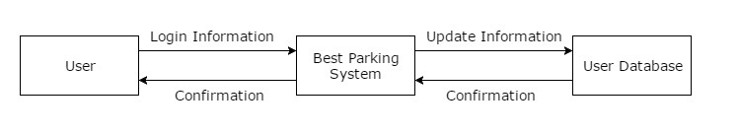

**Context Diagram**

* Context Diagram showing the complete BestParking.com system as one process. Here User is acting as an external entity who is interacting with the system to perform the specified task.

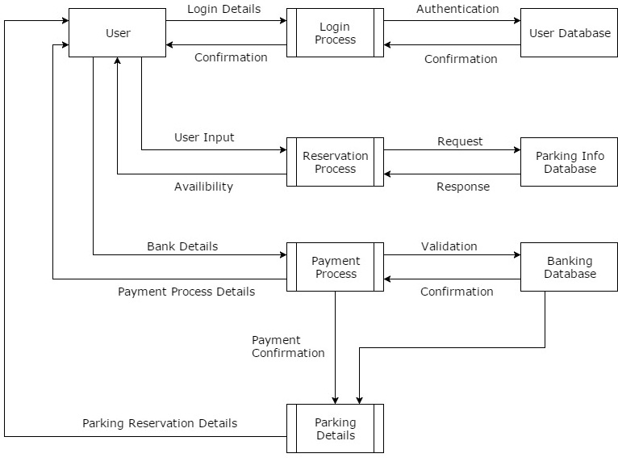

**Level 0 - Data Flow Diagram**

* Level 0 of the above Data Flow Diagram (DFD) shows the individual process and the data flow among them. There are mainly for processes in this system. This diagram also depicting the data flow among the processes and the interrelation between the processes.

# **Network Organization:**

After performing feasibility analysis and requirement analysis for the proposed system our analysis says, this system would be a moderate system that would support multiple users and data would be generated for those users. The system would store details of parking locations, users & vehicles details, payment information. Also, accessing these details should be quick and easy. This requires efficient servers, database with good storage capacity. By keeping all these points in mind, we have suggested designing a Three-Tier Client-Server Architecture for the proposed system. The three-tier system would consist of client and three servers i.e. Client, Application Server, Database Server and three components: Presentation logic, Business logic, Data Access. Client server model will help to balance processing between client devices and one or more server devices. Here, the clients are the ‘Users’ who would request for the services like checking parking slot availability, booking a parking lot and payment activity. Application server would be responsible for business logic. In our proposed system, we are integrating GPS with PGIS which would provide real time information on parking a vehicle within controlled areas and directing drivers to park a car where availability is high. It would also help to find a car location when returning to vehicle by using lightning sensors and parking space led indicators. The system combines traffic monitoring, communication and variable message sign technologies. It may consist of one or more separate modules running on a workstation or application server. Finally, a relational DBMS running on the database server is responsible for the data access logic and data storage where the all data would be stored and easily fetched from the server. So, considering all the features like Scalability, Load balancing, Accessibility, Flexibility, Easy maintenance, Integration of services, we have decided to incorporate 3-Tier Client-Server Architecture Model for our system.

# **Data Storage and Organization:**

Based on the preliminary analysis and the logical process model of the system, we have decided to use the relational database for BestParking.com application. The data is in the tabular format and there will be four tables: Users tables: for storing user information, Parking tables: for storing parking lot details, Rate tables: for storing rate details and Invoice tables: to store the billing information of the users. These tables are connected to each other through entity relationships via foreign keys.

Structured Query Language (SQL) will be used to access and manipulate the data from the relational database. Some of the examples of RDBMS softwares are Oracle, Microsoft Access, Microsoft SQL Server, MySQL. We will choose one of these RDBMS softwares based on the logical process model and the type of information that will be stored in the database. We highly prefer to choose Oracle 12C database because Oracle Databases hold majority of the world’s relational data as well as it provides the following benefits [5]:

* It achieves recovery from disaster with zero data loss.
* Provides protection against planned and unplanned outages.
* Load balancing and service management across multiple replicated databases.
* Secure backup data via encryption mechanism on disk or tape.

## **ER Diagram:**

We have shown the logical representation of our proposed system through ER diagram. It shows all data components of our systems. It represents 4 entities with all its attributes.

* Users: User_id, Password, Address, email, Phone_no
* Booking: Booking_id, Book_date, In_time, Out_time, Rate, Parking_id, User_id
* Parking: Parking_id, Address, Parking_slot_no.
* Invoice: Invoice_id, Total_amount, Booking_id

Specified attributes defines properties of that entity and relationships between entities shown by the dotted line.

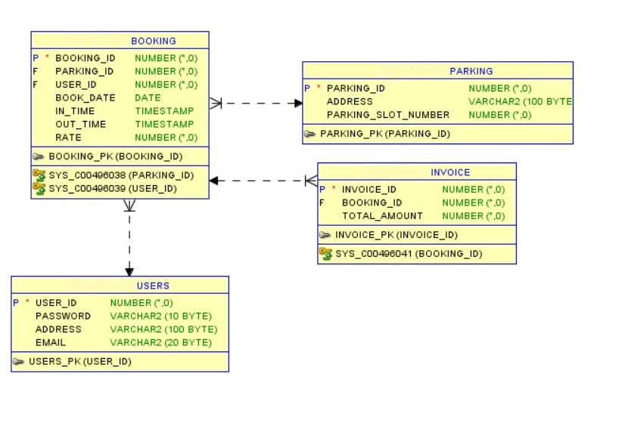

# **Program Organization:**

Program Organization process includes dividing the entire application into modules or individual tasks and working on each divided module separately. Each of this module performs specific task and interacts with other modules, transfers the data within them. As per our requirements and use case analysis, we have divided the entire application into four different modules like Login module where user inputs username and password. Reservation module where user inputs city name, location (based on street name, attraction or neighborhood), reservation date and time. Payment module where user inputs the payment details to make reservation confirmed. Last module is Parking details where the user is provided with the parking confirmation details once the payment is successful.

All these modules are to be designed considering the concepts of coupling and cohesion. By analyzing the types of cohesion, the login module and the payment module are designed as per the functional cohesion. The reservation module and parking details modules are designed as per the sequential cohesion and data coupling because the user inputs from reservation module are fetched by booking details module to send the confirmation to the user about parking. This module design work with highly cohesive and loosely coupled program organization.

# **User Interface Design:**

Interface design is the process of demonstrating how the system will interact with external entities and the nature of the inputs and outputs the system processes. In our system, the external entities are the users and the data the system processes is the geographic data which the user has provided the place where they wish to make a reservation. Also, the system stores and processes the payment information the user has provided. The interface design should satisfy all principles like the layout, context awareness, aesthetics, user experience, consistency and ease of access.

Interface design comprises of 3 steps:

* **Navigation Mechanism** – It is the way in which the user gives commands to the system and instructs the system on how to process the data.
* **Input Mechanism** – It is the way in which the system captures the data and processes the geographic data provided by the users and payment information.
* **Output Mechanism** – It is the way in which the system provides information or data received by it to the users or other systems like GPS and PGIS like the confirmation email which is sent to the users on successful booking.

Our goal is to make the interface appealing to the eye and simple to use, and to maximize the ease of access. A good interface design has a simple interface; it is consistent and it makes sure the system communicates what is happening and processes the data accordingly.

## **Desktop User Interface:**

* The users of the application can search for the available parking spaces by entering the city or airport. The reservation can be on a daily or monthly basis. The user should also provide the arrival and departure date.

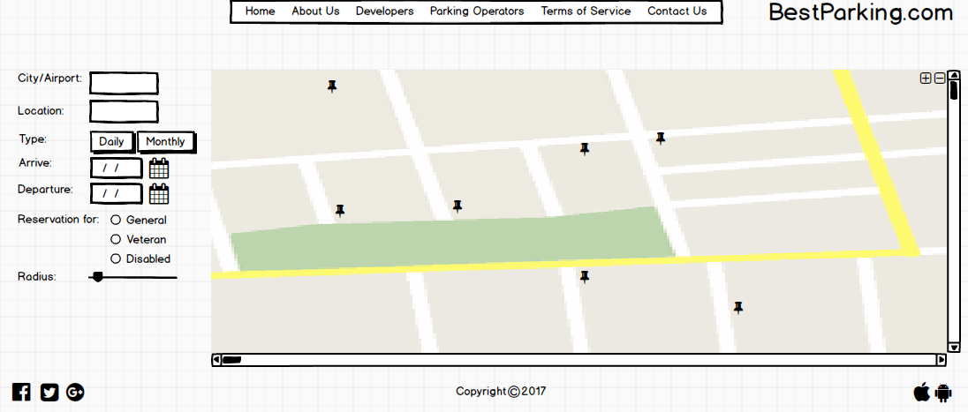

* Upon selection, the address details of the parking space, its capacity, the duration of the booking and the cost of the booking is shown to the user and the user can proceed with the booking.

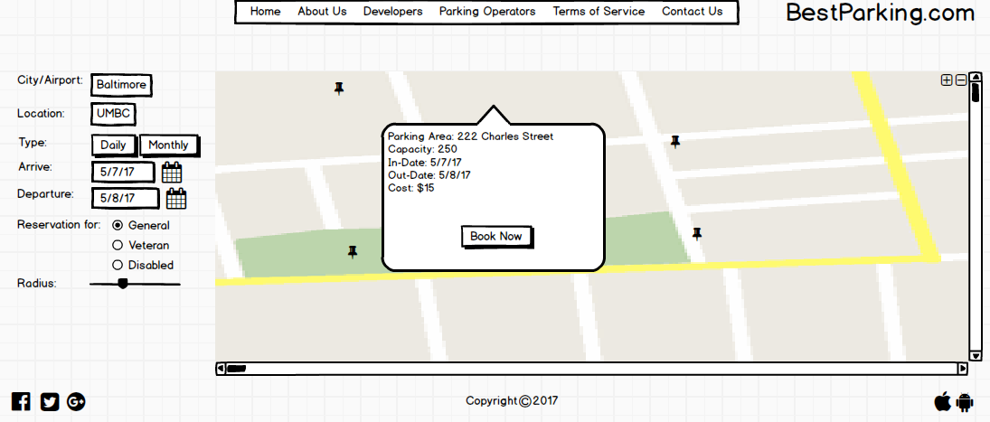

* After the selection of parking slot, the application shows a reservation summary to the user and then user can proceed to book the parking slot by entering the payment details.

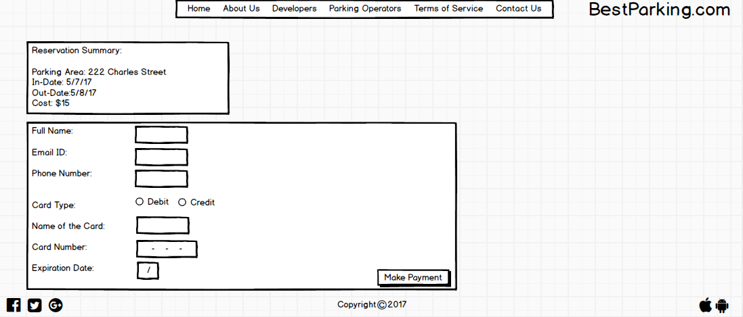

* After successful payment, user will get reservation confirmation on registered email address and phone number.

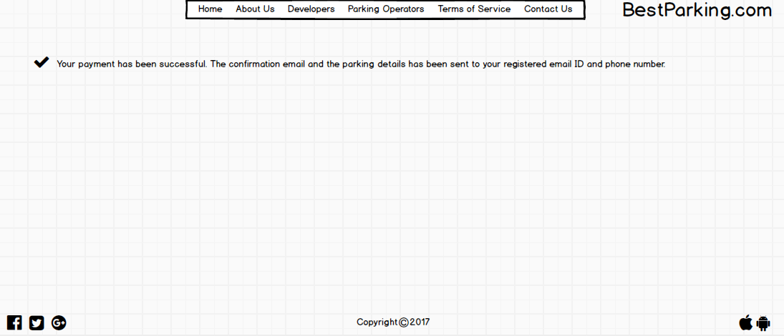

## **10.2 Mobile User Interface:**

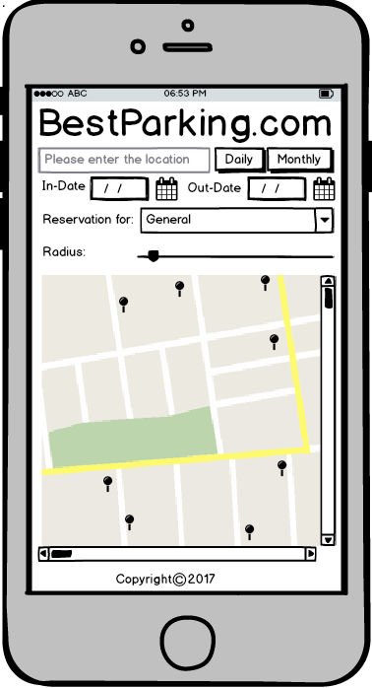

# **Testing, Implementation and Maintenance:**

## **11.1 Testing:**

Testing is a vital part in software development and needs to be initiated during the Feasibility Requirements phase. As truly depicted by the Software Development Life Cycle, testing represents requirements of a system and the system is not delivered completely to the client until these tests pass successfully.

Testing plays an important role in quality assurance and ensures the reliability of an application.

The BestParking.com application will undergo four phases of testing namely, Unit Testing Integration testing, System Testing and Acceptance Testing.

### **11.1.1 Unit Testing:**

Unit Testing focuses on each module of the individual systems where the tester decides if each unit meets the requirements stated in program specifications. We have defined both black box testing and white box testing for BestParking.com. Preferably we have given more importance to white box testing as we are verifying the output with the expected outputs.

* Below were the test cases that were run to check for errors within the modules:

|  |  |  |
| --- | --- | --- |
| **Test case** | **Expected Result** | **Result** |
| User connects to the application and enters inputs such as city or airport | User successfully connects to the application | Pass |
| Based on inputs, nearly parking slots are visible via GPS. | Nearby parking slots are shown to the user based on the inputs | Pass |
| User selects the desired parking slot and enter card details | The parking slot is booked for the desired time duration successfully | Pass |
| If required, user contacts the owner if the slot belongs to garage or private parking place | Owner confirms the booking and reserves the slot to the user | Pass |

### **11.1.2 Integration Testing:**

Integration testing decides whether different set of modules, interfaces when integrated together should work without error. Each individual model has passed unit testing before this test. We have used interface testing and data flow testing for our application. Interface testing determines how good modules are working well each other while integrating.  Whereas data testing is used to determine the data flow between the modules and components such as Global Positioning System (GPS), Parking Guidance Information System(PGIS) and the BestParking.com application system.

### **11.1.3 Systems Testing:**

System testing focuses on functional requirements and nonfunctional requirements. It ensures that systems meet business requirements and addresses security, usability and performance issues under network load.

This system will address the usability testing, security testing and performance testing. Security testing will prevent unauthorized access such as the access would be restricted to users and Admin. Performance testing will manage the network load during peak hours when the user's access are high. Usability Testing will test the ease of interface use such that it is easy to use and easy to learn.

### **11.1.4 Acceptance Testing:**

Acceptance Testing is performed by the users to confirm if the system is completely developed, requirements are met as stated during the initial stages of cycle, and finally accepted by them. This testing is done in 2 Stages-Alpha Testing and Beta Testing. Alpha testing would be done by our users so that they could accept the changes in the system. Beta testing will include releasing beta version of the application to users, to gain feedback, monitor the system for errors and to perform further improvements within the application if required.

## **11.2 Implementation:**

BestParking.com is a smart parking system, a web-based application that helps users to book slots during any time of the day. The main objective of this system is to provide real-time parking slots and rates as well provide details of the same for any future date from the current system date/time. We had suggested Parking Guidance and Information System along with Global Positioning System (GPS). The main features of the PGIS are:

* **Parking Slot Occupancy** [6]: Real time analysis of the occupancy statuses of the parking slots will be updated to the application and refreshed frequently every 2 seconds.
* **Parking History Analysis** [6]: Users will be able to see the statuses of the rates of each parking lot along with the occupancy status during any time of the day as well the future dates.

It will also check the status of the slot and the rates of slots.

Also, implementing the features such as selecting/checking for a parking spot with ‘x’ miles can be accomplished through GPS and adding a ‘Distance Slider’ that would provide the flexibility to the users to select the closest parking slots. We also plan to provide the option to users of selecting the type of reservation they want like general, disabled and veteran.

The conversion would require 3 important factors that would be addressed, namely, risk, cost and time.

* **Risk [7]**: Parallel conversion is less risky as compared to direct conversion. Similarly, pilot conversion is less risky as compared to phased or simultaneous conversion as the effects of bugs will be limited, along with modular conversion. As we have performed rigorous alpha and beta testing, the probability of the undetected bugs reduces.
* **Cost [7]**: Though parallel conversion and modular conversion is expensive; both are less risky as compared to direct conversion and phased & simultaneous conversion. Pilot conversion will be more suitable to our system as we would require both old and new systems during the transition depending on locations as BestParking.com covers multiple cities and airports across United States.
* **Time [7]**: Amount of time required for transition between old system and new system plays an important factor during the implementation. We chose parallel conversion, pilot conversion along with modular conversion because after pilot test completes, remaining locations will be simultaneously converted, modules would be introduced one after the other, which would require more time than the whole system conversion.

After thorough checks of requirement analysis and feasibility analysis, we suggest to the BestParking.com owners to proceed towards implementing the changes in the system.

## **11.3 Maintenance:**

Maintenance activities will involve documentation of the processes, screenshots of the new upgrade activities to the support teams. We will create procedure manuals to capture business tasks such as taking hot and cold backups, process approval procedures etc. This would help the team to provide 24X7 support to the business for a certain period. Mechanisms for data backups, recovery, patch deployments, upgrades and downtimes would be documented to ensure that the system is up to date and free of bugs. Emergency outages can be documented for the infrastructure support team which will detail the processes, steps and notification templates that would help to send communications to the users and to the business.

# **References:**

[1] Parking Search Engine - Cities & Airports - Daily/Monthly Garages & Lots. (n.d.). Retrieved May 08, 2017, from <http://www.bestparking.com/>

[2] * All products require an annual contract.    Prices do not include sales tax  (New York residents only). (n.d.). Number of cars in U.S. Retrieved May 08, 2017, from https://www.statista.com/statistics/183505/number-of-vehicles-in-the-united-states-since-1990/

[3] A. Sakai, K. Mizuno, T. Sugimoto and T. Okuda, "Parking guidance and information systems," Pacific Rim TransTech Conference. 1995 Vehicle Navigation and Information Systems Conference Proceedings. 6th International VNIS. A Ride into the Future, Seattle, WA, 1995, pp. 478-485.

doi: 10.1109/VNIS.1995.518880

[4] Higgins, M. (2011, January 08). 11 Tricks to Cutting Travel Costs in 2011. Retrieved May 08, 2017,from http://www.nytimes.com/2011/01/09/travel/09pracsave.html?_r=1&src=me&ref=homepage

[5] Top 12 New Features of Oracle 12c Summarized. (n.d.). Retrieved May 08, 2017, from http://www.orafaq.com/node/2822

[6] M.Y.I. Idris, Y.Y. Leng, E.M. Tamil, N.M. Noor and Z. Razak, 2009. Car Park System: A Review of Smart Parking System and its Technology. Information Technology Journal, 8: 101-113.

[7] Dennis, A., Wixom, B. H., & Roth, R. M. (n.d.). Transition to the New System. In Systems Analysis and Design (5th ed., pp. 476-478). John Wiley & Sons Inc.