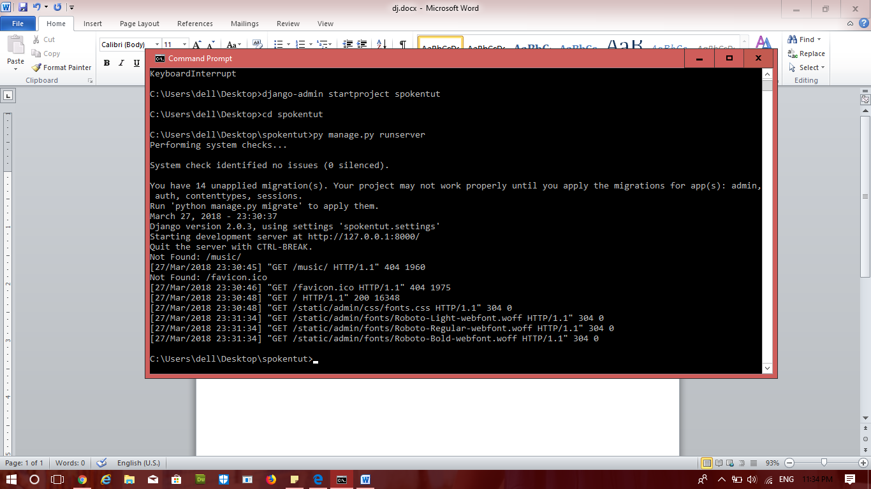

py manage.py startapp spoken

creating template, static…

including login.html

creating database in models.py

adding this in settings.py **'spoken.apps.SpokenConfig'**,

cmd:

py manage.py makemigrations

py manage.py migrate

py manage.py sqlmigrate spoken 0001