**Project 1**

*Group Members: Nikhil Chopra (9897-3831), Kanika Gupta (9697-7046)*

* **Commands to be run on the server**

Compile the project - mix escript.build

Run - escript project1 5

* **Commands to be run on the client**

Compile the project - mix escript.build

Run - escript project1 {serverIP}

* **Approach to assign size of the Work Unit**

In our project, we are using following random function to generate random strings based on the number of bytes given as argument:

:crypto.strong_rand_bytes(num_bytes)

If the number of bytes of the generated random string is larger, greater is the possibility to find the required zeros in the Hash.

To leverage its distributed behavior fully while assigning work to the workers, we increment number of bytes of the random string for every worker and assign work (work here is the number of iterations to generate random string for those number of bytes passed to it) in multiples of num_bytes. So, the worker which is assigned larger number of bytes of random strings finds more random strings as there is more probability to mine more bitcoins.

So, to increase the entropy, each process finds random strings of different length and finds their hash to check for leading zeroes. Work is assigned in proportion to the number of bytes of generated random strings.

No Of iterations by one process to mineBitCoins = num_bytes * 200000

This is the work unit we have given to one process (worker). The work unit here refers to the number of calls the process will make to findBitCoins method which does the work of generating random strings of length num_length , calculating the hash of each string and checking if the leading zeroes are correct as per the requirement.

Our Methodology of assigning this work unit - More the num_length of random strings, more permutations of the strings possible, more is the probability of finding a suitable hash.

* **Result of Running program for ./project1 4**

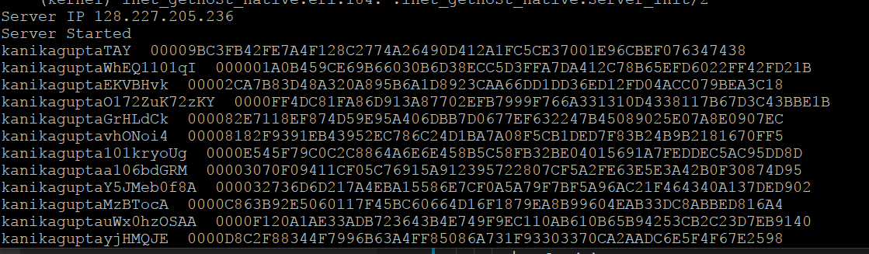

* **Result of Running program for ./project1 5**

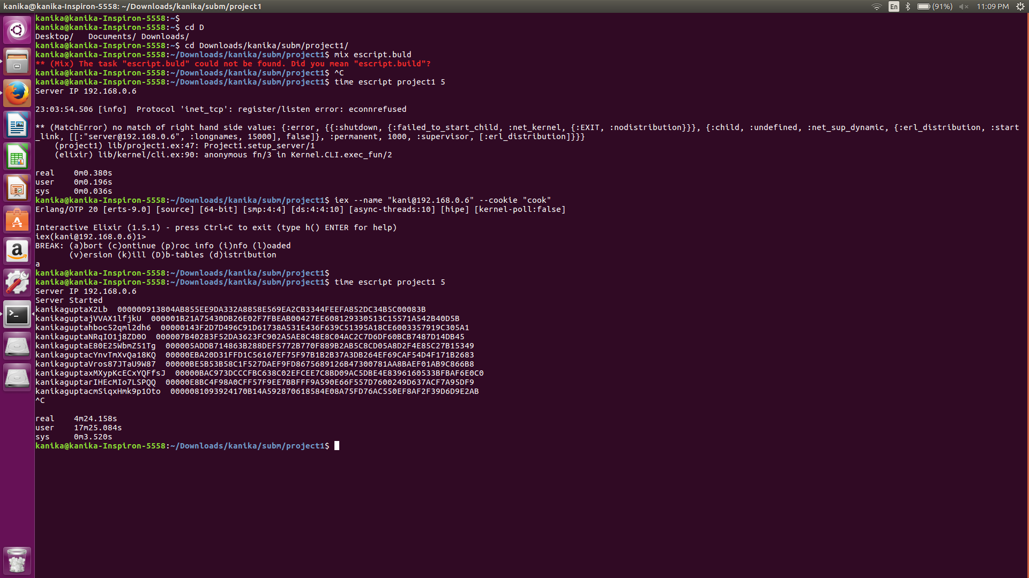

Real time = 4m 24sec

CPU Time = 17m 25sec

Ratio of CPU to Real time = 17m25sec/4m24sec = **4.068**

* **Coin with the most 0s**

Coin having 6 zeroes -

kanikaguptaIUriGEAN6Jou0wFe0A4 0000009F181A6AF722A4EE7CB248198476999217E4940CB8EB3BD4B0133E0137

* **Largest number of machines connected**

3 machines (each having 4 cores) were connected at one time.