Kanika Jain

Excel Challenge Homework

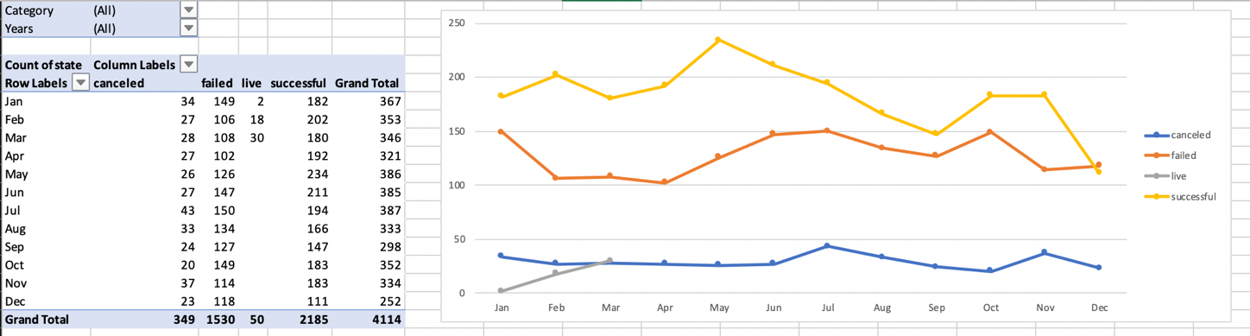

Create a report in Microsoft Word and answer the following questions.

1. Given the provided data, what are three conclusions we can draw about Kickstarter campaigns?

First conclusion is that there are more successes than fails. Second conclusion is that the canceled campaigns remain pretty constant and low. Third conclusion is that it seems when the number of successful campaigns goes up, so does the number of failed campaigns and vice versa.

2. What are some limitations of this dataset?

It is only focusing on the date timeline when there are many other factors that take place of why the numbers are shown as they are.

3. What are some other possible tables and/or graphs that we could create?

You can create more graphs on trends focusing on country and categories that are popular in that country.