**Assignment 1**

**Due Date:** September 13, 2015, 11:59 PM

**Part 1 -** **Create your personal homepage**

Create your personal homepage (file should be named **index.html**) and upload it to utdallas.edu. Instructions for uploading process are provided below.

The web page should contain legitimate information about you (background information, hobbies, interests etc.) and should not contain any HTML code that is generated by a web design tool (FrontPage, PageMaker, and etc. )

1. In your page’s HTML, make sure to include following elements.

* <p>
* <ul> : Set all bulleted lists of items on the page to use an image for their bullet icon rather than the normal black circle
* <img>
* <a>
* <meta> for description of your web page
* <meta> for the keywords associated with your page

2. Use the same page layout you have created for Practice Session – 1. Make sure you have different background colors for the left panel (content area) and the right panel.

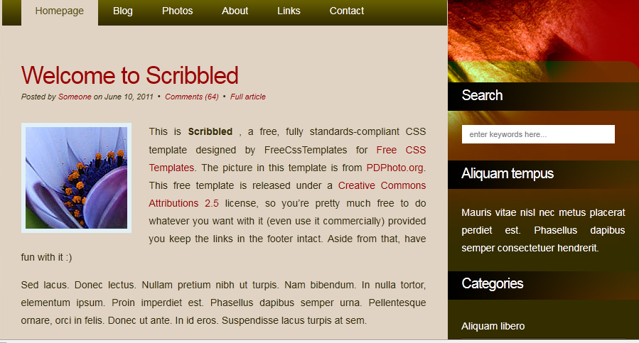

**Part 2 – Add style to your page**

Add an external CSS file called **index.css** to your webpage. Embedded and inline style rules are not allowed and you should have all css rules defined in the external css file.

Make the following changes and additions to your index.html file:

1. Add a photograph of yourself and float it to the left side of a paragraph using CSS. The paragraph can include short information about yourself. Add border and margins to the image.

2. Change the font used throughout the document to sans-serif.

3. Use your name for the page heading and align it to the left.

4. Setup your links to use the “:hover” pseudo-class (use a:hover so that only the links are effected). How the link changes when the mouse moves on top of it is up to you, but if you’re short on ideas, just have the link change colors.

5. Add <span> tags and setup your style sheet so that every time the word “UTD” appears, it is in “orange” and bold.

6. When the user hovers the mouse over the word “UTD”, full university name should appear as a tooltip.

7. Set your home page to have a "favorites icon" ("favicon"). The icon may not work in Internet Explorer; you may ignore this.

**NOTES:**

**1.** Webpages should be laid out using CSS floats (no HTML tables or CSS absolute positioning).

**2.** For full credit, your pages must pass the W3C HTML and CSS validator with no errors (a green bar). Choose appropriate HTML tags to match the structure of the content on the page. Do not express style information in HTML with inline styles or presentational HTML tags such as b or font.

Use following sites for validation of your pages:

http://validator.w3.org/ (for HTML)

http://jigsaw.w3.org/css-validator (for CSS)

**4.** Your files should work on both the latest version of Mozilla Firefox and Google Chrome. You will not be tested in Microsoft Internet Explorer or other browsers that do not comply with the web standards.

**5.** You can use colors you like on your home page. You can also check popular color schemes online. (i.e.: <http://www.colorschemer.com/schemes/)>

**Instructions for setting up a web page**

You can find these steps also at <http://www.utdallas.edu/ir/howto/personal-webpage/>

To set up your homepage, perform following steps:

1. Get a NetID. You can set it up in the Student Microcomputer Labs or at <http://netid.utdallas.edu>.
2. Launch an SSH client such as Putty.
3. Type giant.utdallas.edu into the Host Name field and select the SSH circle below. Click Yes at the following notice window.
4. Enter your netid and password when prompted.
5. Type makeweb, then press enter. Do not close Putty.
6. Place your index.html file in your home directory’s public_html folder, called your H: drive in the Labs (ask a Computer Assistant if you need help accessing it). Alternatively, you can use an FTP program (i.e. FireFTP for Mozilla Firefox, WinSCP) to upload your files to your home directory.
7. Go back to Putty and type cd public_html to get to your personal web space.
8. Ensure that you are in the public_html directory and type chmod 755 index.html, then enter.
9. For all subsequent pages you wish to add, it is required that you type chmod 755 filename.html (where filename.html is the directory and the name of your webpage), as this will set read and write permissions for each page.
10. Your homepage should then be accessible as http://www.utdallas.edu/~netid.
11. For further assistance, contact the Help Desk at 972-883-2911 or [assist@utdallas.edu](mailto:assist@utdallas.edu).

You will automatically be added to the list of personal homepages the following day.