The following paragraph is considered:

“Sunset is the time of day when our sky meets the outer space solar winds. There are blue, pink, and purple swirls, spinning and twisting, like clouds of balloons caught in a whirlwind. The sun moves slowly to hide behind the line of horizon, while the moon races to take its place in prominence atop the night sky. People slow to a crawl, entranced, fully forgetting the deeds that must still be done. There is a coolness, a calmness, when the sun does set.”

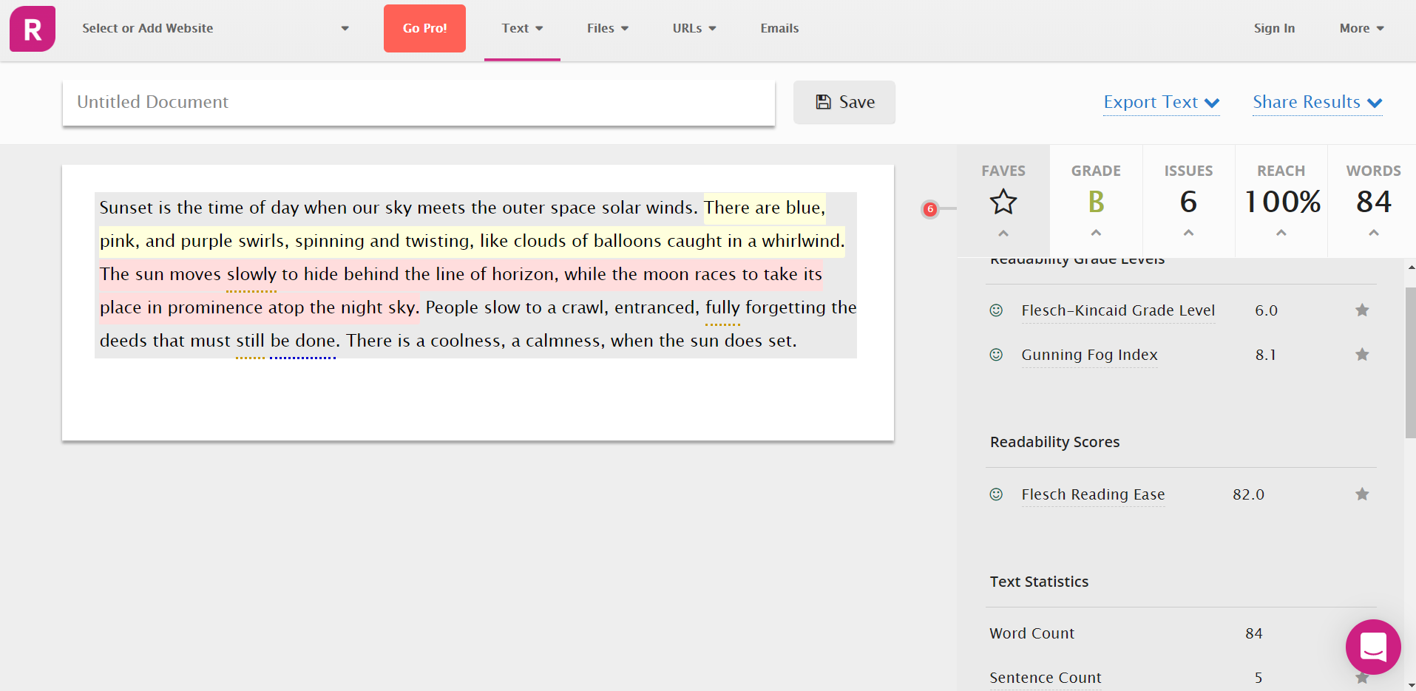

The grade given is “B” and the number of issues is “6”. The underlined and highlighted text shows errors.

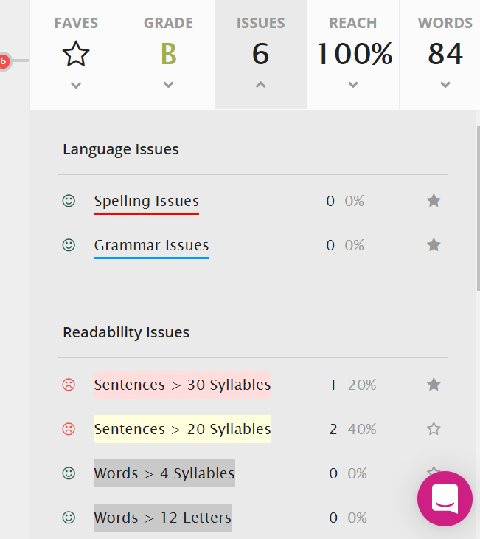

This shows that in the given paragraph, there are zero spelling and grammar issues.

The text highlighted with pink and yellow colour shows that the sentence is too long.

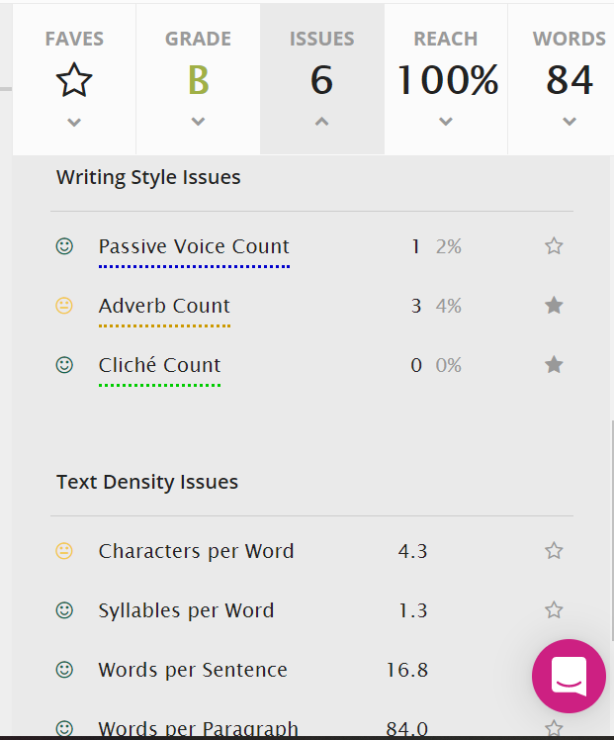

It also shows whether the passage has passive voice or there are too many adverbs, or the same word has been used in the passage many times.

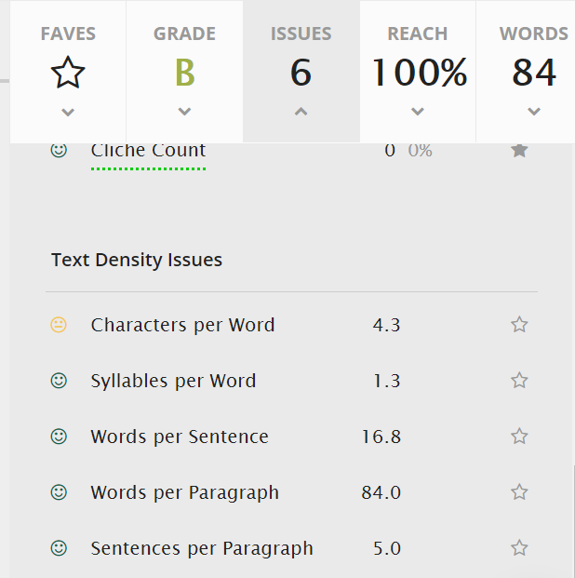

After the correction of the errors shown in the above screenshots, the paragraph is as follows:

“Sunset is the time of day when our sky meets the outer space solar winds. There are blue, pink, and purple swirls. These are spinning and twisting, like clouds of balloons caught in a whirlwind. The sun hides behind the line of horizon with its slow movement. In contrast to this, the moon takes its place in prominence atop the night sky. Entranced people slow to a crawl and forget to do their deeds. There is a coolness, a calmness, when the sun does set.”

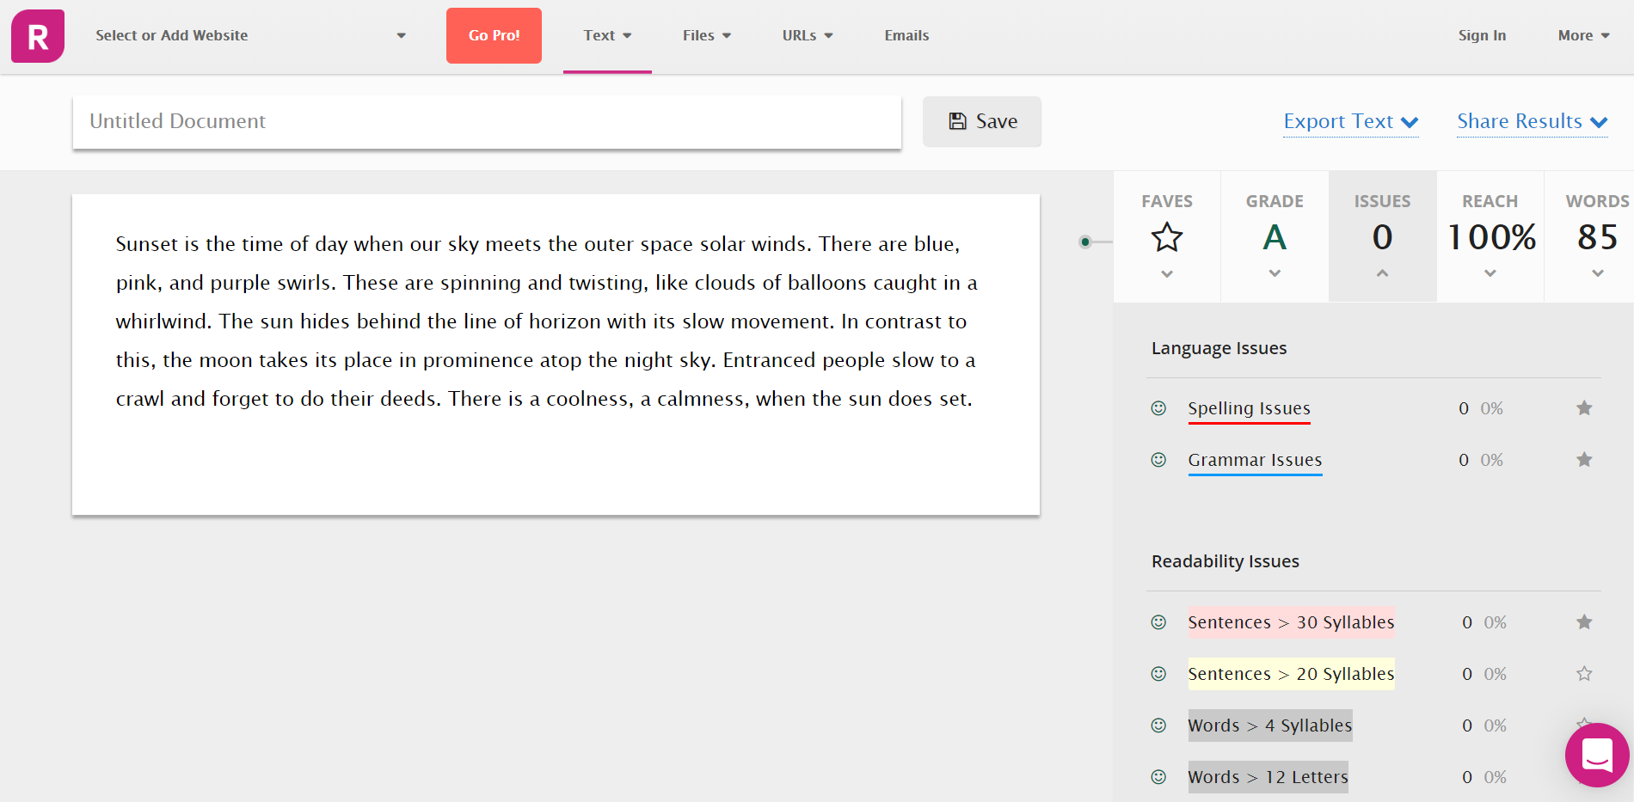

The grade obtained is “A” and issues is “0”.

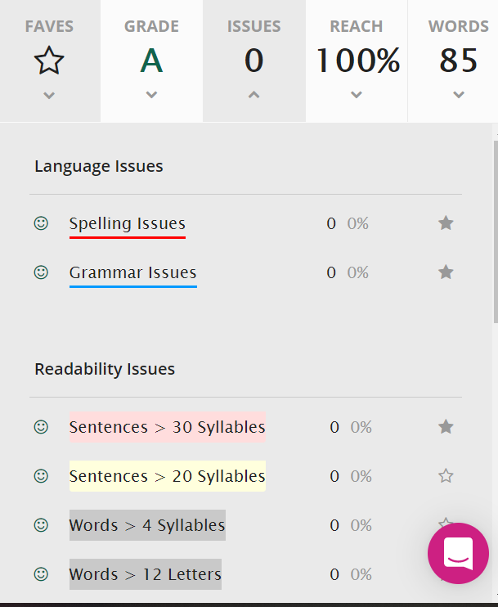

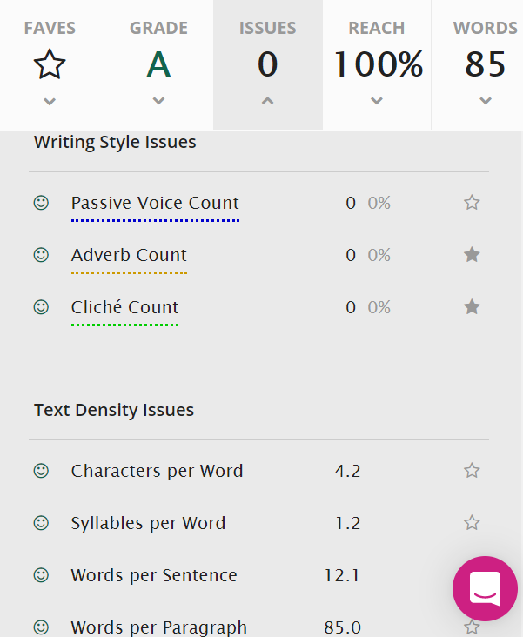

A grade level (based on the USA education system) is equivalent to the number of years of education a person has had. A score of around 10-12 is roughly the reading level on completion of high school.

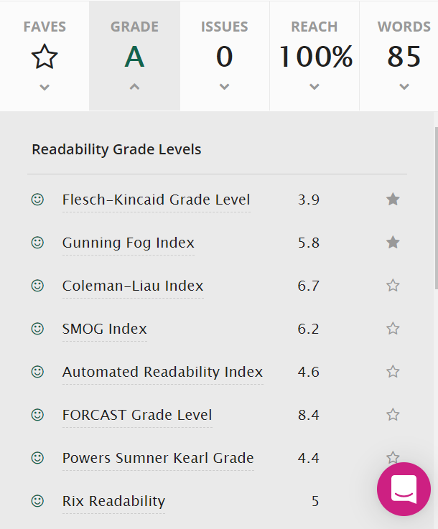

These readability scoring algorithms do not provide grade levels, or provide grades for a limited range of uses.

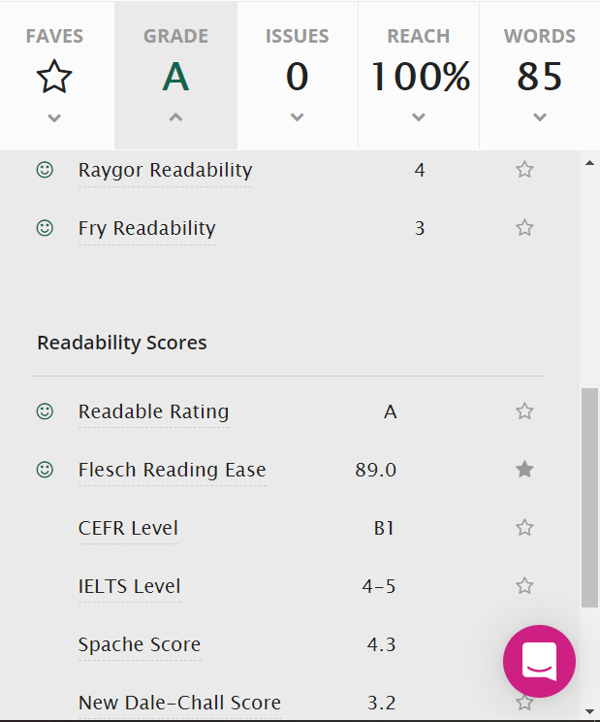

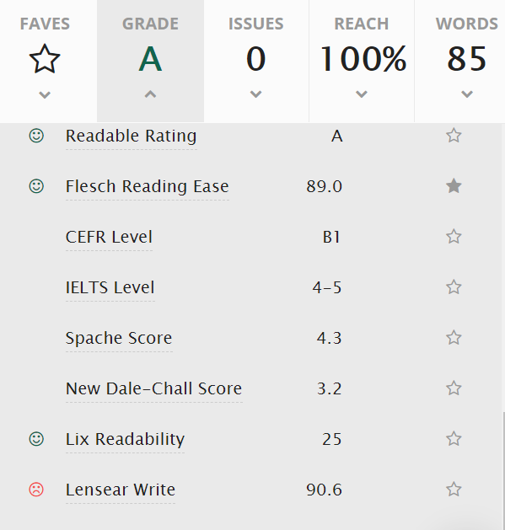

Reach is a measure of the proportion of your target audience that can read your content easily. It is currently calibrated against the literate general public, so a reach of 100% means your content is readable by about 85% of the public

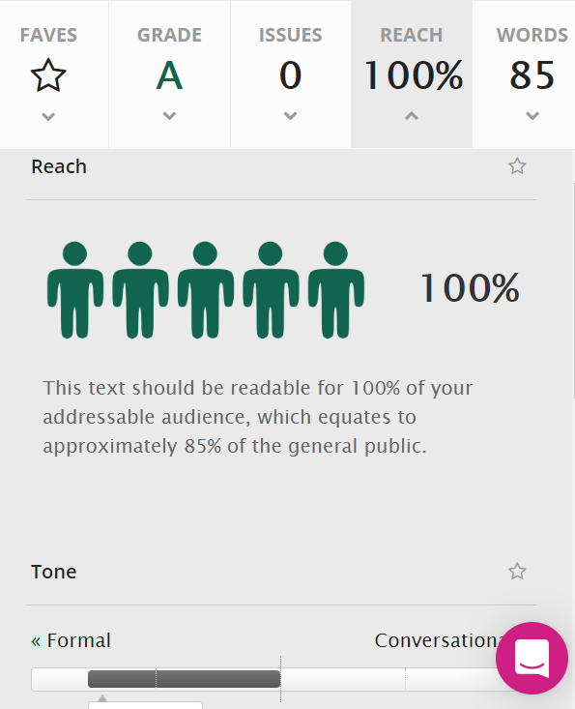

Tone analysis gives an idea of how formal or how conversational the text looks. Conversational text uses more pronouns and fewer prepositions, among other differences.

Sentiment analysis gives an idea of whether the text uses mostly positive language, negative language, or neutral language. For longer pieces, the text is split into three to give sentiment analysis for the beginning, middle and end of the piece.

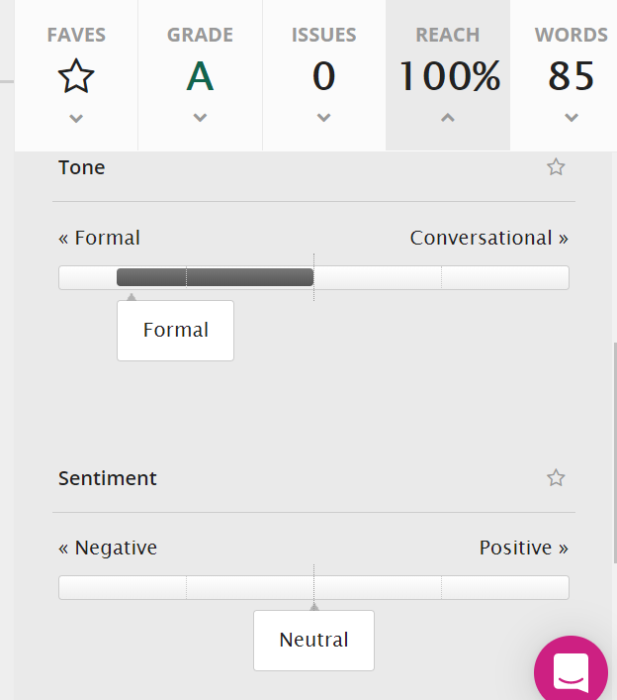

Personalism is the measure of the degree to which you are writing about the reader, rather than yourself.

