**KNN:**

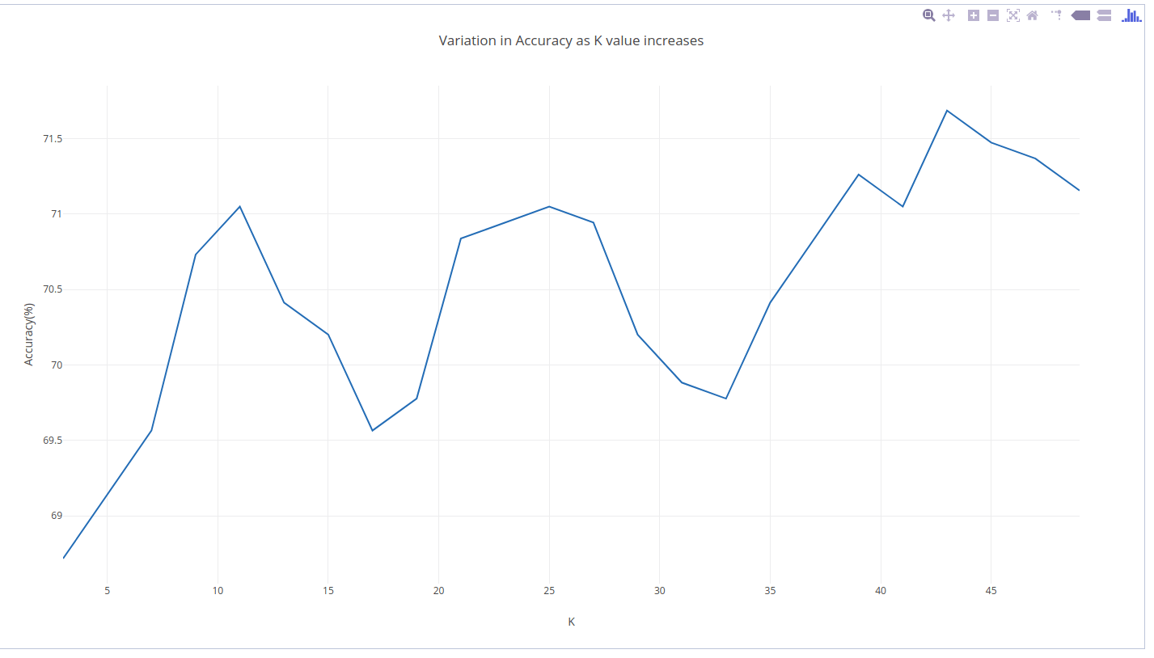

**ADABOOST:**

**Results:**

Adaboost accuracy is 63.20 % on test-data

|  |  |
| --- | --- |
| **Weak Classifier** | **Accuray(%)** |
| Blue | 81 |
| Red | 73 |
| Green | 79 |

**Observation:**

We found that most of the images in the training set has blue at the top of the image for a 0 degree orientation of the image. Thus the blue classifier for each of the orientation has a dominant weight. For example if a red and green classifier of 180 degree orientation says that the image is 180 degrees and the blue classifier of 0 degree orientation says its a 0 degree oriented image the image is classified as 0. Thus adaboost is giving less accuray

**NEURAL NETWORK:**

(See file comments for implementation details)

In the neural network, 3 different activation functions were used to test the data.

The performance for sigmoid is attached here due to its better performance.

The accuracy is the average accuracy for 5 runs.

|  |  |  |  |  |  |  |
| --- | --- | --- | --- | --- | --- | --- |
| Hidden neuron | Iteration | Learning rate | Momentum | Decay | Accuracy | Running  Time on local machine (sec) |
| 10 | 5 | 0.01 | 0.5 | 0.001 | 54.14% | 29.99 |
| 10 | 54.08% | 50.63 |
| 20 | 57.37% | 97.30 |
| 40 | 5 | 61.71% | 38.29 |
| 10 | 62.87% | 63.32 |
| 20 | 68.34% | 113.86 |
| 100 | 5 | 55.56% | 42.63 |
| 10 | 54.79% | 86.05 |
| 20 | 54.28% | 170.63 |

By comparing the predicted results, pic with 270  
Some misclassified image:  
9406463030.jpg  
3847697001.jpg  
3940396224.jpg  
9483846588.jpg  
39815369.jpg  
  
Those images are all taken outside, and include rocks or mountains.  
Those can be difficult to classify cause there are no evidences (like sky) can indicate the direction.  
  
Some successfully classified image  
3978889742.jpg  
4082824675.jpg  
4238737977.jpg  
4279815500.jpg  
4393512978.jpg  
  
Those images are also taken outside, but the either captured the sky, or they have some objects (like house)