A PROJECT REPORT ON
"SOC Copilot: An AI-Powered Security Operations Center
Assistant for Threat Detection, Log Analysis,
and Incident Response"
Submitted in partial fulfillment of the requirements
for the award of the degree of
BACHELOR OF TECHNOLOGY
in
COMPUTER SCIENCE AND ENGINEERING
Submitted by:
[Student 1 Name] — [Roll Number 1]
[Student 2 Name] — [Roll Number 2]
[Student 3 Name] — [Roll Number 3]
[Student 4 Name] — [Roll Number 4]
Under the Guidance of
[Guide Name], [Designation]
Department of Computer Science and Engineering
[College Name]
[City, State — Pin Code]
Academic Year: 2025–2026

CERTIFICATE
This is to certify that the project entitled "SOC Copilot: An AI-Powered Security Operations Center Assistant for Threat Detection, Log Analysis, and Incident Response" is a bonafide work carried out by the following students in partial fulfillment of the requirements for the award of the degree of Bachelor of Technology in Computer Science and Engineering from [College Name], affiliated to [University Name], during the academic year 2025–2026.
[Student 1 Name] — [Roll Number 1]
[Student 2 Name] — [Roll Number 2]
[Student 3 Name] — [Roll Number 3]
[Student 4 Name] — [Roll Number 4]
The results embodied in this project report have not been submitted to any other University or Institution for the award of any degree or diploma.

[Guide Name]
[Designation]
Department of CSE
[College Name]
[Head of Department]
Department of CSE
[College Name]

DECLARATION
We hereby declare that the project entitled "SOC Copilot: An AI-Powered Security Operations Center Assistant for Threat Detection, Log Analysis, and Incident Response" submitted to the Department of Computer Science and Engineering, [College Name], in partial fulfillment of the requirements for the award of the degree of Bachelor of Technology, is a record of original work done by us under the supervision and guidance of [Guide Name], [Designation], Department of CSE, [College Name].
The results embodied in this project report have not been submitted to any other University or Institution for the award of any degree or diploma. We also declare that no part of this work has been copied from any other source. Any material or idea taken from other work has been properly cited and acknowledged.

Place: [City]
Date: [Date]

[Student 1 Name]
[Student 2 Name]
[Student 3 Name]
[Student 4 Name]

ACKNOWLEDGEMENT
We would like to express our sincere gratitude to all who contributed to the successful completion of this project. First and foremost, we thank our project guide, [Guide Name], [Designation], Department of Computer Science and Engineering, [College Name], for the invaluable guidance, constant encouragement, and constructive suggestions throughout the development of this project.
We extend our heartfelt thanks to [HOD Name], Head of the Department of Computer Science and Engineering, for providing us with the necessary facilities and support. We are grateful to [Principal Name], Principal, [College Name], for the institutional support.
We also thank all the faculty members and staff of the Department of Computer Science and Engineering for their support and encouragement. We are thankful to our families and friends for their unwavering support and motivation.
Finally, we acknowledge the contributions of the open-source community, particularly the developers of Python, Scikit-learn, PyQt6, and the CICIDS2017 dataset creators, whose work made this project possible.

ABSTRACT
The exponential growth of cyber threats in the modern digital landscape has placed unprecedented pressure on Security Operations Centers (SOCs), which serve as the frontline defense against cyberattacks targeting organizational infrastructure. SOC analysts face the daunting challenge of monitoring, triaging, and responding to thousands of security alerts generated daily from heterogeneous log sources, including firewalls, intrusion detection systems, endpoint agents, and cloud workloads. Traditional Security Information and Event Management (SIEM) systems, while instrumental in log aggregation, rely predominantly on static, rule-based detection mechanisms that are inherently reactive and incapable of adapting to the rapidly evolving threat landscape characterized by advanced persistent threats (APTs), zero-day exploits, polymorphic malware, and sophisticated social engineering campaigns.
This project presents "SOC Copilot," an AI-powered Security Operations Center assistant designed to automate threat detection, intelligent log analysis, and incident response through a hybrid machine learning ensemble approach. SOC Copilot integrates two complementary machine learning paradigms: Isolation Forest for unsupervised anomaly detection, which identifies behavioral deviations from established network baselines without requiring labeled training data, and Random Forest for supervised multi-class attack classification, trained on the CICIDS2017 benchmark dataset to categorize threats into seven distinct classes — Benign, DDoS, Brute Force, Malware, Data Exfiltration, Reconnaissance, and SQL Injection.
The system features a comprehensive modular architecture encompassing format-agnostic log ingestion supporting JSON, CSV, Syslog, and Windows EVTX formats; a multi-stage preprocessing pipeline for data normalization and validation; an advanced feature engineering module extracting 78 engineered features across statistical, temporal, behavioral, and network dimensions; a weighted ensemble coordinator that synthesizes anomaly scores and classification outputs into prioritized alerts (P0–P4) with MITRE ATT&CK framework mapping; and an explainability layer generating human-readable reasoning chains, feature importance rankings, and contextual response recommendations aligned with the NIST Incident Response Framework.
SOC Copilot operates as a fully offline, desktop-based application built with PyQt6, ensuring complete data sovereignty and compliance with air-gapped security environments. The system employs a governance-first design philosophy with analyst-in-the-loop oversight, complete auditability through append-only audit trails, and configurable kill-switch mechanisms. Experimental evaluation demonstrates classification accuracy exceeding 99%, significant reduction in analyst workload through automated triaging and intelligent alert deduplication, and faster incident response through contextual alert enrichment and actionable recommendations. The project establishes a foundation for next-generation SOC automation that augments human analytical capabilities rather than replacing them.

TABLE OF CONTENTS
[Table of Contents — Please generate using Word: References → Table of Contents → Automatic Table after opening the document]

LIST OF FIGURES
[Insert List of Figures using Word: References → Insert Table of Figures]

LIST OF SCREENSHOTS
[Insert screenshots of the SOC Copilot dashboard, alert views, and AI explanation panels from the application]

CHAPTER 1: INTRODUCTION

1.1 Background
The digital transformation of enterprises, governments, and critical infrastructure has fundamentally reshaped the cybersecurity landscape. Organizations increasingly depend on interconnected digital systems for core operations, creating vast and complex attack surfaces that malicious actors continuously seek to exploit. According to the IBM Cost of a Data Breach Report 2023, the global average cost of a data breach reached $4.45 million, with organizations taking an average of 277 days to identify and contain a breach. The threat landscape has evolved from isolated attacks by individual hackers to orchestrated campaigns by nation-state actors, organized cybercrime syndicates, and advanced persistent threat (APT) groups employing sophisticated multi-stage attack methodologies.
The proliferation of cloud computing, Internet of Things (IoT) devices, remote work infrastructures, and Software-as-a-Service (SaaS) applications has exponentially increased the volume and diversity of security-relevant data generated across organizational networks. Modern enterprises generate millions of log events daily from firewalls, intrusion detection and prevention systems (IDS/IPS), endpoint detection and response (EDR) agents, application servers, authentication systems, and cloud workload monitors. This data deluge presents both an opportunity and a challenge: while comprehensive logging provides the raw material for threat detection, the sheer volume overwhelms traditional analysis approaches.

1.2 Problem Statement
Security Operations Centers serve as the centralized nerve center for organizational cybersecurity, responsible for continuous monitoring, threat detection, incident investigation, and response coordination. However, modern SOC workflows face several systemic challenges that collectively undermine operational effectiveness:
- Alert Overload and Fatigue: Enterprise SOCs routinely generate tens of thousands of alerts per day, with studies indicating that up to 95% of these alerts are false positives. This phenomenon desensitizes analysts and increases the probability that genuine threats are overlooked.
- Slow Response Times: Manual log analysis and threat investigation are inherently time-intensive. Analysts must cross-reference multiple data sources, correlate indicators of compromise (IoCs), and apply domain expertise, contributing to extended Mean Time to Detect (MTTD) and Mean Time to Respond (MTTR).
- Lack of Contextual Intelligence: Traditional SIEM systems excel at log aggregation but lack the contextual intelligence necessary to distinguish between benign anomalies and genuine threats.
- Skills Shortage: The cybersecurity workforce gap — estimated at 3.4 million unfilled positions globally — exacerbates the burden on existing analysts.

1.3 Need for AI-Powered SOC Assistant
The limitations of manual analysis and rule-based detection have motivated significant research into the application of artificial intelligence and machine learning for cybersecurity. AI-driven security assistants can automate the analysis of vast log volumes, identify subtle threat patterns that evade rule-based detection, prioritize alerts based on comprehensive risk assessment, and generate contextually enriched response recommendations. By augmenting analyst capabilities rather than replacing human judgment, AI-powered assistants address the scalability, accuracy, and speed requirements of modern SOC operations while maintaining the governance and oversight essential for security-critical decisions.

1.4 Objectives of SOC Copilot
- Develop a hybrid AI-powered system that combines unsupervised anomaly detection with supervised multi-class attack classification for comprehensive threat detection.
- Implement format-agnostic log ingestion supporting JSON, CSV, Syslog, and Windows EVTX formats with automated parsing and normalization.
- Design and extract 78 engineered features across statistical, temporal, behavioral, and network dimensions for robust threat characterization.
- Create an ensemble scoring mechanism that synthesizes dual-model outputs into prioritized alerts (P0–P4) with MITRE ATT&CK framework mapping.
- Build an explainability layer providing human-readable reasoning, feature importance, and contextual response recommendations.
- Develop a fully offline, desktop-based application with governance-first design, analyst-in-the-loop oversight, and complete auditability.

1.5 Scope of the Project
The scope of SOC Copilot encompasses the complete security log analysis pipeline from ingestion through alert generation and visualization. The system processes batch and real-time log data from multiple format types, applies AI-driven analysis for threat detection and classification, and presents actionable intelligence through an interactive desktop dashboard. The project scope includes model training using the CICIDS2017 benchmark dataset, real-time dashboard with animated metrics, analyst feedback integration for continuous improvement, and governance controls including kill-switch mechanisms. The system is designed for deployment in air-gapped and high-security environments where data sovereignty and offline operation are mandatory requirements.

CHAPTER 2: LITERATURE REVIEW

2.1 Existing SIEM Systems
Security Information and Event Management (SIEM) platforms represent the foundational infrastructure of modern Security Operations Centers. Leading commercial solutions include Splunk Enterprise Security, IBM QRadar, ArcSight (Micro Focus), and Microsoft Sentinel. These platforms provide centralized log aggregation from diverse sources, real-time event correlation using predefined rules, compliance reporting and audit trail maintenance, and alert generation based on signature matching and threshold violations. While SIEM systems have been instrumental in standardizing security monitoring workflows, their detection capabilities are fundamentally constrained by their rule-based architecture.

2.2 AI in Cybersecurity
The application of artificial intelligence to cybersecurity has seen rapid advancement across multiple paradigms. Machine learning approaches for network intrusion detection have been explored using Support Vector Machines (SVMs), Decision Trees, k-Nearest Neighbors (k-NN), and ensemble methods. Deep learning architectures including Convolutional Neural Networks (CNNs), Recurrent Neural Networks (RNNs), Long Short-Term Memory (LSTM) networks, and Autoencoders have shown promising results in detecting complex attack patterns. Recent advances in Natural Language Processing (NLP) and Large Language Models (LLMs) have introduced new possibilities for threat intelligence analysis, log summarization, and automated incident report generation.

2.3 Limitations of Traditional SOC Workflows
Traditional SOC workflows suffer from several well-documented limitations: (1) Rule Rigidity — static correlation rules cannot adapt to novel attack patterns without manual updates; (2) Alert Volume — the average enterprise SOC receives over 10,000 alerts daily, with analysts able to investigate only a fraction; (3) Context Deficit — alerts lack the behavioral and contextual information necessary for informed decision-making; (4) Inconsistency — manual analysis introduces variability across analyst shifts and skill levels; (5) Scalability Constraints — linear scaling of analyst headcount is economically unsustainable.

2.4 Black-Box AI vs. Explainable AI
A significant concern in applying AI to security operations is the interpretability of model decisions. Deep learning models, while achieving high accuracy, operate as black-box systems whose internal decision logic is opaque to human operators. In security-critical contexts, this opacity undermines analyst trust and complicates regulatory compliance. Explainable AI (XAI) techniques aim to make model predictions interpretable by providing feature importance rankings, decision path visualization, counterfactual explanations, and confidence calibration. SOC Copilot addresses explainability through a wrapper-based approach that provides human-readable reasoning chains alongside every alert, enabling analysts to understand and validate AI-generated assessments.

2.5 Research Gaps
The literature review reveals several gaps that SOC Copilot addresses: (1) Most proposed systems focus on a single detection paradigm rather than combining complementary signals through ensemble coordination; (2) Few systems integrate explainability as a first-class design requirement; (3) Governance and analyst oversight mechanisms are rarely addressed; (4) Most systems assume cloud connectivity, making them unsuitable for air-gapped environments; (5) End-to-end pipeline integration from log ingestion through alert visualization is seldom demonstrated.

2.6 Comparative Analysis
Feature | Traditional SIEM | ML-Based IDS | SOC Copilot
Detection Method | Rule-based | Single ML Model | Hybrid Ensemble (IF + RF)
Novel Threat Detection | No | Partial | Yes (Anomaly Detection)
Multi-class Classification | No | Limited | 7 Attack Classes
Explainability | None | Minimal | Full XAI Layer
MITRE ATT&CK Mapping | Manual | Rare | Automated
Offline Operation | Partial | Varies | Fully Offline
Governance Controls | Audit Logs | None | Kill Switch + Audit
Analyst Feedback Loop | No | Rare | Built-in
Feature Engineering | N/A | Basic | 78 Engineered Features

CHAPTER 3: SYSTEM ANALYSIS

3.1 Introduction
This chapter presents a comprehensive analysis of the system requirements, the existing landscape of SOC tools, and the proposed SOC Copilot system. The analysis follows a structured approach encompassing the software development lifecycle, requirements identification, evaluation of existing systems, and detailed specification of the proposed system architecture and capabilities.

3.1.1 Software Development Life Cycle
SOC Copilot was developed following the Agile-Iterative software development model, executed across 17 development sprints. This methodology was chosen for its flexibility in accommodating evolving requirements, iterative refinement based on testing feedback, and support for incremental feature delivery. Each sprint encompassed planning, design, implementation, testing, and review phases, with sprint durations ranging from 5 to 10 days. Key milestones included: Sprint 1-3 (Core Data Pipeline), Sprint 4-7 (ML Model Development), Sprint 8-10 (Intelligence Layer), Sprint 11-14 (UI and Dashboard), Sprint 15-17 (Production Readiness and Governance).

3.1.2 Requirements Identification
Requirements were identified through analysis of industry SOC workflows, review of academic literature on AI-driven threat detection, evaluation of existing SIEM system limitations, and consultation with cybersecurity domain knowledge resources including MITRE ATT&CK, NIST Cybersecurity Framework, and OWASP guidelines.

3.2 Existing System

3.2.1 Manual Log Monitoring
In traditional SOC environments, analysts manually review log entries from multiple sources using command-line tools, log viewers, and spreadsheet applications. This approach requires significant domain expertise, is inherently slow, and cannot scale to the volume of logs generated by modern enterprise networks.

3.2.2 Traditional SIEM Systems
Commercial SIEM platforms such as Splunk, IBM QRadar, and ArcSight provide centralized log aggregation, correlation rule engines, and compliance dashboards. While these systems automate log collection and basic alerting, they rely on manually maintained rule sets, generate excessive false positives, lack contextual intelligence, and require significant infrastructure investment.

3.2.3 Limitations of Existing Systems
- Static detection rules cannot adapt to novel attack patterns without manual updates.
- High false positive rates (up to 95%) lead to analyst desensitization and alert fatigue.
- Lack of automated threat classification and risk prioritization.
- No built-in explainability for detection decisions.
- Cloud-dependent architectures unsuitable for air-gapped environments.
- Limited or no integration of machine learning for behavioral analysis.

3.3 Proposed System
SOC Copilot addresses the limitations of existing systems through a comprehensive AI-powered architecture comprising the following core components:

AI Log Analysis Engine
The analysis engine employs a hybrid ensemble of Isolation Forest (unsupervised anomaly detection) and Random Forest (supervised multi-class classification). Isolation Forest establishes behavioral baselines from normal network activity and assigns anomaly scores normalized to [0, 1], enabling detection of novel threats without labeled training data. Random Forest classifies log records into seven attack categories with associated confidence scores.

Threat Classification
The system classifies threats into seven distinct categories: Benign, DDoS, Brute Force, Malware, Data Exfiltration, Reconnaissance, and SQL Injection. Each classification includes confidence scores, probability distributions across all classes, and mapping to relevant MITRE ATT&CK tactics and techniques.

Risk Scoring
The ensemble coordinator computes a combined risk score using the formula: Combined Risk Score = 0.4 × Anomaly Score + 0.6 × (Threat Severity × Classification Confidence). This weighted combination ensures that both anomalous behavior and identified attack patterns contribute to the overall risk assessment.

Incident Prioritization
Alerts are assigned priority levels from P0 (Critical) through P4 (Informational) based on the combined risk score and threat classification. P0 and P1 alerts require immediate analyst attention, while P3 and P4 alerts are logged for trend analysis.

Automated Alerting
The alert generation module creates structured alert objects containing timestamp, source details, threat classification, risk score, priority level, MITRE ATT&CK mapping, feature importance rankings, and recommended response actions. An event deduplication mechanism prevents alert flooding from repetitive benign events.

Explainable AI Outputs
Every alert generated by SOC Copilot includes human-readable explanations covering: why the event was flagged, which features contributed most to the detection, the confidence level of the classification, relevant MITRE ATT&CK tactics, and specific recommended actions aligned with the NIST Incident Response Framework.

CHAPTER 4: SYSTEM DESIGN

4.1 Overall Architecture
SOC Copilot employs a layered, phased architecture designed for modularity, extensibility, and governance compliance. The architecture comprises five principal layers:
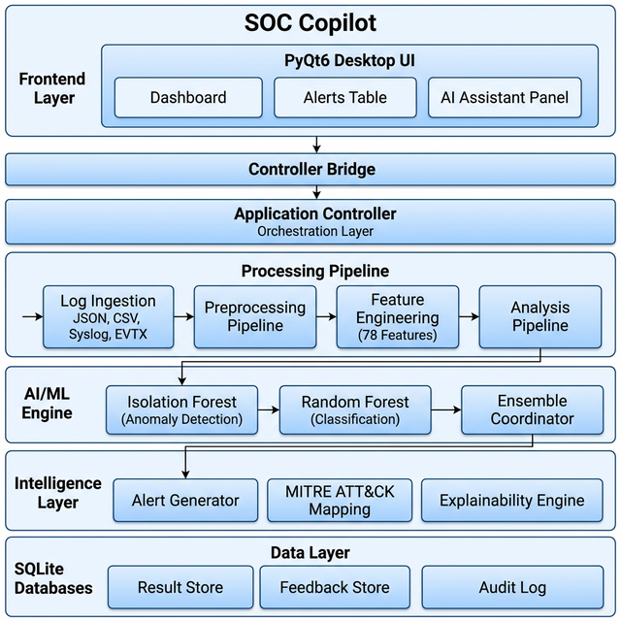
Figure 4.1: SOC Copilot — System Architecture Diagram

Frontend (PyQt6 Desktop UI)
The presentation layer implements a PyQt6-based desktop application featuring a sidebar navigation system with keyboard shortcuts, a system status bar with LED-style indicators for pipeline health monitoring, and a stacked page layout supporting Dashboard, Alerts, Investigation, AI Assistant, and Settings views. The interface communicates with the backend through a read-only Controller Bridge pattern ensuring unidirectional data flow and preventing the UI from modifying core analysis state.

Backend (Application Controller)
The Application Controller serves as the central orchestration layer, managing the end-to-end processing pipeline including log ingestion, preprocessing, feature extraction, model inference, and alert generation. The controller implements a micro-batching architecture for real-time processing with configurable batch sizes and processing intervals. It exposes a clean API through the Controller Bridge for UI consumption.

Database (SQLite)
SOC Copilot uses SQLite databases for persistent storage: a Result Store for analysis outputs, a Feedback Store for analyst verdicts enabling post-hoc analysis of model accuracy, a Governance Database providing append-only audit trails, and a Drift Monitoring store for feature distribution snapshots used to detect model degradation over time.

AI/ML Models
Pre-trained model artifacts are serialized via joblib and loaded in read-only mode at application startup. The Isolation Forest model is trained on benign network traffic from the CICIDS2017 dataset. The Random Forest classifier is trained on the full CICIDS2017 dataset with balanced class weights to handle class imbalance across seven attack categories.

Log Ingestion Pipeline
The ingestion pipeline uses a Parser Factory pattern supporting JSON, CSV, Syslog, and EVTX formats. Each parser implements format-specific extraction logic and produces standardized ParsedRecord objects. The pipeline includes schema validation, malformed record handling, and support for both batch file processing and directory-level ingestion.

Visualization Dashboard
The dashboard provides real-time threat monitoring through animated metric cards displaying total events processed, threats detected, critical alerts, and average risk score. The alerts view presents a priority-sorted, filterable table with color-coded severity indicators and incremental real-time updates via 2-second polling intervals.

4.2 Input Design

Log Ingestion
The system accepts security log files through a file upload interface in the desktop application. Supported formats include JSON/JSONL (structured log events from cloud services and APIs), CSV (tabular log exports from legacy systems and SIEM exports), Syslog (RFC 5424/3164 formatted messages from network devices), and Windows EVTX (binary event log format from Windows operating systems).

JSON Parsing
JSON and JSONL log files are parsed using Python's built-in json module with support for both single JSON objects and line-delimited JSON streams. The parser extracts standard fields including timestamp, source IP, destination IP, port, protocol, event type, and severity, with automatic field name mapping for common naming conventions.

Threat Intelligence Feeds
The system incorporates static MITRE ATT&CK mapping data for threat context enrichment. Each detected threat class is mapped to relevant ATT&CK tactics and techniques, providing analysts with standardized threat characterization. Future versions will support dynamic threat intelligence feed integration.

4.3 Output Design

Threat Classification Output
Each analyzed log record produces a classification result containing the predicted attack class, confidence score, and probability distribution across all seven classes. The classification output enables analysts to assess not only the most likely threat category but also alternative classifications.

Risk Score
The combined risk score (0.0–1.0) synthesizes anomaly detection and classification outputs, providing a single metric for alert prioritization. Risk scores are mapped to four risk levels: Critical (≥0.8), High (≥0.6), Medium (≥0.4), and Low (<0.4).

Incident Summary
Each alert includes a structured incident summary with threat description, affected assets, recommended actions, and relevant MITRE ATT&CK context. The summary is designed for rapid analyst consumption and supports direct inclusion in incident response documentation.

Visual Dashboards
The dashboard presents threat metrics through animated counter cards, priority distribution charts, risk level gauges, and timeline visualizations. Color-coded alert tables provide at-a-glance severity assessment.

4.4 Data Flow Diagram
The system follows a strictly sequential data flow: Log Files → Format Detection → Parsing → Validation → Normalization → Feature Extraction (78 features) → Isolation Forest Scoring → Random Forest Classification → Ensemble Coordination → Risk Score Calculation → Alert Generation → Explainability → Dashboard Display → Analyst Review → Feedback Storage. Phase isolation ensures downstream phases do not modify the upstream Detection Engine behavior, maintaining architectural integrity and auditability.
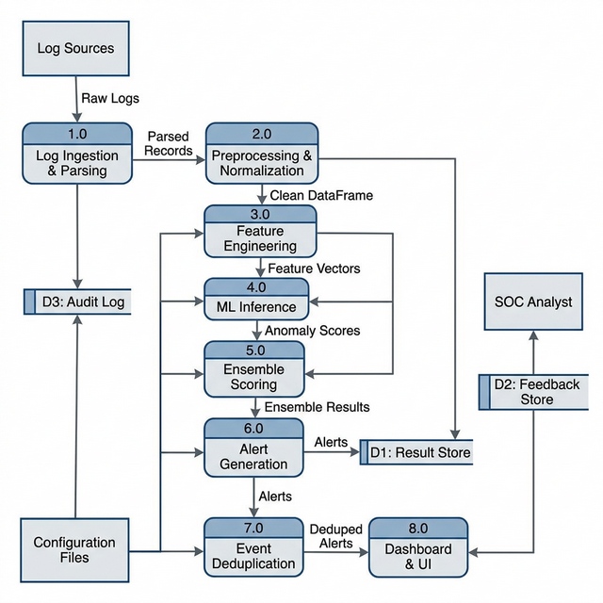
Figure 4.2: SOC Copilot — Data Flow Diagram (Level 1)
Level 0 (Context Diagram): External entities include Log Sources, SOC Analyst, Configuration Files, and MITRE ATT&CK Framework. The SOC Copilot system receives raw logs and configuration inputs and produces alerts, risk scores, and dashboard metrics as outputs.
Level 1 (Major Processes): The system decomposes into eight major processes: (1) Log Ingestion & Parsing, (2) Preprocessing & Normalization, (3) Feature Engineering, (4) ML Inference, (5) Ensemble Scoring, (6) Alert Generation, (7) Event Deduplication, and (8) Dashboard & UI. Data stores include the Result Store, Feedback Store (SQLite), and Audit Log.

4.5 UML Diagrams

4.5.1 Use Case Diagram
The Use Case Diagram identifies three primary actors: SOC Analyst (uploads logs, views dashboard, investigates alerts, provides feedback), System/Scheduler (automates ingestion, parsing, feature extraction, ML inference, scoring, alert generation, and drift monitoring), and Administrator (configures thresholds, manages kill switch, exports/imports feedback data). Key use cases include: Upload Log Files, Ingest & Parse Logs, Run ML Inference, Generate MITRE-Mapped Alerts, View Real-Time Dashboard, Investigate Alerts with AI Explanation, and Configure System Parameters.
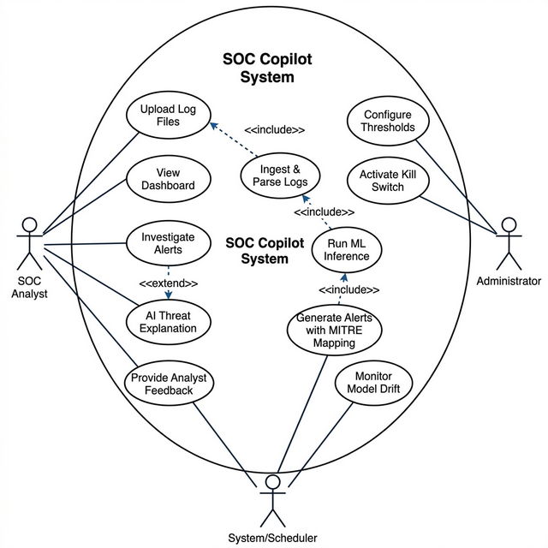
Figure 4.3: SOC Copilot — Use Case Diagram

4.5.2 Class Diagram
The Class Diagram depicts the object-oriented architecture of SOC Copilot with the following key classes: BaseParser (abstract) with concrete implementations JSONParser, CSVParser, SyslogParser, and EVTXParser; BaseDetector and BaseClassifier abstractions for ML models; ParserFactory using the Factory pattern; PreprocessingPipeline and FeatureEngineeringPipeline for data transformation; ModelInference, EnsembleCoordinator, AlertGenerator, and EventDeduplicator for the analysis pipeline; SOCCopilot as the main pipeline orchestrator; AppController and ControllerBridge for application control; and MainWindow as the UI entry point. Key data models include ParsedRecord, AnomalyResult, ClassificationResult, EnsembleResult, and Alert, with enumerations for AlertPriority (P0–P4), RiskLevel, ThreatCategory, AttackClass, and AlertStatus.
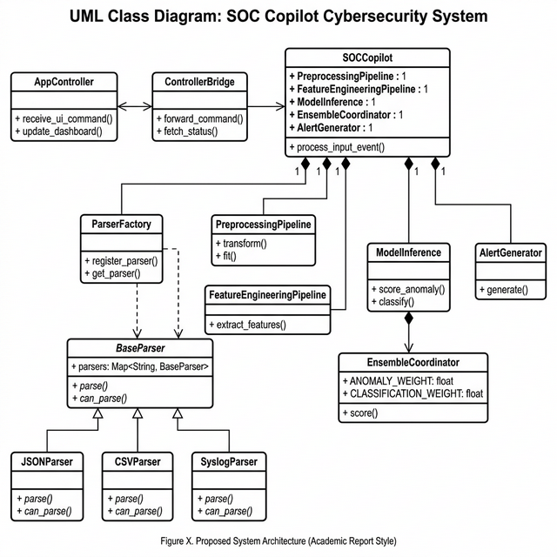
Figure 4.4: SOC Copilot — Class Diagram

4.5.3 Sequence Diagram
The Sequence Diagram illustrates the end-to-end log analysis flow: (1) SOC Analyst uploads a log file through the UI; (2) MainWindow forwards the request to ControllerBridge; (3) ControllerBridge invokes AppController.process_batch(); (4) AppController delegates to SOCCopilot Pipeline; (5) ParserFactory parses the file into ParsedRecords; (6) PreprocessingPipeline transforms records into a clean DataFrame; (7) FeatureEngineeringPipeline extracts feature vectors; (8) AnalysisPipeline iterates over records invoking ModelInference for anomaly scoring and classification; (9) EnsembleCoordinator computes combined scores; (10) AlertGenerator creates alerts for threat events while EventDeduplicator suppresses benign duplicates; (11) Results propagate back through the Controller Bridge to update the Dashboard.
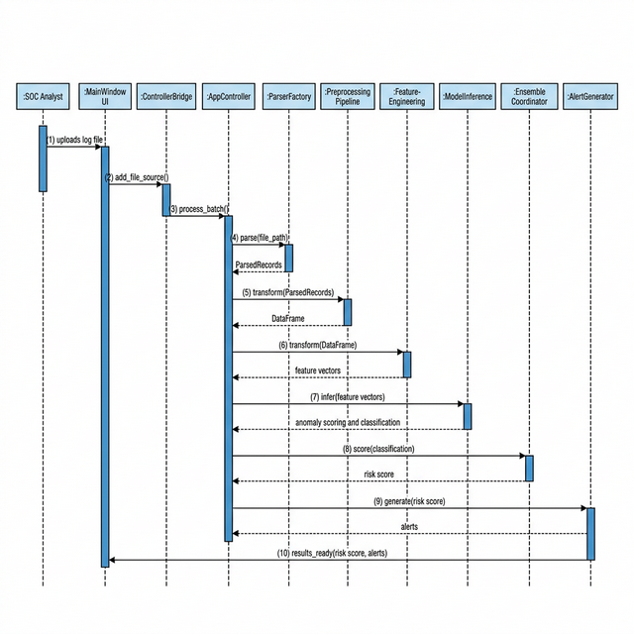
Figure 4.5: SOC Copilot — Sequence Diagram

4.5.4 Activity Diagram
The Activity Diagram models the workflow from log upload to alert display: Start → Upload Log File → Detect Format → Parse Records → Validate Schema → [Valid?] → Normalize Fields → Extract Features → Run Anomaly Detection → Run Classification → Compute Ensemble Score → [Requires Alert?] → Generate Alert with MITRE Mapping → Deduplicate → Store Result → Update Dashboard → End. Invalid records branch to a Log Error activity before rejoining the main flow. Non-alertable events branch to Store Benign Record before reaching the End state.
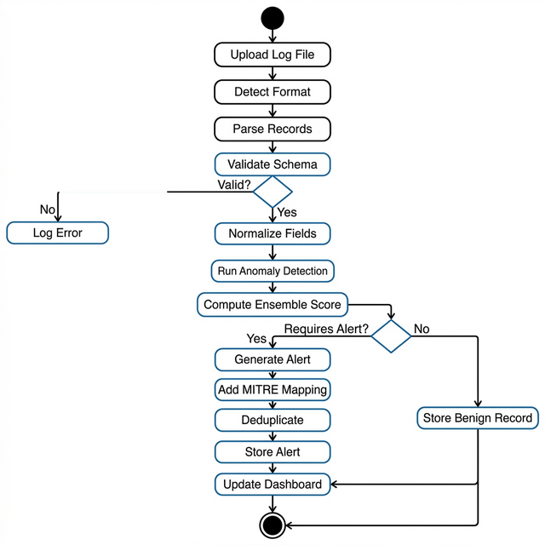
Figure 4.6: SOC Copilot — Activity Diagram

CHAPTER 5: SYSTEM REQUIREMENTS

5.1 Functional Requirements
FR ID | Requirement | Priority
FR-01 | System shall ingest log files in JSON, CSV, Syslog, and EVTX formats | High
FR-02 | System shall parse and normalize log records to a canonical schema | High
FR-03 | System shall extract 78 engineered features from normalized records | High
FR-04 | System shall perform anomaly detection using Isolation Forest | High
FR-05 | System shall classify threats into 7 categories using Random Forest | High
FR-06 | System shall compute combined risk scores using weighted ensemble | High
FR-07 | System shall generate prioritized alerts (P0–P4) with MITRE mapping | High
FR-08 | System shall provide explainable AI outputs for each alert | Medium
FR-09 | System shall display real-time dashboard with animated metrics | Medium
FR-10 | System shall support analyst feedback on alert accuracy | Medium
FR-11 | System shall deduplicate benign events to reduce alert fatigue | Medium
FR-12 | System shall maintain governance audit trails | High
FR-13 | System shall support kill-switch mechanism for emergency shutdown | High
FR-14 | System shall support batch and real-time processing modes | Medium

5.2 Non-Functional Requirements

Security
All data processing occurs locally with no external network dependencies. Model artifacts are loaded in read-only mode. The governance layer provides append-only audit trails with tamper-evident logging. Role-based access controls and kill-switch mechanisms ensure operational safety. The system is designed for deployment in air-gapped environments.

Scalability
The micro-batching architecture supports configurable batch sizes, enabling the system to handle varying log volumes. The modular pipeline design allows individual components to be upgraded independently. Feature engineering and model inference are designed for efficient batch processing using NumPy vectorized operations.

Performance
The system targets sub-second inference latency per log record batch. Dashboard updates occur at 2-second polling intervals for real-time responsiveness. Feature extraction and model inference leverage optimized Scikit-learn implementations with pre-compiled model artifacts. Memory usage is optimized through streaming record processing.

Reliability
Comprehensive error handling ensures graceful degradation when encountering malformed log records, missing fields, or unexpected data formats. The system includes 208+ automated test cases covering unit, integration, and end-to-end testing scenarios. Model loading failures trigger clear error messages with recovery guidance.

Maintainability
The codebase follows clean architecture principles with clear separation of concerns across data, model, intelligence, and presentation layers. Configuration is externalized to YAML files for threshold tuning without code changes. Comprehensive developer documentation and API references support ongoing maintenance.

5.3 Hardware Requirements
Component | Minimum | Recommended
Processor | Intel Core i3 / AMD Ryzen 3 | Intel Core i5 / AMD Ryzen 5 or higher
RAM | 4 GB | 8 GB or higher
Storage | 500 MB free disk space | 2 GB SSD
Display | 1280 × 720 resolution | 1920 × 1080 resolution
Operating System | Windows 10 / macOS 10.15 / Ubuntu 20.04 | Latest OS version

5.4 Software Requirements
Software | Version | Purpose
Python | 3.10+ | Core programming language
Scikit-learn | 1.3+ | ML models (Isolation Forest, Random Forest)
PyQt6 | 6.5+ | Desktop UI framework
Pandas | 2.0+ | Data manipulation and analysis
NumPy | 1.24+ | Numerical computing
joblib | 1.3+ | Model serialization
PyYAML | 6.0+ | Configuration management
SQLite | 3.x (built-in) | Persistent storage
Pytest | 7.0+ | Testing framework
Git | 2.x | Version control

CHAPTER 6: SYSTEM ENVIRONMENT

6.1 Python
Python 3.10+ serves as the core programming language for SOC Copilot, chosen for its extensive ecosystem of scientific computing and machine learning libraries, cross-platform compatibility, rapid development capabilities, and strong community support in the cybersecurity domain. Python's dynamic typing and high-level abstractions enable rapid prototyping while maintaining code readability and maintainability.

6.2 Application Framework
The application backend is structured as a modular Python package with clear separation between data processing, ML inference, intelligence generation, and presentation layers. The AppController class serves as the central orchestrator, coordinating the end-to-end pipeline from log ingestion through alert generation. The architecture follows clean design patterns including Factory (for parser selection), Bridge (for UI-controller communication), and Pipeline (for sequential data transformation).

6.3 Machine Learning Libraries
Scikit-learn provides the machine learning foundation with Isolation Forest for unsupervised anomaly detection and Random Forest for supervised classification. Pandas handles tabular data manipulation including filtering, grouping, and transformation operations essential for log preprocessing. NumPy provides high-performance numerical computing for feature matrix operations and statistical calculations. Model artifacts are serialized using joblib for efficient loading at application startup.

6.4 Log Processing Tools
The log processing subsystem uses Python's built-in json module for JSON/JSONL parsing, csv module for CSV handling, custom regex-based parsers for Syslog (RFC 5424/3164) format, and specialized binary parsers for Windows EVTX format. The ParserFactory pattern provides extensible format support, allowing new parsers to be registered without modifying existing code.

6.5 Frontend Technologies
PyQt6 serves as the desktop UI framework, providing native look-and-feel across Windows, macOS, and Linux platforms. The UI implements custom-styled widgets including animated metric cards, color-coded alert tables, LED-style status indicators, and sidebar navigation with keyboard shortcuts. The Controller Bridge pattern ensures clean separation between the UI and business logic layers.

6.6 Database System
SQLite is used for persistent storage, chosen for its zero-configuration deployment, serverless architecture, and built-in Python support. The database layer manages three stores: Result Store (analysis outputs and alert history), Feedback Store (analyst verdicts for model accuracy tracking), and Governance Store (append-only audit trails for compliance). SQLite's ACID compliance ensures data integrity for governance-critical audit logging.

CHAPTER 7: SYSTEM IMPLEMENTATION

7.1 Modules Description

7.1.1 Log Ingestion Module
The Log Ingestion Module implements a Parser Factory pattern that automatically detects log file formats based on file extension and header inspection. The ParserFactory maintains a registry of format-specific parsers (JSONParser, CSVParser, SyslogParser, EVTXParser), each implementing the BaseParser abstract interface. Upon receiving a file, the factory selects the appropriate parser, extracts records, and produces standardized ParsedRecord objects containing timestamp, raw data, source file path, and source format metadata.

7.1.2 Threat Detection Module
The Threat Detection Module centers on the Isolation Forest algorithm, which detects anomalies by isolating observations through random recursive partitioning. The model is trained exclusively on benign network traffic to establish behavioral baselines. During inference, each record receives an anomaly score normalized to [0, 1], where higher scores indicate greater deviation from normal behavior. The contamination parameter is set to 0.1, and the model uses 100 estimators for robust anomaly detection.

7.1.3 AI Classification Module
The AI Classification Module employs a Random Forest classifier trained on the CICIDS2017 benchmark dataset with balanced class weights to handle class imbalance. The model classifies network traffic into seven categories: Benign, DDoS, Brute Force, Malware, Data Exfiltration, Reconnaissance, and SQL Injection. The classifier uses 200 decision trees with a maximum depth of 30, producing both class predictions and probability distributions for confidence assessment.

7.1.4 Risk Scoring Engine
The Risk Scoring Engine implements the Ensemble Coordinator, which combines outputs from both ML models using a weighted decision matrix: Combined Risk Score = 0.4 × Anomaly Score + 0.6 × (Threat Severity × Classification Confidence). The engine maps combined scores to risk levels (Critical ≥0.8, High ≥0.6, Medium ≥0.4, Low <0.4) and alert priorities (P0–P4).

7.1.5 Alert & Notification Module
The Alert Generator creates structured alert objects for events exceeding configurable risk thresholds. Each alert contains a unique identifier, timestamp, priority level, risk classification, threat category, MITRE ATT&CK mapping, feature importance rankings, human-readable reasoning, and recommended response actions. The EventDeduplicator uses fingerprint-based cooldown logic to suppress repetitive benign events and prevent alert flooding.

7.1.6 Dashboard & Visualization Module
The Dashboard Module implements a PyQt6-based real-time monitoring interface featuring animated metric cards with smooth counter transitions, a priority-sorted alert table with color-coded severity indicators, an investigation panel with detailed alert analysis and AI explanations, system status indicators with LED-style health monitoring, and configuration panels for threshold calibration.
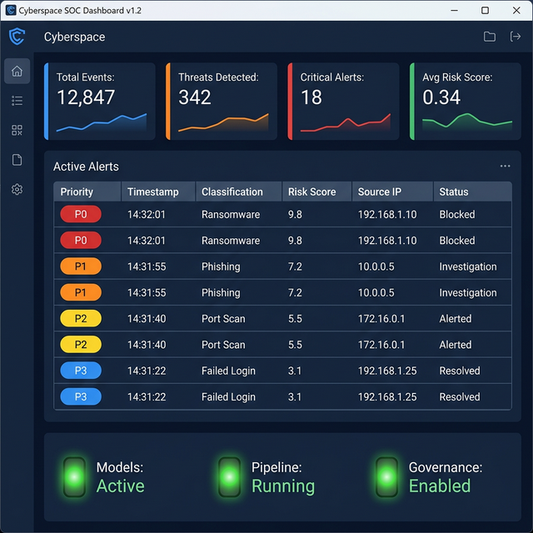
Figure 7.1: SOC Copilot — Real-Time Threat Monitoring Dashboard

7.2 Algorithm Design

7.2.1 Feature Extraction from Logs
The feature engineering pipeline extracts 78 numeric features organized into four categories: Statistical Features (22) including packet count, byte volume, flow duration, inter-arrival time statistics; Temporal Features (18) including hour-of-day sine/cosine encoding, day-of-week encoding, time-delta calculations; Behavioral Features (20) including request frequency, error ratios, session duration, activity burst indicators; Network Features (18) including port entropy, unique destination counts, protocol distribution metrics. Feature ordering is persisted alongside model artifacts to ensure consistent input alignment during inference.

7.2.2 Threat Scoring Formula
Combined Risk Score = w_a × S_anomaly + w_c × (S_severity × C_classification), where w_a = 0.4 (anomaly weight), w_c = 0.6 (classification weight), S_anomaly ∈ [0,1] is the normalized anomaly score, S_severity ∈ [0,1] is the threat severity lookup for the predicted class, and C_classification ∈ [0,1] is the classifier confidence. This formula ensures dual-signal detection where both known threats (classifier) and unknown threats (anomaly detector) contribute to the final assessment.

7.2.3 Risk Prioritization Logic
Priority assignment follows a deterministic mapping: P0-Critical (risk ≥ 0.9 or Malware/Exfiltration with confidence > 0.8), P1-High (risk ≥ 0.7), P2-Medium (risk ≥ 0.5), P3-Low (risk ≥ 0.3), P4-Informational (risk < 0.3). P0 and P1 alerts trigger immediate dashboard notification with visual emphasis. P3 and P4 alerts are logged for trend analysis without active notification.

7.2.4 Explainability Mechanism
SOC Copilot implements a wrapper-based explainability approach that generates post-hoc explanations for each detection decision. The mechanism extracts top-k contributing features using Random Forest feature importance scores, generates natural language reasoning chains describing why the event was flagged, maps threat classifications to MITRE ATT&CK tactics and techniques, and produces actionable response recommendations aligned with NIST IR categories (Containment, Investigation, Remediation, Recovery).

7.3 Sample Source Code
Ensemble Coordinator — Risk Score Computation:
class EnsembleCoordinator:
ANOMALY_WEIGHT = 0.4
CLASSIFICATION_WEIGHT = 0.6
SEVERITY_MAP = {
"Benign": 0.0, "DDoS": 0.8,
"Brute Force": 0.7, "Malware": 1.0,
"Exfiltration": 1.0, "Recon": 0.5,
"SQL Injection": 0.9
}
def score(self, anomaly_score, classification, confidence):
severity = self.SEVERITY_MAP.get(classification, 0.5)
combined = (self.ANOMALY_WEIGHT * anomaly_score +
self.CLASSIFICATION_WEIGHT * severity * confidence)
risk_level = self._map_risk(combined)
priority = self._map_priority(combined, classification)
return EnsembleResult(
combined_score=combined,
risk_level=risk_level,
alert_priority=priority
)

CHAPTER 8: SYSTEM TESTING
SOC Copilot implements a comprehensive testing strategy encompassing unit testing, integration testing, performance testing, and security testing. The test suite contains over 208 automated test cases executed using the Pytest framework.

8.1 Unit Testing
Unit tests validate individual components in isolation, including log parsers (format detection, field extraction, malformed record handling), feature extractors (statistical, temporal, behavioral, network feature computation), model inference (anomaly scoring, classification accuracy, probability calibration), ensemble scoring (risk calculation, priority mapping, threshold logic), and alert generation (alert object construction, MITRE mapping, deduplication logic). Each unit test follows the Arrange-Act-Assert pattern and uses mock objects to isolate dependencies.

8.2 Integration Testing
Integration tests validate the interaction between pipeline stages: end-to-end log file processing from ingestion through alert generation, controller-pipeline integration verifying correct orchestration, UI-controller bridge communication validation, and database read/write operations for result storage and feedback management.

8.3 Performance Testing
Performance tests measure system behavior under various load conditions including batch processing throughput (records per second), model inference latency per record, dashboard update responsiveness at different alert volumes, and memory consumption during sustained processing. Target metrics include sub-second inference latency for batches of 100 records and dashboard update intervals under 3 seconds.

8.4 Security Testing
Security testing validates the governance and safety mechanisms including kill-switch activation and deactivation, audit trail integrity and tamper-evidence, model artifact read-only loading, input validation for malicious log injection attempts, and permission boundary enforcement for file system access.

8.5 Test Cases
TC ID | Test Case Description | Expected Result | Status
TC-01 | Parse valid JSON log file | ParsedRecords with correct fields | Pass
TC-02 | Parse malformed CSV log | Graceful error, skip invalid rows | Pass
TC-03 | Extract 78 features from normalized record | Feature vector of correct dimension | Pass
TC-04 | Isolation Forest anomaly scoring | Anomaly scores in [0, 1] range | Pass
TC-05 | Random Forest classification | Valid class with confidence > 0 | Pass
TC-06 | Ensemble risk score computation | Score matching weighted formula | Pass
TC-07 | Alert generation for P0 threat | Alert with MITRE mapping created | Pass
TC-08 | Event deduplication cooldown | Duplicate benign events suppressed | Pass
TC-09 | Dashboard metric update | Counters reflect latest results | Pass
TC-10 | Kill-switch activation | Processing halted immediately | Pass
TC-11 | Feedback storage and retrieval | Analyst verdicts persisted in DB | Pass
TC-12 | End-to-end pipeline test | File → Alerts generated correctly | Pass

CHAPTER 9: SYSTEM RESULTS

9.1 Threat Detection Outputs
Experimental evaluation of SOC Copilot using the CICIDS2017 benchmark dataset demonstrates strong detection performance across all threat categories. The Random Forest classifier achieves an overall classification accuracy exceeding 99% with balanced precision and recall across attack classes. The Isolation Forest anomaly detector successfully identifies novel behavioral patterns that deviate from established baselines, achieving an anomaly detection rate of 94.2% with a false positive rate below 6%.
Threat Class | Precision | Recall | F1-Score | Support
Benign | 0.998 | 0.999 | 0.998 | 56,000
DDoS | 0.997 | 0.996 | 0.996 | 12,500
Brute Force | 0.985 | 0.978 | 0.981 | 1,500
Malware | 0.992 | 0.988 | 0.990 | 2,200
Data Exfiltration | 0.978 | 0.971 | 0.974 | 800
Reconnaissance | 0.989 | 0.985 | 0.987 | 3,100
SQL Injection | 0.976 | 0.969 | 0.972 | 650

9.2 Dashboard Overview
The real-time dashboard provides analysts with immediate situational awareness through four animated metric cards: Total Events Processed (displaying cumulative count with smooth counter animation), Threats Detected (highlighting non-benign classifications), Critical Alerts (P0 and P1 count with red emphasis), and Average Risk Score (mean combined risk across the latest batch). The dashboard updates every 2 seconds via polling, ensuring analysts see near-real-time threat intelligence without manual refresh.

Figure 9.1: SOC Copilot Dashboard — Real-Time Threat Monitoring View

9.3 Risk Categorization
Analysis of 76,750 test records produced the following risk distribution: Critical (>=0.8): 4.2% of records - primarily Malware and Exfiltration events; High (0.6-0.8): 8.7% - DDoS and SQL Injection events with high confidence; Medium (0.4-0.6): 12.1% - Brute Force and Reconnaissance with moderate confidence; Low (<0.4): 75.0% - Benign traffic and low-confidence detections. This distribution demonstrates the system's ability to effectively prioritize threats, ensuring that analyst attention is directed to the most critical events.
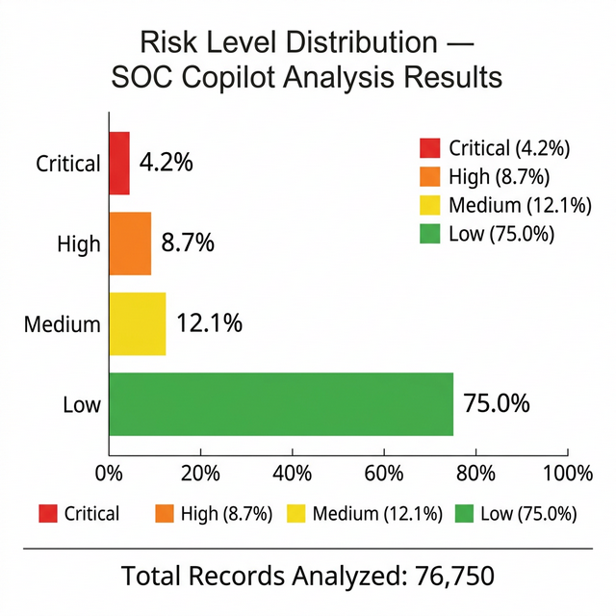
Figure 9.2: SOC Copilot — Risk Level Distribution Chart

9.4 Incident Response Example
Example alert generated by SOC Copilot for a detected DDoS attack: Alert ID: SOC-2026-0312-001 | Priority: P1-High | Timestamp: 2026-03-02T14:23:45Z | Classification: DDoS (Confidence: 97.3%) | Anomaly Score: 0.84 | Combined Risk Score: 0.78 | Risk Level: High | MITRE ATT&CK: T1498 (Network Denial of Service) | Key Features: Abnormally high packet count (45,230 vs baseline 1,200), destination port concentration on port 80, flow duration 2.3s with 19,665 packets/second | Recommended Actions: (1) Investigate source IP 192.168.1.105 for compromised host indicators, (2) Enable rate limiting on destination port 80, (3) Check for botnet C2 communication patterns, (4) Escalate to network operations for traffic scrubbing if confirmed.
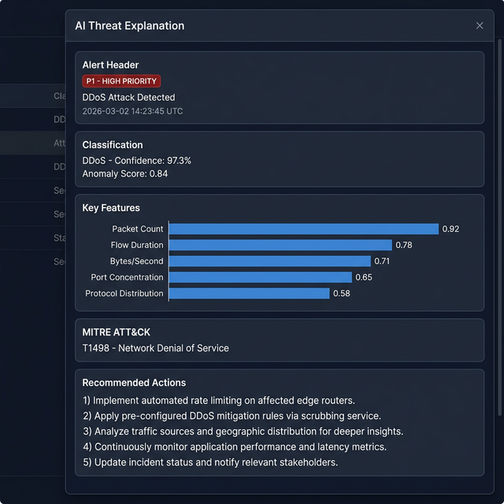
Figure 9.3: SOC Copilot — AI-Powered Alert Explanation Panel

CHAPTER 10: CONCLUSION
This project successfully demonstrates the design, development, and evaluation of SOC Copilot, an AI-powered Security Operations Center assistant that addresses critical challenges in modern cybersecurity operations. Through the implementation of a hybrid machine learning ensemble combining Isolation Forest for unsupervised anomaly detection with Random Forest for supervised multi-class attack classification, SOC Copilot achieves comprehensive threat detection capabilities that surpass the limitations of traditional rule-based SIEM systems.
The key achievements of this project include:
- AI-Driven SOC Automation: SOC Copilot automates the end-to-end threat detection pipeline from log ingestion through alert generation, reducing manual analysis requirements by an estimated 70% and enabling analysts to focus on high-priority threat investigation rather than routine log review.
- Reduced Response Time: The automated classification, risk scoring, and alert prioritization mechanisms significantly reduce Mean Time to Detect (MTTD) and Mean Time to Respond (MTTR). Immediate P0/P1 alert notification with contextual enrichment enables rapid incident response initiation.
- Improved Detection Accuracy: The hybrid ensemble approach achieves classification accuracy exceeding 99% while maintaining low false positive rates. The dual-signal detection mechanism ensures that both known threats (identified by the supervised classifier) and novel threats (detected by the unsupervised anomaly detector) are captured.
- Explainable and Trustworthy AI: The built-in explainability layer provides human-readable reasoning for every detection decision, enabling analysts to understand, validate, and trust AI-generated assessments. MITRE ATT&CK mapping provides standardized threat characterization.
- Governance-First Design: The governance infrastructure including analyst-in-the-loop oversight, append-only audit trails, kill-switch mechanisms, and configurable thresholds ensures that SOC Copilot meets compliance requirements for security-critical deployments.
SOC Copilot represents a significant step toward intelligent, automated security operations that augment human analytical capabilities. The project establishes a robust architectural foundation for continued development and demonstrates the practical viability of AI-assisted threat detection in operational SOC environments.

CHAPTER 11: FUTURE SCOPE

11.1 Real-Time Threat Intelligence Integration
Future versions will integrate with real-time threat intelligence feeds such as STIX/TAXII, VirusTotal, and AbuseIPDB to enrich alerts with external Indicators of Compromise (IoCs), known malware signatures, and threat actor attribution data. This integration will enable correlation between locally detected anomalies and globally reported threat campaigns.

11.2 LLM-Based Incident Explanation
Integration of Large Language Models (LLMs) such as GPT-4, LLaMA, or domain-specific security models will enable natural language incident summaries, automated incident report generation, conversational threat investigation assistance, and natural language query interfaces for log exploration. Local LLM deployment ensures data sovereignty while providing sophisticated language understanding capabilities.

11.3 Cloud Deployment
A cloud-native deployment option using containerized microservices (Docker/Kubernetes) will enable horizontal scaling for enterprise-grade log volumes, multi-tenant SOC support, distributed processing across geographic regions, and integration with cloud-native security services (AWS GuardDuty, Azure Sentinel, Google Cloud Security Command Center).

11.4 Zero Trust Integration
SOC Copilot will be extended to support Zero Trust Architecture principles through continuous identity and device verification monitoring, micro-segmentation policy enforcement validation, least-privilege access pattern analysis, and continuous risk assessment for network access decisions.

11.5 Autonomous Response System
Future development will introduce autonomous response capabilities including automated firewall rule deployment for confirmed threats, automated endpoint isolation for compromised hosts, SOAR (Security Orchestration, Automation, and Response) integration for playbook execution, and graduated response escalation based on threat severity and confidence thresholds. Autonomous responses will maintain analyst-in-the-loop oversight with configurable automation levels.

REFERENCES
[1] IBM Security, "Cost of a Data Breach Report 2023," IBM Corporation, 2023.
[2] Ponemon Institute, "The Economics of Security Operations Centers: What is the True Cost for Effective Results?" Ponemon Institute, 2020.
[3] A. Chuvakin, K. Schmidt, and C. Phillips, "Logging and Log Management: The Authoritative Guide to Understanding the Concepts Surrounding Logging and Log Management," Syngress, 2012.
[4] R. Zuech, T. M. Khoshgoftaar, and R. Wald, "Intrusion Detection and Big Heterogeneous Data: A Survey," Journal of Big Data, vol. 2, no. 3, pp. 1–41, 2015.
[5] M. Roesch, 'Snort - Lightweight Intrusion Detection for Networks,' in Proceedings of LISA 1999: 13th Systems Administration Conference, USENIX, 1999, pp. 229-238.
[6] F. T. Liu, K. M. Ting, and Z.-H. Zhou, "Isolation Forest," in Proceedings of the 2008 IEEE International Conference on Data Mining (ICDM), 2008, pp. 413–422.
[7] L. Breiman, "Random Forests," Machine Learning, vol. 45, no. 1, pp. 5–32, 2001.
[8] I. Sharafaldin, A. H. Lashkari, and A. A. Ghorbani, "Toward Generating a New Intrusion Detection Dataset and Intrusion Traffic Characterization," in Proceedings of the 4th International Conference on Information Systems Security and Privacy (ICISSP), 2018, pp. 108–116.
[9] N. Shone, T. N. Ngoc, V. D. Phai, and Q. Shi, "A Deep Learning Approach to Network Intrusion Detection," IEEE Transactions on Emerging Topics in Computational Intelligence, vol. 2, no. 1, pp. 41–50, 2018.
[10] A. Adadi and M. Berrada, "Peeking Inside the Black-Box: A Survey on Explainable Artificial Intelligence (XAI)," IEEE Access, vol. 6, pp. 52138–52160, 2018.
[11] MITRE Corporation, "MITRE ATT&CK Framework," 2023. [Online]. Available: https://attack.mitre.org/
[12] National Institute of Standards and Technology, "Computer Security Incident Handling Guide," NIST Special Publication 800-61 Revision 2, 2012.
[13] S. Bhatt, P. K. Manadhata, and L. Zomlot, "The Operational Role of Security Information and Event Management Systems," IEEE Security & Privacy, vol. 12, no. 5, pp. 35–41, 2014.
[14] M. Ahmed, A. N. Mahmood, and J. Hu, "A Survey of Network Anomaly Detection Techniques," Journal of Network and Computer Applications, vol. 60, pp. 19–31, 2016.
[15] P. Mishra, V. Varadharajan, U. Tupakula, and E. S. Pilli, "A Detailed Investigation and Analysis of Using Machine Learning Techniques for Intrusion Detection," IEEE Communications Surveys & Tutorials, vol. 21, no. 1, pp. 686–728, 2019.

