CLOUD-BASED SMART HOME MONITORING & AUTOMATION
PLATFORM USING AWS AND DEVOPS ARCHITECTURE
Prepared in the partial fulfillment of the Summer Internship Program on AWS
AT


Under the guidance of
Mrs. Sumana Bethala, APSSDC

Submitted by
KESANAPALLI POOJITHA, 24A81A4387, Sri Vasavi Engineering College, (Batch -1)
KONDREDDY NIKHITHA DHANAMJAYA,24A81A4388, Sri Vasavi Engineering College,(Batch-1)
KODAKATLA CHOMESWARI, 24A81A4373, Sri Vasavi Engineering College, (Batch -1)
DONTHAMSETTI DEVI, 24A81A4374, Sri Vasavi Engineering College, (Batch -1)
KANIKINEEDI TEJASWI, 25A85A4308, Sri Vasavi Engineering College, (Batch -1)

ACKNOWLEDGEMENT
We would like to express our heartfelt gratitude to all those who have contributed to the successful completion of our summer internship project at Andhra Pradesh Skill Development Corporation (APSSDC). This opportunity has been an enriching and transformative experience for us, and we are truly thankful for the support, guidance, and encouragement we have received along the way.
First and foremost, we extend our sincere regards to Mrs. Sumana Bethala, our supervisor and mentor, for providing us with valuable insights, constant guidance, and unwavering support throughout the duration of the internship. Her expertise and encouragement have been instrumental in shaping the direction of this project.
We would like to thank the entire team at Andhra Pradesh Skill Development Corporation (APSSDC) for fostering a collaborative and innovative environment. The camaraderie, knowledge sharing, and feedback we received from our colleagues significantly contributed to the development and success of this project.
In conclusion, we are honoured to have been a part of this internship program, and we look forward to leveraging the skills and knowledge gained to contribute positively to future endeavours.

Thank you
Sincerely,
Kesanapalli Poojitha, 24A81A4387
Kondreddy Nikhitha Dhanamjaya, 24A81A4388
Kodakatla Chomeswari, 24A81A4373
Donthamsetti Devi, 24A81A4374
Kanikineedi Tejaswi, 25A85A4308

ABSTRACT
The Cloud-Based Smart Home Monitoring & Automation Platform is an intelligent IoT-style solution designed to monitor and control home appliances remotely using Amazon Web Services (AWS) and DevOps practices. The system allows users to monitor the status of smart devices such as lights, fans, doors, and an air conditioner, along with live environmental sensor readings, through a web-based dashboard.
The platform utilizes AWS cloud services to provide scalability, reliability, and near real-time monitoring. Device status and sensor data are stored in Amazon DynamoDB, while the dashboard itself is hosted as a static website in Amazon S3. Amazon API Gateway exposes secure REST endpoints, and AWS Lambda executes the automation and data-processing logic behind each request. Amazon CloudWatch is available to continuously monitor application performance and system logs.
DevOps practices are implemented using Git, GitHub, and GitHub Actions to manage source code and automate deployment. The project demonstrates the integration of cloud computing, automation, monitoring, and continuous deployment into a single smart-home ecosystem.
This solution improves home security, energy awareness, and user convenience while showcasing the practical application of AWS cloud technologies and DevOps methodologies. Security is maintained through AWS Identity and Access Management (IAM), which enforces secure access control and role-based permissions across all cloud resources. The architecture follows cloud-native design principles that promote scalability, flexibility, fault tolerance, and efficient resource utilization.

TABLE OF CONTENTS
ACKNOWLEDGEMENT 1
ABSTRACT 1
TABLE OF CONTENTS 1
1. INTRODUCTION 1
2. METHODOLOGY 1
2.1 Requirement Analysis 1
2.2 System Design 1
2.3 Development Phase 1
2.4 Cloud Infrastructure Setup 1
2.5 DevOps Implementation 1
2.6 Testing 1
2.7 Monitoring and Maintenance 1
2.8 Continuous Improvement 1
3. TECHNOLOGY STACK 1
Cloud Platform 1
AWS Services Used 1
DevOps Tools 1
Programming Languages 1
Database 1
Development Environment 1
Monitoring Tools 1
4. SYSTEM DESIGN / ARCHITECTURE 1
4.1 Workflow 1
4.2 Key Features 1
4.3 API Layer — Amazon API Gateway 1
4.4 Processing Logic — AWS Lambda 1
4.5 Storage — Amazon S3 1
4.6 Data Storage — Amazon DynamoDB 1
4.7 Security and Access Control — AWS IAM 1
4.8 Monitoring and Logging — Amazon CloudWatch 1
4.9 Future Enhancements 1
5. IMPLEMENTATION 1
6. RESULTS 1
6.1 Screenshots of the Output 1
7. CONCLUSION 1

INTRODUCTION
In today's rapidly evolving digital world, smart technologies are transforming the way people interact with their homes. The concept of a Smart Home has gained significant popularity due to advancements in the Internet of Things (IoT), Cloud Computing, and Automation technologies. A smart home enables users to monitor, control, and automate household devices remotely through internet-connected applications, improving convenience, security, energy efficiency, and overall quality of life.
Traditional home-automation systems often require expensive hardware, complex installation procedures, and limited accessibility. Moreover, managing multiple devices manually can be inefficient and time-consuming. To overcome these challenges, cloud-based smart home solutions have emerged as a modern approach that leverages cloud computing services to provide scalable, secure, and remotely accessible automation platforms.
The Cloud-Based Smart Home Monitoring & Automation Platform is designed to provide users with a centralized system for monitoring and controlling smart devices such as lights, fans, doors, an air conditioner, and other household appliances. The platform utilizes Amazon Web Services (AWS) to ensure high availability, scalability, reliability, and cost-effective operation. Through a web-based dashboard, users can access real-time information about connected devices and perform remote control operations from anywhere with an internet connection.

2. METHODOLOGY
The development of the Cloud-Based Smart Home Monitoring & Automation Platform followed a structured methodology to ensure successful implementation of cloud services, automation mechanisms, monitoring systems, and DevOps practices. The methodology consists of several phases including requirement analysis, system design, development, cloud deployment, testing, monitoring, and continuous improvement.

2.1 Requirement Analysis
The first phase involved identifying the requirements of a smart home automation system. The primary objective was to enable users to monitor and control home appliances remotely while ensuring security, scalability, and reliability. The following functional requirements were identified:
- Remote monitoring of smart devices
- Control of home appliances through a web dashboard
- Real-time device status updates
- Automated notifications for abnormal conditions
- Secure storage of device information
- Continuous monitoring of application performance
- Automated deployment using DevOps tools
Non-functional requirements such as scalability, availability, security, and maintainability were also considered during the planning stage.

2.2 System Design
Based on the identified requirements, a cloud-native architecture was designed using AWS services. The architecture follows a modular approach where each service performs a specific function. The major components include:
- Amazon S3 for hosting the dashboard as a static website and for file storage
- Amazon DynamoDB for storing device status and sensor data
- Amazon API Gateway for exposing secure REST endpoints
- AWS Lambda for automation and event processing
- Amazon CloudWatch for monitoring and logging
- AWS IAM for access control and security
The design ensures seamless communication between all cloud services while maintaining security and high availability.

2.3 Development Phase
The application was developed using modern web technologies and cloud-based services.
Frontend Development:
- User dashboard creation
- Device monitoring interface
- Device control panels
- Live sensor and alert display modules
Backend Development:
- Device management APIs
- Database integration
- Automation logic implementation
The application was designed to provide a simple and user-friendly interface for smart home management.

2.4 Cloud Infrastructure Setup
AWS services were configured to support the application.
- Amazon S3 — used to host the Smart Home Dashboard as a static website and to store project assets.
- Amazon DynamoDB — used to store device information and sensor readings.
- Amazon API Gateway — used to expose REST endpoints that route dashboard requests to Lambda.
- AWS Lambda — configured to perform automated actions based on predefined events and conditions.
- AWS IAM — used to create roles and permissions to ensure secure communication between AWS services.

2.5 DevOps Implementation
DevOps practices were incorporated to automate development and deployment processes.
- Git — used for local version control.
- GitHub — used as a central repository for source code management and collaboration.
- GitHub Actions — used to implement Continuous Integration and Continuous Deployment (CI/CD).
The CI/CD pipeline performs the following tasks:
- Source code commit to GitHub
- Automated build process
- Code validation and testing
- Deployment of the dashboard
- Deployment verification
This automation reduces manual effort and improves deployment efficiency.

2.6 Testing
Multiple testing techniques were performed to ensure system reliability and performance.
- Functional Testing — verified proper operation of device monitoring, device control, and alert generation.
- Integration Testing — validated communication between the dashboard, API Gateway, Lambda, and DynamoDB.
- Performance Testing — evaluated response time, system stability, and resource utilization.
- Security Testing — verified access permissions and data protection mechanisms.

2.7 Monitoring and Maintenance
Amazon CloudWatch was integrated to continuously monitor system performance. Monitoring activities included application log tracking, error detection and troubleshooting, and service health monitoring. CloudWatch alarms can be configured to notify administrators when predefined thresholds are exceeded.

2.8 Continuous Improvement
The project followed an iterative development approach. Feedback obtained during testing was used to improve functionality, security, and performance. Future enhancements such as mobile application support, AI-based automation, predictive analytics, and voice assistant integration can be incorporated without major architectural modifications.
The methodology adopted for this project ensured systematic development, secure deployment, efficient monitoring, and scalable cloud infrastructure. By integrating AWS services with DevOps practices, the system successfully delivers a reliable and intelligent smart home automation solution.

3. TECHNOLOGY STACK

Cloud Platform
- Amazon Web Services (AWS)

AWS Services Used
- Amazon S3 — hosts the Smart Home Dashboard as a static website and stores project assets.
- Amazon DynamoDB — stores device and sensor information.
- Amazon API Gateway — exposes secure REST endpoints (SmartHomeAPI) that route requests to Lambda.
- AWS Lambda — executes automation and data-processing tasks.
- Amazon CloudWatch — monitoring and logging.
- AWS IAM — security and access management.

DevOps Tools
- Git
- GitHub
- GitHub Actions

Programming Languages
- Python
- HTML
- CSS
- JavaScript

Database
- Amazon DynamoDB (NoSQL)

Development Environment
- VS Code
- Git Bash

Monitoring Tools
- CloudWatch Logs
- CloudWatch Metrics

4. SYSTEM DESIGN / ARCHITECTURE
The Smart Home Monitoring & Automation Platform follows a serverless, event-driven architecture. The system is organized into a frontend layer, an API layer, a processing layer, and a data-storage layer, all powered by managed AWS services.

4.1 Workflow
Step 1: Dashboard Access. Users access the Smart Home Dashboard through a web browser.
Step 2: Static Hosting. The dashboard (HTML, CSS, and JavaScript) is hosted on Amazon S3 as a static website.
Step 3: API Requests. Device actions from the dashboard are sent as HTTPS requests to Amazon API Gateway (SmartHomeAPI).
Step 4: Automation Logic. API Gateway invokes the appropriate AWS Lambda function to process the request.
Step 5: Data Storage. Device status and sensor readings are stored in and retrieved from Amazon DynamoDB.
Step 6: Monitoring. Amazon CloudWatch monitors Lambda execution and records logs for troubleshooting.
Step 7: Version Control. Developers push code changes to GitHub.
Step 8: CI/CD. GitHub Actions automatically builds and deploys updates to the hosting environment.

4.2 Key Features
- Remote appliance control
- Real-time device and sensor monitoring
- Automated backend processing via Lambda
- Cloud-based static hosting and storage
- Continuous deployment
- Secure, role-based access via IAM
- Performance monitoring via CloudWatch

4.3 API Layer — Amazon API Gateway
A single HTTP API, SmartHomeAPI, routes incoming HTTPS requests from the dashboard to the appropriate Lambda function and acts as the secure entry point for all backend operations.
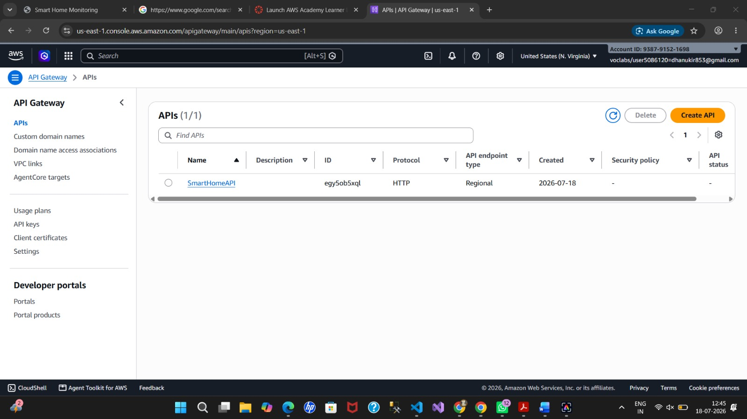
Figure 1. SmartHomeAPI registered in Amazon API Gateway.
The API is deployed to a live prod stage, which exposes a public invoke URL used by the dashboard to communicate with the backend.
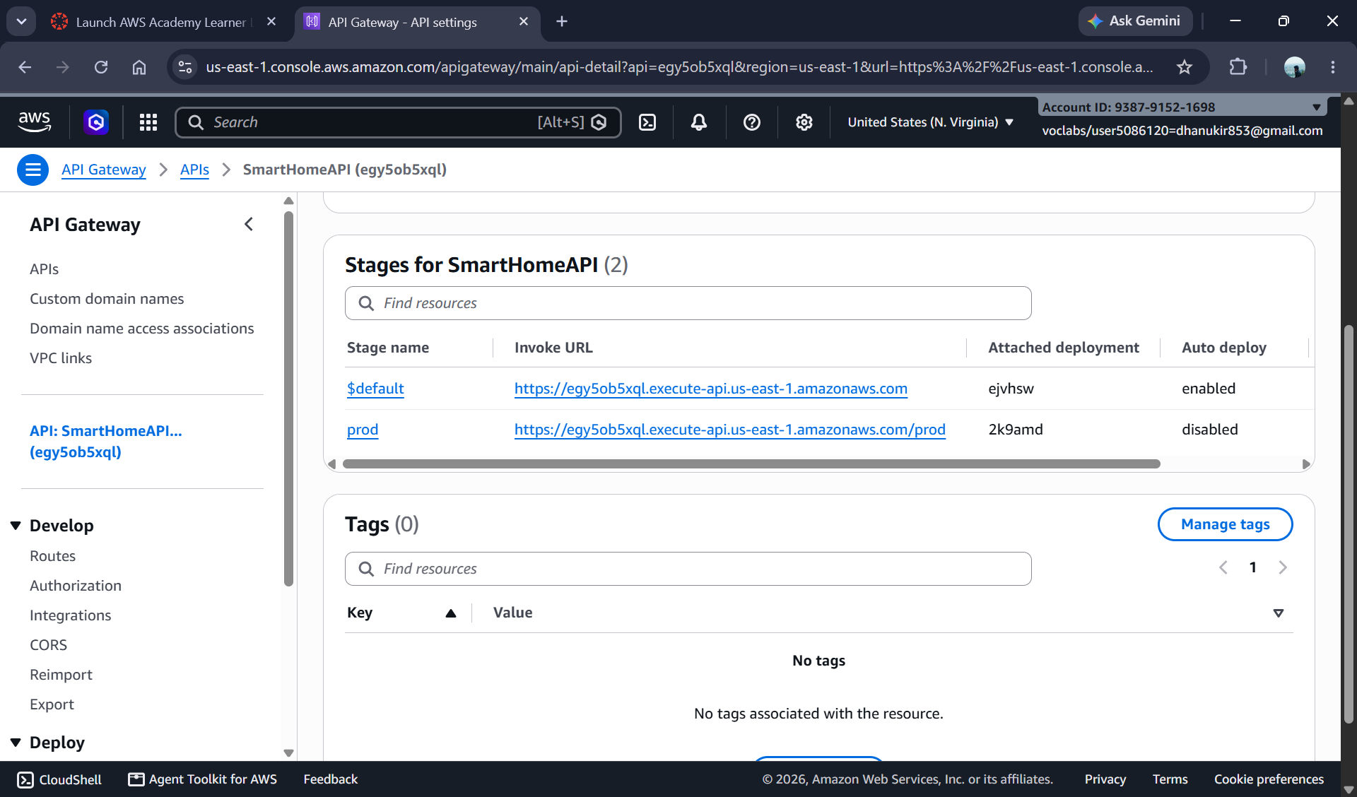
Figure 2. API Gateway prod stage details showing the deployed invoke URL.

4.4 Processing Logic — AWS Lambda
AWS Lambda functions handle the core automation logic of the system, including reading and updating device status and coordinating monitoring tasks. The following project-specific functions were deployed: Smart Home Controller, Ge tSmart Home Data, and Main Monitoring Function.
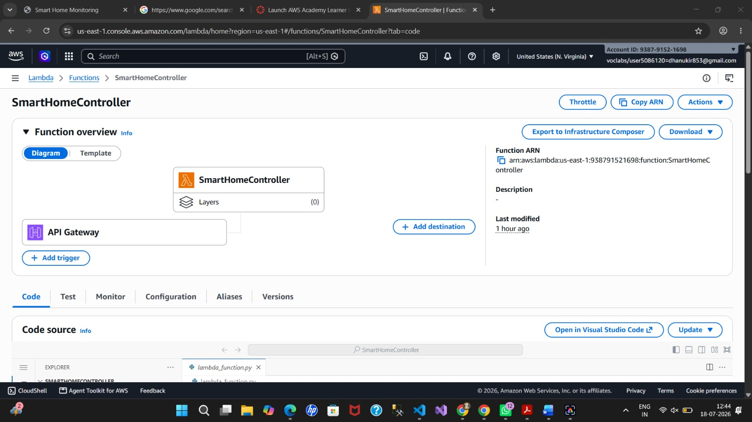
Figure 3. Lambda functions deployed for the project, including SmartHomeController, GetSmartHomeData, and MainMonitoringFunction.

4.5 Storage — Amazon S3
The dashboard files are hosted in a dedicated Amazon S3 bucket named smart-home-monitoring-456, deployed in the US East (N. Virginia) region, and served using S3 static website hosting. This provides durable, scalable, and cost-effective hosting without a dedicated web server.
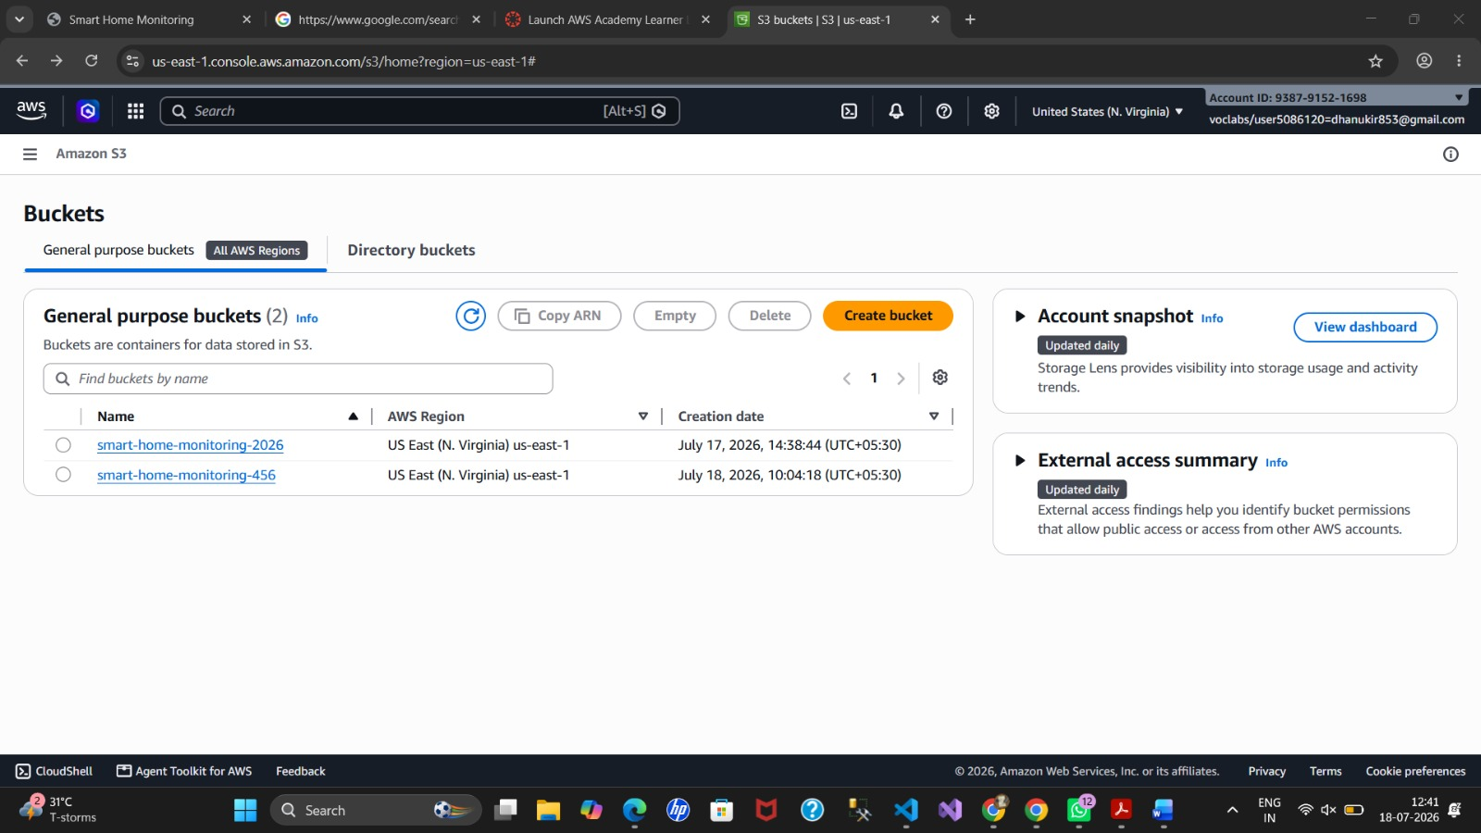
Figure 4. S3 bucket smart-home-monitoring-456 used to host the dashboard as a static website.

4.6 Data Storage — Amazon DynamoDB
Device records are stored in Amazon DynamoDB, a fast, fully managed NoSQL database. Each entry in the SmartHomeDevices table includes:
- deviceId (Primary Key),status
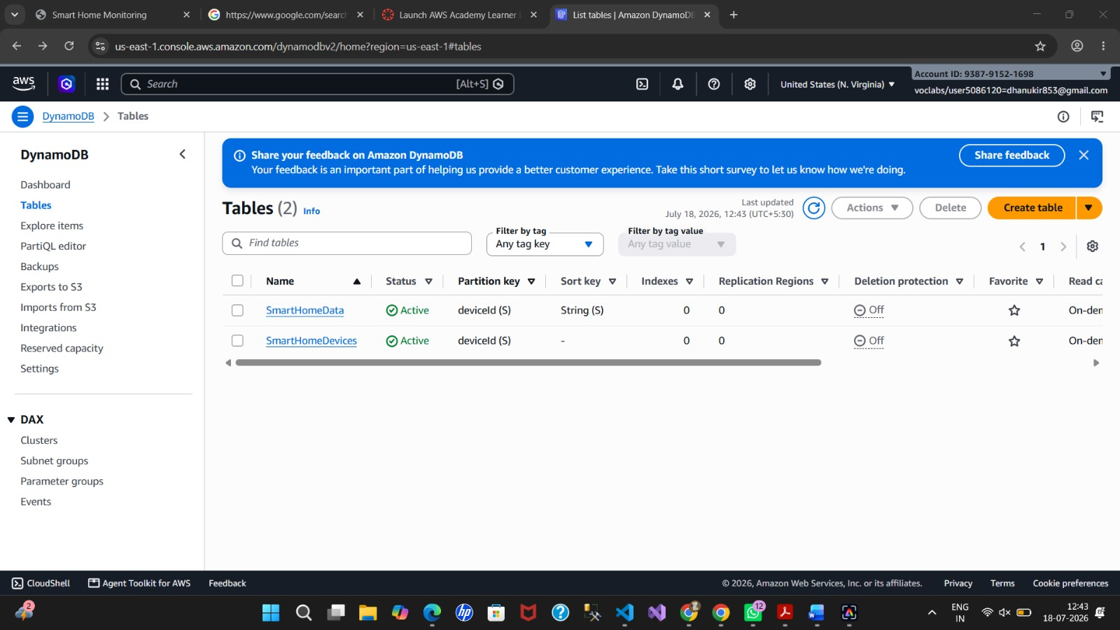
Figure 5. DynamoDB tables SmartHomeData and SmartHomeDevices in the Explore Items view.

A scan of the SmartHomeDevices table confirms that device records are correctly persisted and retrievable.

Figure 6. DynamoDB scan of the SmartHomeDevices table returning stored device records.
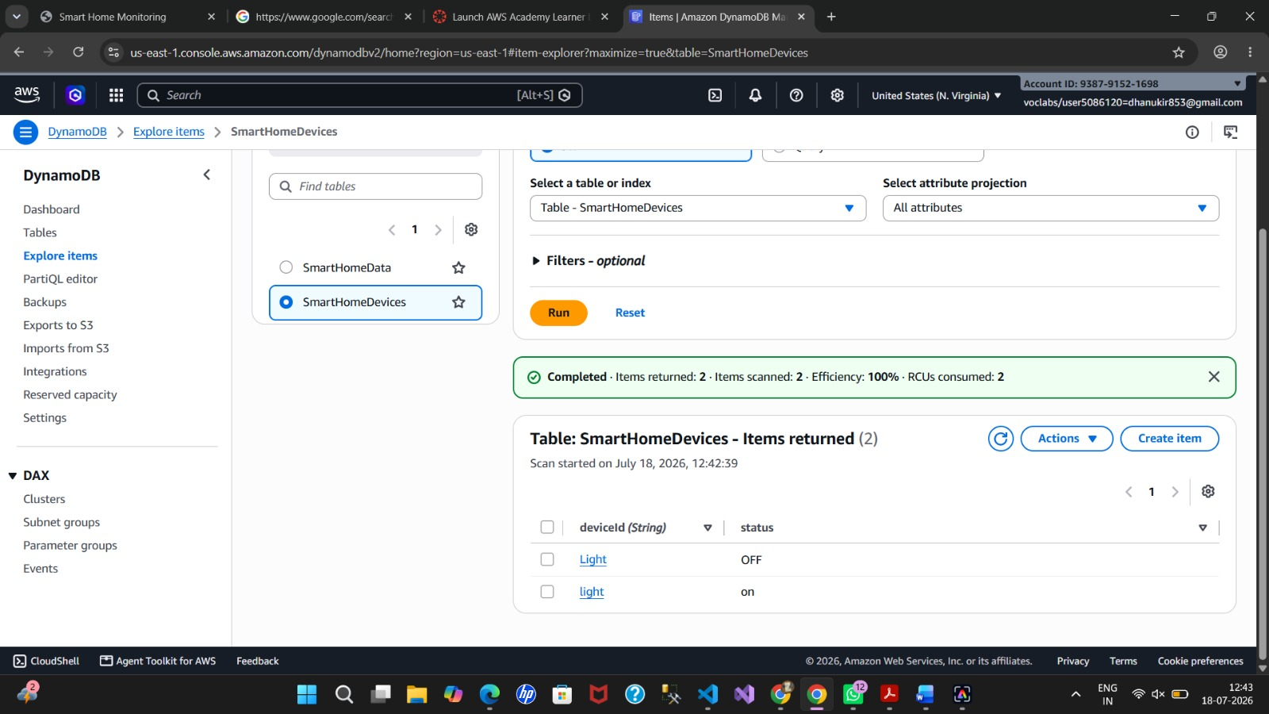
Figure 7. A later scan of the SmartHomeDevices table showing updated device records after further testing.

4.7 Security and Access Control — AWS IAM
AWS Identity and Access Management (IAM) is used to securely grant permissions between services:
- Lambda can read from and write to DynamoDB
- Lambda can be invoked only through the authorized API Gateway route
- Least-privilege access policies are enforced to enhance security

4.8 Monitoring and Logging — Amazon CloudWatch
Amazon CloudWatch is integrated for:
- Real-time monitoring of Lambda execution
- Viewing logs for debugging and error tracing
- Setting alerts for function failures or unusual activity

4.9 Future Enhancements
- Mobile application integration
- Voice assistant support
- AI-based energy optimization
- Smart security camera integration
- Predictive maintenance analytics

5. IMPLEMENTATION
The implementation of the Cloud-Based Smart Home Monitoring & Automation Platform was carried out using a combination of AWS Cloud services, web development technologies, and DevOps tools. The project was developed in a structured manner, beginning with frontend development, followed by cloud resource configuration, source code management, deployment, and testing.
Step 1: Project Planning. The project requirements were analyzed, and a cloud-based architecture was designed to support smart home monitoring and automation. The system was planned to include a user-friendly dashboard for controlling home appliances while utilizing AWS services for hosting, storage, monitoring, and data management.
Step 2: Frontend Development. A responsive web dashboard was developed using HTML, CSS, and JavaScript. The interface provides controls for smart devices such as lights, fans, doors, and an air conditioner, along with live sensor cards for temperature, humidity, gas, and motion. Interactive buttons were implemented using JavaScript to control appliance status, and a live-updating temperature chart and activity log were added for real-time feedback.
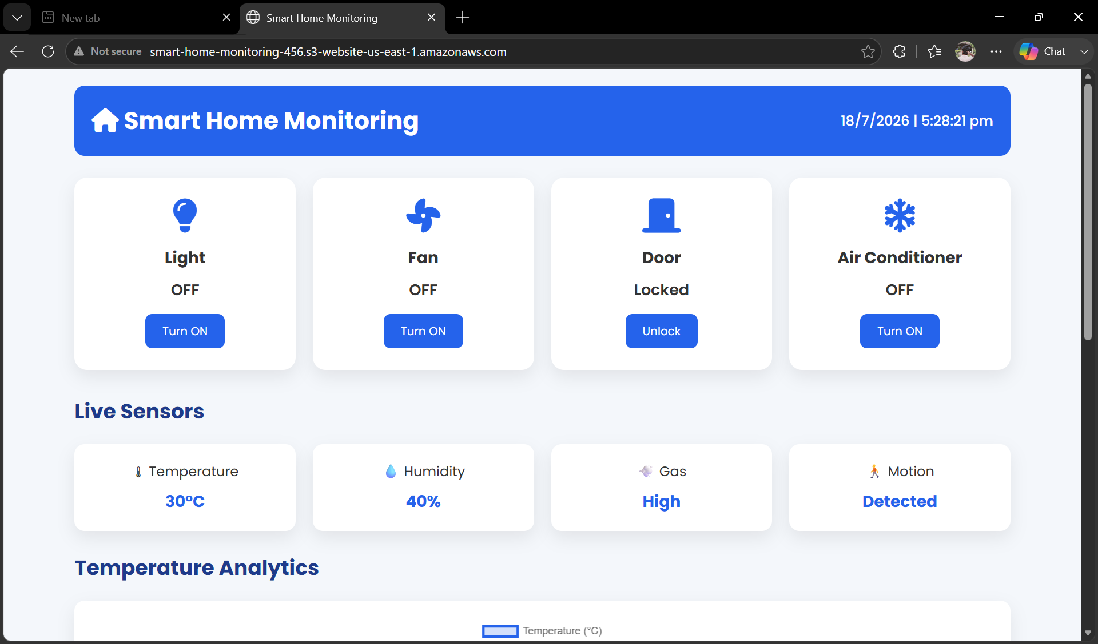
Figure 8. Smart Home Dashboard with all devices in their default state and live sensor readings.
Step 3: Version Control using Git and GitHub. The complete project source code was managed using Git for version control. A GitHub repository was created to securely store the project files, track code changes, and facilitate collaboration.
Step 4: Deployment. After finalizing the project files, the Smart Home Dashboard was deployed and hosted on Amazon S3 as a static website, providing a publicly accessible URL for demonstrating the project online without requiring a dedicated server.
Step 5: AWS IAM Configuration. An IAM role was created and configured to provide secure access to AWS services, following the principle of least privilege.
Step 6: Amazon API Gateway Configuration. A SmartHomeAPI HTTP API was created and deployed to a prod stage, providing the public invoke URL used by the dashboard to reach the backend.
Step 7: Amazon S3 Storage. An Amazon S3 bucket (smart-home-monitoring-456) was created to host the dashboard and store project assets, demonstrating durable and scalable cloud-based storage.
Step 8: Amazon DynamoDB Database. DynamoDB tables named SmartHomeDevices and SmartHomeData were created to store smart device information. Sample records were added to represent appliance status and sensor data.
Step 9: AWS Lambda. AWS Lambda functions (SmartHomeController, GetSmartHomeData, MainMonitoringFunction) were configured to demonstrate serverless computing, processing requests from the Smart Home Dashboard and updating device information stored in DynamoDB.
Step 10: Amazon CloudWatch Monitoring. Amazon CloudWatch was used to monitor AWS resources and application performance, collecting metrics and logs that help observe system health and troubleshoot issues.
Step 11: System Testing. The application was tested by interacting with the Smart Home Dashboard. Device controls, live sensor updates, and gas-level alerts were verified to ensure proper functionality. Each toggle action and alert was confirmed against the Recent Activity log and the underlying DynamoDB records.
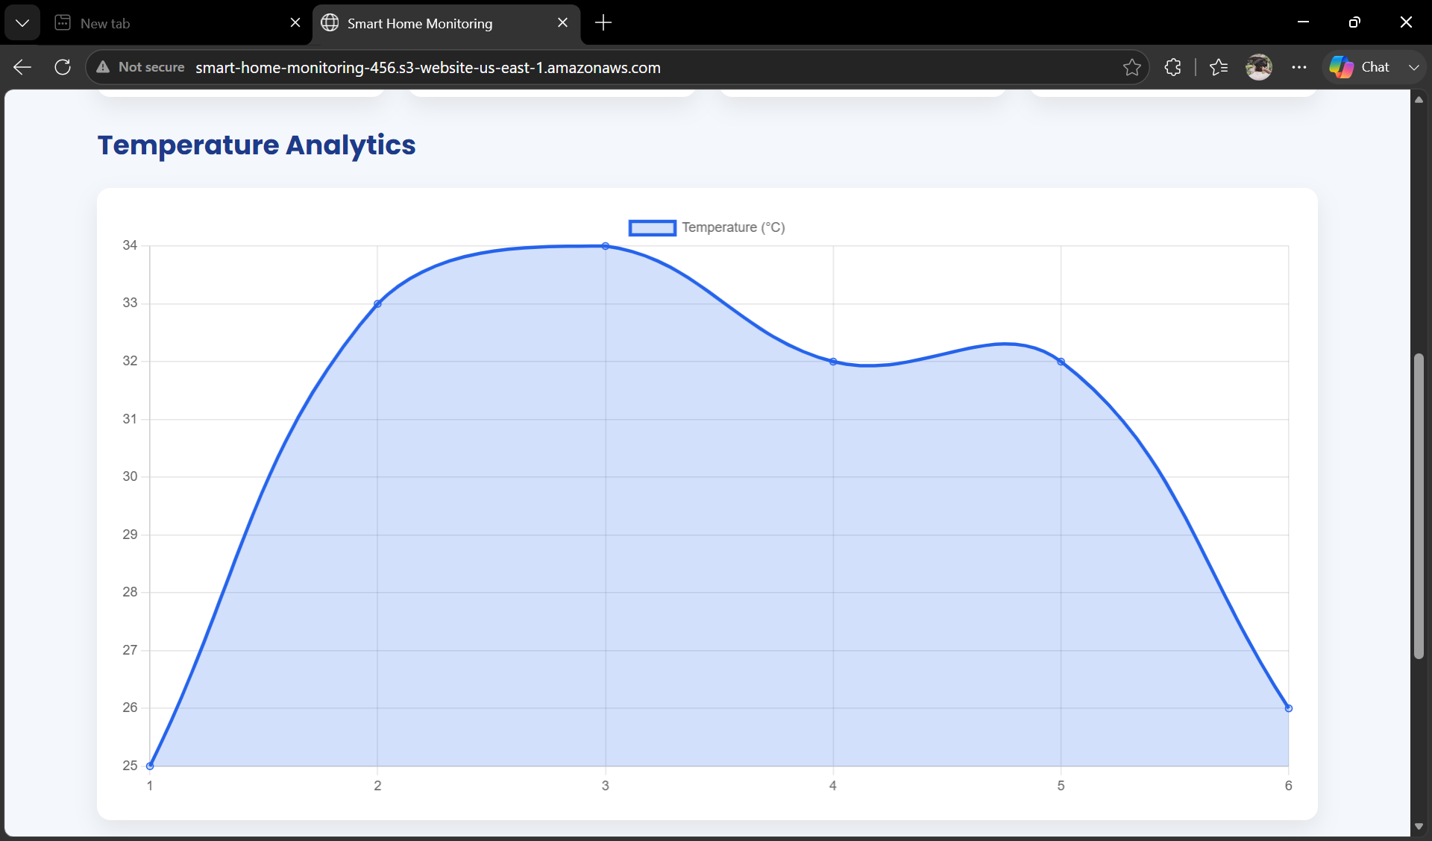
Figure 9. Temperature Analytics chart and Recent Activity log recording repeated Gas Level High alerts during testing.
Step 12: Documentation and Final Deployment. Finally, screenshots of the AWS Console (API Gateway, Lambda, S3, DynamoDB) and the deployed dashboard were collected and incorporated into this documentation. The completed project demonstrates the integration of cloud computing, web development, and DevOps practices for building a Smart Home Monitoring and Automation Platform.

6. RESULTS
The Cloud-Based Smart Home Monitoring & Automation Platform was successfully developed and deployed using AWS cloud services, Git, GitHub, and modern web technologies. The project achieved its primary objective of providing a responsive web-based dashboard for monitoring and controlling smart home devices in a cloud-hosted environment.
The Smart Home Dashboard was designed using HTML, CSS, and JavaScript, offering an intuitive interface for controlling appliances such as lights, fans, doors, and an air conditioner, alongside live sensor readings for temperature, humidity, gas, and motion. The application responded correctly to user interactions, demonstrating the functionality of a smart home automation system.
The project source code was successfully managed using Git and GitHub, ensuring efficient version control and collaborative development practices.
AWS services were configured successfully to demonstrate cloud computing concepts. Amazon S3 hosted the dashboard as a static website, Amazon API Gateway exposed the SmartHomeAPI backend, AWS Lambda executed the device-control and data-retrieval logic, Amazon DynamoDB stored device and sensor information, IAM ensured secure access management, and Amazon CloudWatch was available for monitoring cloud resources.
The integration of cloud technologies and DevOps practices enhanced the scalability, reliability, and maintainability of the project, while also demonstrating the practical application of cloud-based infrastructure for smart home systems.
Overall, the project successfully met its planned objectives and provided valuable hands-on experience in AWS Cloud Computing, DevOps, Git, GitHub, web application development, and cloud service integration. The developed solution serves as a strong foundation for future enhancements such as real-time IoT device connectivity, mobile application support, AI-based automation, voice assistant integration, and advanced cloud analytics.

7. CONCLUSION
The Cloud-Based Smart Home Monitoring & Automation Platform was successfully designed, developed, and deployed as part of the APSSDC Summer Internship on AWS Cloud Computing and DevOps. The project demonstrated how cloud technologies can be effectively integrated with web development to create a modern and scalable smart home solution.
Throughout the project, various AWS services, including Amazon S3, Amazon API Gateway, AWS Lambda, Amazon DynamoDB, IAM, and Amazon CloudWatch, were utilized to understand cloud infrastructure, secure resource management, data storage, serverless computing, and system monitoring. The project also incorporated Git and GitHub for version control and source code management, while GitHub Actions supported the CI/CD workflow.
The developed Smart Home Dashboard provides a user-friendly interface for monitoring and controlling home devices such as lights, fans, doors, and an air conditioner, along with live temperature, humidity, gas, and motion readings. This implementation establishes a strong foundation for integrating real IoT devices and advanced cloud services in future developments.
This project significantly enhanced practical knowledge of cloud computing, DevOps practices, web application development, and cloud deployment. It also strengthened skills in problem-solving, project management, and cloud service integration. Overall, the project successfully achieved its objectives and demonstrates the potential of AWS cloud technologies in building secure, scalable, and efficient smart home automation systems.

