LOGISTICS DATA ANALYSIS

Week 3: Advanced Data Analysis and Visualization
Prepared by: Kanimozhi R
Dataset: Hypothetical logistics sample

1. Introduction
This project uses Python to explore logistics data and visualize delivery performance, shipping cost, transportation distance, traffic, and vehicle types. The dataset is an illustrative sample.

2. Dataset and Methodology
The dataset contains 20 orders and 12 columns. Pandas is used to load and analyze the data. Mean, median, descriptive statistics, and correlation are calculated. Matplotlib is used to create charts.

3. Key Results
Metric | Result
Total orders | 20
Average shipping cost | 1446.00
Average delivery time (days) | 2.15
Average distance (km) | 277.00
Orders delivered on time | 13
Delayed orders | 7
On-time delivery rate | 65.0%

4. Visualizations and Interpretation

4.1 Delivery Time Distribution
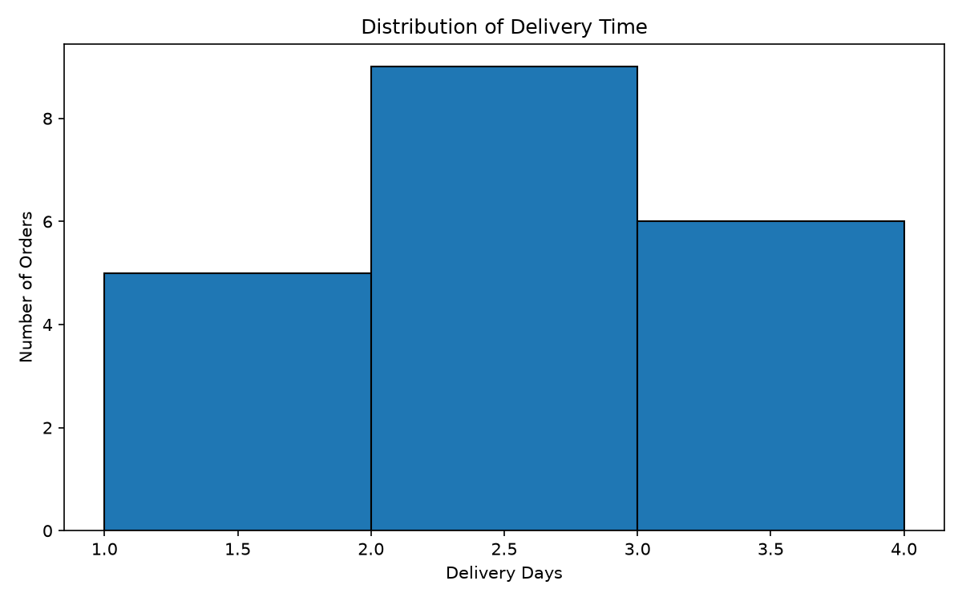
The histogram shows how delivery times are distributed across orders and helps identify common delivery durations.

4.2 Delivery Time by Traffic
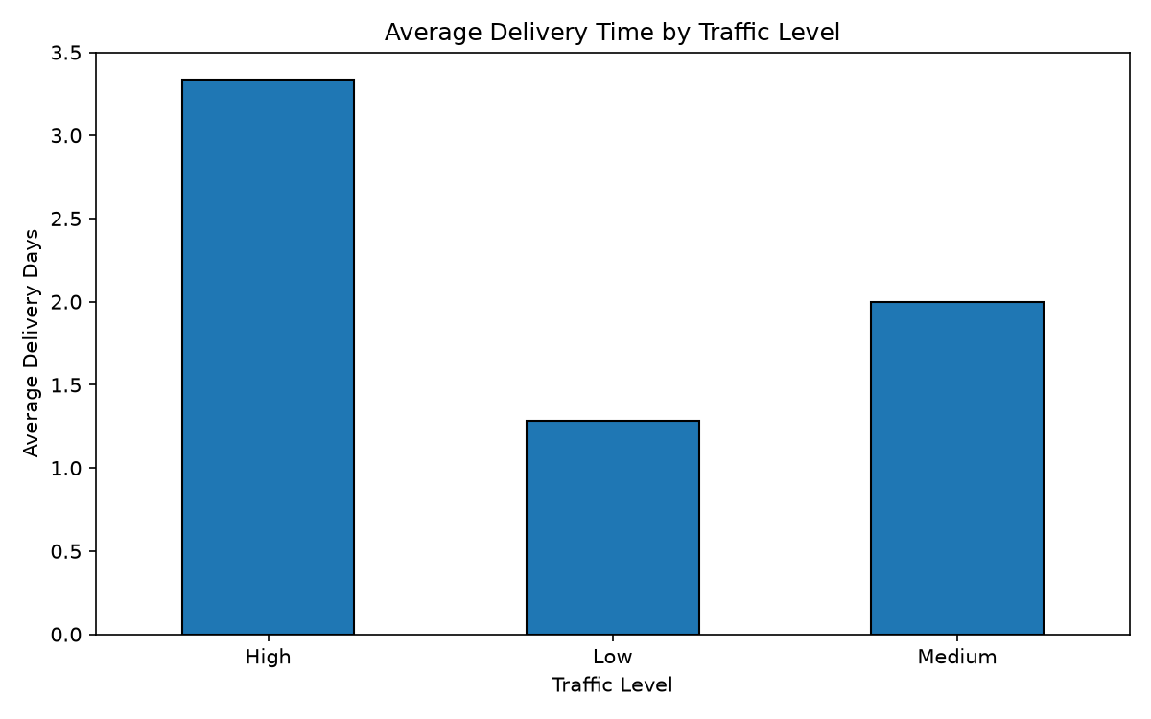
The bar chart compares average delivery days for traffic levels. Higher values may indicate a need to investigate congestion.

4.3 Shipping Cost by Vehicle
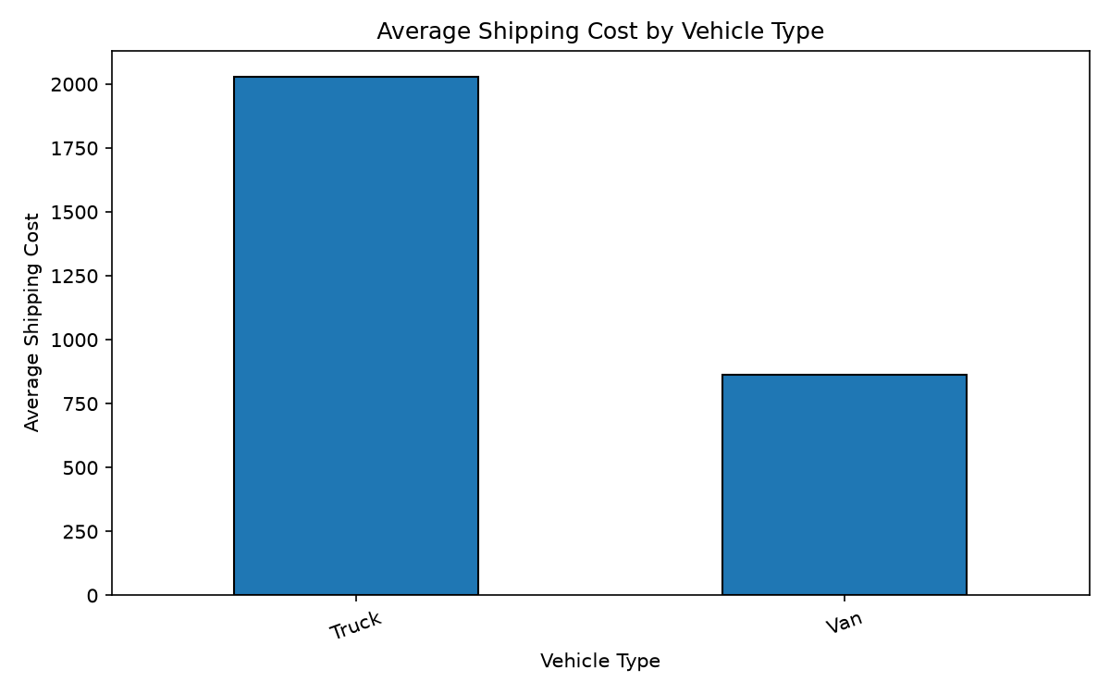
The bar chart compares average shipping costs across vehicle types and supports further cost-efficiency investigation.

4.4 Distance and Shipping Cost
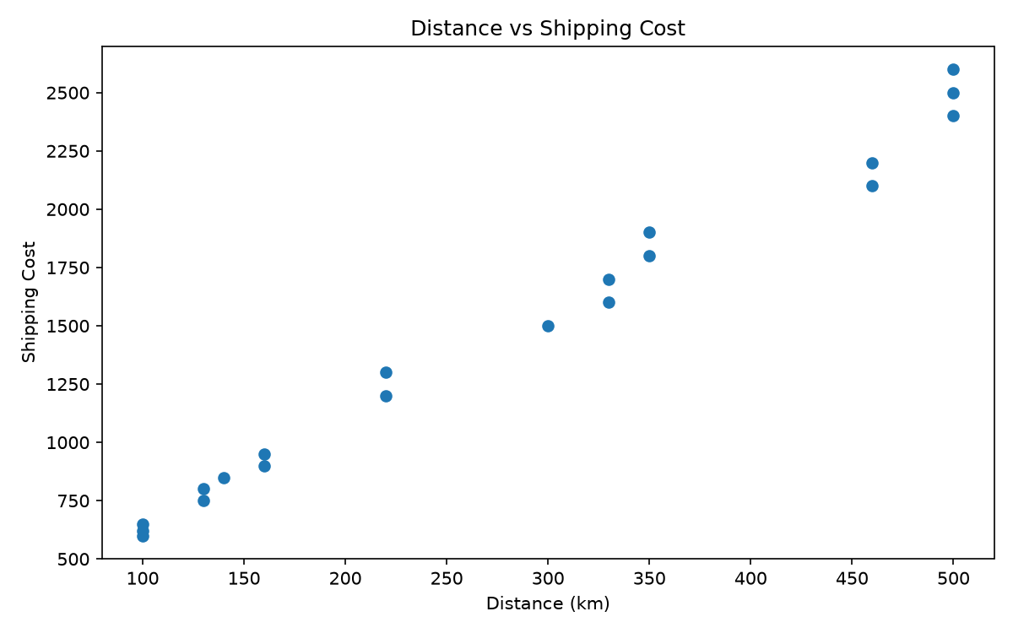
The scatter plot helps examine whether longer distances are associated with higher shipping costs.

4.5 Correlation Heatmap
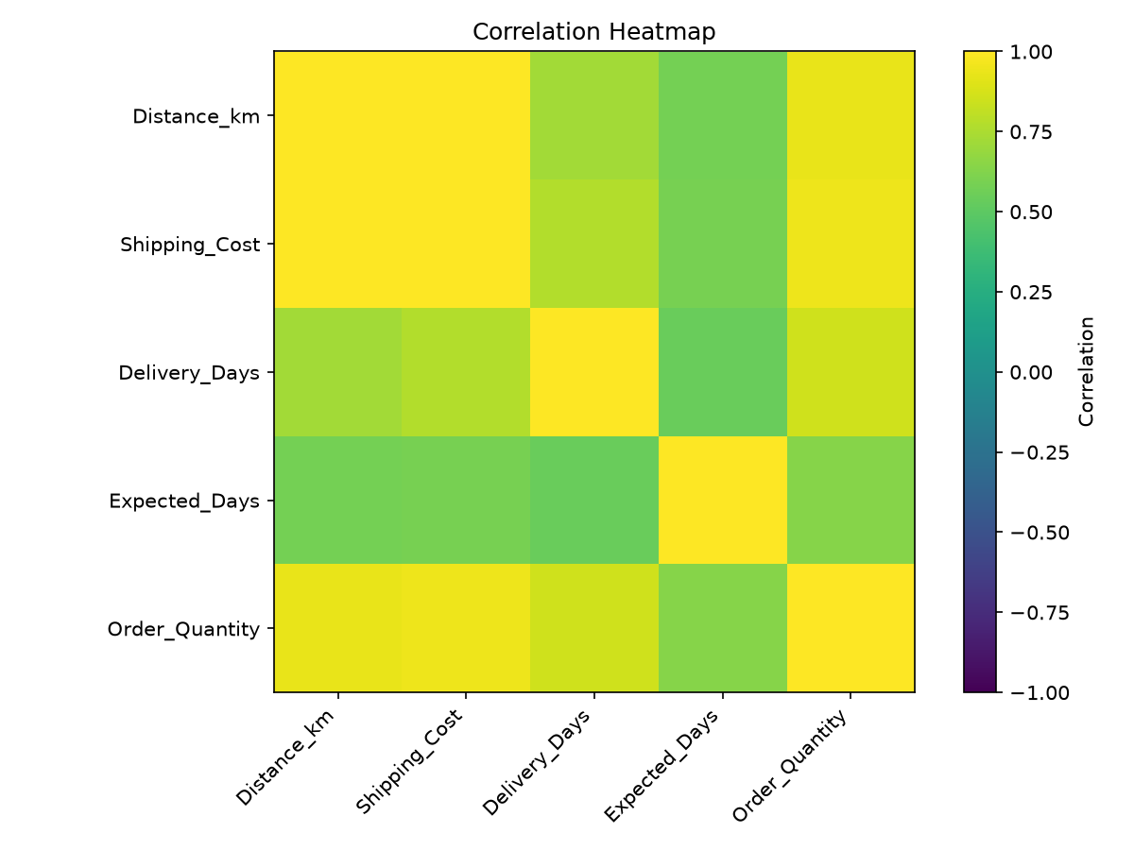
The heatmap summarizes linear relationships between numeric variables. Correlation does not prove causation.

5. Recommendations
- Monitor actual delivery time against expected delivery time.
- Investigate delays by traffic, weather, destination, and warehouse.
- Compare shipping cost with distance and vehicle type.
- Track on-time delivery rate and average shipping cost regularly.
- Use a larger real-world dataset before making major operational changes.

6. Limitations
The dataset is small and illustrative. Its patterns may not represent all logistics operations. Correlations show associations, not causes.

7. Conclusion
Exploratory data analysis and visualizations help summarize logistics performance and highlight areas for further investigation. More representative data would improve the reliability of future findings.

