LOGISTICS DATA ANALYSIS

Week 4: Predictive Modeling and Optimization
Prepared by: Kanimozhi R
Dataset: Hypothetical logistics dataset

1. Problem Definition
The objective is to predict delivery time in days using logistics information. Accurate estimates can help teams plan deliveries, identify potentially delayed orders, and improve operational efficiency.

2. Dataset and Features
The dataset contains 20 usable orders. Delivery_Days is the target variable. Input features include distance, expected delivery days, shipping cost, order quantity, traffic level, weather, and vehicle type. Missing input values are handled through median or most-frequent-value imputation. Categorical variables are converted using one-hot encoding.

3. Model Selection
Linear Regression is used as a simple baseline model. A Decision Tree Regressor is also tested because it can model non-linear patterns. The tree depth and minimum leaf size are limited to reduce overfitting. Three-fold cross-validation compares models using Mean Absolute Error (MAE).

4. Training and Validation
- Separate Delivery_Days from the input features.
- Split the data into 75% training and 25% testing.
- Impute missing values and encode categories inside a pipeline.
- Compare the two models using three-fold cross-validation.
- Evaluate the selected model on the held-out test data.

5. Model Performance
Metric | Result
Selected model | Decision Tree
Training records | 15
Testing records | 5
Cross-validation MAE (days) | 0.333
Test MAE (days) | 0.000
Test RMSE (days) | 0.000
Test R-squared | 1.000
MAE measures the average absolute prediction error. RMSE penalizes larger errors more strongly. Lower MAE and RMSE generally indicate better predictions. R-squared compares model performance with a mean-based baseline; it can be negative on test data. Since this dataset is very small, the scores are only an initial demonstration.

6. Visualization and Interpretation

6.1 Model Comparison
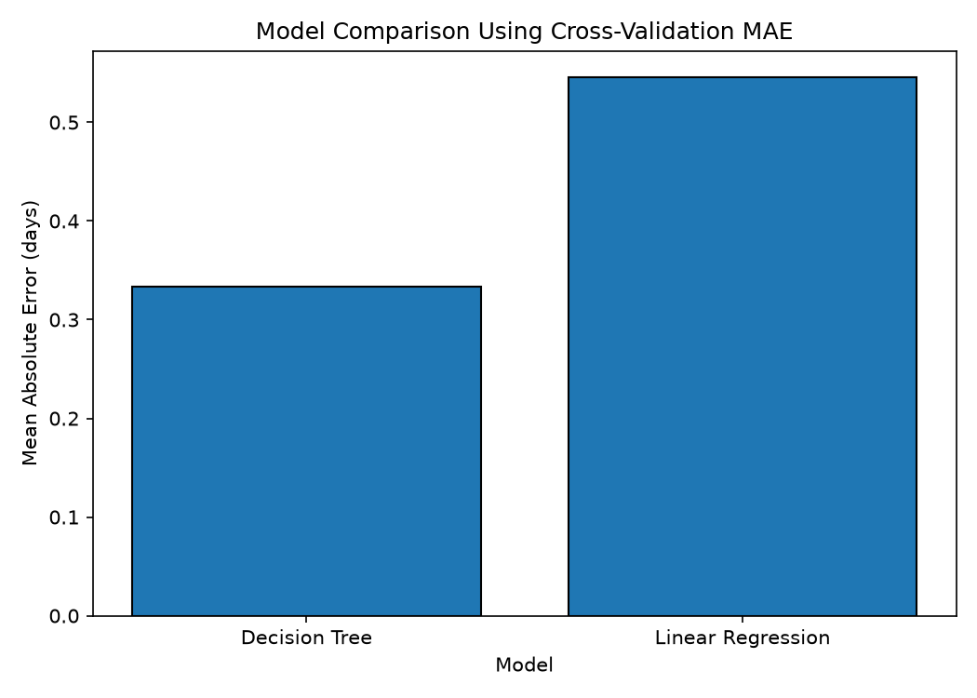
This chart compares cross-validation MAE. A lower bar means the model had a lower average absolute error across the training folds.

6.2 Actual vs Predicted Delivery Time
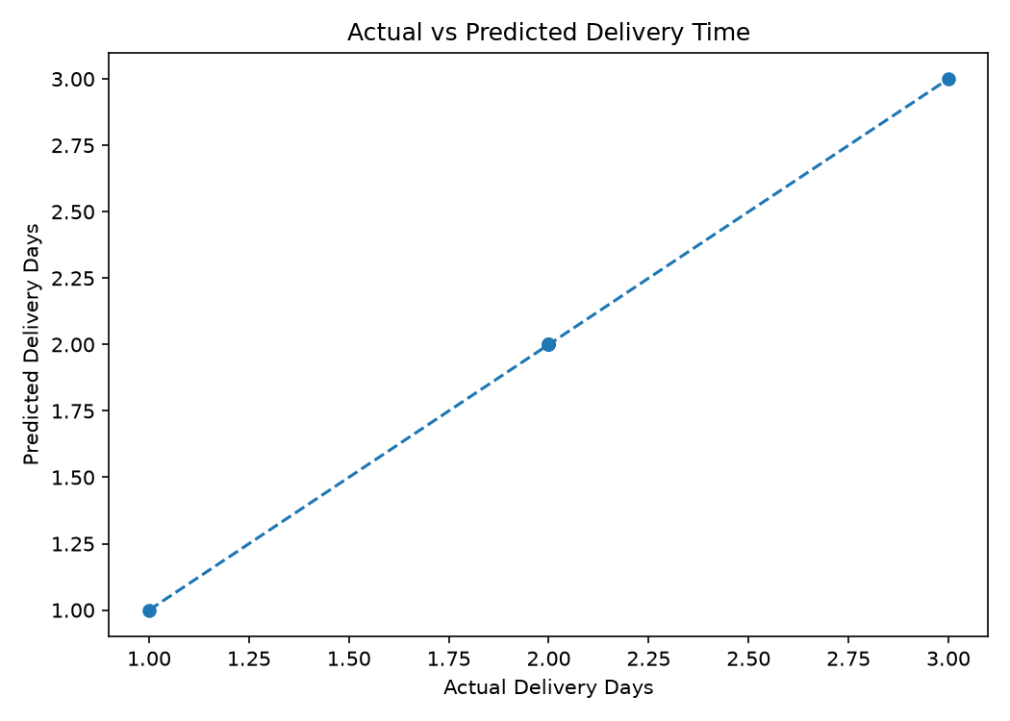
Points closer to the diagonal line indicate more accurate predictions. Larger gaps show orders with larger prediction errors.

7. Logistics Optimization Strategies
- Review orders predicted to exceed their expected delivery window.
- Check traffic, weather, route distance, and dispatch time before responding to delay risks.
- Group deliveries to nearby destinations when capacity and promised delivery windows allow.
- Compare vehicle costs for similar routes before reallocating vehicles.
- Track actual delivery times against predictions and monitor errors regularly.
- Collect more historical records before using the model for operational decisions.

8. Limitations
The dataset has only 20 illustrative records, so the test set is very small and the results may change with a different split. Cross-validation helps compare candidate models but does not replace testing on a larger real-world dataset. Predictions should not be treated as guaranteed delivery times.

9. Conclusion
The experiment compared Linear Regression and Decision Tree models to predict delivery time. Decision Tree was selected because it had the lower mean cross-validation MAE. The evaluation and charts demonstrate a basic predictive workflow that can support logistics planning when combined with reliable data and operational judgment.

