FARM MANADEMENT SYSTEM
Project work submitted to Thiruvalluvar University, Serkkadu, Vellore.
In partial fulfillment for the award of degree
BACHELOR OF SCIENCE
IN
COMPUTER SCIENCE
By
TEAM ID : SWTID-2026-9161
KANIMOZHI M (20924U18077)
JAYALAKSHMI D (20924U18069)
LOGESHWARI S (20923U18097)

DEPARTMENT OF COMPUTER SCIENCE
SHANMUGA INDUSTRIES ARTS &SCIENCE COLLEGE
Accredited with “B+” Grade by NAAC,
Certified Under Section 2(f) & 12B of the UGC Act 1956,
An ISO 9001:2015 Certified Institution
Permanently Affiliated to Thiruvalluvar University, Vellore,
Approved by Govt. of Tamil Nadu & AICTE,
Tiruvannamalai – 606603.
OCTOBER – 2026
PROJECT OVERVIEW CONCLUSION

- Purpose
- Problem Statement
- Proposed Solution
- Objectives
- System Overview
- Functional & Performance Testing
- Advantages & Disadvantages
- Conclusion
- Future Scope
- Appendix

1.Introduction
The Farm Management System (FMS) is a Salesforce-based application designed to digitize and streamline agricultural operations. It manages data related to farms, crops, farmers, and buyers while providing real-time insights through reports and dashboards. The system helps farmers and managers monitor agricultural activities efficiently and make informed decisions.

2.Purpose :
The main purpose of this project is to:
- Digitize agricultural data management
- Improve data accuracy and accessibility
- Automate record handling
- Enable real-time monitoring
- Support data-driven farming decisions
- Enhance productivity and transparency

3.Problem Statement

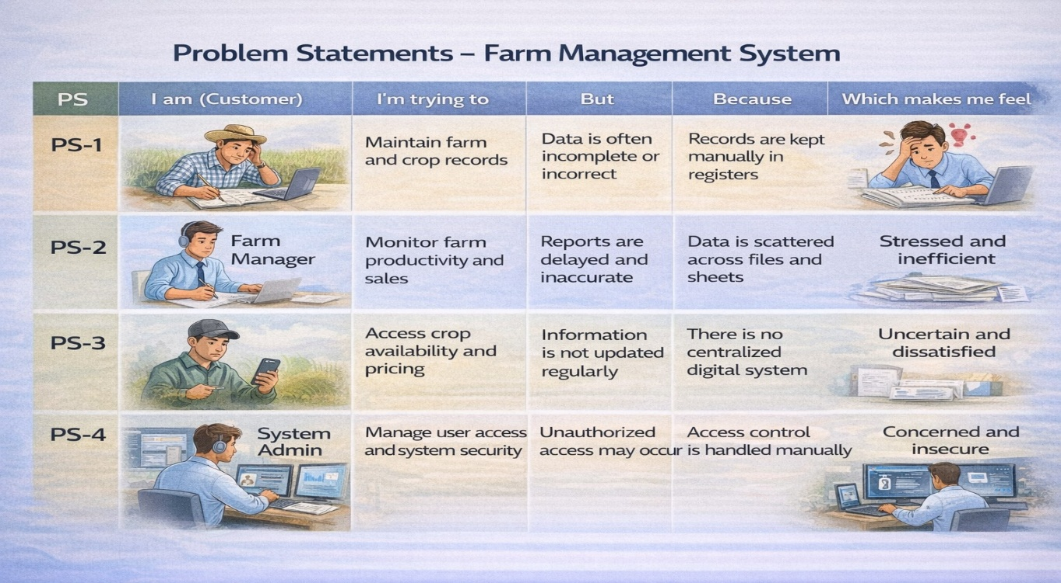

4.Proposed Solution

Functional Requirements

Parameter | Description
Problem | Manual maintenance of farm, crop, farmer, and buyer records leading to errors, data loss, and delays.
Solution | Salesforce-based Farm Management System with centralized data storage and automation.
Innovation | Automated data entry validation, cloud storage, and real-time reporting dashboards.
Impact | Improved data accuracy, faster reporting, and better decision-making for farmers and managers.es
Business Model | Digital farm management and agricultural data services platform.
Scalability | Supports multiple farms, users, and regions with cloud-based infrastructure.

5.Objectives

- To develop a centralized digital platform for managing farm, crop, farmer, and buyer information efficiently.

- To replace manual record keeping with an automated system to reduce paperwork and minimize errors in agricultural data management.

- To improve data accuracy and accessibility by storing farm-related data securely in the Salesforce cloud platform.

- To provide real-time reports and dashboards that help farmers and farm managers analyze productivity and sales performance.

- To implement role-based access control so that administrators, farmers, and managers can access only the data relevant to them.

- To support data-driven decision making by providing insights about crop production, farm performance, and buyer
transactions.

- To increase operational efficiency and transparency in farm management activities through automation and centralized data management.

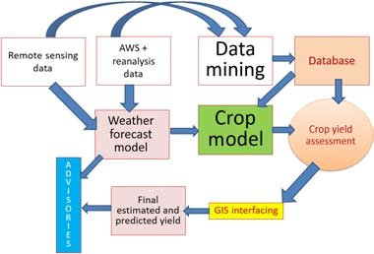

6.System Overview (Professional Version)

The System Overview Diagram shows how the Farm Management System works and how data flows between users and system components.

1. Users
- Farmers
- Farm Managers
- System Administrators
They interact with the system to enter and manage agricultural data.

2. Salesforce Interface (Application Layer)
- Provides the user interface to access the system.
- Allows users to add, update, and view farm-related data.

3. Core Modules / Objects
- Farm – Stores farm details such as location, size, soil type.
- Crop – Maintains crop information like planting date, harvest date, yield.
- Farmer – Stores farmer contact and location details.
- Buyer – Maintains buyer information and transaction records.

4. Data Processing
- Validation rules ensure correct data entry.
- Relationships connect farm, crop, farmer, and buyer data.

5. Reports & Dashboards
- Generate visual reports and analytics.
- Help farm managers monitor productivity and sales.

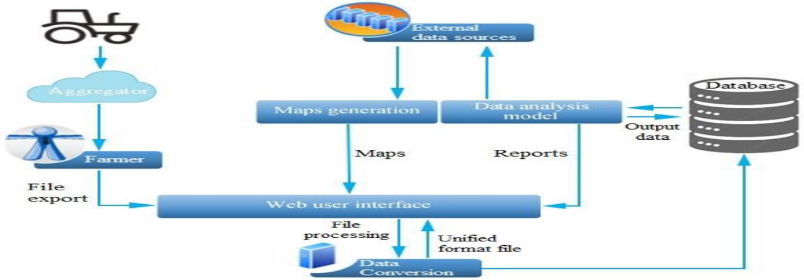

Solution Requirements

The solution requirements define the features and conditions required for the Farm Management System to function effectively. These requirements are divided into Functional Requirements and Non-Functional Requirements.

1. Functional Requirements

Functional requirements describe the main operations and features that the system must perform.

FR No | Requirement | Description
FR-1 | User Authentication | The system should allow users to log in securely.
FR-2 | Farm, Crop, Farmer, Buyer Management | The system should allow users to create, update, and manage records of farms, crops, farmers, and buyers.
FR-3 | Data Entry and Validation | The system should validate input data to avoid incorrect or incomplete entries.
FR-4 | Relationship Mapping | The system should maintain relationships between farms, crops, farmers, and buyers.
FR-5 | Report Generation | The system should generate reports for farm activities and crop production.
FR-6 | Dashboard Visualization | The system should display information visually through charts and dashboards.
FR-7 | User Role Management | The system should allow role-based access for administrators, managers, and other users.

These requirements ensure that the system can effectively manage agricultural data and support farm operations.

2. Non-Functional Requirements

Non-functional requirements define the quality and performance aspects of the system.

NFR | Description | Example
Usability | The system should have an easy and user-friendly interface. | Salesforce Lightning UI
Security | The system should protect data using access control. | Roles and profiles
Reliability | The system should ensure no data loss. | Cloud backup
Performance | The system should respond quickly. | Reports generated in less than 3 seconds
Availability | The system should be accessible anytime. | 24/7 cloud access
Scalability | The system should support more users and farms in the future. | Cloud-based infrastructure

These requirements ensure the system remains secure, reliable, and efficient for farm management operations.

PROJECT DESIGN PHASE
Problem–Solution Fit

The FMS replaces manual farming records with automated data management. Cloud storage prevents data loss, dashboards improve analysis, and real-time reports eliminate delays. This ensures accurate and timely agricultural insights.
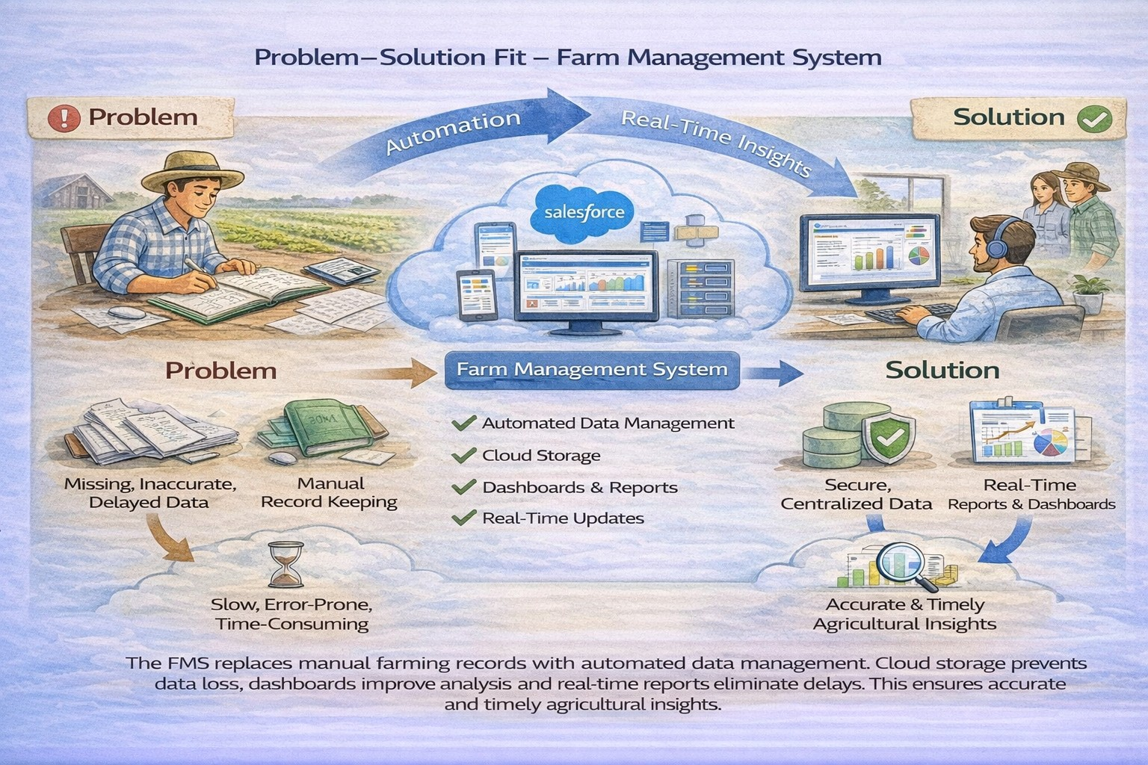

Proposed Solution

Functional Requirements

Parameter | Description
Problem | Manual maintenance of farm, crop, farmer, and buyer records leading to errors, data loss, and delays.
Solution | Salesforce-based Farm Management System with centralized data storage and automation.
Innovation | Automated data entry validation, cloud storage, and real-time reporting dashboards.
Impact | Improved data accuracy, faster reporting, and better decision-making for farmers and managers.es
Business Model | Digital farm management and agricultural data services platform.
Scalability | Supports multiple farms, users, and regions with cloud-based infrastructure.

Solution Architecture

Architecture Layers

- Presentation Layer – Salesforce Lightning UI
- Application Layer – Validation Rules, Relationships
- Data Layer – Custom Objects
- Analytics Layer – Reports and Dashboards

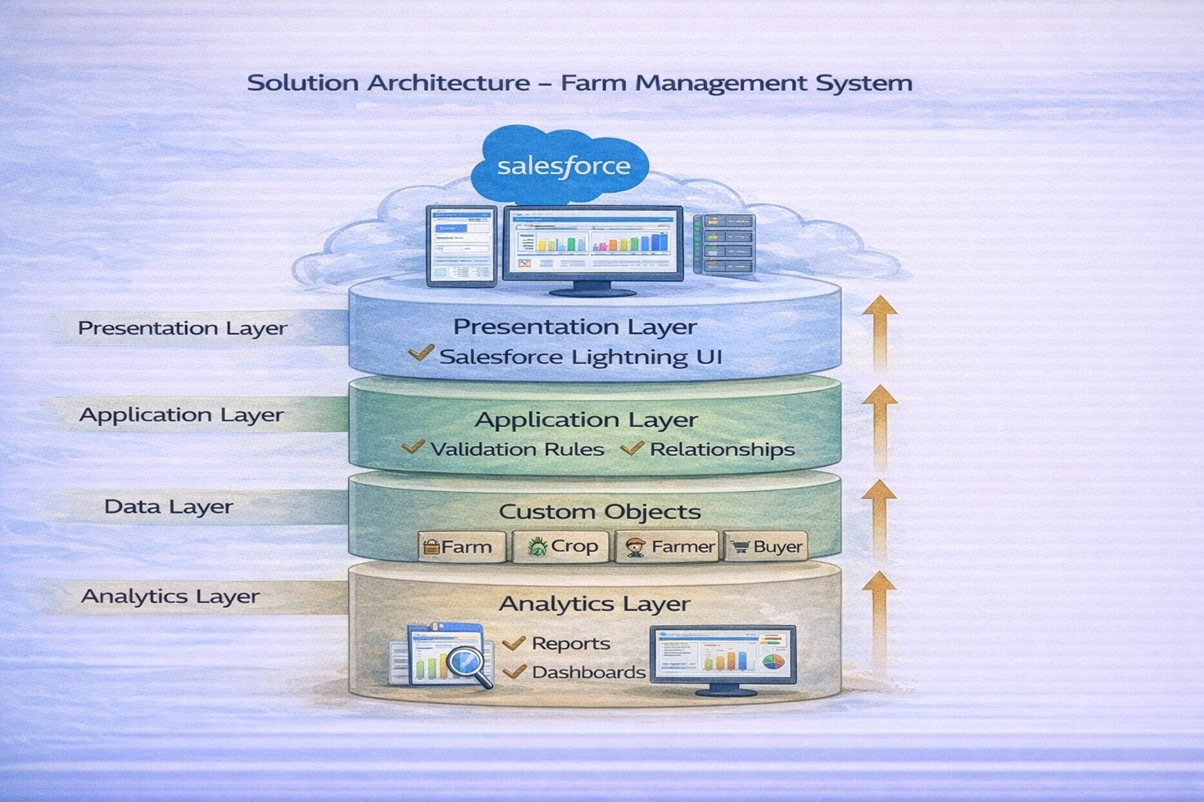

Solution Architecture

The Solution Architecture of the Farm Management System explains how different components of the system work together to manage agricultural data efficiently. The system is designed using a layered architecture model that separates user interface, application logic, data storage, and analytics.
1. Presentation Layer
- This is the user interface of the system.
- Users interact with the system through Salesforce Lightning UI.
- It provides forms, tabs, and dashboards for entering and viewing farm data.
- Farmers, managers, and administrators access the system through this layer.
2. Application Layer
- Handles the business logic and processing of the system.
- Includes validation rules, automation, and relationships between objects.
- Ensures correct data entry and smooth operation of the application.
3. Data Layer
- Responsible for storing all system data in the Salesforce cloud database.
- Includes custom objects such as:
  - Farm
  - Crop
  - Farmer
  - Buyer
- Maintains relationships between these objects.
4. Analytics Layer
- Provides reports and dashboards for analysis.
- Helps managers monitor:
  - Crop productivity
  - Farm performance
  - Buyer transactions
- Supports data-driven decision making.

Project Flow

Milestone 1 : Salesforce
Milestone 2 : Object Creation
Milestone 3 : Tabs
Milestone 4 : The Lightning App
Milestone 5 : Fields & Relationships
Milestone 6 : Profile
Milestone 7 : Role
Milestone 8 : User
Milestone 9 : Sharing Rules
Milestone10: User Adoption
Milestone11: Reports
Milestone12 : Dashboard
Milestone13 : View Report and Dashboard

Milestone 1 : Salesforce
What Is Salesforce?
Salesforce is your customer success platform, designed to help you sell, service, market, analyze, and connect with your customers.
Salesforce has everything you need to run your business from anywhere. Using standard products and features, you can manage relationships with prospects and customers, collaborate and engage with employees and partners, and store your data securely in the cloud.
Creating a Salesforce Developer Org:
A Developer org has all the features and licenses you need to get started with Salesforce.
- Search Developer.salesforce.com/signup
- Enter the following details like First name, last name, Email, Role, Company, Country/Region, Postal code, and Username must be unique.
- Click sign me up, after a few min you will reserve a mail salesforce org and by using the verify account link you can create your new password.
- Click save.
- Search login.salesforce.com

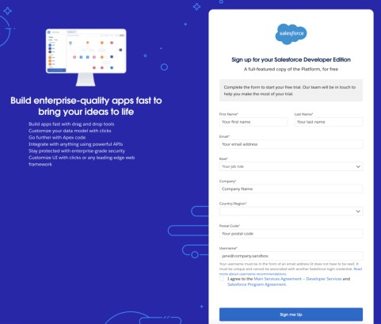
- By using username and password you can into the Salesforce org. The homepage will appear below
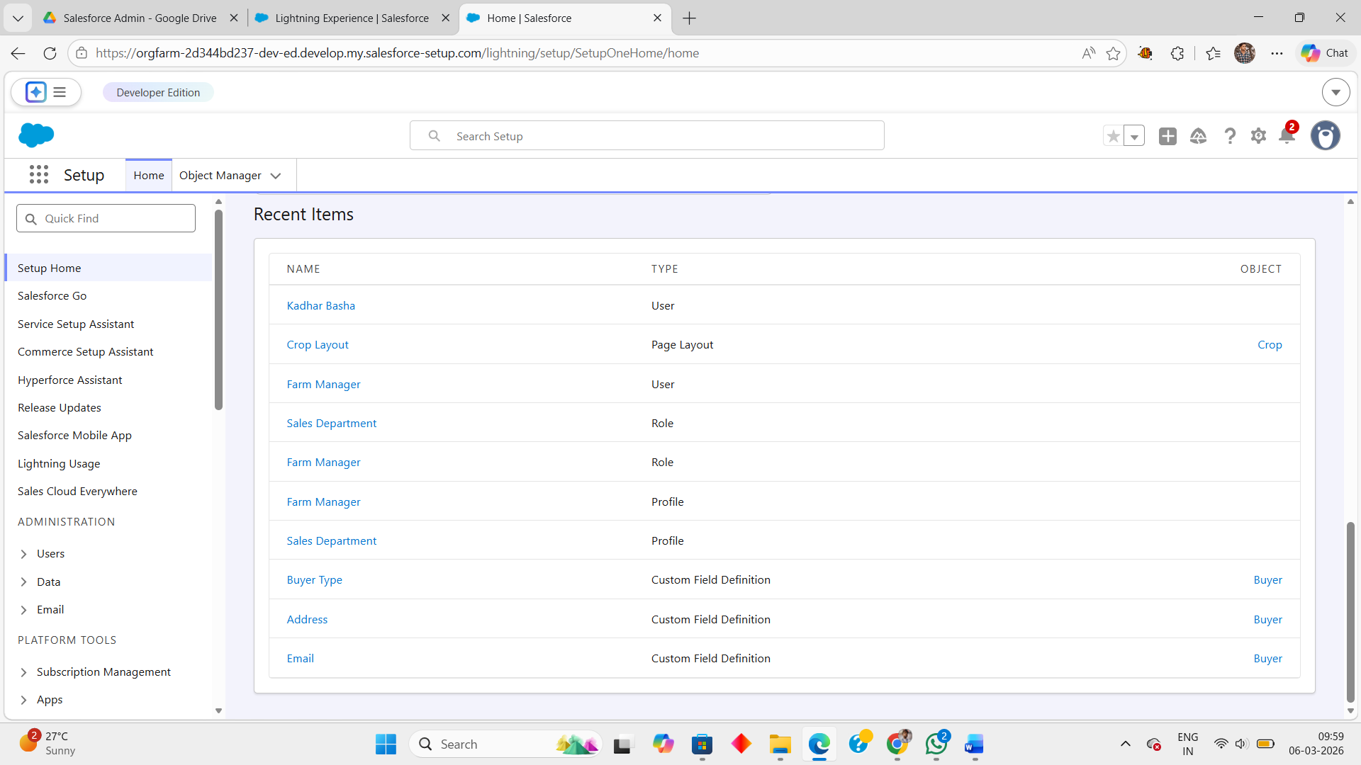
Milestone 2 : Object Creation

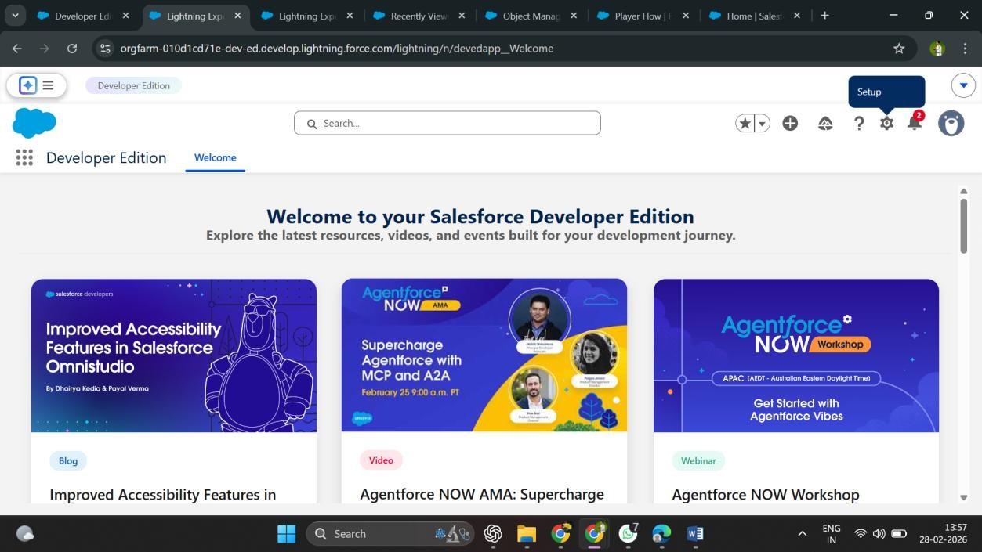

In the Farm Management System, custom objects are created in Salesforce to store and manage agricultural data. Objects act like database tables where information is stored in the form of fields (columns) and records (rows).
The system uses four main custom objects.

1. Farm Object

The Farm object stores information related to farms.

Example Fields
- Farm Name
- Farm Type (Crop, Livestock, Mixed)
- Soil Quality
- Irrigation Type
- Location
- Size
This object helps track farm details and connect them with farmers and crops.

2. Crop Object

The Crop object stores crop production details.

Example Fields
- Crop Name
- Planting Date
- Harvest Date
- Actual Yield
- Total Acres Harvested
- Expected Yield per Acre (Formula Field)
This object is related to the Farm object using a lookup relationship.

3. Farmer Object

The Farmer object stores farmer information.

Example Fields
- Farmer Name
- Contact Number
- State
- District
- Village
This helps manage farmer contact and location details.

4. Buyer Object

The Buyer object stores buyer information.

Example Fields
- Buyer Name
- Contact Number
- Email
- Address
- Buyer Type (Wholesale / Retail)
This object helps track buyers who purchase farm products.

Milestone 3 : Tabs
What are Tabs?
In Salesforce, Tabs are used to display the data of objects in the application interface. Tabs help users quickly access records and manage information stored in different objects. They appear in the navigation bar of the application and allow users to view, create, and edit records easily.

Tabs Created in the Farm Management System
In this project, four custom tabs are created for the main objects:
- Farm Tab
  - Displays all farm records.
  - Allows users to add and manage farm details.
- Crop Tab
  - Displays crop information such as planting date, harvest date, and yield.
- Farmer Tab
  - Shows farmer details like contact number, state, district, and village.
- Buyer Tab
  - Displays buyer information including contact details and buyer type.
These tabs help users navigate between different modules of the Farm Management System efficiently.

Steps to Create a Tab in Salesforce
- Go to Setup.
- Search for Tabs in the Quick Find box.
- Select Tabs and click New under Custom Object Tabs.
- Choose the object (Farm, Crop, Farmer, or Buyer).
- Select a Tab Style (icon).
- Click Next → Save.

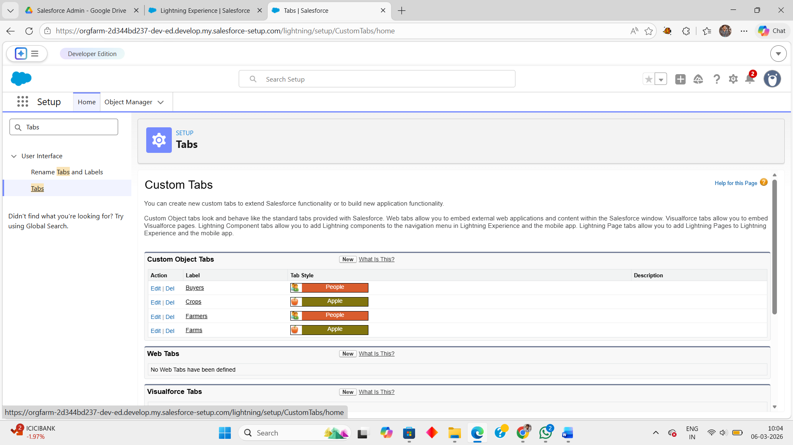

Milestone 4: The Lightning App

What is a Lightning App?

A Lightning App in Salesforce is a collection of related tabs and objects that work together as a single application. It provides a centralized workspace where users can access all modules such as farms, crops, farmers, buyers, reports, and dashboards in one place.

In the Farm Management System, the Lightning App organizes all system components so users can easily manage agricultural data through a single interface.

Features of the Lightning App

- Centralized Navigation
All objects like Farm, Crop, Farmer, and Buyer are available in one application.

- Easy Data Management
Users can quickly add, edit, and view records.

- Reports and Dashboards Integration
The app includes analytics tools to monitor farm productivity and sales.

- User-Friendly Interface
Salesforce Lightning UI provides a modern and simple interface for users.

Steps to Create the Lightning App

- Go to Setup in Salesforce.
- Search for App Manager in the Quick Find box.
- Click New Lightning App.
- Enter the App Name – Farm Management System.
- Add navigation items such as:
  - Farm
  - Crop
  - Farmer
  - Buyer
  - Reports
  - Dashboards
- Select user profiles and click Save & Finish

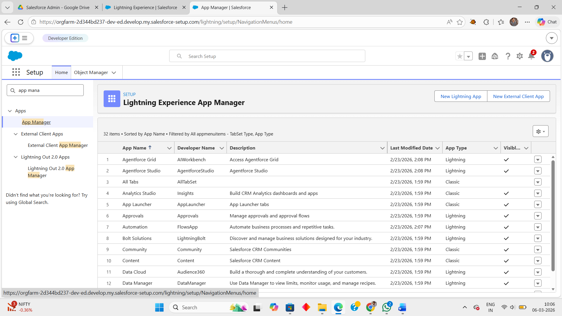

Milestone 5: Fields & Relationships

- Fields are used to store specific information in an object, similar to columns in a database table.

- Each object contains multiple fields to store data such as text, number, date, currency, and picklist values.

- In the Farm Management System, fields store details related to Farm, Crop, Farmer, and Buyer records.

- Relationships connect different objects in Salesforce so that related data can be accessed together.

- The system uses Master–Detail and Lookup relationships to link objects like Farmer, Farm, and Crop.

- These fields and relationships help organize data, maintain connections between records, and support report and dashboard generation.

In Salesforce, Fields and Relationships are used to organize and connect data within the system. Fields represent the attributes of an object and store specific information about records, similar to columns in a database table. Relationships define how different objects are connected so that related information can be accessed and managed efficiently.

In the Farm Management System, several fields are created within the custom objects such as Farm, Crop, Farmer, and Buyer to store agricultural data. For example, the Farm object contains fields like Farm Type, Soil Quality, Irrigation Type, Location, and Size. The Crop object includes fields such as Crop Name, Planting Date, Harvest Date, Actual Yield, and Total Acres Harvested. Similarly, the Farmer object stores details like Contact Number, State, District, and Village, while the Buyer object contains fields such as Contact, Email, Address, and Buyer Type. These fields allow the system to capture all important information related to farm operations.

Relationships are used to link these objects so that data can be shared and managed across the system. In this project, a Master–Detail relationship connects the Farmer and Farm objects, ensuring that each farm is associated with a particular farmer. A Lookup relationship connects the Crop object with the Farm object, allowing crops to be linked to the farms where they are cultivated. These relationships help maintain structured data and enable the generation of meaningful reports and dashboards.

Overall, fields store the detailed information, while relationships connect different objects, enabling the Farm Management System to manage agricultural data in an organized and efficient manner.

Example Fields in the System

1. Farm Object Fields
- Farm Name
- Farm Type (Picklist)
- Soil Quality (Picklist)
- Irrigation Type (Picklist)
- Location (Text)
- Size (Text)

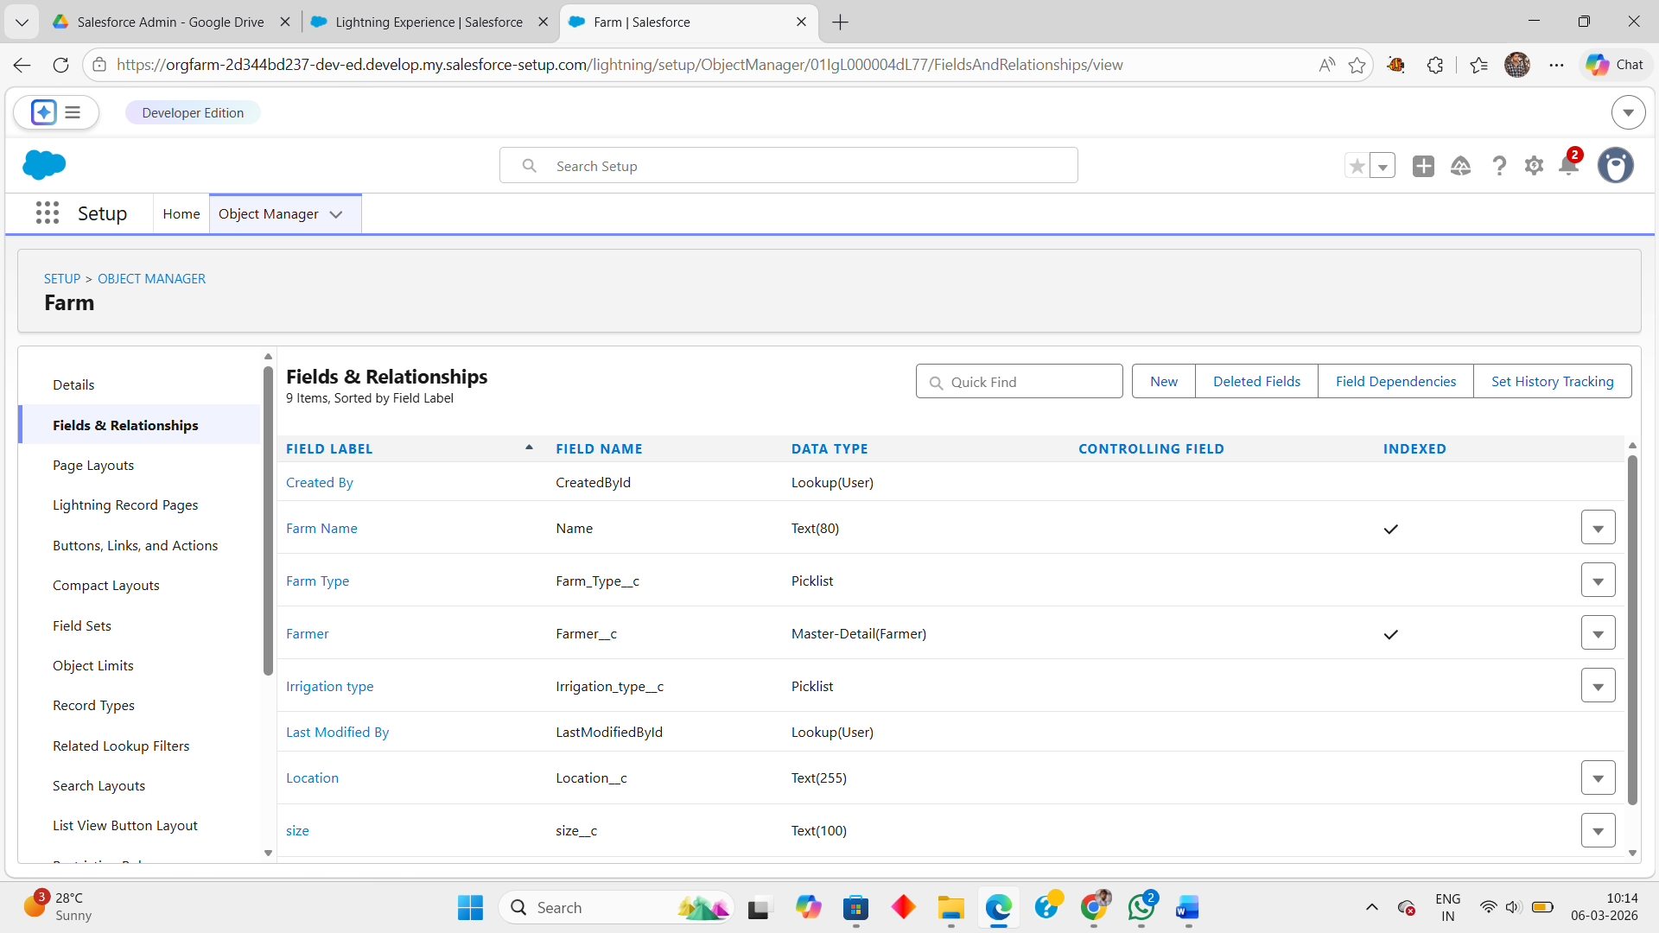

2. Crop Object Fields
- Crop Name
- Planting Date (Date)
- Harvest Date (Date)
- Actual Yield (Currency)
- Total Acres Harvested (Number)
- Expected Yield per Acre (Formula Field)

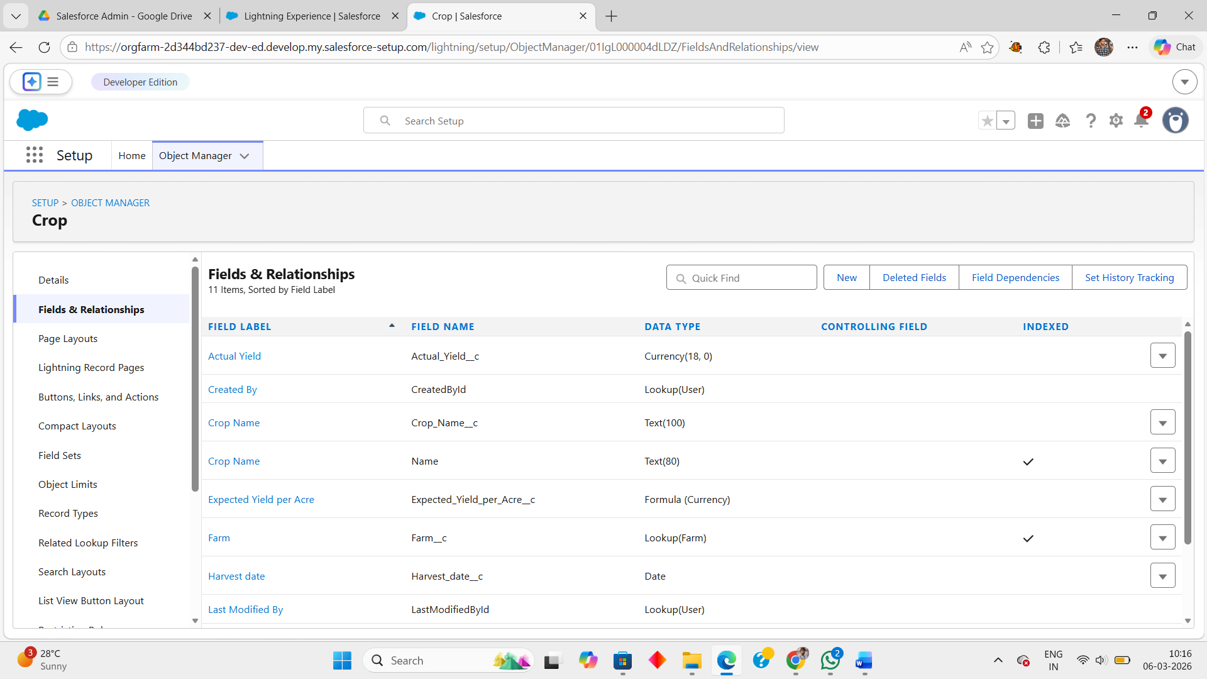

3. Farmer Object Fields
- Farmer Name
- Contact Number (Phone)
- State (Picklist)
- District (Picklist)
- Village (Picklist)

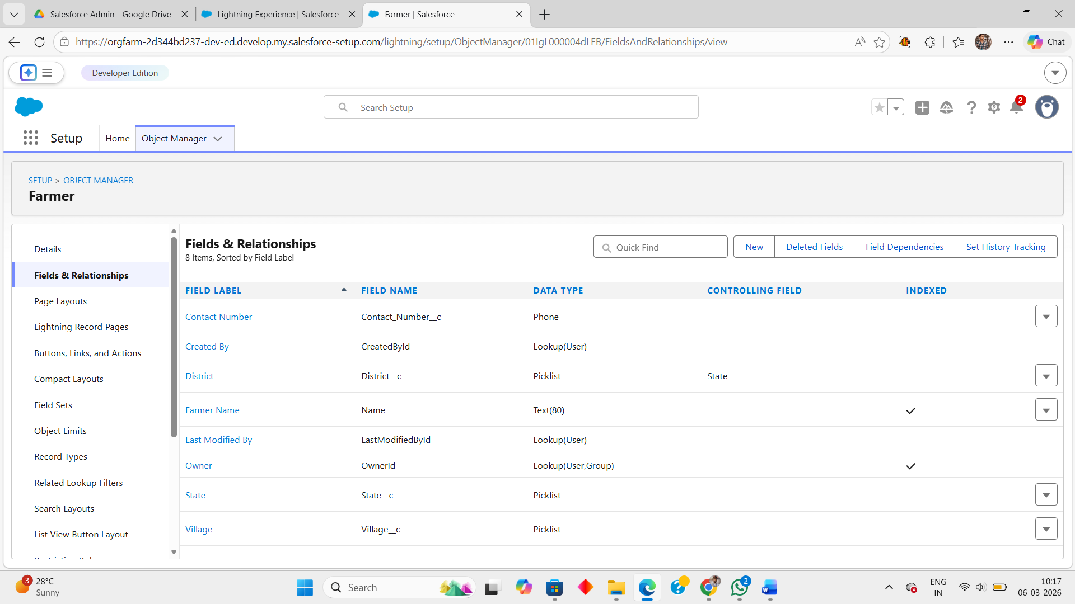

4. Buyer Object Fields
- Buyer Name
- Contact (Phone)
- Email
- Address (Text Area)
- Buyer Type (Picklist)

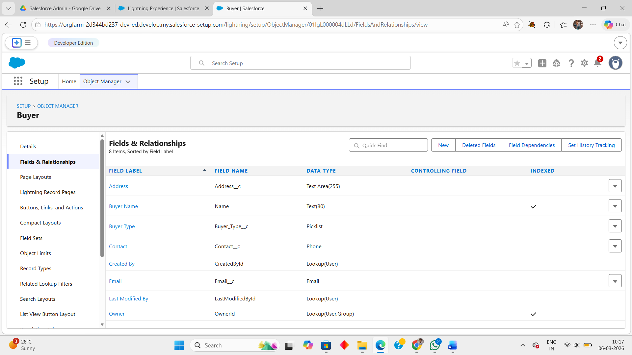

Milestone 6: Profile

What is a profile?

A profile is a group/collection of settings and permissions that define what a user can do in
salesforce. A profile controls “Object permissions, Field permissions, User permissions, Tab
settings, App settings, Apex class access, Visualforce page access, Page layouts, Record Types, Login hours & Login IP ranges.
A profile can be assigned to many users, but user can be assigned single profile at a time.

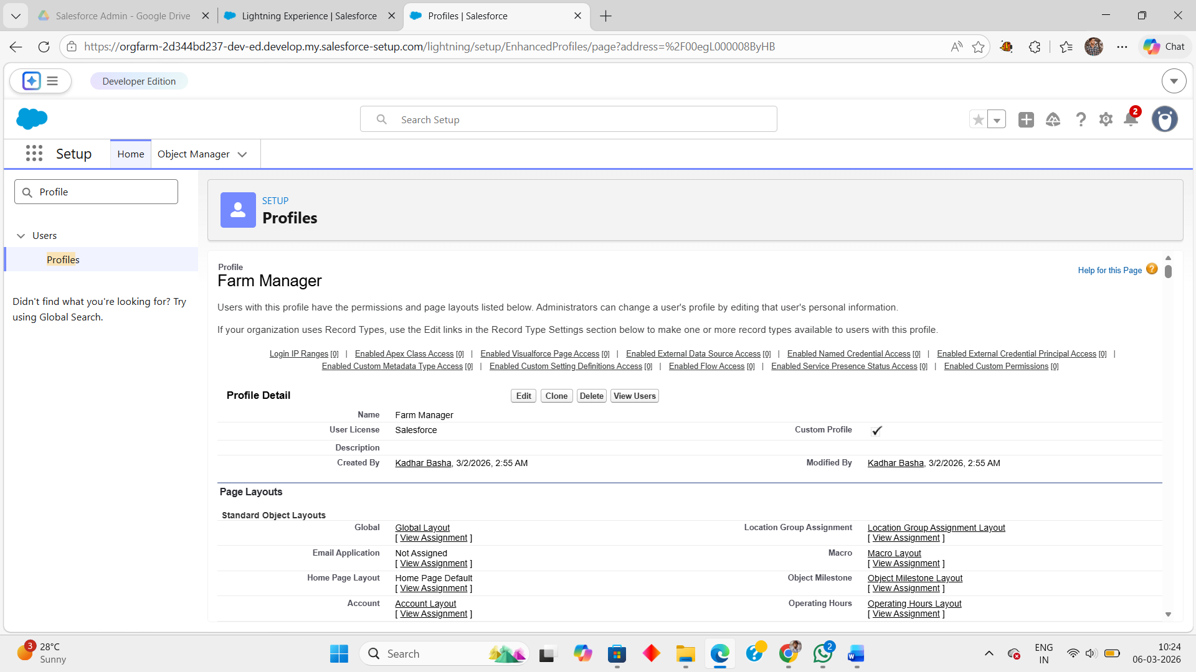

- A Profile in Salesforce is a collection of settings and permissions that defines what a user can access and perform in the system.

- It controls object permissions, field permissions, user permissions, tab settings, and app access.

- Profiles determine what actions a user can perform such as create, read, edit, or delete records.

- Each user in Salesforce is assigned only one profile at a time.
- In the Farm Management System, profiles help manage access for different users such as Farm Manager and Sales Department users.

Profiles improve system security and data control by restricting unauthorized access.

Milestone 7 : Role

In Salesforce, roles are used to determine which users have access to certain data and functions within the system. They are also used to define the reporting hierarchy within an organization. Users with higher roles have greater access to data and more control over the system.

- Roles in Salesforce define the hierarchy of users and control how data is shared between them.
  - They help determine which users can view, access, and manage records in the system.
- Roles are mainly used to create a reporting structure within an organization.

- Users with higher roles in the hierarchy can access the data of users below them.
  - In the Farm Management System, roles help organize users such as Farm Manager and other staff members.
  - Roles improve data visibility and management across different levels of users.

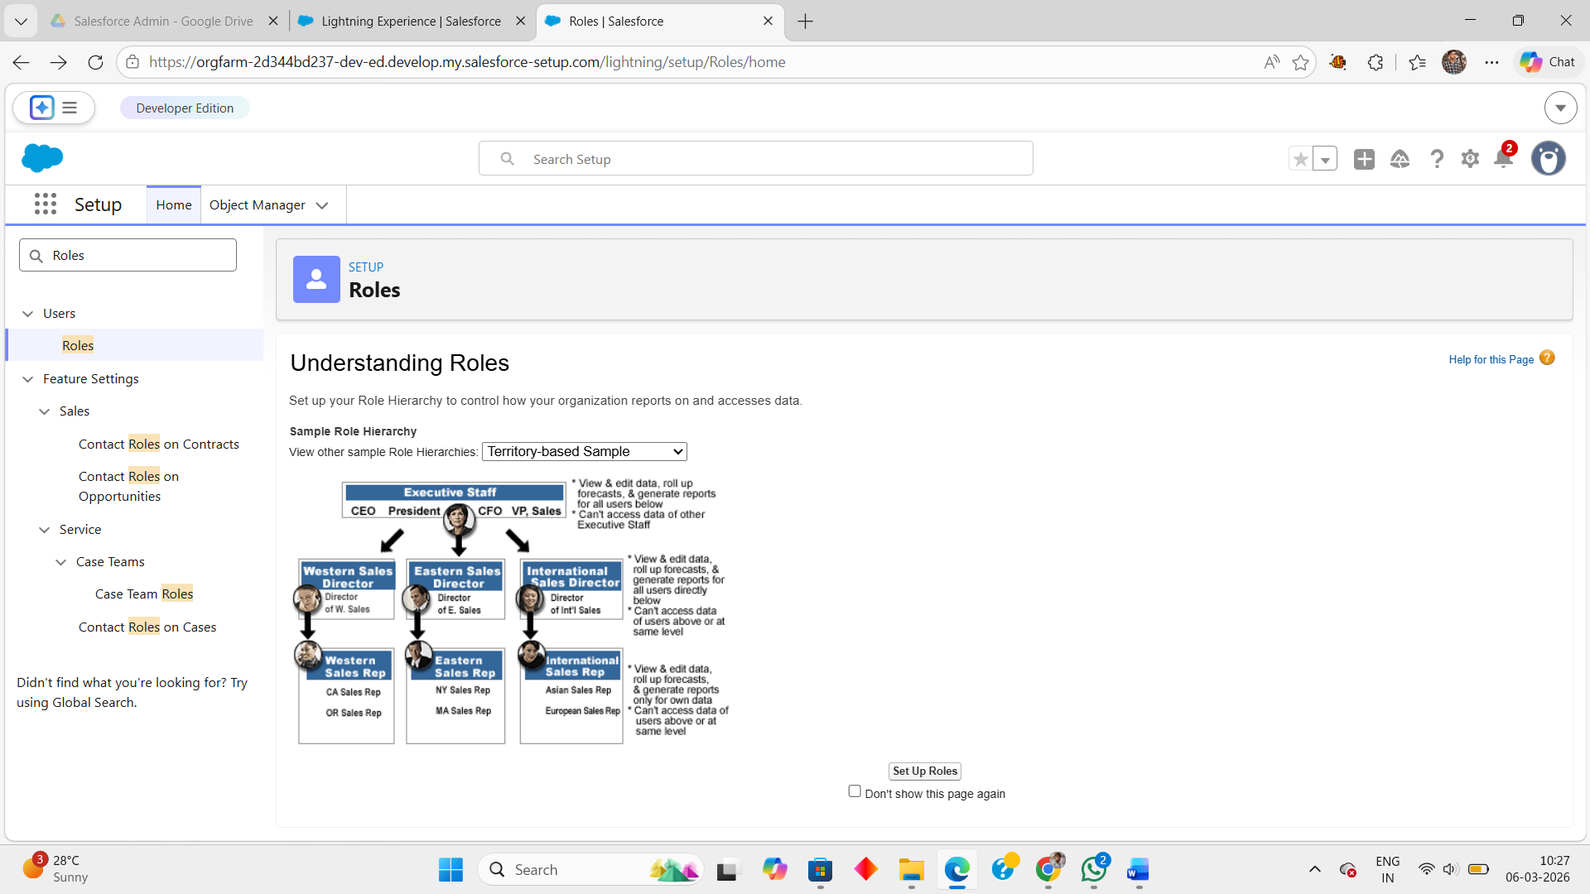

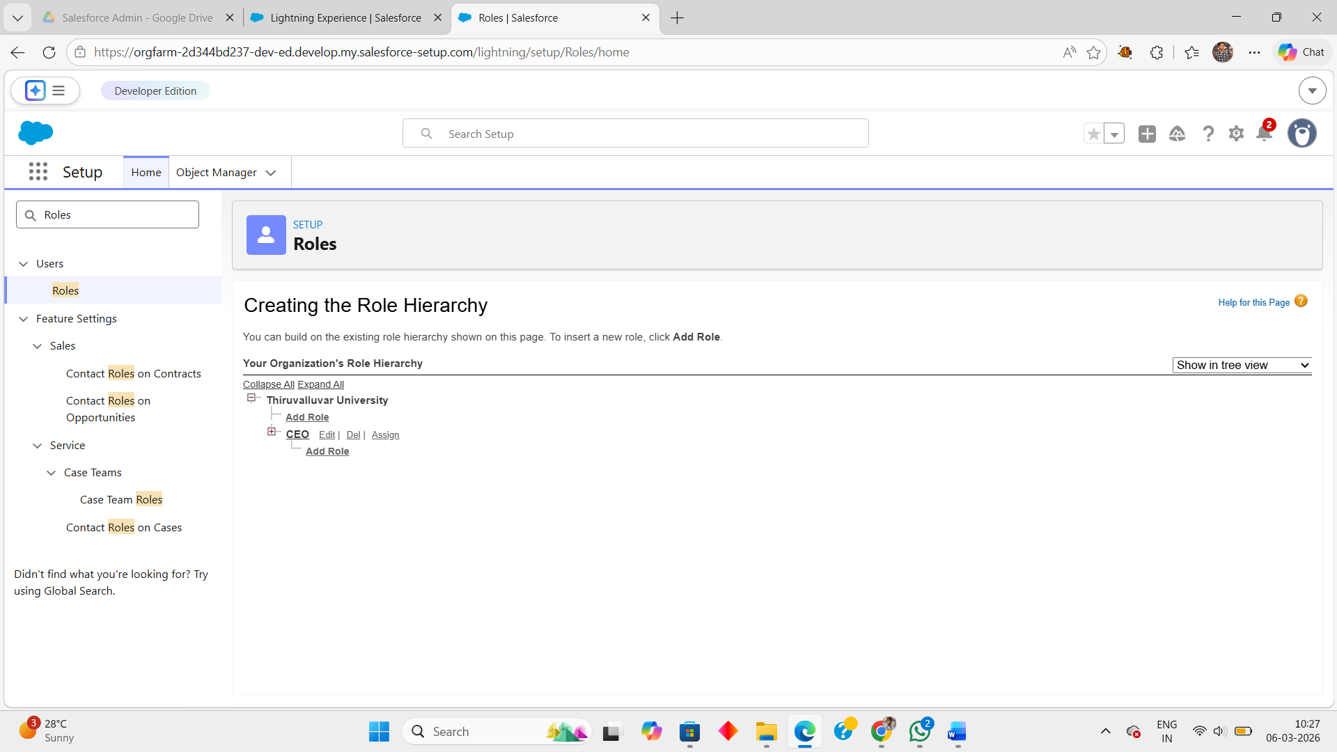

Milestone 8: User

What is a user?
A user is anyone who logs into Salesforce. Users are employees at your company, such as sales reps, managers, and IT specialists, who need access to the company's records. Every user in
Salesforce has a user account. The user account identifies the user, and the user account settings determine what features and records the user can access.

NOTE- As Salesforce license can only be used by 2 Users at a time in Dev Org, so If you don’t find salesforce license then deactivate a user who has salesforce license Or change the license type from Salesforce to any other.
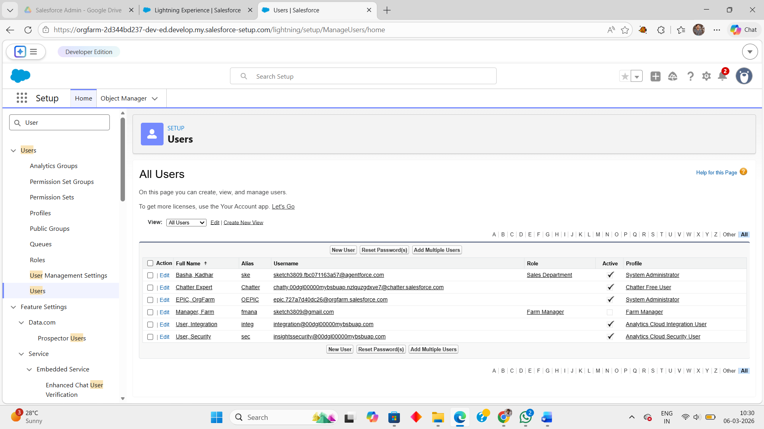

Milestone 9: Sharing Rules

What are Sharing Rules?
Sharing rules help users to share records based on conditions. It is basically created for objects whose organization-wide defaults (OWD) are set to public read-only or private because sharing rules can only extend the access and not restrict it.
Types of sharing rules,
•Owner-based Sharing Rules •Criteria-based Sharing Rules
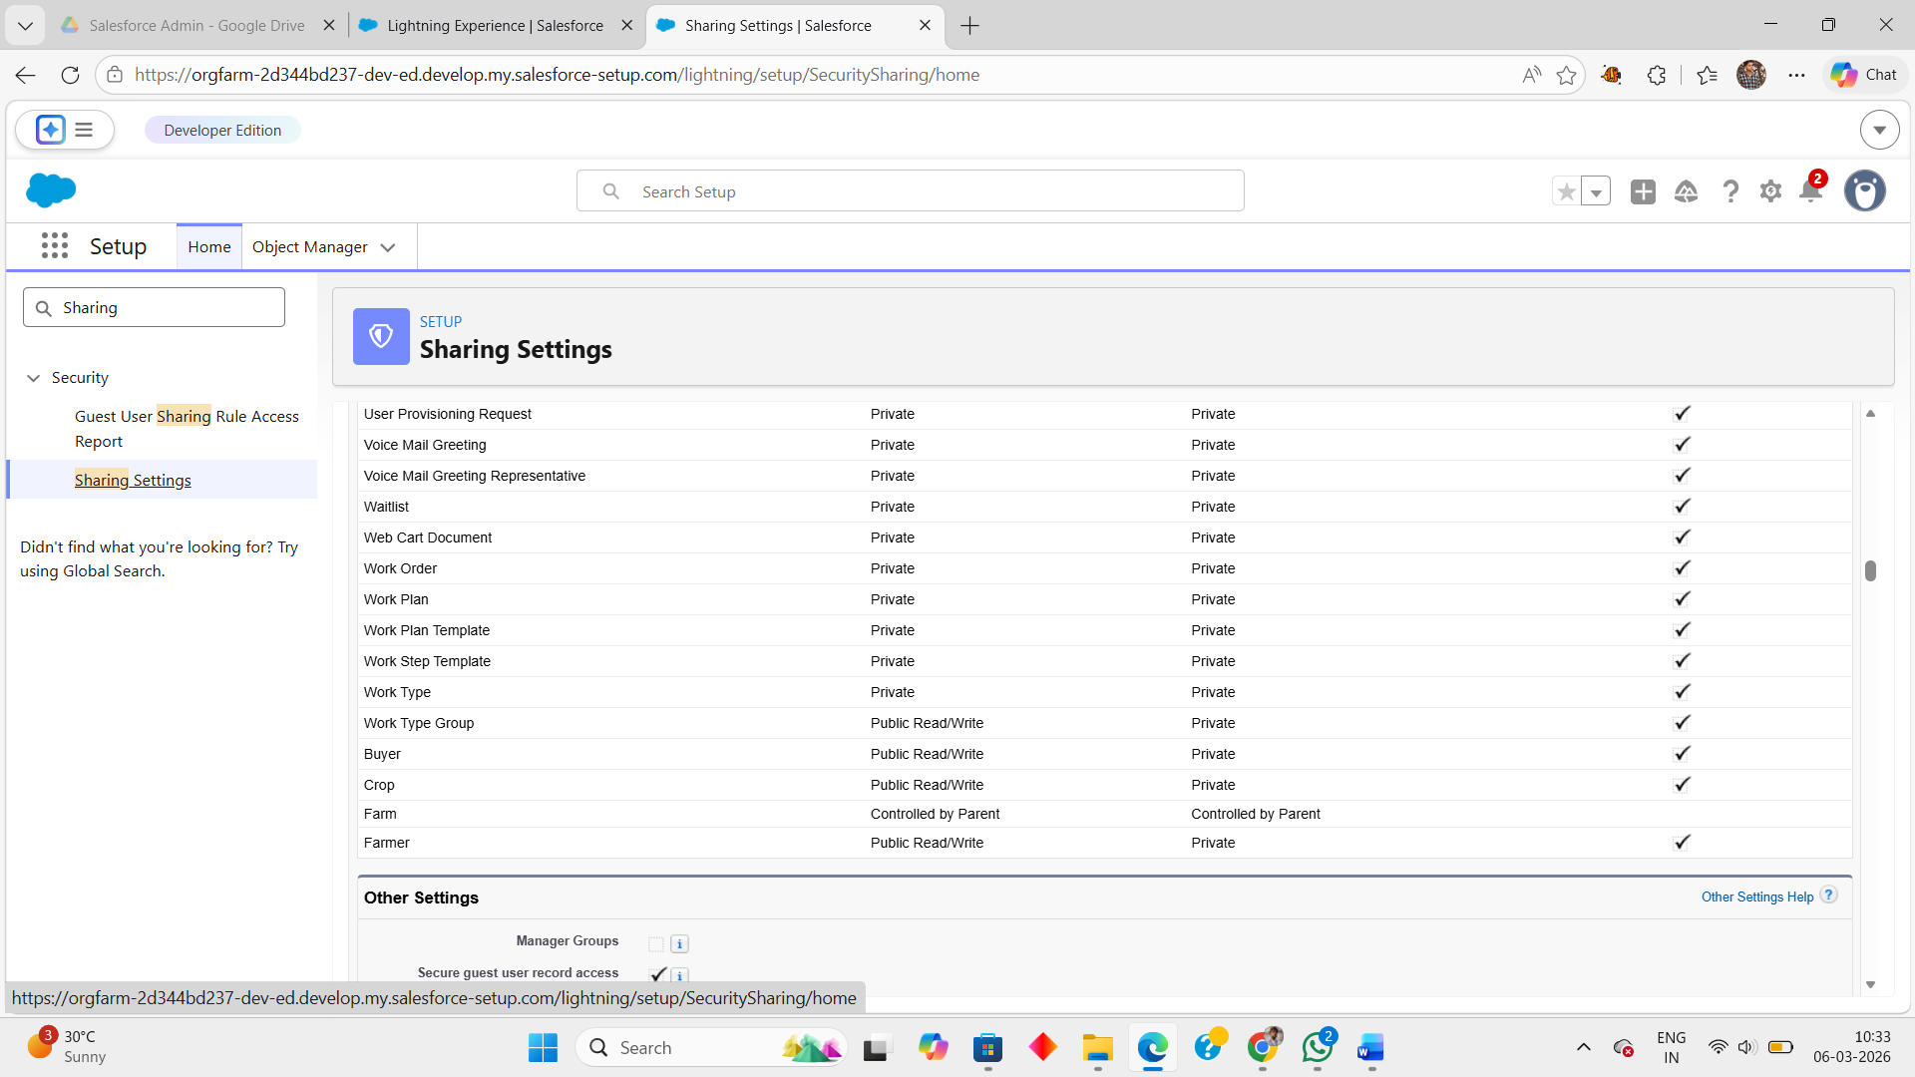

Milestone 10: User Adoption

- User Adoption refers to how effectively users start using the Farm Management System in their daily operations.

- It ensures that farmers, managers, and administrators can easily access and use the system features.

- Users can create and manage records such as farmer details, farm information, crop data, and buyer records.

- The system provides a simple interface and navigation tabs to make data entry easy.

- Proper user adoption helps improve data accuracy and operational efficiency.

- It ensures that the system is used regularly for monitoring farm activities and managing agricultural data.

User adoption ensures that the Farm Management System is successfully implemented and actively used by all stakeholders.

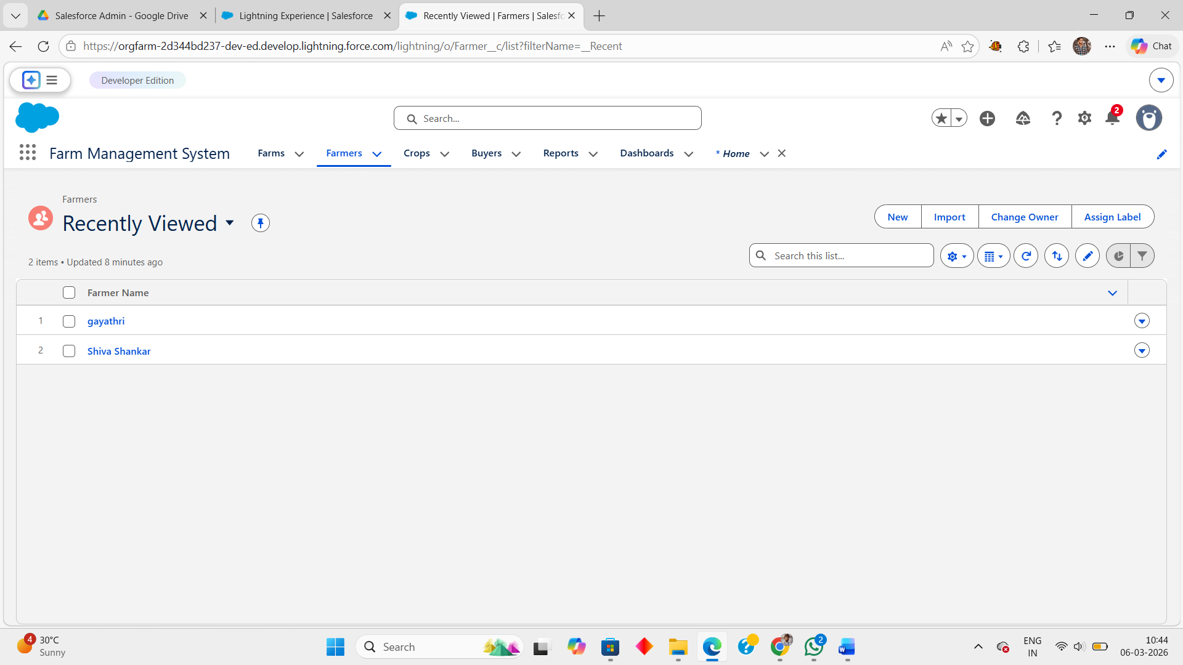

Milestone 11: Reports

A report is a list of records that meet the criteria you define. It's displayed in rows and columns, and can be filtered, grouped, or displayed in a graphical chart. Every report is stored in a folder. Folders can be public, hidden, or shared, and can be set to read-only or read/write.
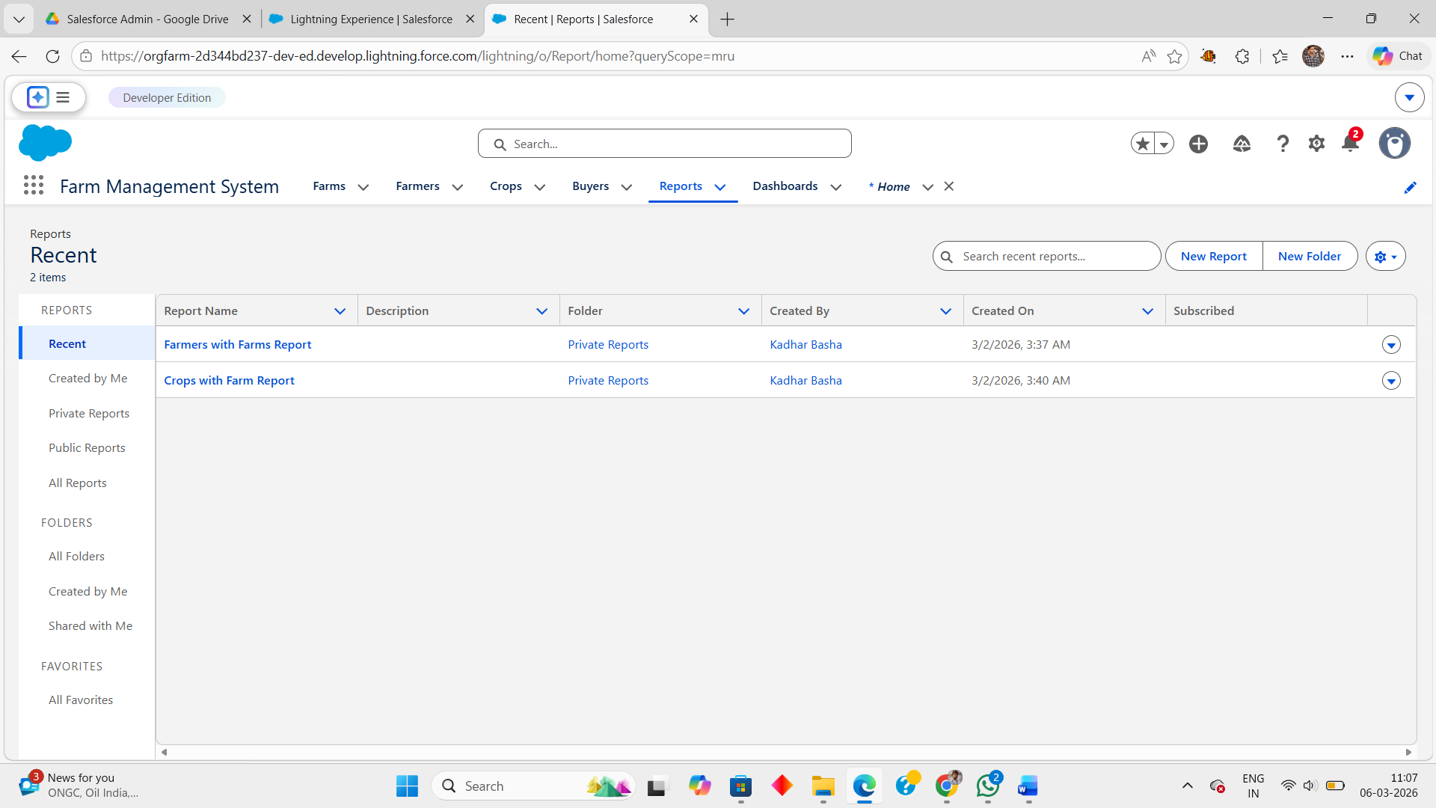

Milestone 12: Dashboard

Dashboards provide more insights than reports as they combine the data from many reports and show a summarized result. Looking at many reports at a time gives the flexibility of combining the results from them quickly. Also summaries in dashboards help us decide on action plans quicker. The dashboards can contain charts, graphs and Tabular data.
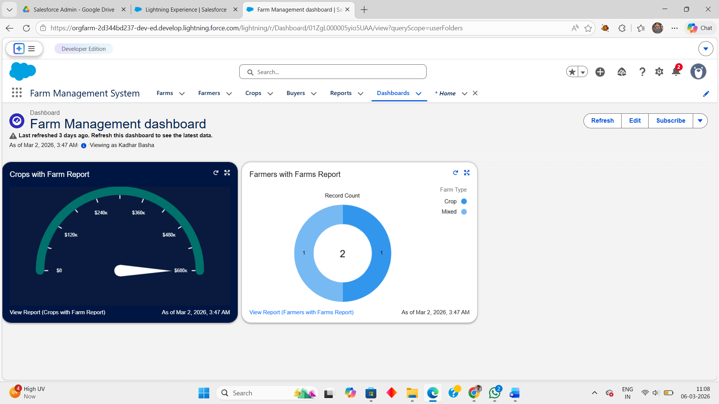

7. FUNCTIONAL & PERFORMANCE TESTING

During the testing phase, screenshots were captured from the Salesforce interface to verify system functionality. The following were tested:
- Creation of Farm, Crop, Farmer, and Buyer records
- Validation of input fields
- Relationship and dependency checks
- Profile and role access testing
- Sharing rule verification
- Report and dashboard generation
Performance testing ensured smooth system response and stability during multiple user operations.

8. ADVANTAGES & DISADVANTAGES

Advantages
- Centralized data system
- Reduced paperwork
- Improved accuracy
- Better monitoring
- Real-time analytics

Disadvantages
- Requires internet connection
- Salesforce license dependency
- Limited offline access

9. Conclusion:

The Farm Management System successfully digitizes agricultural data management using Salesforce. It improves efficiency, reduces errors, and enables farmers and managers to make informed decisions through automation and analytics.

10.FUTURE SCOPE

- Mobile application integration
- AI-based crop prediction
- Weather data integration
- IoT sensor connectivity
- Government scheme integration
- Market price forecasting

11. APPENDIX

- Source Code: Salesforce Configuration and Metadata
- Dataset: Farm, Crop, Farmer, and Buyer Records
- Tools Used: Salesforce Developer Org

Thank You

